UNITED STATES
SECURITIES AND EXCHANGE COMMISSION
WASHINGTON, DC 20549
________________________________________
FORM 10-Q
________________________________________
(Mark One)
☒ |  |  | QUARTERLY REPORT PURSUANT TO SECTION 13 OR 15(d) OF THE SECURITIES EXCHANGE ACT OF 1934
For the quarterly period ended June 30, 2026
OR
o |  |  | TRANSITION REPORT PURSUANT TO SECTION 13 OR 15(d) OF THE SECURITIES EXCHANGE ACT OF 1934
For the transition period from ________ to ________
Commission File Number: 001-39252
________________________________________
Clover Health Investments, Corp.
(Exact Name of Registrant as Specified in its Charter)
________________________________________
Delaware |  |  | 98-1515192
(State or other jurisdiction of  incorporation or organization) |  |  | (I.R.S. Employer  Identification No.)
Not Applicable(1) |  |  | Not Applicable(1)
(Address of principal executive offices) |  |  | (Zip Code)
Not Applicable(1)
Registrant's telephone number, including area code
________________________________________
Securities registered pursuant to Section 12(b) of the Act:
Title of each class |  |  |  |  |  | Trading  Symbol(s) |  |  |  |  |  | Name of each exchange on which registered
Class A Common Stock, par value $0.0001 per share |  |  |  |  |  | CLOV |  |  |  |  |  | The NASDAQ Stock Market LLC
Indicate by check mark whether the registrant (1) has filed all reports required to be filed by Section 13 or 15(d) of the Securities Exchange Act of 1934 during the preceding 12 months (or for such shorter period that the registrant was required to file such reports), and (2) has been subject to such filing requirements for the past 90 days. Yes x No o
Indicate by check mark whether the registrant has submitted electronically every Interactive Data File required to be submitted pursuant to Rule 405 of Regulation S-T (§232.405 of this chapter) during the preceding 12 months (or for such shorter period that the registrant was required to submit such files). Yes x No o
Indicate by check mark whether the registrant is a large accelerated filer, an accelerated filer, a non-accelerated filer, a smaller reporting company, or an emerging growth company. See the definitions of "large accelerated filer," "accelerated filer," "smaller reporting company," and "emerging growth company" in Rule 12b-2 of the Exchange Act.
Large accelerated filer |  |  | x |  |  |  |  |  | Accelerated filer |  |  | o
Non-accelerated filer |  |  | o |  |  |  |  |  | Smaller reporting company |  |  | o
Emerging growth company |  |  | o
If an emerging growth company, indicate by check mark if the registrant has elected not to use the extended transition period for complying with any new or revised financial accounting standards provided pursuant to Section 13(a) of the Exchange Act. ☐
Indicate by check mark whether the registrant is a shell company (as defined in Rule 12b-2 of the Exchange Act). Yes o No x
At July 31, 2026, the registrant had 435,441,337 shares of Class A Common Stock, $0.0001 par value per share, and 95,714,926 shares of Class B Common Stock, $0.0001 par value per share, issued and outstanding.
(1) We are a remote-first company. Accordingly, we do not maintain a headquarters. For purposes of compliance with applicable requirements of the Securities Act of 1933, as amended, and the Securities Exchange Act of 1934, as amended, stockholder communications required to be sent to our principal executive offices may be directed to the email address: secretary@cloverhealth.com, or to our agent for service of process at The Corporation Trust Company, 1209 Orange Street, Wilmington, Delaware 19801.

1

 |  |  |  |  |  | Page
PART I. |  |  | FINANCIAL INFORMATION |  |  | 5
Item 1. |  |  | Financial Statements (Unaudited) |  |  | 5
 |  |  | Condensed Consolidated Balance Sheets at June 30, 2026 and December 31, 2025 |  |  | 6
 |  |  | Condensed Consolidated Statements of Operations and Comprehensive Income (Loss) for the three and six months ended June 30, 2026 and 2025 |  |  | 7
 |  |  | Condensed Consolidated Statements of Changes in Stockholders' Equity for the three and six months ended June 30, 2026 and 2025 |  |  | 8
 |  |  | Condensed Consolidated Statements of Cash Flows for the six months ended June 30, 2026 and 2025 |  |  | 10
 |  |  | Notes to Condensed Consolidated Financial Statements |  |  | 11
Item 2. |  |  | Management's Discussion and Analysis of Financial Condition and Results of Operations |  |  | 24
Item 3. |  |  | Quantitative and Qualitative Disclosures About Market Risk |  |  | 35
Item 4. |  |  | Controls and Procedures |  |  | 36
PART II. |  |  | OTHER INFORMATION |  |  | 37
Item 1. |  |  | Legal Proceedings |  |  | 37
Item 1A. |  |  | Risk Factors |  |  | 37
Item 2. |  |  | Unregistered Sales of Equity Securities and Use of Proceeds |  |  | 38
Item 3. |  |  | Defaults Upon Senior Securities |  |  | 38
Item 4. |  |  | Mine Safety Disclosures |  |  | 38
Item 5. |  |  | Other Information |  |  | 39
Item 6. |  |  | Exhibits |  |  | 40
Signatures |  |  |  |  |  | 41

2

As used in this report, "Company," "Clover," "Clover Health," "we," "us," "our," "our company," and similar terms refer to Clover Health Investments, Corp. and its consolidated subsidiaries, unless otherwise noted or the context otherwise requires.
CAUTIONARY NOTE REGARDING FORWARD-LOOKING STATEMENTS
This Quarterly Report on Form 10-Q contains forward-looking statements within the meaning of Section 27A of the Securities Act of 1933, as amended (the "Securities Act"), and Section 21E of the Securities Exchange Act of 1934, as amended (the "Exchange Act"). All statements contained in this Quarterly Report on Form 10-Q, other than statements of historical fact, including statements regarding our future results of operations, financial position, market size and opportunity, our business strategy and plans, the factors affecting our performance and our objectives for future operations, are forward-looking statements. The words "believe," "may," "will," "estimate," "continue," "anticipate," "intend," "could," "should," "would," "can," "expect," "project," "outlook," "forecast," "objective," "opportunity," "plan," "potential," "seek," "aim," "grow," "target," "if," and the negative or plural of these words and similar expressions are intended to identify forward-looking statements. We have based these forward-looking statements largely on our current expectations and projections about future events and trends that we believe may affect our financial condition, results of operations, business strategy, short-term and long-term business operations and objectives and financial needs. These forward-looking statements are subject to a number of risks, uncertainties and assumptions, including the risk factors described in Part II, Item 1A, “Risk Factors” of this Quarterly Report on Form 10-Q. Moreover, we operate in a very competitive and rapidly changing environment. New risks emerge from time to time. It is not possible for our management to predict all risks, nor can we assess the impact of all factors on our business or the extent to which any factor, or combination of factors, may cause actual results to differ materially from those contained in any forward-looking statements we may make. In light of these risks, uncertainties and assumptions, the future events and trends discussed in this Quarterly Report on Form 10-Q may not occur, and actual results could differ materially and adversely from those anticipated or implied in the forward-looking statements. Forward-looking statements contained in this Quarterly Report on Form 10-Q involve a number of judgments, risks and uncertainties, including, without limitation, risks related to:
•our expectations regarding results of operations, financial condition, and cash flows;
•our expectations regarding the development and management of our business;
•our ability to maintain and increase adoption and use of Clover Assistant ("CA"), including the expansion of Clover Assistant technology for external payors and providers under the brand name Counterpart Assistant;
•our ability to successfully enter new service markets and manage our operations;
•anticipated trends and challenges in our business and in the markets in which we operate;
•any current, pending, or future legislation, regulations or policies that could have a negative effect on our revenue, profit margins, cash flows and business, including, without limitation The Patient Protection and Affordable Care Act, or the ACA, and other rules, regulations, and policies relating to healthcare, Medicare generally and medical loss ratios;
•our ability to effectively manage our member base and provider network;
•the anticipated benefits associated with the use of Clover Assistant, including our ability to utilize the platform to manage our medical expenses and medical loss ratios;
•our ability to maintain or improve our Star Ratings or otherwise continue to improve the financial performance of our business;
•our ability to protect our sites, networks, and systems against security breaches, or otherwise to protect our confidential or health information or the confidential or health information of our members, providers, or other third parties;
•our ability to develop new features and functionality that meet market needs and achieve market acceptance;
•our ability to retain and hire necessary employees and staff our operations appropriately;
•the timing and amount of certain investments in growth;
•the outcome of any known and unknown litigation and regulatory proceedings;
•fluctuations in the price of our Class A common stock and our continued compliance with Nasdaq's listing requirements;
•our ability to maintain, protect, and enhance our intellectual property;
•general economic conditions and uncertainty;
•inflation and fluctuating interest rates; and
•geopolitical uncertainty and instability.
We caution you that the foregoing list of judgments, risks, and uncertainties that may cause actual results to differ materially from those in the forward-looking statements may not be complete. You should not rely upon forward-looking statements as predictions of future events. The events and circumstances reflected in the forward-looking statements may not be achieved or occur or may be materially different from what we expect. Although we believe that the expectations reflected in the forward-looking statements are reasonable, we cannot guarantee future results, levels of activity, performance, or achievements. Except as required by law, we undertake no obligation to update any of these forward-looking statements after the date of this Quarterly Report on Form 10-Q or to conform these statements to actual results or revised expectations.

3

This Quarterly Report on Form 10-Q contains estimates, projections, and other information concerning our industry, our business and the markets for our products. We obtained the industry, market, and similar data set forth in this Quarterly Report on Form 10-Q from our own internal estimates and research and from industry research, publications, surveys, and studies conducted by third parties, including governmental agencies, and such information is inherently subject to uncertainties. Actual events or circumstances may differ materially from events and circumstances that are assumed in this information. You are cautioned not to give undue weight to any such information, projections or estimates.
As a result of a number of known and unknown risks and uncertainties, including without limitation, the important factors described in our reports filed with the SEC, including the discussion under "Risk Factors" in this Quarterly Report on Form 10-Q, our actual results or performance may be materially different from those expressed or implied by these forward-looking statements.
Additional Information
Our website address is www.cloverhealth.com. Our filings with the SEC are posted on our website and available free of charge as soon as reasonably practicable after they are electronically filed with, or furnished to, the SEC. The content on our website or on any other website referred to in this document is not incorporated by reference in this document. Further, the Company's references to website URLs are intended to be inactive textual references only.
Channels for Disclosure of Information
Investors and others should note that we routinely announce material information to investors and the marketplace using filings with the SEC, press releases, public conference calls, presentations, webcasts, and the investor relations page of our website at investors.cloverhealth.com. We use the investor relations page of our website for purposes of compliance with Regulation FD and as a routine channel for distribution of important information, including news releases, analyst presentations, financial information, and corporate governance practices. We also use certain social media channels as a means of disclosing information about the Company and our products to our customers, investors, and the public, including @CloverHealth and #CloverHealth on X and the LinkedIn account of our Chief Executive Officer, Andrew Toy. The information posted on social media channels is not incorporated by reference in this report or in any other report or document we file with the SEC. While not all of the information that we post to the investor relations page of our website or to social media accounts is of a material nature, some information could be deemed to be material. Accordingly, we encourage investors, the media, and others interested in the Company to review the information that we share on our investor relations page of our website at investors.cloverhealth.com and to sign up for and regularly follow our social media accounts. Users may automatically receive email alerts and other information about the Company when enrolling an email address by visiting "Email Alerts" in the "Investor Resources" section of our website at investors.cloverhealth.com.

4

PART 1

Item 1. Financial Statements (Unaudited)

5

CLOVER HEALTH INVESTMENTS, CORP.
CONDENSED CONSOLIDATED BALANCE SHEETS
(Dollars in thousands, except share amounts)
 |  |  | June 30, 2026 |  |  |  |  |  | December 31, 2025
Assets
Current assets:
Cash and cash equivalents |  |  | $ | 198,837 |  |  |  |  | $ | 78,301
Short-term investments |  |  | 2,481 |  |  |  |  |  | 17,047
Investment securities, available-for-sale (Amortized cost: 2026: $39,950; 2025: $23,231) |  |  | 39,727 |  |  |  |  |  | 23,131
Investment securities, held-to-maturity (Fair value: 2026: $2,021; 2025: $1,779) |  |  | 2,055 |  |  |  |  |  | 1,777
Accrued retrospective premiums |  |  | 129,614 |  |  |  |  |  | 63,875
Healthcare receivables |  |  | 73,121 |  |  |  |  |  | 94,866
Prepaid expenses |  |  | 19,213 |  |  |  |  |  | 18,209
Other assets, current |  |  | 20,398 |  |  |  |  |  | 10,649
Total current assets |  |  | 485,446 |  |  |  |  |  | 307,855
Investment securities, available-for-sale (Amortized cost: 2026: $190,771; 2025: $186,464) |  |  | 189,443 |  |  |  |  |  | 187,092
Investment securities, held-to-maturity (Fair value: 2026: $10,295; 2025: $12,495) |  |  | 10,471 |  |  |  |  |  | 12,571
Property and equipment, net |  |  | 7,231 |  |  |  |  |  | 6,385
Other intangible assets |  |  | 2,990 |  |  |  |  |  | 2,990
Other assets, non-current |  |  | 24,745 |  |  |  |  |  | 24,118
Total assets |  |  | $ | 720,326 |  |  |  |  | $ | 541,011
Liabilities and Stockholders' Equity
Current liabilities:
Unpaid claims |  |  | $ | 250,890 |  |  |  |  | $ | 153,250
Accounts payable and accrued expenses |  |  | 35,407 |  |  |  |  |  | 36,211
Accrued salaries and benefits |  |  | 31,156 |  |  |  |  |  | 16,038
Other liabilities, current |  |  | 5,877 |  |  |  |  |  | 3,324
Total current liabilities |  |  | 323,330 |  |  |  |  |  | 208,823
Other liabilities, non-current |  |  | 20,739 |  |  |  |  |  | 23,484
Total liabilities |  |  | 344,069 |  |  |  |  |  | 232,307
Commitments and Contingencies (Note 12)
Stockholders' equity:
Class A Common Stock, $0.0001 par value; 2,500,000,000 shares authorized at June 30, 2026 and December 31, 2025; 433,432,644 and 426,669,369 issued and outstanding at June 30, 2026 and December 31, 2025, respectively |  |  | 43 |  |  |  |  |  | 43
Class B Common Stock, $0.0001 par value; 500,000,000 shares authorized at June 30, 2026 and December 31, 2025; 95,714,926 and 92,373,157 issued and outstanding at June 30, 2026 and December 31, 2025, respectively |  |  | 9 |  |  |  |  |  | 9
Additional paid-in capital |  |  | 2,706,640 |  |  |  |  |  | 2,682,663
Accumulated other comprehensive (loss) income |  |  | (1,551) |  |  |  |  |  | 528
Accumulated deficit |  |  | (2,233,017) |  |  |  |  |  | (2,288,352)
Less: Treasury stock, at cost; 35,782,658 and 33,412,273 shares held at June 30, 2026 and December 31, 2025, respectively |  |  | (95,867) |  |  |  |  |  | (86,187)
Total stockholders' equity |  |  | 376,257 |  |  |  |  |  | 308,704
Total liabilities and stockholders' equity |  |  | $ | 720,326 |  |  |  |  | $ | 541,011
The accompanying notes are an integral part of these condensed consolidated financial statements.

6

CLOVER HEALTH INVESTMENTS, CORP.
CONDENSED CONSOLIDATED STATEMENTS OF OPERATIONS AND COMPREHENSIVE INCOME (LOSS)
(Dollars in thousands, except per share and share amounts)
 |  |  | Three Months Ended  June 30, |  |  |  |  |  |  |  |  |  |  |  | Six Months Ended  June 30,
 |  |  | 2026 |  |  |  |  |  | 2025 |  |  |  |  |  | 2026 |  |  |  |  |  | 2025
Revenues:
Premiums earned, net (Net of ceded premiums of $91 and $96 for the three months ended June 30, 2026 and 2025 respectively, and $183 and $192 for the six months ended June 30, 2026 and 2025, respectively) |  |  | $ | 737,767 |  |  |  |  | $ | 469,826 |  |  |  |  | $ | 1,481,956 |  |  |  |  | $ | 926,732
Other income |  |  | 5,400 |  |  |  |  |  | 7,794 |  |  |  |  |  | 10,400 |  |  |  |  |  | 13,219
Total revenues |  |  | 743,167 |  |  |  |  |  | 477,620 |  |  |  |  |  | 1,492,356 |  |  |  |  |  | 939,951
Operating expenses:
Net medical claims incurred |  |  | 590,165 |  |  |  |  |  | 377,992 |  |  |  |  |  | 1,179,813 |  |  |  |  |  | 731,434
Salaries and benefits |  |  | 54,138 |  |  |  |  |  | 61,309 |  |  |  |  |  | 111,201 |  |  |  |  |  | 120,331
General and administrative expenses |  |  | 70,299 |  |  |  |  |  | 48,484 |  |  |  |  |  | 144,928 |  |  |  |  |  | 99,159
Depreciation and amortization |  |  | 564 |  |  |  |  |  | 394 |  |  |  |  |  | 1,079 |  |  |  |  |  | 860
Total operating expenses |  |  | 715,166 |  |  |  |  |  | 488,179 |  |  |  |  |  | 1,437,021 |  |  |  |  |  | 951,784
Income (loss) from operations |  |  | 28,001 |  |  |  |  |  | (10,559) |  |  |  |  |  | 55,335 |  |  |  |  |  | (11,833)
Change in fair value of warrants |  |  | — |  |  |  |  |  | 19 |  |  |  |  |  | — |  |  |  |  |  | 19
Net income (loss) |  |  | $ | 28,001 |  |  |  |  | $ | (10,578) |  |  |  |  | $ | 55,335 |  |  |  |  | $ | (11,852)
Per share data:
Basic weighted average number of class A and class B common shares and common share equivalents outstanding |  |  | 524,186,885 |  |  |  |  |  | 509,043,210 |  |  |  |  |  | 523,861,227 |  |  |  |  |  | 508,893,753
Diluted weighted average number of class A and class B common shares and common share equivalents outstanding |  |  | 545,447,735 |  |  |  |  |  | 509,043,210 |  |  |  |  |  | 540,272,301 |  |  |  |  |  | 508,893,753
Basic earnings (loss) per share |  |  | $ | 0.05 |  |  |  |  | $ | (0.02) |  |  |  |  | $ | 0.11 |  |  |  |  | $ | (0.02)
Diluted earnings (loss) per share |  |  | $ | 0.05 |  |  |  |  | $ | (0.02) |  |  |  |  | $ | 0.10 |  |  |  |  | $ | (0.02)
Net unrealized (loss) gain on available-for-sale investments |  |  | (879) |  |  |  |  |  | 251 |  |  |  |  |  | (2,079) |  |  |  |  |  | 1,761
Comprehensive income (loss) |  |  | $ | 27,122 |  |  |  |  | $ | (10,327) |  |  |  |  | $ | 53,256 |  |  |  |  | $ | (10,091)
The accompanying notes are an integral part of these condensed consolidated financial statements.

7

CLOVER HEALTH INVESTMENTS, CORP.
CONDENSED CONSOLIDATED STATEMENTS OF CHANGES IN STOCKHOLDERS' EQUITY
(Dollars in thousands, except share amounts)
 |  |  | Class A Common Stock |  |  |  |  |  |  |  |  |  |  |  | Class B Common Stock |  |  |  |  |  |  |  |  |  |  |  | Treasury Stock |  |  |  |  |  |  |  |  |  |  |  | Additional paid-in capital |  |  |  |  |  | Accumulated  deficit |  |  |  |  |  | Accumulated  other  comprehensive (loss) income |  |  |  |  |  |  |  | Total stockholders' equity
 |  |  | Shares |  |  |  |  |  | Amount |  |  |  |  |  | Shares |  |  |  |  |  | Amount |  |  |  |  |  | Shares |  |  |  |  |  | Amount
Balance, December 31, 2025 |  |  | 426,669,369 |  |  |  |  |  | $ | 43 |  |  |  |  | 92,373,157 |  |  |  |  |  | $ | 9 |  |  |  |  | 33,412,273 |  |  |  |  |  | $ | (86,187) |  |  |  |  | $ | 2,682,663 |  |  |  |  | $ | (2,288,352) |  |  |  |  | $ | 528 |  |  |  |  |  |  | $ | 308,704
Stock issuance for exercise of stock options, net of early exercise liability |  |  | 23,782 |  |  |  |  |  | — |  |  |  |  |  | — |  |  |  |  |  | — |  |  |  |  |  | — |  |  |  |  |  | — |  |  |  |  |  | 30 |  |  |  |  |  | — |  |  |  |  |  | — |  |  |  |  |  |  |  | 30
Stock-based compensation |  |  | — |  |  |  |  |  | — |  |  |  |  |  | — |  |  |  |  |  | — |  |  |  |  |  | — |  |  |  |  |  | — |  |  |  |  |  | 12,451 |  |  |  |  |  | — |  |  |  |  |  | — |  |  |  |  |  |  |  | 12,451
Vested restricted stock units |  |  | 4,427,824 |  |  |  |  |  | — |  |  |  |  |  | 3,342,699 |  |  |  |  |  | — |  |  |  |  |  | — |  |  |  |  |  | — |  |  |  |  |  | — |  |  |  |  |  | — |  |  |  |  |  | — |  |  |  |  |  |  |  | —
Unrealized holdings loss on investment securities, available for sale |  |  | — |  |  |  |  |  | — |  |  |  |  |  | — |  |  |  |  |  | — |  |  |  |  |  | — |  |  |  |  |  | — |  |  |  |  |  | — |  |  |  |  |  | — |  |  |  |  |  | (1,200) |  |  |  |  |  |  |  | (1,200)
Shares withheld for taxes on equity awards |  |  | (1,565,397) |  |  |  |  |  | — |  |  |  |  |  | — |  |  |  |  |  | — |  |  |  |  |  | 1,565,397 |  |  |  |  |  | (7,893) |  |  |  |  |  | — |  |  |  |  |  | — |  |  |  |  |  | — |  |  |  |  |  |  |  | (7,893)
Net income |  |  | — |  |  |  |  |  | — |  |  |  |  |  | — |  |  |  |  |  | — |  |  |  |  |  | — |  |  |  |  |  | — |  |  |  |  |  | — |  |  |  |  |  | 27,334 |  |  |  |  |  | — |  |  |  |  |  |  |  | 27,334
Balance, March 31, 2026 |  |  | 429,555,578 |  |  |  |  |  | $ | 43 |  |  |  |  | 95,715,856 |  |  |  |  |  | $ | 9 |  |  |  |  | 34,977,670 |  |  |  |  |  | $ | (94,080) |  |  |  |  | $ | 2,695,144 |  |  |  |  | $ | (2,261,018) |  |  |  |  | $ | (672) |  |  |  |  |  |  | $ | 339,426
Stock issuance for exercise of stock options, net of early exercise liability |  |  | 938,635 |  |  |  |  |  | — |  |  |  |  |  | — |  |  |  |  |  | — |  |  |  |  |  | — |  |  |  |  |  | — |  |  |  |  |  | 1,652 |  |  |  |  |  | — |  |  |  |  |  | — |  |  |  |  |  |  |  | 1,652
Stock-based compensation |  |  | — |  |  |  |  |  | — |  |  |  |  |  | — |  |  |  |  |  | — |  |  |  |  |  | — |  |  |  |  |  | — |  |  |  |  |  | 9,293 |  |  |  |  |  | — |  |  |  |  |  | — |  |  |  |  |  |  |  | 9,293
Vested restricted stock units |  |  | 3,472,290 |  |  |  |  |  | — |  |  |  |  |  | — |  |  |  |  |  | — |  |  |  |  |  | — |  |  |  |  |  | — |  |  |  |  |  | — |  |  |  |  |  | — |  |  |  |  |  | — |  |  |  |  |  |  |  | —
Unrealized holdings loss on investment securities, available for sale |  |  | — |  |  |  |  |  | — |  |  |  |  |  | — |  |  |  |  |  | — |  |  |  |  |  | — |  |  |  |  |  | — |  |  |  |  |  | — |  |  |  |  |  | — |  |  |  |  |  | (879) |  |  |  |  |  |  |  | (879)
Conversion from Class B common stock to Class A common stock |  |  | 930 |  |  |  |  |  | — |  |  |  |  |  | (930) |  |  |  |  |  | — |  |  |  |  |  | — |  |  |  |  |  | — |  |  |  |  |  | — |  |  |  |  |  | — |  |  |  |  |  | — |  |  |  |  |  |  |  | —
Shares withheld for taxes on equity awards |  |  | (804,988) |  |  |  |  |  | — |  |  |  |  |  | — |  |  |  |  |  | — |  |  |  |  |  | 804,988 |  |  |  |  |  | (1,787) |  |  |  |  |  | — |  |  |  |  |  | — |  |  |  |  |  | — |  |  |  |  |  |  |  | (1,787)
Issuance of common stock under employee stock purchase plan |  |  | 270,199 |  |  |  |  |  |  |  |  |  |  |  |  |  |  |  |  |  |  |  |  |  |  |  |  |  |  |  |  |  |  |  |  |  |  |  | 551 |  |  |  |  |  | — |  |  |  |  |  | — |  |  |  |  |  |  |  | 551
Net income |  |  | — |  |  |  |  |  | — |  |  |  |  |  | — |  |  |  |  |  | — |  |  |  |  |  | — |  |  |  |  |  | — |  |  |  |  |  | — |  |  |  |  |  | 28,001 |  |  |  |  |  | — |  |  |  |  |  |  |  | 28,001
Balance, June 30, 2026 |  |  | 433,432,644 |  |  |  |  |  | $ | 43 |  |  |  |  | 95,714,926 |  |  |  |  |  | $ | 9 |  |  |  |  | 35,782,658 |  |  |  |  |  | $ | (95,867) |  |  |  |  | $ | 2,706,640 |  |  |  |  | $ | (2,233,017) |  |  |  |  | $ | (1,551) |  |  |  |  |  |  | 376,257

8

 |  |  | Class A Common Stock |  |  |  |  |  |  |  |  |  |  |  | Class B Common Stock |  |  |  |  |  |  |  |  |  |  |  | Treasury Stock |  |  |  |  |  |  |  |  |  |  |  | Additional paid-in capital |  |  |  |  |  | Accumulated  deficit |  |  |  |  |  | Accumulated  other  comprehensive (loss) income |  |  |  |  |  |  |  | Total stockholders' equity
 |  |  | Shares |  |  |  |  |  | Amount |  |  |  |  |  | Shares |  |  |  |  |  | Amount |  |  |  |  |  | Shares |  |  |  |  |  | Amount
Balance, December 31, 2024 |  |  | 414,493,051 |  |  |  |  |  | $ | 41 |  |  |  |  | 89,032,305 |  |  |  |  |  | $ | 9 |  |  |  |  | 18,752,947 |  |  |  |  |  | $ | (30,991) |  |  |  |  | $ | 2,576,471 |  |  |  |  | $ | (2,202,803) |  |  |  |  | $ | (1,584) |  |  |  |  |  |  | $ | 341,143
Stock issuance for exercise of stock options, net of early exercise liability |  |  | 139,709 |  |  |  |  |  | — |  |  |  |  |  | — |  |  |  |  |  | — |  |  |  |  |  | — |  |  |  |  |  | — |  |  |  |  |  | 215 |  |  |  |  |  | — |  |  |  |  |  | — |  |  |  |  |  |  |  | 215
Stock-based compensation |  |  | — |  |  |  |  |  | — |  |  |  |  |  | — |  |  |  |  |  | — |  |  |  |  |  | — |  |  |  |  |  | — |  |  |  |  |  | 26,437 |  |  |  |  |  | — |  |  |  |  |  | — |  |  |  |  |  |  |  | 26,437
Vested restricted stock units |  |  | 6,431,417 |  |  |  |  |  | 1 |  |  |  |  |  | 3,342,698 |  |  |  |  |  | — |  |  |  |  |  | — |  |  |  |  |  | — |  |  |  |  |  | — |  |  |  |  |  | — |  |  |  |  |  | — |  |  |  |  |  |  |  | 1
Unrealized holdings gain on investment securities, available for sale |  |  | — |  |  |  |  |  | — |  |  |  |  |  | — |  |  |  |  |  | — |  |  |  |  |  | — |  |  |  |  |  | — |  |  |  |  |  | — |  |  |  |  |  | — |  |  |  |  |  | 1,510 |  |  |  |  |  |  |  | 1,510
Shares withheld for taxes on equity awards |  |  | (1,833,218) |  |  |  |  |  | — |  |  |  |  |  | — |  |  |  |  |  | — |  |  |  |  |  | 1,833,218 |  |  |  |  |  | (13,659) |  |  |  |  |  | — |  |  |  |  |  | — |  |  |  |  |  | — |  |  |  |  |  |  |  | (13,659)
Repurchases of common stock |  |  | (5,069,423) |  |  |  |  |  | (1) |  |  |  |  |  | — |  |  |  |  |  | — |  |  |  |  |  | 5,069,423 |  |  |  |  |  | (18,297) |  |  |  |  |  | — |  |  |  |  |  | — |  |  |  |  |  | — |  |  |  |  |  |  |  | (18,298)
Net loss |  |  | — |  |  |  |  |  | — |  |  |  |  |  | — |  |  |  |  |  | — |  |  |  |  |  | — |  |  |  |  |  | — |  |  |  |  |  | — |  |  |  |  |  | (1,274) |  |  |  |  |  | — |  |  |  |  |  |  |  | (1,274)
Balance, March 31, 2025 |  |  | 414,161,536 |  |  |  |  |  | $ | 41 |  |  |  |  | 92,375,003 |  |  |  |  |  | $ | 9 |  |  |  |  | 25,655,588 |  |  |  |  |  | $ | (62,947) |  |  |  |  | $ | 2,603,123 |  |  |  |  | $ | (2,204,077) |  |  |  |  | $ | (74) |  |  |  |  |  |  | $ | 336,075
Stock issuance for exercise of stock options, net of early exercise liability |  |  | 97,249 |  |  |  |  |  | — |  |  |  |  |  | — |  |  |  |  |  | — |  |  |  |  |  | — |  |  |  |  |  | — |  |  |  |  |  | 148 |  |  |  |  |  | — |  |  |  |  |  | — |  |  |  |  |  |  |  | 148
Stock-based compensation |  |  | — |  |  |  |  |  | — |  |  |  |  |  | — |  |  |  |  |  | — |  |  |  |  |  | — |  |  |  |  |  | — |  |  |  |  |  | 26,195 |  |  |  |  |  | — |  |  |  |  |  | — |  |  |  |  |  |  |  | 26,195
Vested restricted stock units |  |  | 6,417,884 |  |  |  |  |  | 1 |  |  |  |  |  | — |  |  |  |  |  | — |  |  |  |  |  | — |  |  |  |  |  | — |  |  |  |  |  | — |  |  |  |  |  | — |  |  |  |  |  | — |  |  |  |  |  |  |  | 1
Unrealized holdings gain on investment securities, available for sale |  |  | — |  |  |  |  |  | — |  |  |  |  |  | — |  |  |  |  |  | — |  |  |  |  |  | — |  |  |  |  |  | — |  |  |  |  |  | — |  |  |  |  |  | — |  |  |  |  |  | 251 |  |  |  |  |  |  |  | 251
Shares withheld for taxes on equity awards |  |  | (2,476,795) |  |  |  |  |  | — |  |  |  |  |  | — |  |  |  |  |  | — |  |  |  |  |  | 2,476,795 |  |  |  |  |  | (8,468) |  |  |  |  |  | — |  |  |  |  |  | — |  |  |  |  |  | — |  |  |  |  |  |  |  | (8,468)
Issuance of Common Stock under Employee Stock Purchase Plan |  |  | 186,901 |  |  |  |  |  | — |  |  |  |  |  | — |  |  |  |  |  | — |  |  |  |  |  | — |  |  |  |  |  | — |  |  |  |  |  | 555 |  |  |  |  |  | — |  |  |  |  |  | — |  |  |  |  |  |  |  | 555
Net loss |  |  | — |  |  |  |  |  | — |  |  |  |  |  | — |  |  |  |  |  | — |  |  |  |  |  | — |  |  |  |  |  | — |  |  |  |  |  | — |  |  |  |  |  | (10,578) |  |  |  |  |  | — |  |  |  |  |  |  |  | (10,578)
Balance, June 30, 2025 |  |  | 418,386,775 |  |  |  |  |  | $ | 42 |  |  |  |  | 92,375,003 |  |  |  |  |  | $ | 9 |  |  |  |  | 28,132,383 |  |  |  |  |  | $ | (71,415) |  |  |  |  | $ | 2,630,021 |  |  |  |  | $ | (2,214,655) |  |  |  |  | $ | 177 |  |  |  |  |  |  | 344,179
The accompanying notes are an integral part of these condensed consolidated financial statements.

9

CLOVER HEALTH INVESTMENTS, CORP.
CONDENSED CONSOLIDATED STATEMENTS OF CASH FLOWS
(Dollars in thousands)
 |  |  | Six months ended June 30,
 |  |  | 2026 |  |  |  |  |  | 2025
Cash flows from operating activities:
Net income (loss) |  |  | $ | 55,335 |  |  |  |  | $ | (11,852)
Adjustments to reconcile net income (loss) to net cash provided by (used in) operating activities:
Depreciation and amortization expense |  |  | 1,079 |  |  |  |  |  | 860
Stock-based compensation |  |  | 21,355 |  |  |  |  |  | 52,632
Change in fair value of warrants and amortization of warrants |  |  | — |  |  |  |  |  | 19
Accretion, net of amortization |  |  | (869) |  |  |  |  |  | (946)
Change in accrued interest earned |  |  | (178) |  |  |  |  |  | 347
Net realized gains on investment securities |  |  | (30) |  |  |  |  |  | (437)
Changes in operating assets and liabilities:
Accrued retrospective premiums |  |  | (65,739) |  |  |  |  |  | (43,201)
Prepaid expenses |  |  | (1,004) |  |  |  |  |  | (2,078)
Other assets |  |  | (10,373) |  |  |  |  |  | (2,084)
Healthcare receivables |  |  | 21,745 |  |  |  |  |  | 4,646
Unpaid claims |  |  | 97,640 |  |  |  |  |  | (16,736)
Accounts payable and accrued expenses |  |  | (804) |  |  |  |  |  | (613)
Accrued salaries and benefits |  |  | 15,118 |  |  |  |  |  | 6,094
Other liabilities |  |  | (192) |  |  |  |  |  | 2,464
Net cash provided by (used in) operating activities |  |  | 133,083 |  |  |  |  |  | (10,885)
Cash flows from investing activities:
Purchases of short-term investments, available-for-sale, and held-to-maturity securities |  |  | (68,088) |  |  |  |  |  | (59,864)
Proceeds from sales of short-term investments and available-for-sale securities |  |  | 56,318 |  |  |  |  |  | 79,313
Proceeds from maturities of short-term investments and available-for-sale securities |  |  | 8,206 |  |  |  |  |  | 25,801
Purchases of property and equipment |  |  | (1,536) |  |  |  |  |  | (754)
Net cash (used in) provided by investing activities |  |  | (5,100) |  |  |  |  |  | 44,496
Cash flows from financing activities:
Issuance of common stock, net of early exercise liability |  |  | 1,682 |  |  |  |  |  | 363
Issuance of common stock under employee stock purchase plan, net of stock issuance costs |  |  | 551 |  |  |  |  |  | 555
Cash paid for shares withheld related to stock-based compensation |  |  | (9,680) |  |  |  |  |  | (22,127)
Repurchases of common stock |  |  | — |  |  |  |  |  | (18,297)
Net cash used in financing activities |  |  | (7,447) |  |  |  |  |  | (39,506)
Net increase (decrease) in cash and cash equivalents |  |  | 120,536 |  |  |  |  |  | (5,895)
Cash and cash equivalents, beginning of period |  |  | 78,301 |  |  |  |  |  | 194,543
Cash and cash equivalents, end of period |  |  | $ | 198,837 |  |  |  |  | $ | 188,648
The accompanying notes are an integral part of these condensed consolidated financial statements.

10

CLOVER HEALTH INVESTMENTS, CORP.
Notes to the Condensed Consolidated Financial Statements

1. Organization and Operations
Clover Health Investments, Corp. (collectively with its affiliates and subsidiaries, "Clover" or the "Company") is focused on empowering physicians to identify and manage chronic diseases early. Clover has centered its strategy on building and deploying technology through its flagship software platform, Clover Assistant, to help America's seniors receive better care at lower costs.

Clover aims to provide affordable, high-quality Medicare Advantage plans, including Preferred Provider Organization ("PPO") and Health Maintenance Organization ("HMO") plans, through its regulated insurance subsidiaries. The Company's regulated insurance subsidiaries consist of Clover Insurance Company and Clover HMO of New Jersey Inc., which operate the Company's PPO and HMO health plans, respectively. Medical Service Professionals of NJ, LLC, houses Clover's employed physicians and the related support staff for Clover's in-home care program. Clover's administrative functions and insurance operations are primarily operated by its Clover Health, LLC and Clover Health Labs, LLC subsidiaries.
Clover's approach is to combine technology, data analytics, and preventive care to lower costs and increase the quality of health and life of Medicare beneficiaries. Clover's technology platform is designed to use machine learning-powered systems to deliver data and insights to physicians in order to improve outcomes for beneficiaries through the early identification and management of chronic disease and drive down costs. Clover's MA plans generally provide access to a wide network of primary care providers, specialists, and hospitals, enabling its members to see any doctor participating in Medicare willing to accept them. Clover focuses on minimizing members' out-of-pocket costs and offers many plans that allow members to pay the same co-pays for primary care provider visits regardless of whether their physician is in- or out-of-network.
In 2024, the Company launched Counterpart Health, Inc., a new Software-as-a-Service (“SaaS”) and Tech Enabled Services Solution to bring the power of CA Technology to Medicare Advantage payors and providers. This external offering aims to equip clinician users with the Company's already built, clinician-centric, and AI-powered care management platform. Strategically, Counterpart Health, Inc., a subsidiary of Clover Health, aims to extend the benefits of data-driven proven technology and personalized care to a wider audience, enabling enhanced patient outcomes and reduced healthcare costs across the nation. Counterpart Health is complementary to Clover Health, and enables the Company to deploy and expand the reach of its existing technology asset for new potential growth and high margin business opportunities, with low startup costs.
For additional information, see Note 1 included in the Company's Annual Report on Form 10-K for the year ended December 31, 2025 (the "2025 Form 10-K").

2. Summary of Significant Accounting Policies
Basis of presentation
The Company's unaudited condensed consolidated financial statements have been prepared in conformity with the generally accepted accounting principles in the United States ("GAAP") as well as in accordance with the rules and regulations of the U.S. Securities and Exchange Commission (the “SEC”) and include the accounts of the Company and its wholly-owned subsidiaries. In the opinion of management, the Company has made all necessary adjustments, which include normal recurring adjustments, necessary for a fair presentation of its financial condition and its results of operations for the periods presented. All material intercompany balances and transactions have been eliminated in consolidating these financial statements. Investments over which we exercise significant influence, but do not control, are accounted for using the applicable accounting treatment based on the nature of the investment. These condensed consolidated financial statements should be read in conjunction with the audited consolidated financial statements and related notes to the financial statements included in the 2025 Form 10-K.
Use of estimates
The preparation of the condensed consolidated financial statements in conformity with GAAP requires management to make estimates and assumptions that impact the amounts reported in the condensed consolidated financial statements and the accompanying notes.

11

The areas involving the most significant use of estimates are the amounts of incurred but not reported claims. Many factors can cause actual outcomes to deviate from these assumptions and estimates, such as changes in economic conditions, changes in government healthcare policy (including CMS's May 2025 announcement of its intention to significantly increase the volume of Risk Adjustment Data Validation ("RADV") audits), advances in medical technology, changes in treatment patterns, and changes in average lifespan. Accordingly, the Company cannot determine with precision the ultimate amounts that it will pay for, or the timing of payment of actual claims, or whether the assets supporting the liabilities will grow to the level the Company assumes prior to payment of claims. If the Company's actual experience is different from its assumptions or estimates, the Company's reserves may prove inadequate. As a result, the Company would incur a charge to operations in the period in which it determines such a shortfall exists, which could have a material adverse effect on the Company's business, results of operations, and financial condition. Other areas involving significant estimates include risk adjustment provisions related to Medicare contracts and the valuation of the Company's investment securities, reinsurance, premium deficiency reserve, stock-based compensation, recoveries from third parties for coordination of benefits, and final determination of medical cost adjustment pools.
Deferred acquisition costs
Acquisition costs directly related to the successful acquisition of new business, which are primarily made up of commission costs, are deferred and subsequently amortized. Deferred acquisition costs are recorded within Other assets, current in the Condensed Consolidated Balance Sheets and are amortized over the estimated life of the related contracts. The amortization of deferred acquisition costs is recorded within General and administrative expenses in the Condensed Consolidated Statements of Operations and Comprehensive Income (Loss). For the three months ended June 30, 2026 and 2025, charges related to deferred acquisition costs of $5.5 million and $4.3 million, respectively, were recognized within General and administrative expenses. For the six months ended June 30, 2026 and 2025, charges related to deferred acquisition costs of $10.3 million and $7.1 million, respectively, were recognized within General and administrative expenses.
Recent accounting pronouncements
Recently adopted accounting pronouncements
There have been no new accounting pronouncements adopted during the six months ended June 30, 2026 that had a material impact on the Company's condensed consolidated financial statements.
Accounting pronouncements effective in future periods
In November 2024, the FASB issued ASU 2024-03, Income Statement-Reporting Comprehensive Income-Expense Disaggregation Disclosures (Subtopic 220-40). The amendments in this update would require a public entity to disclose information about purchases of inventory, employee compensation, depreciation, intangible asset amortization, and depletion for each income statement line item that contains those expenses. ASU 2024-03 is effective for annual reporting periods beginning after December 15, 2026 and interim reporting periods beginning after December 15, 2027. ASU 2024-03 allows for early adoption and requires either prospective adoption to consolidated financial statements issued for reporting periods after the effective date of ASU 2024-03 or retrospectively to any or all prior periods presented in the consolidated financial statements. The Company is currently evaluating the impact of ASU 2024-03 on its consolidated financial statements and related disclosures.
In August 2025, the FASB issued ASU 2025-06, Intangibles-Goodwill and Other-Internal-Use Software (Subtopic 350-40): Targeted Improvements to the Accounting for Internal-Use Software. The amendments in this update modernize the accounting for costs related to internal-use software to better align with current software development practices, such as agile methodologies. The update removes the previous stage-based model for capitalization. Instead, capitalization will begin when management authorizes and commits funding to a project, and it is probable the project will be completed for its intended function. The ASU is effective for annual periods beginning after December 15, 2027, with early adoption permitted. The Company is currently evaluating the impact of ASU 2025-06 on its consolidated financial statements and related disclosures.
In September 2025, the FASB issued ASU 2025-07, Derivatives and Hedging (Topic 815) and Revenue from Contracts with Customers (Topic 606): Derivatives Scope Refinements and Clarification for Share-Based Noncash Consideration from a Customer in a Revenue Contract. The amendments in this update expand the scope exception in Topic 815 to exclude certain non-exchange-traded contracts with underlying based on the operations or activities of one of the parties to the contract. Additionally, the update clarifies that share-based noncash consideration received from a customer is subject to the guidance in Topic 606 until the right to consideration is unconditional. The ASU is effective for annual periods beginning after December 15, 2026, with early adoption permitted. The Company is currently evaluating the impact of ASU 2025-07 on its consolidated financial statements and related disclosures.
In December 2025, the FASB issued ASU 2025-12, Codification Improvements. The amendments in this update provide technical corrections, clarifications, and other minor improvements to a variety of topics in the Codification, including amendments to Topic 260, Earnings Per Share, related to the calculation of diluted earnings per share when an entity reports a loss from continuing

12

operations. The ASU is effective for annual periods beginning after December 15, 2026, including interim periods within those fiscal years, with early adoption permitted. The Company is currently evaluating the impact of ASU 2025-12 on its consolidated financial statements and related disclosures.

In April 2026, the FASB issued ASU 2026-01, Equity (Topic 505): Initial Measurement of Paid-in-Kind Dividends on Equity-Classified Preferred Stock. The amendments in this update require entities to initially measure paid-in-kind ("PIK") dividends on equity-classified preferred stock using the PIK dividend rate stated in the preferred stock agreement, rather than at fair value. The ASU is effective for annual periods beginning after December 15, 2026, including interim periods within those fiscal years, with early adoption permitted. The Company is currently evaluating the impact of ASU 2026-01 on its consolidated financial statements and related disclosures.

3. Investment Securities
The following tables present amortized cost and fair values of investments at June 30, 2026 and December 31, 2025, respectively:
June 30, 2026 |  |  |  |  |  | Amortized cost |  |  |  |  |  | Accumulated unrealized gains |  |  |  |  |  | Accumulated unrealized losses |  |  |  |  |  | Fair value
 |  |  |  |  |  | (in thousands)
Investment securities, held-to-maturity:
U.S. government and government agencies and authorities |  |  |  |  |  | $ | 12,526 |  |  |  |  | $ | — |  |  |  |  | $ | (210) |  |  |  |  | $ | 12,316
Investment securities, available-for-sale:
U.S. government and government agencies and authorities |  |  |  |  |  | 142,021 |  |  |  |  |  | 15 |  |  |  |  |  | (1,141) |  |  |  |  |  | 140,895
Corporate debt securities |  |  |  |  |  | 88,483 |  |  |  |  |  | 11 |  |  |  |  |  | (435) |  |  |  |  |  | 88,059
Other |  |  |  |  |  | 217 |  |  |  |  |  | — |  |  |  |  |  | (1) |  |  |  |  |  | 216
Total held-to-maturity and available-for-sale investment securities |  |  |  |  |  | $ | 243,247 |  |  |  |  | $ | 26 |  |  |  |  | $ | (1,787) |  |  |  |  | $ | 241,486
December 31, 2025 |  |  |  |  |  | Amortized cost |  |  |  |  |  | Accumulated unrealized gains |  |  |  |  |  | Accumulated unrealized losses |  |  |  |  |  | Fair value
 |  |  |  |  |  | (in thousands)
Investment securities, held-to-maturity:
U.S. government and government agencies and authorities |  |  |  |  |  | $ | 14,348 |  |  |  |  | $ | 3 |  |  |  |  | $ | (77) |  |  |  |  | $ | 14,274
Investment securities, available-for-sale:
U.S. government and government agencies and authorities |  |  |  |  |  | 129,217 |  |  |  |  |  | 522 |  |  |  |  |  | (292) |  |  |  |  |  | 129,447
Corporate debt securities |  |  |  |  |  | 80,197 |  |  |  |  |  | 309 |  |  |  |  |  | (11) |  |  |  |  |  | 80,495
Other |  |  |  |  |  | 281 |  |  |  |  |  | — |  |  |  |  |  | — |  |  |  |  |  | 281
Total held-to-maturity and available-for-sale investment securities |  |  |  |  |  | $ | 224,043 |  |  |  |  | $ | 834 |  |  |  |  | $ | (380) |  |  |  |  | $ | 224,497
The following table presents the amortized cost and fair value of debt securities at June 30, 2026, by contractual maturity:
June 30, 2026 |  |  |  |  |  | Held-to-maturity |  |  |  |  |  |  |  |  |  |  |  | Available-for-sale
 |  |  |  |  |  | Amortized cost |  |  |  |  |  | Fair value |  |  |  |  |  | Amortized cost |  |  |  |  |  | Fair value
 |  |  |  |  |  | (in thousands)
Due within one year |  |  |  |  |  | $ | 2,055 |  |  |  |  | $ | 2,021 |  |  |  |  | $ | 39,950 |  |  |  |  | $ | 39,727
Due after one year through five years |  |  |  |  |  | 10,361 |  |  |  |  |  | 10,209 |  |  |  |  |  | 190,771 |  |  |  |  |  | 189,443
Due after five years through ten years |  |  |  |  |  | — |  |  |  |  |  | — |  |  |  |  |  | — |  |  |  |  |  | —
Due after ten years |  |  |  |  |  | 110 |  |  |  |  |  | 86 |  |  |  |  |  | — |  |  |  |  |  | —
Total |  |  |  |  |  | $ | 12,526 |  |  |  |  | $ | 12,316 |  |  |  |  | $ | 230,721 |  |  |  |  | $ | 229,170

13

For the three and six months ended June 30, 2026 and 2025, respectively, net investment income, which is included in Other income in the Condensed Consolidated Statements of Operations and Comprehensive Income (Loss), was derived from the following sources:
 |  |  |  |  |  | Three Months Ended June 30, |  |  |  |  |  |  |  |  |  |  |  | Six Months Ended  June 30,
 |  |  |  |  |  | 2026 |  |  |  |  |  | 2025 |  |  |  |  |  | 2026 |  |  |  |  |  | 2025
 |  |  |  |  |  | (in thousands)
Cash and cash equivalents |  |  |  |  |  | $ | 2,165 |  |  |  |  | $ | 1,984 |  |  |  |  | $ | 4,272 |  |  |  |  | $ | 4,334
Short-term investments |  |  |  |  |  | 31 |  |  |  |  |  | — |  |  |  |  |  | 134 |  |  |  |  |  | —
Investment securities |  |  |  |  |  | 2,311 |  |  |  |  |  | 2,698 |  |  |  |  |  | 4,463 |  |  |  |  |  | 4,956
Investment income, net |  |  |  |  |  | $ | 4,507 |  |  |  |  | $ | 4,682 |  |  |  |  | $ | 8,869 |  |  |  |  | $ | 9,290
Gross unrealized losses and fair values aggregated by investment category and length of time that individual securities have been in a continuous unrealized loss position were as follows at June 30, 2026 and December 31, 2025, respectively:
June 30, 2026 |  |  |  |  |  | Less than 12 months |  |  |  |  |  |  |  |  |  |  |  | Greater than 12 months |  |  |  |  |  |  |  |  |  |  |  | Total
 |  |  |  |  |  | Fair value |  |  |  |  |  | Unrealized loss |  |  |  |  |  | Fair value |  |  |  |  |  | Unrealized loss |  |  |  |  |  | Fair value |  |  |  |  |  | Unrealized loss
 |  |  |  |  |  | (in thousands, except number of positions)
U.S. government and government agencies and authorities |  |  |  |  |  | $ | 138,540 |  |  |  |  | $ | (1,150) |  |  |  |  | $ | 5,167 |  |  |  |  | $ | (201) |  |  |  |  | $ | 143,707 |  |  |  |  | $ | (1,351)
Corporate debt securities |  |  |  |  |  | 77,285 |  |  |  |  |  | (435) |  |  |  |  |  | — |  |  |  |  |  | — |  |  |  |  |  | 77,285 |  |  |  |  |  | (435)
Other |  |  |  |  |  | 216 |  |  |  |  |  | (1) |  |  |  |  |  | — |  |  |  |  |  | — |  |  |  |  |  | 216 |  |  |  |  |  | (1)
Total |  |  |  |  |  | $ | 216,041 |  |  |  |  | $ | (1,586) |  |  |  |  | $ | 5,167 |  |  |  |  | $ | (201) |  |  |  |  | $ | 221,208 |  |  |  |  | $ | (1,787)
Number of positions |  |  |  |  |  | 159 |  |  |  |  |  |  |  |  |  |  |  | 11 |  |  |  |  |  |  |  |  |  |  |  | 170
December 31, 2025 |  |  |  |  |  | Less than 12 months |  |  |  |  |  |  |  |  |  |  |  | Greater than 12 months |  |  |  |  |  |  |  |  |  |  |  | Total
 |  |  |  |  |  | Fair value |  |  |  |  |  | Unrealized loss |  |  |  |  |  | Fair value |  |  |  |  |  | Unrealized loss |  |  |  |  |  | Fair value |  |  |  |  |  | Unrealized loss
 |  |  |  |  |  | (in thousands, except number of positions)
U.S. government and government agencies and authorities |  |  |  |  |  | $ | 16,669 |  |  |  |  | $ | (38) |  |  |  |  | $ | 14,626 |  |  |  |  | $ | (331) |  |  |  |  | $ | 31,295 |  |  |  |  | $ | (369)
Corporate debt securities |  |  |  |  |  | 13,733 |  |  |  |  |  | (11) |  |  |  |  |  | — |  |  |  |  |  | — |  |  |  |  |  | 13,733 |  |  |  |  |  | (11)
Total |  |  |  |  |  | $ | 30,402 |  |  |  |  | $ | (49) |  |  |  |  | $ | 14,626 |  |  |  |  | $ | (331) |  |  |  |  | $ | 45,028 |  |  |  |  | $ | (380)
Number of positions |  |  |  |  |  | 24 |  |  |  |  |  |  |  |  |  |  |  | 9 |  |  |  |  |  |  |  |  |  |  |  | 33
The Company did not record any credit allowances for debt securities that were in an unrealized loss position at June 30, 2026 and December 31, 2025.
At June 30, 2026, all securities were investment grade, with credit ratings of BBB or higher by S&P Global or as determined by other credit rating agencies within the Company's investment policy. Unrealized losses on investment grade securities are principally related to changes in interest rates or changes in issuer or sector related credit spreads since the securities were acquired. The gross unrealized investment losses at June 30, 2026, were assessed, based on, among other things:
•The relative magnitude to which fair values of these securities have been below their amortized cost was not indicative of an impairment loss;
•The absence of compelling evidence that would cause the Company to call into question the financial condition or near-term prospects of the issuer of the applicable security; and
•The Company's ability and intent to hold the applicable security for a period of time sufficient to allow for any anticipated recovery.

14

Proceeds from sales and maturities of investment securities, inclusive of short-term investments, and related gross realized gains (losses) which are included in Other income in the Condensed Consolidated Statements of Operations and Comprehensive Income (Loss), were as follows for the three and six months ended June 30, 2026 and 2025, respectively:
 |  |  |  |  |  | Three Months Ended June 30, |  |  |  |  |  |  |  |  |  |  |  | Six Months Ended  June 30,
 |  |  |  |  |  | 2026 |  |  |  |  |  | 2025 |  |  |  |  |  | 2026 |  |  |  |  |  | 2025
 |  |  |  |  |  | (in thousands)
Proceeds from sales of investment securities |  |  |  |  |  | $ | 22,481 |  |  |  |  | $ | 62,830 |  |  |  |  | $ | 56,318 |  |  |  |  | $ | 79,313
Proceeds from maturities of investment securities |  |  |  |  |  | 5,343 |  |  |  |  |  | — |  |  |  |  |  | 8,206 |  |  |  |  |  | 25,801
Gross realized gains |  |  |  |  |  | 33 |  |  |  |  |  | 402 |  |  |  |  |  | 114 |  |  |  |  |  | 444
Gross realized losses |  |  |  |  |  | (31) |  |  |  |  |  | (8) |  |  |  |  |  | (84) |  |  |  |  |  | (7)
Net realized gains |  |  |  |  |  | $ | 2 |  |  |  |  | $ | 394 |  |  |  |  | $ | 30 |  |  |  |  | $ | 437
At June 30, 2026 and December 31, 2025, the Company had $14.9 million and $14.6 million, respectively, in deposits with various states and regulatory bodies that are included as part of the Company's investment balances.

4. Fair Value Measurements
The following tables present a summary of fair value measurements for financial instruments at June 30, 2026 and December 31, 2025, respectively:
June 30, 2026 |  |  |  |  |  | Level 1 |  |  |  |  |  | Level 2 |  |  |  |  |  | Level 3 |  |  |  |  |  | Total Fair Value
 |  |  |  |  |  | (in thousands)
U.S. government and government agencies |  |  |  |  |  | $ | — |  |  |  |  | $ | 140,895 |  |  |  |  | $ | — |  |  |  |  | $ | 140,895
Corporate debt securities |  |  |  |  |  | — |  |  |  |  |  | 88,059 |  |  |  |  |  | — |  |  |  |  |  | 88,059
Private equity investments |  |  |  |  |  | — |  |  |  |  |  | — |  |  |  |  |  | 12,226 |  |  |  |  |  | 12,226
Other |  |  |  |  |  | — |  |  |  |  |  | 216 |  |  |  |  |  | — |  |  |  |  |  | 216
Total assets at fair value |  |  |  |  |  | $ | — |  |  |  |  | $ | 229,170 |  |  |  |  | $ | 12,226 |  |  |  |  | $ | 241,396
December 31, 2025 |  |  |  |  |  | Level 1 |  |  |  |  |  | Level 2 |  |  |  |  |  | Level 3 |  |  |  |  |  | Total Fair Value
 |  |  |  |  |  | (in thousands)
U.S. government and government agencies |  |  |  |  |  | $ | — |  |  |  |  | $ | 129,447 |  |  |  |  | $ | — |  |  |  |  | $ | 129,447
Corporate debt securities |  |  |  |  |  | — |  |  |  |  |  | 80,495 |  |  |  |  |  | — |  |  |  |  |  | 80,495
Private equity investments |  |  |  |  |  | — |  |  |  |  |  | — |  |  |  |  |  | 12,226 |  |  |  |  |  | 12,226
Other |  |  |  |  |  | — |  |  |  |  |  | 281 |  |  |  |  |  | — |  |  |  |  |  | 281
Total assets at fair value |  |  |  |  |  | $ | — |  |  |  |  | $ | 210,223 |  |  |  |  | $ | 12,226 |  |  |  |  | $ | 222,449
The changes in balances of Clover's Level 3 financial assets and liabilities were as follows:
Equity
Investments
 |  |  |  |  |  | (in thousands)
Balance, December 31, 2025 |  |  |  |  |  | $ | 12,226
Realized gains |  |  |  |  |  | —
Unrealized gains (losses) |  |  |  |  |  | —
Purchases |  |  |  |  |  | —
Sales |  |  |  |  |  | —
Transfers in |  |  |  |  |  | —
Balance, June 30, 2026 |  |  |  |  |  | $ | 12,226
Unrealized gains for assets still held, included in Net income |  |  |  |  |  | $ | —

15

Equity Investments
The Company owns equity securities in privately held companies. Their fair value is classified as Level 3 because the valuation relies primarily on unobservable inputs that require significant management judgment. While the valuation process utilizes inputs based on observable market transactions such as comparable company multiples or similar private placements, these must be significantly adjusted using unobservable assumptions to reflect the specific risks and characteristics of the non-marketable private investment. This reliance on subjective, unobservable inputs is the basis for the Level 3 classification and results in a higher degree of valuation uncertainty.

5. Healthcare Receivables
Healthcare receivables include pharmaceutical rebates that are accrued as they are earned and estimated based on contracted rebate rates, eligible amounts submitted to the manufacturers by the Company's pharmacy manager, pharmacy utilization volume, and historical collection patterns. Also included in Healthcare receivables are Medicare Part D settlement receivables, member premium receivables, and other CMS receivables. The Company reported $73.1 million and $94.9 million within Healthcare receivables at June 30, 2026 and December 31, 2025, respectively.

6. Related Party Transactions
Related party agreements
The Company has a contract with Medical Records Exchange, LLC (formerly known as "ChartFast," now d/b/a Credo) pursuant to which the Company receives administrative services related to medical records retrieval via Credo's electronic applications and web portal platform. Vivek Garipalli, the Company's Executive Chairman and significant stockholder of the Company, is an indirect owner of Credo Health Solutions, Inc. Expenses and fees incurred related to this agreement were less than $0.1 million and $0.1 million for the three months ended June 30, 2026 and 2025, respectively, and $1.8 million and $0.3 million for the six months ended June 30, 2026 and 2025, respectively. Additionally, less than $0.1 million and zero were payable to Credo at June 30, 2026, and December 31, 2025, respectively.
Since July 2, 2021, the Company has contracted with Thyme Care, Inc. ("Thyme Care"), an oncology care management company, through which Thyme Care was engaged to provide cancer care management services to the Company's Insurance members and develop a provider network to help ensure member access to high-value oncology care. The Company and Thyme Care have amended the terms of the engagement, effective April 1, 2023, to include additional clinical services available to Clover members as well as the value based payment terms. The Company entered into an agreement with Thyme Care effective September 23, 2020 where the Company purchased 1,773,049 shares (less than five percent (5%) of its class A common stock). The fair value of these shares is $3.9 million at June 30, 2026, and December 31, 2025, and is recognized within Other assets, non-current, in the Condensed Consolidated Balance Sheets. In accordance with ASC 321, Investments - Equity Securities, any changes in fair value associated with these shares are recognized within Other income in the Condensed Consolidated Statements of Operations and Comprehensive Income (Loss). Mr. Garipalli is a member of the board of directors of Thyme Care and holds an equity interest of less than five percent (5%) of that entity. Expenses and fees incurred related to this agreement were $1.8 million and $1.5 million for the three months ended June 30, 2026 and 2025, respectively, and $5.8 million and $4.2 million for the six months ended June 30, 2026 and 2025, respectively. Additionally, $10.4 million and $6.6 million were payable to Thyme Care at June 30, 2026, and December 31, 2025, respectively.
The Company entered into a Master Services Agreement in July 2025 with Guidehealth, LLC ("Guidehealth") for value-based care enablement and outsourced administrative services. These services primarily leverage technology and support teams to accelerate and enhance medication adherence rates and patient outcomes. Thomas Tran, a member of the Company's Board of Directors and Chair of the Company's Audit Committee, also serves as a director of Guidehealth and holds an ownership interest of less than 5% in Guidehealth. Pursuant to this agreement, the Company did not recognize any expense for the three and six months ended June 30, 2026 and $0.5 million was payable to Guidehealth at June 30, 2026. The Company has terminated its agreement with Guidehealth and does not expect to recognize additional expense.
The Company holds a non-controlling equity investment in Character Biosciences ("CB"), which is accounted for under ASC 321, Investments - Equity Securities, at fair value. In accordance with ASC 321, the Company recognizes the fair value of its equity investment in CB within Other assets, non-current on its Condensed Consolidated Balance Sheets and recognizes any change in fair value within Other Income in its Condensed Consolidated Statements of Operations and Comprehensive Income (Loss). At June 30, 2026 and December 31, 2025, the fair value of this investment was $8.3 million. CB is considered a related party due to the Company's Executive Chairman and a significant stockholder of the Company, Vivek Garipalli, serves as a member of CB’s Board of Directors. There were no transactions between the Company and CB during the periods presented.

16

The Company entered into a Master Services Agreement in May 2026 with GoldenScript, Inc. ("GoldenScript"), a value-based care management organization, for administrative and clinical management services designed to lower the cost of prescription drugs for members while maintaining or improving quality. GoldenScript is approximately 25% owned by Wormhole Capital, an investment entity affiliated with Vivek Garipalli, the Company's Executive Chairman and a significant stockholder of the Company. As a result, Mr. Garipalli holds an indirect ownership interest in GoldenScript. Expenses and fees incurred related to this agreement were $0.5 million for the three and six months ended June 30, 2026. Additionally, $0.3 million was payable to GoldenScript at June 30, 2026.

7. Unpaid Claims
Activity within the liability for Unpaid claims, including claims adjustment expenses, for the six months ended June 30, 2026 and 2025, respectively, is summarized as follows:
Six Months Ended June 30, |  |  |  |  |  | 2026 |  |  |  |  |  | 2025
 |  |  |  |  |  | (in thousands)
Gross and net balance, beginning of period |  |  |  |  |  | $ | 153,250 |  |  |  |  | $ | 156,396
Incurred related to:
Current year |  |  |  |  |  | 1,156,700 |  |  |  |  |  | 718,649
Prior years |  |  |  |  |  | (6,444) |  |  |  |  |  | (2,830)
Total incurred |  |  |  |  |  | 1,150,256 |  |  |  |  |  | 715,819
Paid related to:
Current year |  |  |  |  |  | 927,521 |  |  |  |  |  | 586,926
Prior years |  |  |  |  |  | 125,095 |  |  |  |  |  | 145,629
Total paid |  |  |  |  |  | 1,052,616 |  |  |  |  |  | 732,555
Gross and net balance, end of period |  |  |  |  |  | $ | 250,890 |  |  |  |  | $ | 139,660
The Company uses two methods of standard actuarial techniques to establish unpaid claims reserves. Management estimates are supported by the Company's actuarial analysis. The Company utilizes an internal actuarial team to review the adequacy of unpaid claim and unpaid claim adjustment expense. The estimation of claim costs is inherently difficult and requires significant judgment. The estimation has considerable inherent variability and can fluctuate significantly depending upon several factors, including medical cost trends and claim payment patterns, general economic conditions, and regulatory changes. The time value of money is not taken into account for the purposes of calculating the liability for unpaid claims. Management believes that the current reserves are adequate based on currently available information.
Unpaid Claims for Insurance Operations
Unpaid claims for Insurance operations were $250.9 million at June 30, 2026. During the six months ended June 30, 2026, $125.1 million was paid for incurred claims attributable to insured events of prior years. A favorable development of $6.4 million was recognized during the six months ended June 30, 2026, resulting from the Company's actual experience with claims developing differently as compared to the Company's estimates at December 31, 2025. A favorable development of $2.8 million was recognized during the six months ended June 30, 2025, resulting from the Company's actual experience with claims developing differently as compared to the Company's estimates at December 31, 2024. Original estimates are increased or decreased, as additional information becomes known regarding individual claims. The ratio of current year medical claims paid as a percentage of current year net medical claims incurred was 80.2% for the six months ended June 30, 2026, and 81.7% for the six months ended June 30, 2025. This ratio serves as an indicator of claims processing speed, indicating that claims were processed at a slower rate during the six months ended June 30, 2026, than during the six months ended June 30, 2025.

17

8. Variable Interest Entity and Equity Method of Accounting
On February 4, 2022, CB, a former affiliate of the Company, completed a private capital transaction in which it raised $17.9 million from the issuance of 16,210,602 shares of its preferred stock. Upon completion of the transaction, the Company owned approximately 25.5% of CB. As a result, the Company reassessed its interest in CB and determined that while CB was a Variable Interest Entity ("VIE"), the Company was not considered the primary beneficiary of the VIE because it did not have the power, through voting or similar rights and the license agreements, to direct the activities of CB that most significantly impacted CB's economic performance. Since that initial financing, CB has completed a series of additional capital raises through the issuance of its shares, each of which has diluted the Company’s ownership.
At September 30, 2025, it was concluded that the Company's ability to exert significant influence over CB no longer existed. This change in conclusion was influenced by the multiple rounds of funding dropping the Company's ownership below the 20% threshold and the lack of evidence to support continued significant influence. As a result, the Company transitioned its recognition of its equity investment in CB from the equity method of accounting under ASC 323, Investments - Equity Method and Joint Ventures, to fair value measurement under ASC 321, Investments - Equity Securities. See Note 4 "Fair Value Measurements" for further information regarding the valuation techniques and inputs used to determine the fair value of Level 3 investments.

9. Employee Benefit Plans
Employee Savings Plan
The Company has a defined contribution retirement savings plan (the "401(k) Plan") covering eligible employees, which includes safe harbor matching contributions based on the amount of employees' contributions to the 401(k) Plan. The Company contributes to the 401(k) Plan annually 100.0% of the first 4.0% of compensation that is contributed by the employee up to 4.0% of eligible annual compensation after one year of service. The Company's service contributions to the 401(k) Plan amounted to approximately $0.7 million and $0.5 million for the three months ended June 30, 2026 and 2025, respectively, and $1.2 million and $1.0 million for the six months ended June 30, 2026 and 2025, respectively, and are included in Salaries and benefits in the Condensed Consolidated Statements of Operations and Comprehensive Income (Loss). The Company's cash match is invested pursuant to the participant's contribution direction. Employer contributions are immediately 100.0% vested.
Stock-based Compensation
The Company maintains various equity incentive plans (the "Plans"), which are described in Note 14 to the consolidated financial statements in the Company's Annual Report on Form 10-K for the year ended December 31, 2025. During the period ended June 30, 2026, there were no material modifications to the Plans.
Shares authorized, outstanding and remaining under the Plans at June 30, 2026 were as follows:
June 30, 2026 |  |  |  |  |  | Shares Authorized Under Plans |  |  |  |  |  | Shares Outstanding Under Plans |  |  |  |  |  | Shares Remaining Under Plans
2014 Equity Incentive Plan ("2014 Plan") |  |  |  |  |  | 54,402,262 |  |  |  |  |  | 20,993,945 |  |  |  |  |  | N/A
2020 Equity Incentive Plan ("2020 Plan") |  |  |  |  |  | 112,256,721 |  |  |  |  |  | 35,011,171 |  |  |  |  |  | 16,267,632
2020 Management Incentive Plan ("2020 MIP") |  |  |  |  |  | 33,426,983 |  |  |  |  |  | — |  |  |  |  |  | —
2022 Inducement Award Plan ("Inducement Plan") |  |  |  |  |  | 11,000,000 |  |  |  |  |  | 1,187,543 |  |  |  |  |  | 1,321,485

18

Compensation cost presented in Salaries and benefits in the Condensed Consolidated Statements of Operations and Comprehensive Income (Loss) were as follows:
 |  |  |  |  |  | Three Months Ended  June 30, |  |  |  |  |  |  |  |  |  |  |  | Six Months Ended  June 30,
 |  |  |  |  |  | 2026 |  |  |  |  |  | 2025 |  |  |  |  |  | 2026 |  |  |  |  |  | 2025
 |  |  |  |  |  | (in thousands)
Stock options |  |  |  |  |  | $ | — |  |  |  |  | $ | 116 |  |  |  |  | $ | 29 |  |  |  |  | $ | 294
Restricted Stock Units ("RSUs") |  |  |  |  |  | 8,903 |  |  |  |  |  | 23,069 |  |  |  |  |  | 20,955 |  |  |  |  |  | 46,093
Performance Restricted Stock Units ("PRSUs") |  |  |  |  |  | (109) |  |  |  |  |  | 2,904 |  |  |  |  |  | 124 |  |  |  |  |  | 5,987
2020 Employee Stock Purchase Plan ("ESPP") |  |  |  |  |  | 110 |  |  |  |  |  | 106 |  |  |  |  |  | 247 |  |  |  |  |  | 258
Total compensation cost recognized for stock-based compensation plans |  |  |  |  |  | $ | 8,904 |  |  |  |  | $ | 26,195 |  |  |  |  | $ | 21,355 |  |  |  |  | $ | 52,632
At June 30, 2026, there was approximately $76.8 million of unrecognized stock-based compensation expense related to unvested stock options, unvested RSUs, unvested PRSUs and the ESPP.
Stock Options
The Company did not grant stock options during the six months ended June 30, 2026 and 2025, respectively.
A summary of option activity under the 2020 Plan during the six months ended June 30, 2026, was as follows:
 |  |  | Number of stock options |  |  |  |  |  | Weighted-average exercise price
Outstanding, January 1, 2026 |  |  | 773,859 |  |  |  |  |  | $ | 8.88
Granted |  |  | — |  |  |  |  |  | —
Exercised |  |  | — |  |  |  |  |  | —
Forfeited |  |  | — |  |  |  |  |  | —
Outstanding, June 30, 2026 |  |  | 773,859 |  |  |  |  |  | $ | 8.88
A summary of stock option activity under the 2014 Plan during the six months ended June 30, 2026, was as follows:
 |  |  | Number of stock options |  |  |  |  |  | Weighted-average exercise price
Outstanding, January 1, 2026 |  |  | 22,990,399 |  |  |  |  |  | $ | 2.75
Granted |  |  | — |  |  |  |  |  | —
Exercised |  |  | (962,417) |  |  |  |  |  | 1.75
Forfeited |  |  | (1,034,037) |  |  |  |  |  | 1.94
Outstanding, June 30, 2026 |  |  | 20,993,945 |  |  |  |  |  | $ | 2.84
At June 30, 2026, outstanding stock options, substantially all of which are expected to vest, had an aggregate intrinsic value of $52.6 million, and a weighted-average remaining contractual term of 3.00 years. At June 30, 2026, there were 21,767,804 options exercisable under the Plan, with an aggregate intrinsic value of $52.6 million, a weighted-average exercise price of $3.05 per share, and a weighted-average remaining contractual term of 3.00 years. The total value of stock options exercised during the six months ended June 30, 2026 and 2025 was $4.1 million and $0.9 million, respectively. Cash received from stock option exercises during the six months ended June 30, 2026 and 2025 totaled $1.7 million and $0.4 million, respectively.

19

Restricted Stock Units
A summary of total RSU activity is presented below:
 |  |  |  |  |  | Number of RSUs |  |  |  |  |  | Weighted-average grant date fair value per share
Outstanding, January 1, 2026 |  |  |  |  |  | 42,953,954 |  |  |  |  |  | $ | 3.44
Granted |  |  |  |  |  | 7,792,462 |  |  |  |  |  | 2.32
Released |  |  |  |  |  | (11,273,136) |  |  |  |  |  | 6.26
Forfeited |  |  |  |  |  | (4,240,770) |  |  |  |  |  | 1.67
Outstanding, June 30, 2026 |  |  |  |  |  | 35,232,510 |  |  |  |  |  | $ | 2.51
Performance Restricted Stock Units
The Company has granted PRSUs to certain executives and key employees, which become eligible to vest based on achievement of certain Company or individual performance milestones (“Non-Market PRSUs”) and certain Company stock price targets (“Market PRSUs”), each as determined by the Compensation Committee. Market PRSUs will vest if prior to the vesting date the average closing price of one share of the Company's common stock for 90 consecutive days equals or exceeds a specified price. The PRSU expense referenced above is mainly attributable to Market PRSUs that vest based on pre-established milestones that primarily consist of the volume-weighted average stock closing price ranging from $20 to $30 for 90 consecutive days. The grant date fair value of the Non-Market PRSUs was based on the closing price of the Company’s Class A common stock and recognized as expense over the requisite performance period under the accelerated attribution method and is adjusted in future periods for the success or failure to achieve the specified performance condition. The grant date fair value of the Market PRSUs was determined using a Monte Carlo simulation model that incorporated multiple valuation assumptions, including the probability of achieving the specified market condition. Expense for Market PRSUs is recognized over the derived service period under the accelerated attribution method and is not adjusted in future periods for the success or failure to achieve the specified market condition.
At January 7, 2026, the end of the performance period, the market conditions associated with the Company's Market PRSUs were not achieved. Accordingly, the awards were forfeited and cancelled. Consistent with ASC 718, Compensation - Stock Compensation, previously recognized compensation cost associated with these awards was not reversed and no additional compensation expense was recognized upon cancellation as the derived service period had been completed.
A summary of PRSU activity is presented below:
 |  |  |  |  |  | Number of PRSUs |  |  |  |  |  | Weighted-average grant date fair value per share
Non-vested, January 1, 2026 |  |  |  |  |  | 27,523,030 |  |  |  |  |  | $ | 9.57
Granted during 2026 |  |  |  |  |  | 192,345 |  |  |  |  |  | 1.70
Vested |  |  |  |  |  | — |  |  |  |  |  | —
Forfeited |  |  |  |  |  | (27,523,030) |  |  |  |  |  | 9.57
Non-vested at June 30, 2026 |  |  |  |  |  | 192,345 |  |  |  |  |  | $ | 1.70
At June 30, 2026, there was $0.3 million unrecognized share-based compensation expense related to PRSUs.
2020 Employee Stock Purchase Plan
At June 30, 2026, 16,157,671 shares of Class A common stock were available for issuance under the ESPP.

20

The assumptions that the Company used in the Black-Scholes option-pricing model to determine the fair value of the purchase rights under the ESPP for the most recent offering period, is as follows:
Offering period from May 22, 2026 to November 21, 2026
Weighted-average risk-free interest rate |  |  |  |  |  | 3.8 |  | %
Expected term (in years) |  |  |  |  |  | 0.50 years
Expected volatility |  |  |  |  |  | 52.2 |  | %

10. Income Taxes
The consolidated effective tax rate of the Company for the three and six months ended June 30, 2026 and 2025, was 0.0% and 0.0%, respectively. Although the Company generated net income for the three and six months ended June 30, 2026, it continues to maintain significant net operating loss carryforwards and a net deferred tax asset position. As a result, and in accordance with accounting standards, the Company maintains a valuation allowance to reduce the value of the net deferred tax assets to zero. The Company believes that at June 30, 2026, it had no material uncertain tax positions. Interest and penalties related to unrecognized tax expense (benefits) are recognized in income tax expense, when applicable.
There were no material liabilities for interest and penalties accrued at June 30, 2026 and December 31, 2025.

11. Earnings (Loss) per Share
Basic and diluted earnings (loss) per share attributable to Class A common stockholders and Class B common stockholders (collectively, "Common Stockholders") for the years indicated were calculated as follows:
 |  |  | Three Months Ended  June 30, |  |  |  |  |  |  |  |  |  |  |  | Six Months Ended  June 30,
 |  |  | 2026 |  |  |  |  |  | 2025 |  |  |  |  |  | 2026 |  |  |  |  |  | 2025
 |  |  | (in thousands, except for per share and share amounts)
Numerator:
Net income (loss) |  |  | $ | 28,001 |  |  |  |  | $ | (10,578) |  |  |  |  | $ | 55,335 |  |  |  |  | $ | (11,852)
Denominator:
Basic weighted average number of common shares and common share equivalents outstanding |  |  | 524,186,885 |  |  |  |  |  | 509,043,210 |  |  |  |  |  | 523,861,227 |  |  |  |  |  | 508,893,753
Dilutive shares:
RSU |  |  | 14,153,256 |  |  |  |  |  | N/A |  |  |  |  |  | 11,242,548 |  |  |  |  |  | N/A
PRSU |  |  | 106,365 |  |  |  |  |  | N/A |  |  |  |  |  | 44,045 |  |  |  |  |  | N/A
Stock Options |  |  | 7,001,229 |  |  |  |  |  | N/A |  |  |  |  |  | 5,124,481 |  |  |  |  |  | N/A
Diluted weighted average number of class A and class B common shares and common share equivalents outstanding |  |  | 545,447,735 |  |  |  |  |  | 509,043,210 |  |  |  |  |  | 540,272,301 |  |  |  |  |  | 508,893,753
Basic earnings (loss) per share |  |  | $ | 0.05 |  |  |  |  | $ | (0.02) |  |  |  |  | $ | 0.11 |  |  |  |  | $ | (0.02)
Diluted earnings (loss) per share |  |  | $ | 0.05 |  |  |  |  | $ | (0.02) |  |  |  |  | $ | 0.10 |  |  |  |  | $ | (0.02)
Potentially dilutive securities are excluded from the computation of diluted earnings (loss) per share if their effect would be anti-dilutive. For the three and six months ended June 30, 2026, certain potentially dilutive securities were excluded from the computation of diluted earnings per share because their inclusion would have been anti-dilutive. For the three and six months ended June 30, 2025, the Company incurred a net loss; therefore, all potentially dilutive securities, which include Options, RSUs, and PRSUs, were excluded from the computation of diluted loss per share as their effect would have been anti-dilutive.

21

The following table presents the potentially dilutive shares that were excluded from the computation of diluted net earnings (loss) per share of common stock:
 |  |  | Three Months Ended  June 30, |  |  |  |  |  |  |  |  |  | Six months ended June 30,
 |  |  | 2026 |  |  |  |  |  |  | 2025 |  |  |  |  |  | 2026 |  |  |  |  |  | 2025
Options to purchase common stock |  |  | 5,901,641 |  |  |  |  |  |  | 23,993,192 |  |  |  |  |  | 5,901,641 |  |  |  |  |  | 23,993,192
RSUs |  |  | 5,962,028 |  |  |  |  |  |  | 41,224,131 |  |  |  |  |  | 7,434,329 |  |  |  |  |  | 41,224,131
PRSUs |  |  | — |  |  |  |  |  |  | 28,799,293 |  |  |  |  |  | — |  |  |  |  |  | 28,799,293
Total potentially dilutive shares excluded from computation of net earnings (loss) per share |  |  | 11,863,669 |  |  |  |  |  |  | 94,016,616 |  |  |  |  |  | 13,335,970 |  |  |  |  |  | 94,016,616

12. Commitments and Contingencies
Legal Actions
Various lawsuits against the Company may arise in the ordinary course of the Company's business. Contingent liabilities arising from ordinary course litigation, income taxes and other matters are not expected to be material in relation to the financial position of the Company. At June 30, 2026, and December 31, 2025, respectively, there were no material known contingent liabilities arising outside the normal course of business other than as set forth below. In accordance with ASC No. 450-20, Loss Contingencies, we will record accruals for loss contingencies when it is probable that a liability has been incurred and the amount of loss can be reasonably estimated.
Class Actions and Investigations
Beginning in February 2021, the Company received subpoenas from the SEC related to certain disclosures and aspects of our business as well as certain matters described in an article issued on February 4, 2021, by Hindenburg Research LLC (the "Hindenburg Article"). The Company cooperated with the SEC's investigation (the "Investigation"). The Hindenburg Article, which discussed, among other things, an inquiry by the U.S. Attorney's Office for the Eastern District of Pennsylvania relating to, among other things, certain of the Company’s arrangements with providers participating in its network and programs, and Clover Assistant, was the subject of the Company’s Current Report on Form 8-K dated February 5, 2021. As previously disclosed on the Company's Current Report on Form 8-K filed on September 30, 2024, by letter dated September 26, 2024 (the “Notice”), the Staff of the SEC Division of Enforcement notified the Company that the SEC had concluded the Investigation, and based on the information that the SEC had as of the date of the Notice, the Staff did not intend to recommend an enforcement action by the SEC against the Company relating to the Investigation.
On July 22, 2026, a putative class action complaint was filed against the Company in the United States District Court for the Middle District of Tennessee, captioned Christian et al. v. Clover Health Investments, Corp., Case No. 3:26-cv-01035. On July 23, 2026, two additional putative class action complaints were filed in the same court, captioned Holman v. Clover Health Investments, Corp., Case No. 3:26-cv-01047, and Griffin v. Clover Health Investments, Corp., Case No. 3:26-cv-01049. On July 24, 2026, another putative class action complaint was filed in the same court, captioned Karwoski v. Clover Health Investments, Corp., Case No. 3:26-cv-01054. The complaints arise from the cybersecurity incident disclosed by the Company on July 17, 2026, and generally assert claims relating to the alleged compromise of personally identifiable information and protected health information, including claims for negligence and other common law causes of action, on behalf of putative classes of individuals whose information was allegedly affected. The Company intends to vigorously defend these matters. At this early stage of the proceedings, the Company cannot reasonably estimate the possible loss or range of loss, if any.

13. Operating Segments
Clover Health has one reportable segment: Insurance. The Insurance segment provides PPO and HMO plans to Medicare Advantage members in several states. The segment information is prepared on the same basis that the Company's chief executive officer uses, who is the Chief Operating Decision Maker ("CODM"). These segment groupings are consistent with information used by the CODM, to assess performance and allocate resources. The CODM uses segment gross profit in competitive analysis by benchmarking to the Company’s competitors. The competitive analysis along with the monitoring of budgeted versus actual results are used in assessing performance of the segment and in establishing management’s compensation. The accounting policies of the Insurance segment are the same as those described in the summary of significant accounting policies. The CODM does not receive or review a measure of assets by segment; asset information reviewed by the CODM is limited to consolidated liquidity metrics, including total cash and investment balances; accordingly, segment assets are not disclosed.

22

 |  |  |  |  |  | Three Months Ended  June 30, |  |  |  |  |  |  |  |  |  |  |  | Six Months Ended  June 30,
Insurance Segment |  |  |  |  |  | 2026 |  |  |  |  |  | 2025 |  |  |  |  |  | 2026 |  |  |  |  |  | 2025
 |  |  |  |  |  | (in thousands)
Premiums earned, net (net of ceded premiums) |  |  |  |  |  | $ | 737,767 |  |  |  |  | $ | 469,826 |  |  |  |  | $ | 1,481,956 |  |  |  |  | $ | 926,732
Less:
Net medical claims incurred |  |  |  |  |  | 615,422 |  |  |  |  |  | 394,212 |  |  |  |  |  | 1,225,423 |  |  |  |  |  | 762,100
Segment gross profit |  |  |  |  |  | $ | 122,345 |  |  |  |  | $ | 75,614 |  |  |  |  | $ | 256,533 |  |  |  |  | $ | 164,632
Reconciliation:
Elimination of intersegment profits |  |  |  |  |  | $ | 25,257 |  |  |  |  | $ | 16,220 |  |  |  |  | $ | 45,610 |  |  |  |  | $ | 30,666
Other income |  |  |  |  |  | 5,400 |  |  |  |  |  | 7,794 |  |  |  |  |  | 10,400 |  |  |  |  |  | 13,219
Salaries and benefits |  |  |  |  |  | (54,138) |  |  |  |  |  | (61,309) |  |  |  |  |  | (111,201) |  |  |  |  |  | (120,331)
General and administrative expenses |  |  |  |  |  | (70,299) |  |  |  |  |  | (48,484) |  |  |  |  |  | (144,928) |  |  |  |  |  | (99,159)
Depreciation and amortization |  |  |  |  |  | (564) |  |  |  |  |  | (394) |  |  |  |  |  | (1,079) |  |  |  |  |  | (860)
Change in fair value of warrants |  |  |  |  |  | — |  |  |  |  |  | (19) |  |  |  |  |  | — |  |  |  |  |  | (19)
Net income (loss) |  |  |  |  |  | $ | 28,001 |  |  |  |  | $ | (10,578) |  |  |  |  | $ | 55,335 |  |  |  |  | $ | (11,852)

14. Dividend Restrictions
The Company’s regulated insurance subsidiaries are subject to regulations and standards in their respective jurisdictions. These standards, among other things, require these subsidiaries to maintain specified levels of statutory capital and limit the timing and amount of dividends and other distributions that may be paid to their parent companies. Accordingly, the Company’s regulated insurance subsidiaries’ ability to declare and pay dividends is limited by state regulations, including requirements to obtain prior approval from the New Jersey Department of Banking and Insurance.

23

Item 2. Management's Discussion and Analysis of Financial Condition and Results of Operations
The following discussion and analysis provides information that management believes is relevant to an assessment and understanding of our condensed consolidated results of operations and financial condition. The discussion should be read in conjunction with the unaudited condensed consolidated financial statements and notes thereto for the three and six months ended June 30, 2026, contained in this Quarterly Report on Form 10-Q (the "Form 10-Q") and the audited consolidated financial statements and notes thereto for the year ended December 31, 2025, contained in the Company's Annual Report on Form 10-K for the year ended December 31, 2025, filed with the Securities and Exchange Commission (the "SEC") on February 27, 2026 (the "2025 Form 10-K"). This discussion contains forward-looking statements and involves numerous risks and uncertainties, including, but not limited to, those described in the "Risk Factors" section of the 2025 Form 10-K. Actual results may differ materially from those contained in any forward-looking statements. See "Cautionary Note Regarding Forward-Looking Statements" for additional information. Unless the context otherwise requires, references in this "Management's Discussion and Analysis of Financial Condition and Results of Operations" to "we," "us," "our," "Clover," "Clover Health," and the "Company" mean the business and operations of Clover Health Investments, Corp. and its consolidated subsidiaries.

Overview
At Clover Health, our vision is to empower every physician with the technology to identify, manage, and treat chronic diseases earlier. Our strategy is to improve the care of people with Medicare, develop wide physician networks, and provide technology to help empower physicians. Our proprietary software platform, Clover Assistant (licensed externally as Counterpart Assistant), helps us execute this strategy by enabling physicians to detect, identify, and manage chronic diseases earlier than they otherwise could. This technology is a cloud-based software platform that provides physicians with access to data-driven and personalized insights for the patients they treat.
We operate Preferred Provider Organization ("PPO") and Health Maintenance Organization ("HMO") Medicare Advantage ("MA") plans for Medicare-eligible individuals. We aim to provide high-quality, affordable healthcare for all Medicare beneficiaries. Among plans with similar major characteristics, we offer most members in our MA plans (the "members") among the lowest average out-of-pocket costs for primary care provider and specialist co-pays in their markets. We strongly believe in providing our members provider choice, and we consider our PPO plans to be our flagship insurance product. An important feature of our MA product is wide network access. We believe the use of Clover Assistant and related data insights allows us to improve clinical decision-making through a highly scalable platform. At June 30, 2026, we operated our MA plans in five states and 203 counties, with 157,309 members.

Executive Summary
The following summary highlights matters that management considers most significant to an understanding of our results for the three and six months ended June 30, 2026. It is not a complete description of, and should be read together with, the more detailed discussion that follows and our condensed consolidated financial statements.
Total revenues increased 56% to $743.2 million for the three months ended June 30, 2026, and 59% to $1,492.4 million for the six months ended June 30, 2026, compared to the respective prior-year periods, driven primarily by growth in our Medicare Advantage membership and higher per-member premium. We reported income from operations of $28.0 million and $55.3 million for the three and six month periods, respectively, compared to losses in the prior-year periods.
Our results reflect continued membership growth alongside disciplined management of administrative spend. Adjusted SG&A as a percentage of total revenues improved to 16% for the six months ended June 30, 2026, from 18% in the prior-year period, as revenue growth outpaced growth in our administrative cost base. Adjusted EBITDA increased to $81.2 million for the six months ended June 30, 2026, from $42.9 million in the prior-year period. We continued to maintain a strong liquidity position, with cash, cash equivalents, and investments of $443.0 million at June 30, 2026.
Consolidated gross profit increased approximately 50% to $312.5 million for the six months ended June 30, 2026, broadly in line with our membership growth.
As described under "Recent Developments" below, developments during the quarter relating to our 2026 Star Ratings are expected to affect payment year 2027 rather than our current period results.

24

Recent Developments
CMS Star Ratings
Pursuant to CMS’s MA Star Ratings system, CMS annually awards between 1.0 and 5.0 Stars to MA plans based on performance in several categories. CMS released the Company’s 2026 Star Ratings on October 9, 2025 and had awarded the Company's PPO (contract H5141) and HMO plans (contract H8010) with 3.5 Stars and 4.0 Stars, respectively.
As previously disclosed, on June 9, 2026, CMS informed the Company that, consistent with a court judgment in Clover Insurance Co. V. HHS, Civ. A. No. 25-142 (S.D. Ga) (the "Stars Litigation"), CMS had recalculated the 2026 Star Rating for the Company's PPO MA contract, H5141, from 3.5 Stars to 4.5 Stars for payment year 2027.
On June 17, 2026, CMS issued updated guidance informing all MA Organizations that it was voluntarily recalculating the 2027 Quality Bonus Payment ratings for certain MA contracts as a result of the decision in the Stars Litigation.

CMS’s guidance stated that MA organizations can view their recalculated 2027 QBP ratings in the Health Plan Management System ("HPMS"). HPMS displays the Company's PPO MA contract, H5141, rated at 4.5 Stars for payment year 2027, and also displays that the 2026 Star Rating for the Company's HMO MA contract, H8010, increased from 4.0 Stars to 4.5 Stars, which also impacts payment year 2027.

On July 21, 2026, CMS filed its Notice of Appeal of the district court's decision in the Stars Litigation with the United States Court of Appeals for the Eleventh Circuit.

Key Performance Measures
We manage our operations based on one reportable segment: Insurance. Through our Insurance segment, we provide PPO and HMO plans to Medicare Advantage members in several states.
The segment grouping is consistent with the information used by our Chief Executive Officer (identified as our chief operating decision maker) ("CODM") to assess performance and allocate the Company's resources.
We review several key performance measures, discussed below, to evaluate our business and results, measure performance, identify trends, formulate plans, and make strategic decisions. We believe that the presentation of such metrics is useful to management and counterparties to model the performance of healthcare companies such as Clover.
Through our Insurance segment, we provide PPO and HMO plans to members in several states. We seek to improve care and lower costs for our members by empowering providers with intuitive data-driven, personalized insights to support treatment of members through our software platform, Clover Assistant.

25

The following table presents key financial measures for the periods indicated:
 |  |  |  |  |  | Three Months Ended June 30, |  |  |  |  |  |  |  |  |  |  |  |  |  |  |  |  |  |  |  |  |  |  |  | Six months ended June 30,
 |  |  |  |  |  | 2026 |  |  |  |  |  |  |  |  |  |  |  | 2025 |  |  |  |  |  |  |  |  |  |  |  | 2026 |  |  |  |  |  |  |  |  |  |  |  | 2025
 |  |  |  |  |  | Total |  |  |  |  |  | PMPM (1) |  |  |  |  |  | Total |  |  |  |  |  | PMPM (1) |  |  |  |  |  | Total |  |  |  |  |  | PMPM (1) |  |  |  |  |  | Total |  |  |  |  |  | PMPM (1)
 |  |  |  |  |  | (dollar amounts in thousands, except PMPM amounts)
Consolidated:
Total revenues |  |  |  |  |  | $ | 743,167 |  |  |  |  | $ | 1,579 |  |  |  |  | $ | 477,620 |  |  |  |  | $ | 1,509 |  |  |  |  | $ | 1,492,356 |  |  |  |  | $ | 1,597 |  |  |  |  | $ | 939,951 |  |  |  |  | $ | 1,510
Net medical claims incurred |  |  |  |  |  | $ | 590,165 |  |  |  |  | $ | 1,254 |  |  |  |  | $ | 377,992 |  |  |  |  | $ | 1,194 |  |  |  |  | $ | 1,179,813 |  |  |  |  | $ | 1,263 |  |  |  |  | $ | 731,434 |  |  |  |  | $ | 1,175
Consolidated Gross profit |  |  |  |  |  | $ | 153,002 |  |  |  |  | $ | 325 |  |  |  |  | $ | 99,628 |  |  |  |  | $ | 315 |  |  |  |  | $ | 312,543 |  |  |  |  | $ | 335 |  |  |  |  | $ | 208,517 |  |  |  |  | $ | 335
Adjusted SG&A |  |  |  |  |  | $ | 112,086 |  |  |  |  | $ | 238 |  |  |  |  | $ | 82,493 |  |  |  |  | $ | 261 |  |  |  |  | $ | 231,370 |  |  |  |  | $ | 248 |  |  |  |  | $ | 165,600 |  |  |  |  | $ | 266
Adjusted EBITDA |  |  |  |  |  | $ | 40,916 |  |  |  |  | $ | 87 |  |  |  |  | $ | 17,135 |  |  |  |  | $ | 54 |  |  |  |  | $ | 81,173 |  |  |  |  | $ | 87 |  |  |  |  | $ | 42,917 |  |  |  |  | $ | 69
Adjusted Net income |  |  |  |  |  | $ | 40,352 |  |  |  |  | $ | 86 |  |  |  |  | $ | 16,722 |  |  |  |  | $ | 53 |  |  |  |  | $ | 80,094 |  |  |  |  | $ | 86 |  |  |  |  | $ | 42,038 |  |  |  |  | $ | 68
Insurance Segment:
Average Medicare Advantage membership (#) |  |  |  |  |  | 156,840 |  |  |  |  |  | N/A |  |  |  |  |  | 105,494 |  |  |  |  |  | N/A |  |  |  |  |  | 155,723 |  |  |  |  |  | N/A |  |  |  |  |  | 103,727 |  |  |  |  |  | N/A
Premiums earned, net |  |  |  |  |  | $ | 737,767 |  |  |  |  | $ | 1,568 |  |  |  |  | $ | 469,826 |  |  |  |  | $ | 1,485 |  |  |  |  | $ | 1,481,956 |  |  |  |  | $ | 1,586 |  |  |  |  | $ | 926,732 |  |  |  |  | $ | 1,489
Insurance Net medical claims incurred |  |  |  |  |  | $ | 615,422 |  |  |  |  | $ | 1,308 |  |  |  |  | $ | 394,212 |  |  |  |  | $ | 1,246 |  |  |  |  | $ | 1,225,423 |  |  |  |  | $ | 1,312 |  |  |  |  | $ | 762,100 |  |  |  |  | $ | 1,225
Insurance Benefits Expense Ratio |  |  |  |  |  | 87.6 |  | % |  |  |  | N/A |  |  |  |  |  | 88.4 |  | % |  |  |  | N/A |  |  |  |  |  | 87.1 |  | % |  |  |  | N/A |  |  |  |  |  | 87.3 |  | % |  |  |  | N/A
(1) Calculated per member per month ("PMPM") figures are based on the applicable amount divided by member months in the given period. Member months represents the number of months members are enrolled in a Clover Health plan in the period.
Total revenues
Total revenues represents the sum of Premiums earned, net and Other income for a given period. Premiums earned, net reflects the earned portion of premiums under our Medicare Advantage contracts with CMS, net of premiums ceded to reinsurers and inclusive of risk adjustment revenue. Other income primarily consists of investment income and other ancillary revenues. We believe Total revenues is a useful measure of the overall scale and growth of our business, as it captures the aggregate economic inflows generated from our Insurance operations and related activities. Management uses Total revenues to evaluate period-over-period growth, assess the impact of membership levels and risk adjustment performance, analyze revenue trends relative to medical cost and operating expense trends, and support strategic planning and capital allocation decisions.
Membership and associated premiums earned and medical claim expenses
We define new and returning members on a calendar year basis. Any member who is active on July 1 of a given year is considered a returning member in the following year. Any member who joins a Clover plan after July 1 in a given year is considered a new member for the entirety of the following calendar year. We view our number of members and associated PMPM premiums earned and medical claim expenses, in the aggregate and on a PMPM basis, as useful metrics to assess our financial performance. Member growth and retention aligns with our mission, drives our Total revenues, expands brand awareness, deepens our market penetration, creates additional opportunities to inform our data-driven insights to improve care and decrease medical claim expenses, and generates additional data to continue to improve the functioning of Clover Assistant. Among other things, the longer a member is enrolled in one of our insurance plans, the more data we collect and synthesize and the more actionable insights we generate. We believe these data-driven insights lead to better care delivery as well as improved identification, documentation and management of members' chronic conditions, helping to lower PMPM medical claim expenses.
Premiums earned, net
Premiums earned, net represents the earned portion of our premiums earned, gross, less the earned portion that is ceded to third-party reinsurers under our reinsurance agreements. Premiums are earned in the period in which members are entitled to receive services, and are net of estimated uncollectible amounts, retroactive membership adjustments, and any adjustments to recognize rebates under the minimum benefit ratios required under the ACA.
We earn premiums through our plans offered under contracts with CMS. We receive premiums from CMS on a monthly basis based on our actuarial bid and the risk-adjustment model used by CMS. Premiums anticipated to be received within twelve months based on the documented diagnostic criteria of our members are estimated and included in revenues for the period, including the member months for which the payment is designated by CMS.

26

Premiums ceded is the amount of premiums earned, gross ceded to reinsurers. From time to time, we enter into reinsurance contracts to limit our exposure to potential losses as well as to provide additional capacity for growth. Under these agreements, the "reinsurer," agrees to cover a portion of the claims of another insurer, i.e., us, the "primary insurer," in return for a portion of their premium. Ceded earned premiums are earned over the reinsurance contract period in proportion to the period of risk covered. The volume of our ceded earned premium is impacted by the level of our premiums earned, gross and any decision we make to adjust our reinsurance agreements.
Insurance net medical claims incurred
Insurance net medical claims incurred are our medical expenses and consist of the costs of claims, including the costs incurred for claims net of amounts ceded to reinsurers. We enter into reinsurance contracts to limit our exposure to potential catastrophic losses. These expenses generally vary based on the total number of members and their utilization rate of our services.
Non-GAAP Financial Measures
We use non-GAAP measures in this Form 10-Q, including Consolidated Gross profit, Adjusted SG&A, Adjusted EBITDA, and Adjusted Net income from operations, and Insurance Benefits expense ratio ("BER"). These non-GAAP financial measures are provided to enhance the reader's understanding of Clover Health's past financial performance and our prospects for the future. Clover Health's management team uses these non-GAAP financial measures in assessing Clover Health's performance, as well as in planning and forecasting future periods. These non-GAAP financial measures are not computed according to GAAP, and the methods we use to compute them may differ from the methods used by other companies. Non-GAAP financial measures are supplemental to and should not be considered a substitute for financial information presented in accordance with GAAP and should be read only in conjunction with our consolidated financial statements prepared in accordance with GAAP.
For a description of these non-GAAP financial measures, including the reasons management uses such measures, and the reconciliations of these non-GAAP financial measures to the comparable GAAP measures, please see "Consolidated Gross profit", "Adjusted SG&A", "Adjusted EBITDA", "Adjusted Net income", and "Benefits expense ratio" below.
Consolidated Gross profit
Consolidated Gross profit represents net income (loss) before salaries and benefits, general and administrative expenses, depreciation and amortization, premium deficiency reserve expense, restructuring costs, impairment of goodwill and other intangible assets, interest expense, change in fair value of warrants, and loss on investment. We believe that Consolidated Gross profit provides management, investors, and others a useful view of consolidated business performance and is much more informative of operational results. Accordingly, we believe that Consolidated Gross profit provides investors and others useful information to understand and evaluate our operating results in the same manner as our management and our board of directors.
 |  |  | Three Months Ended  June 30, |  |  |  |  |  |  |  |  |  |  |  | Six Months Ended  June 30,
 |  |  | 2026 |  |  |  |  |  | 2025 |  |  |  |  |  | 2026 |  |  |  |  |  | 2025
 |  |  | (in thousands)
Net income (loss) (GAAP): |  |  | $ | 28,001 |  |  |  |  | $ | (10,578) |  |  |  |  | $ | 55,335 |  |  |  |  | $ | (11,852)
Adjustments:
Salaries and benefits |  |  | 54,138 |  |  |  |  |  | 61,309 |  |  |  |  |  | 111,201 |  |  |  |  |  | 120,331
General and administrative expenses |  |  | 70,299 |  |  |  |  |  | 48,484 |  |  |  |  |  | 144,928 |  |  |  |  |  | 99,159
Depreciation and amortization |  |  | 564 |  |  |  |  |  | 394 |  |  |  |  |  | 1,079 |  |  |  |  |  | 860
Change in fair value of warrants |  |  | — |  |  |  |  |  | 19 |  |  |  |  |  | — |  |  |  |  |  | 19
Consolidated Gross profit (non-GAAP) |  |  | $ | 153,002 |  |  |  |  | $ | 99,628 |  |  |  |  | $ | 312,543 |  |  |  |  | $ | 208,517

27

Adjusted SG&A
Adjusted Salaries and benefits plus General and Administrative expenses ("SG&A") is a non-GAAP financial measure defined by us as total SG&A less stock-based compensation and non-recurring legal expenses and settlements. We believe that Adjusted SG&A provides management, investors, and others a useful view of our operating spend as it excludes non-cash, stock-based compensation and expenses related to investments that management believes do not reflect the Company's core operating expenses. We believe that Adjusted SG&A as a percentage of Total revenues is useful to management, investors, and others because it allows us to measure our operational leverage as revenue scales.
The table below provides a reconciliation of Total SG&A, a GAAP financial measure, to Adjusted SG&A, a non-GAAP measure:
 |  |  | Three Months Ended  June 30, |  |  |  |  |  |  |  |  |  |  |  | Six Months Ended  June 30,
 |  |  | 2026 |  |  |  |  |  | 2025 |  |  |  |  |  | 2026 |  |  |  |  |  | 2025
 |  |  | (in thousands)
Salaries and benefits |  |  | $ | 54,138 |  |  |  |  | $ | 61,309 |  |  |  |  | $ | 111,201 |  |  |  |  | $ | 120,331
General and administrative expenses |  |  | 70,299 |  |  |  |  |  | 48,484 |  |  |  |  |  | 144,928 |  |  |  |  |  | 99,159
Total SG&A (GAAP) |  |  | 124,437 |  |  |  |  |  | 109,793 |  |  |  |  |  | 256,129 |  |  |  |  |  | 219,490
Adjustments:
Stock-based compensation |  |  | (9,084) |  |  |  |  |  | (26,195) |  |  |  |  |  | (21,355) |  |  |  |  |  | (52,632)
Non-recurring legal expenses and settlements |  |  | (3,267) |  |  |  |  |  | (1,105) |  |  |  |  |  | (3,404) |  |  |  |  |  | (1,258)
Adjusted SG&A (non-GAAP) |  |  | $ | 112,086 |  |  |  |  | $ | 82,493 |  |  |  |  | $ | 231,370 |  |  |  |  | $ | 165,600
Total revenues (GAAP) |  |  | $ | 743,167 |  |  |  |  | $ | 477,620 |  |  |  |  | $ | 1,492,356 |  |  |  |  | $ | 939,951
Adjusted SG&A (non-GAAP) as a percentage of Total revenues |  |  | 15.1 |  | % |  |  |  | 17.3 |  | % |  |  |  | 15.5 |  | % |  |  |  | 17.6 |  | %
Adjusted EBITDA
Adjusted EBITDA is a non-GAAP financial measure defined by us as net income (loss) before depreciation and amortization, loss on investment, interest expense, change in fair value of warrants, stock-based compensation, premium deficiency reserve expense, restructuring (recoveries) costs, impairment of goodwill and other intangible assets, and non-recurring legal expenses and settlements. Adjusted EBITDA is a key measure used by our management team and the board of directors to understand and evaluate our operating performance and trends, to prepare and approve our annual budget and to develop short and long-term operating plans. In particular, we believe that the exclusion of the amounts eliminated in calculating Adjusted EBITDA provide useful measures for period-to-period comparisons of our business. Accordingly, we believe that Adjusted EBITDA provides investors and others useful information to understand and evaluate our operating results in the same manner as our management and our board of directors.
The table below provides a reconciliation of Net income (loss), a GAAP financial measure, to Adjusted EBITDA, a non-GAAP financial measure:
 |  |  | Three Months Ended  June 30, |  |  |  |  |  |  |  |  |  |  |  | Six Months Ended  June 30,
 |  |  | 2026 |  |  |  |  |  | 2025 |  |  |  |  |  | 2026 |  |  |  |  |  | 2025
 |  |  | (in thousands)
Net income (loss) (GAAP): |  |  | $ | 28,001 |  |  |  |  | $ | (10,578) |  |  |  |  | $ | 55,335 |  |  |  |  | $ | (11,852)
Adjustments:
Depreciation and amortization |  |  | 564 |  |  |  |  |  | 394 |  |  |  |  |  | 1,079 |  |  |  |  |  | 860
Change in fair value of warrants |  |  | — |  |  |  |  |  | 19 |  |  |  |  |  | — |  |  |  |  |  | 19
Stock-based compensation |  |  | 9,084 |  |  |  |  |  | 26,195 |  |  |  |  |  | 21,355 |  |  |  |  |  | 52,632
Non-recurring legal expenses and settlements |  |  | 3,267 |  |  |  |  |  | 1,105 |  |  |  |  |  | 3,404 |  |  |  |  |  | 1,258
Adjusted EBITDA (non-GAAP) |  |  | $ | 40,916 |  |  |  |  | $ | 17,135 |  |  |  |  | $ | 81,173 |  |  |  |  | $ | 42,917

28

Adjusted Net income
Adjusted Net income is a non-GAAP financial measure defined by us as net income (loss) before stock-based compensation, premium deficiency reserve benefit, restructuring costs, non-recurring legal expenses and settlement, and impairment of goodwill and other intangible assets. Adjusted Net income is a key measure used by our management team and the board of directors to understand and evaluate our operating performance and trends. We believe that Adjusted Net income is helpful to investors in assessing the Company’s financial performance in the same manner as our management and our board of directors.
 |  |  | Three Months Ended  June 30, |  |  |  |  |  |  |  |  |  |  |  | Six Months Ended  June 30,
 |  |  | 2026 |  |  |  |  |  | 2025 |  |  |  |  |  | 2026 |  |  |  |  |  | 2025
 |  |  | (in thousands)
Net income (loss) (GAAP): |  |  | $ | 28,001 |  |  |  |  | $ | (10,578) |  |  |  |  | $ | 55,335 |  |  |  |  | $ | (11,852)
Adjustments:
Stock-based compensation |  |  | 9,084 |  |  |  |  |  | 26,195 |  |  |  |  |  | 21,355 |  |  |  |  |  | 52,632
Non-recurring legal expenses and settlements |  |  | 3,267 |  |  |  |  |  | 1,105 |  |  |  |  |  | 3,404 |  |  |  |  |  | 1,258
Adjusted Net income (non-GAAP) |  |  | $ | 40,352 |  |  |  |  | $ | 16,722 |  |  |  |  | $ | 80,094 |  |  |  |  | $ | 42,038
Insurance Benefits Expense Ratio
Insurance Benefits Expense Ratio ("BER") is a non-GAAP financial measure. We calculate our BER by taking the total of Insurance net medical expenses incurred and quality improvements, and dividing that total by premiums earned on a net basis, in a given period. Quality improvements include expenses associated with activities that improve health outcomes, as defined by the U.S. Department of Health and Human Services ("HHS"), as well as those directly tied to enhancing healthcare quality, such as the Company's spend on health information technology, wellness and prevention programs, initiatives to reduce hospital readmissions, and our clinically focused Member Rewards program for the current year. We believe our BER is useful to management, investors, and others because it offers a clearer and more accurate representation of our investment in healthcare quality and member engagement, and gives a comprehensive view of costs related to maintaining and improving the quality of care of our members, which is crucial for sustaining member satisfaction and adherence to treatment regimens. The Company has discontinued disclosure of Normalized Insurance Benefits Expense Ratio ("Normalized BER") beginning in the first quarter of 2026, as management no longer uses this metric to evaluate operating performance or allocate resources. The Company will continue to present Insurance Benefits Expense Ratio.
The tables below provide reconciliations of Insurance Net medical claims incurred, net and Premiums earned, net which are GAAP measures, to Insurance BER, which represents a non-GAAP measure.
 |  |  | Three Months Ended  June 30, |  |  |  |  |  |  |  |  |  |  |  | Six Months Ended  June 30,
 |  |  | 2026 |  |  |  |  |  | 2025 |  |  |  |  |  | 2026 |  |  |  |  |  | 2025
 |  |  | (in thousands)
Insurance Net medical claims incurred, net (GAAP) |  |  | $ | 615,422 |  |  |  |  | $ | 394,212 |  |  |  |  | $ | 1,225,423 |  |  |  |  | $ | 762,100
Adjustments:
Quality improvements |  |  | 30,636 |  |  |  |  |  | 21,191 |  |  |  |  |  | 64,683 |  |  |  |  |  | 46,903
Insurance Benefits Expense (non-GAAP) |  |  | $ | 646,058 |  |  |  |  | $ | 415,403 |  |  |  |  | $ | 1,290,106 |  |  |  |  | $ | 809,003
Premiums earned, net (GAAP) |  |  | $ | 737,767 |  |  |  |  | $ | 469,826 |  |  |  |  | $ | 1,481,956 |  |  |  |  | $ | 926,732
Insurance Benefits Expense Ratio (non-GAAP) |  |  | 87.6 |  | % |  |  |  | 88.4 |  | % |  |  |  | 87.1 |  | % |  |  |  | 87.3 |  | %

29

Results of Operations
Comparison of the Three Months Ended June 30, 2026 and 2025
The following table summarizes our condensed consolidated results of operations for the three months ended June 30, 2026 and 2025. The period-to-period comparison of results is not necessarily indicative of results for future periods.
 |  |  | Three Months Ended  June 30, |  |  |  |  |  |  |  |  |  |  |  | Change Between 2026 and 2025
 |  |  | 2026 |  |  |  |  |  | 2025 |  |  |  |  |  | ($) |  |  |  |  |  | (%)
 |  |  | (in thousands)
Revenues
Premiums earned, net (Net of ceded premiums of $91 and $96 for the three months ended June 30, 2026 and 2025, respectively) |  |  | $ | 737,767 |  |  |  |  | $ | 469,826 |  |  |  |  | $ | 267,941 |  |  |  |  | 57.0 |  | %
Other income |  |  | 5,400 |  |  |  |  |  | 7,794 |  |  |  |  |  | (2,394) |  |  |  |  |  | (30.7)
Total revenues |  |  | 743,167 |  |  |  |  |  | 477,620 |  |  |  |  |  | 265,547 |  |  |  |  |  | 55.6
Operating expenses
Net medical claims incurred |  |  | 590,165 |  |  |  |  |  | 377,992 |  |  |  |  |  | 212,173 |  |  |  |  |  | 56.1
Salaries and benefits |  |  | 54,138 |  |  |  |  |  | 61,309 |  |  |  |  |  | (7,171) |  |  |  |  |  | (11.7)
General and administrative expenses |  |  | 70,299 |  |  |  |  |  | 48,484 |  |  |  |  |  | 21,815 |  |  |  |  |  | 45.0
Depreciation and amortization |  |  | 564 |  |  |  |  |  | 394 |  |  |  |  |  | 170 |  |  |  |  |  | 43.1
Total operating expenses |  |  | 715,166 |  |  |  |  |  | 488,179 |  |  |  |  |  | 226,987 |  |  |  |  |  | 46.5
Income (loss) from operations |  |  | 28,001 |  |  |  |  |  | (10,559) |  |  |  |  |  | 38,560 |  |  |  |  |  | *
Change in fair value of warrants |  |  | — |  |  |  |  |  | 19 |  |  |  |  |  | (19) |  |  |  |  |  | *
Net income (loss) |  |  | $ | 28,001 |  |  |  |  | $ | (10,578) |  |  |  |  | $ | 38,579 |  |  |  |  | *
* Not presented because the current or prior period amount is zero or the amount for the line item changed from a gain to a loss (or vice versa) and thus yields a result that is not meaningful.
Premiums earned, net
Premiums earned, net increased $267.9 million, or 57%, to $737.8 million for the three months ended June 30, 2026, compared to the three months ended June 30, 2025. The increase was primarily driven by growth in our average membership over the period, which increased approximately 49%, together with an approximately 6% increase in per-member premium. The higher per-member premium reflected higher CMS premium rates, including the effect of being paid on 4.0 Stars in the current payment year compared to 3.5 Stars in the prior period for our PPO plans, which cover the large majority of our members.
Other income
Other income decreased by $2.4 million, or 31%, to $5.4 million for the three months ended June 30, 2026, compared to the three months ended June 30, 2025. The decrease was primarily driven by the absence in 2026 of a non-recurring gain recognized in the prior-year period from the fair value remeasurement of an equity investment in a privately held company, and by lower investment income resulting from a lower interest rate environment, to which our returns are closely correlated given the short-duration nature of our investment portfolio.
Net medical claims incurred
Net medical claims incurred increased $212.2 million, or 56%, to $590.2 million for the three months ended June 30, 2026, compared to the three months ended June 30, 2025. The increase was primarily driven by growth in our average membership during the period, which increased approximately 49%, together with higher per-member medical costs. On a per-member basis, net medical claims incurred increased approximately 5% to $1,254 from $1,194, driven by the current-year benefit design and general medical cost trends.

30

Salaries and benefits
Salaries and benefits decreased by $7.2 million, or 12%, to $54.1 million for the three months ended June 30, 2026, compared to the three months ended June 30, 2025. The decrease was driven primarily by lower stock-based compensation expense, reflecting the completion in January 2026 of the requisite service period for certain founder equity awards granted in 2021, partially offset by higher cash compensation, including base salaries associated with increased headcount to support our membership growth.
General and administrative expenses
General and administrative expenses increased $21.8 million, or 45%, to $70.3 million for the three months ended June 30, 2026, compared to the three months ended June 30, 2025. The increase was primarily driven by higher administrative costs to support the growth in our membership, including higher professional fees, broker commissions, and other operating expenses.

31

Comparison of the Six Months Ended June 30, 2026 and 2025
The following table summarizes our condensed consolidated results of operations for the six months ended June 30, 2026 and 2025. The period-to-period comparison of results is not necessarily indicative of results for future periods.
 |  |  | Six Months Ended  June 30, |  |  |  |  |  |  |  |  |  |  |  | Change Between 2026 and 2025
 |  |  | 2026 |  |  |  |  |  | 2025 |  |  |  |  |  | ($) |  |  |  |  |  | (%)
 |  |  | (in thousands)
Revenues
Premiums earned, net (Net of ceded premiums of $183 and $192 for the six months ended June 30, 2026 and 2025, respectively) |  |  | $ | 1,481,956 |  |  |  |  | $ | 926,732 |  |  |  |  | $ | 555,224 |  |  |  |  | 59.9 |  | %
Other income |  |  | 10,400 |  |  |  |  |  | 13,219 |  |  |  |  |  | (2,819) |  |  |  |  |  | (21.3)
Total revenues |  |  | 1,492,356 |  |  |  |  |  | 939,951 |  |  |  |  |  | 552,405 |  |  |  |  |  | 58.8
Operating expenses
Net medical claims incurred |  |  | 1,179,813 |  |  |  |  |  | 731,434 |  |  |  |  |  | 448,379 |  |  |  |  |  | 61.3
Salaries and benefits |  |  | 111,201 |  |  |  |  |  | 120,331 |  |  |  |  |  | (9,130) |  |  |  |  |  | (7.6)
General and administrative expenses |  |  | 144,928 |  |  |  |  |  | 99,159 |  |  |  |  |  | 45,769 |  |  |  |  |  | 46.2
Depreciation and amortization |  |  | 1,079 |  |  |  |  |  | 860 |  |  |  |  |  | 219 |  |  |  |  |  | 25.5
Total operating expenses |  |  | 1,437,021 |  |  |  |  |  | 951,784 |  |  |  |  |  | 485,237 |  |  |  |  |  | 51.0
Income (loss) from operations |  |  | 55,335 |  |  |  |  |  | (11,833) |  |  |  |  |  | 67,168 |  |  |  |  |  | *
Change in fair value of warrants |  |  | — |  |  |  |  |  | 19 |  |  |  |  |  | (19) |  |  |  |  |  | *
Net income (loss) |  |  | $ | 55,335 |  |  |  |  | $ | (11,852) |  |  |  |  | $ | 67,187 |  |  |  |  | *
* Not presented because the current or prior period amount is zero or the amount for the line item changed from a gain to a loss (or vice versa) and thus yields a result that is not meaningful.
Premiums earned, net
Premiums earned, net increased $555.2 million, or 60%, to $1,482.0 million for the six months ended June 30, 2026, compared to the six months ended June 30, 2025. The increase was primarily driven by growth in our average membership over the period, which increased approximately 50%, together with an approximately 7% increase in per-member premium. The higher per-member premium reflected higher CMS premium rates, including the effect of being paid on 4.0 Stars in the current payment year compared to 3.5 Stars in the prior period for our PPO plans, which cover the large majority of our members.
Other income
Other income decreased by $2.8 million, or 21%, to $10.4 million for the six months ended June 30, 2026, compared to the six months ended June 30, 2025. The decrease was primarily driven by the absence in 2026 of a non-recurring gain recognized in the prior-year period from the fair value remeasurement of an equity investment in a privately held company, and by lower investment income resulting from a lower interest rate environment, to which our returns are closely correlated given the short-duration nature of our investment portfolio.
Net medical claims incurred
Net medical claims incurred increased $448.4 million, or 61%, to $1,179.8 million for the six months ended June 30, 2026, compared to the six months ended June 30, 2025. The increase was primarily driven by growth in our average members during the period, which increased approximately 50%, together with higher per-member medical costs. On a per-member basis, net medical claims incurred increased approximately 7% to $1,263 from $1,175, driven by the current-year benefit design and general medical cost trends.
Salaries and benefits
Salaries and benefits decreased by $9.1 million, or 8%, to $111.2 million for the six months ended June 30, 2026, compared to the six months ended June 30, 2025. This decrease was primarily driven by lower stock-based compensation expense, reflecting the completion in January 2026 of the requisite service period for certain founder equity awards granted in 2021, partially offset by higher cash compensation, including base salaries associated with increased headcount to support our membership growth.

32

General and administrative expenses
General and administrative expenses increased $45.8 million, or 46%, to $144.9 million for the six months ended June 30, 2026, compared to the six months ended June 30, 2025. The increase was primarily driven by higher administrative costs to support the growth in our membership, including higher professional fees, broker commissions, and other operating expenses.

Liquidity and Capital Resources
We manage our liquidity and financial position in the context of our overall business strategy. We continually forecast and manage our cash, investments, working capital balances, and capital structure to meet the short-term and long-term obligations of our businesses while seeking to maintain liquidity and financial flexibility.
Historically, we have financed our operations primarily from the proceeds we received through premiums earned under our MA plans. We expect that our cash, cash equivalents, investments, and our current projections of cash flows, taken together, will be sufficient to meet our projected operating and regulatory requirements for the next 12 months based on our current plans. Our future capital requirements will depend on many factors, including our needs to support our business growth, to respond to business opportunities, challenges or unforeseen circumstances, or for other reasons. We may be required to seek additional equity or debt financing to provide the capital required to maintain or expand our operations. Any future equity financing may be dilutive to our existing investors, and any future debt financing may include debt service requirements and financial and other restrictive covenants that may constrain our operations and growth strategies. If additional financing is required from outside sources, we may not be able to raise it on terms acceptable to us, or at all. If we are unable to raise additional capital when desired, our business, results of operations, and financial condition would be adversely affected.
Consolidated Entities
Our cash equivalents and investment securities consist primarily of money market funds, U.S. government debt securities, and corporate debt securities. At June 30, 2026 and December 31, 2025, total cash, cash equivalents, and investments were $443.0 million and $319.9 million, respectively. These totals consist of $241.7 million and $224.6 million at June 30, 2026 and December 31, 2025, respectively, that specifically relate to available-for-sale and held-to-maturity investment securities.
Unregulated Entities
At June 30, 2026 and December 31, 2025, total cash, cash equivalents, and investments for the parent company, Clover Health Investments, Corp., and unregulated subsidiaries were $128.5 million and $122.0 million, respectively. We operate as a holding company in a highly regulated industry. As such, we may receive dividends and administrative expense reimbursements from our subsidiaries, two of which are subject to regulatory restrictions. We continue to maintain significant levels of aggregate excess statutory capital and surplus in our state-regulated insurance subsidiaries.
Regulated Entities
At June 30, 2026 and December 31, 2025, total cash, cash equivalents, and investments for our regulated subsidiaries were $314.5 million and $197.9 million, respectively. Additionally, our regulated insurance subsidiaries held $177.4 million and $178.1 million of available-for-sale and held-to-maturity investment securities at June 30, 2026 and December 31, 2025, respectively. Our use of operating cash derived from our unregulated subsidiaries is generally not restricted by departments of insurance (or comparable state regulatory agencies). Our regulated insurance subsidiaries are subject to regulations and standards in their respective jurisdictions on their ability to declare and pay dividends to the parent. As of June 30, 2026, there have been no dividends paid to the parent. Insurance regulators have broad powers to prevent reduction of statutory surplus to inadequate levels, and there is no assurance that dividends of the maximum amounts calculated under any applicable formula would be permitted. State insurance regulatory authorities that have jurisdiction over the payment of dividends by our regulated insurance subsidiary may in the future adopt statutory provisions more restrictive than those currently in effect.
For a detailed discussion of our regulatory requirements, including aggregate statutory capital and surplus as well as dividends paid from the subsidiaries to the parent, please refer to Notes 20 "Dividend Restrictions", 21 "Statutory Equity", and 22 "Regulatory Matters" in the 2025 Form 10-K.

33

Cash Flows
The following table summarizes our condensed consolidated cash flows for the six months ended June 30, 2026 and 2025.
Six Months Ended June 30, |  |  |  |  |  | 2026 |  |  |  |  |  | 2025
 |  |  |  |  |  | (in thousands)
Cash Flows Data:
Net cash provided by (used in) operating activities |  |  |  |  |  | $ | 133,083 |  |  |  |  | $ | (10,885)
Net cash (used in) provided by investing activities |  |  |  |  |  | (5,100) |  |  |  |  |  | 44,496
Net cash used in financing activities |  |  |  |  |  | (7,447) |  |  |  |  |  | (39,506)
Increase (decrease) in cash and cash equivalents |  |  |  |  |  | $ | 120,536 |  |  |  |  | $ | (5,895)
Cash Requirements
Our cash requirements within the next twelve months include medical claims payable, accounts payable and accrued liabilities, current liabilities, purchase commitments, and other obligations. We expect the cash required to meet these obligations to be primarily generated through cash, cash equivalents, short-term investments, and our current projections of cash flows from operations.
Operating Activities
Our largest source of operating cash flows is capitated payments from CMS. Our primary uses of cash from operating activities are payments for medical benefits and payments of operating expenses.
For the six months ended June 30, 2026, Net cash provided by operating activities was $133.1 million, which reflects Net income of $55.3 million. The changes in operating assets and liabilities were largely attributable to a $97.6 million increase in Unpaid claims. Non-cash activities primarily included a $21.4 million charge to Stock-based compensation.
For the six months ended June 30, 2025, Net cash used in operating activities was $10.9 million, which reflects a Net loss of $11.9 million. Non-cash activities primarily included a $52.6 million charge to Stock-based compensation expense.
Investing Activities
Net cash used in investing activities for the six months ended June 30, 2026 of $5.1 million was primarily due to $68.1 million used to purchase investments. This was largely attributable to $64.5 million provided from the sales and maturities of investment securities.
Net cash provided by investing activities for the six months ended June 30, 2025 of $44.5 million was primarily due to $105.1 million provided from the sales and maturities of investment securities. This was partially offset by $59.9 million used to purchase investments.
For additional information regarding our investing activities, please refer to Note 3 "Investment Securities" to our condensed consolidated financial statements included in this Form 10-Q.
Financing Activities
Net cash used in financing activities for the six months ended June 30, 2026 of $7.4 million was primarily the result of cash paid for shares withheld related to stock-based compensation totaling $9.7 million.
Net cash used in financing activities for the six months ended June 30, 2025 of $39.5 million was primarily the result of cash paid for shares withheld related to stock-based compensation totaling $22.1 million in addition to repurchases of our Class A common stock totaling $18.3 million.

Financing Arrangements
There have been no material changes to our financing arrangements at June 30, 2026.

34

Contractual Obligations and Commitments
We believe that funds from projected future operating cash flows, cash, cash equivalents, and investments will be sufficient for future operations and commitments, and for capital acquisitions and other strategic transactions, over at least the next 12 months.
Material cash requirements from known contractual obligations and commitments at June 30, 2026 include operating lease obligations of $3.6 million. These commitments are associated with contracts that were enforceable and legally binding at June 30, 2026, and that specified all significant terms, including fixed or minimum services to be used, fixed, minimum, or variable price provisions, and the approximate timing of the actions under the contracts. There were no other material cash requirements from known contractual obligations and commitments at June 30, 2026. For additional information regarding our remaining estimated contractual obligations and commitments, see Note 12 "Commitments and Contingencies" in the accompanying notes to the condensed consolidated financial statements included in this Form 10-Q.

Indemnification Agreements
In the ordinary course of business, we enter into agreements, with various parties (providers, vendors, consultants, etc.), with varying scope and terms, pursuant to which we may agree to defend, indemnify, and hold harmless the other parties from any claim, demand, loss, lawsuit, settlement, judgment, fine, or other liability, and all related expenses that may accrue therefrom (including reasonable attorneys' fees), arising from or in connection with third party claims, including, but not limited to, negligence, recklessness, willful misconduct, fraud, or otherwise wrongful act or omission with respect to our obligations under the applicable agreements.

Off-balance Sheet Arrangements
We do not have any off-balance sheet arrangements, as defined by applicable regulations of the SEC, that are reasonably likely to have a current or future material effect on our financial condition, results of operations, liquidity, capital expenditures, or capital resources.

Critical Accounting Policies and Estimates
We believe that the accounting policies and estimates involve a significant degree of judgment and complexity. There have been no significant changes in our critical accounting policies and estimates during the three months ended June 30, 2026, as compared to the critical accounting policies and estimates disclosed in the section titled "Management's Discussion and Analysis of Financial Condition and Results of Operations" included in the 2025 Form 10-K.

Recently Issued and Adopted Accounting Pronouncements
See Note 2 "Summary of Significant Accounting Policies" in the accompanying notes to the consolidated financial statements included in this Form 10-Q for a discussion of accounting pronouncements recently adopted and recently issued accounting pronouncements not yet adopted and their potential impact to our consolidated financial statements.

Item 3. Quantitative and Qualitative Disclosures About Market Risk
Market risk is the risk of economic losses due to adverse changes in the estimated fair value of a financial instrument as the result of changes in equity prices, interest rates, foreign currency exchange rates and commodity prices. Our Condensed Consolidated Balance Sheets include assets and liabilities with estimated fair values that are subject to market risk. Our primary market risk has been interest rate risk associated with investments in instruments with fixed maturities. We do not have material exposure to commodity risk.
We are also exposed to credit risk on our investment portfolio. We manage the exposure to credit risk in our portfolio by investing in high quality securities and diversifying our holdings.
We monitor our investment portfolio to ensure that credit risk does not exceed prudent levels. Our investment policy is focused on preservation of capital, liquidity, and earning a modest yield. Our fixed-maturity portfolio is invested primarily in U.S. government and government agency securities and investment-grade corporate debt securities. At June 30, 2026, all of our fixed-maturity securities were rated investment grade, and none were unrated or rated below investment grade.

35

Item 4. Controls and Procedures
Evaluation of Disclosure Controls and Procedures
Disclosure controls are procedures that are designed with the objective of ensuring that information required to be disclosed in our reports filed under the Exchange Act, such as this report, is recorded, processed, summarized, and reported within the time period specified in the SEC's rules and forms. Disclosure controls are also designed with the objective of ensuring that such information is accumulated and communicated to our management, including the chief executive officer and chief financial officer, as appropriate to allow timely decisions regarding required disclosure. Our management evaluated, with the participation of our current chief executive officer and chief financial officer (our "Certifying Officers"), the effectiveness of our disclosure controls and procedures at June 30, 2026, pursuant to Rule 13a-15(b) under the Securities Exchange Act of 1934, as amended (the "Exchange Act"). Based upon that evaluation, our Certifying Officers concluded that, at June 30, 2026, our disclosure controls and procedures were effective.
We do not expect that our disclosure controls and procedures will prevent all errors and all instances of fraud. Disclosure controls and procedures, no matter how well conceived and operated, can provide only reasonable, not absolute, assurance that the objectives of the disclosure controls and procedures are met. Further, the design of disclosure controls and procedures must reflect the fact that there are resource constraints, and the benefits must be considered relative to their costs. Because of the inherent limitations in all disclosure controls and procedures, no evaluation of disclosure controls and procedures can provide absolute assurance that we have detected all our control deficiencies and instances of fraud, if any. The design of disclosure controls and procedures also is based partly on certain assumptions about the likelihood of future events, and there can be no assurance that any design will succeed in achieving its stated goals under all potential future conditions.
Changes in Internal Control over Financial Reporting
There were no changes in our internal control over financial reporting (as such term is defined in Rules 13a-15(f) and 15d-15(f) of the Exchange Act) during the most recent fiscal quarter that have materially affected, or are reasonably likely to materially affect, our internal control over financial reporting.

36

PART II

Item 1. Legal Proceedings
From time to time, in the normal course of business, we are subject to various legal proceedings, investigations (both formal and informal), and claims incidental to the conduct of a highly regulated business. Such proceedings can be costly, time consuming, and unpredictable. Therefore, no assurance can be given on the outcome of any proceeding or the potential impact on our financial condition or results of operation.
Information concerning legal proceedings can be found in Note 12 "Commitments and Contingencies" in the accompanying notes to condensed consolidated financial statements included in Part I, Item 1 of this Form 10-Q, which information is incorporated by reference into this item.

Item 1A. Risk Factors
Except as set forth below or as subsequently disclosed in our periodic reports, there have been no material changes in our risk factors from those disclosed in Part I, Item 1A of the 2025 Form 10-K. In the course of conducting our business operations, we are exposed to a variety of recurring and new risks, any of which have affected or could materially adversely affect our business, financial condition, and results of operations. The market price of our Class A common stock could decline, possibly significantly or permanently, if one or more of these risks and uncertainties occurs. Any factor described in this report or in any of our other SEC filings could by itself, or together with other factors, adversely affect our financial results and condition. For a discussion of risk factors that could adversely affect our financial results and condition, and the value of, and return on, an investment in the Company, please see the "Item 1A. Risk Factors" section included in the 2025 Form 10-K, as updated by the risk factor set forth below, as well as the factors identified under "Cautionary Note Regarding Forward-Looking Statements" at the beginning of Part I, Item 1 of this Form 10-Q and as may be updated in subsequent filings with the SEC.
Our failure to protect our sites, networks, and systems against security breaches, or otherwise to protect our confidential or health information or the confidential or health information of our members, providers, or other third parties, could damage our reputation and brands, and substantially harm our business and results of operations.
Breaches of our security measures or those of our third-party service providers or other cybersecurity incidents could result in unauthorized access to our sites, networks, systems and accounts; unauthorized access to, and misappropriation of, individuals' personally identifiable information (“PII”), protected health information (“PHI”) or other confidential or proprietary information of ourselves, our members or other third parties; viruses, worms, spyware or other malware being served from our platform, networks or systems; deletion or modification of content or the display of unauthorized content on our platform; the loss of access to critical data or systems through ransomware, destructive attacks or other means; and business delays, service or system disruptions or denials of service. Healthcare organizations are frequent targets of increasingly sophisticated cyberattacks, including phishing, social engineering, ransomware, credential compromise and other attempts to gain unauthorized access to systems and sensitive information. Such attacks are increasing in their frequency, levels of persistence, sophistication and intensity, and they are being conducted by increasingly sophisticated and organized groups and individuals with a wide range of motives and expertise, including through the use of artificial intelligence and other technologies (including generative AI models). Threat actors are using these technologies to create sophisticated new attack methods that are increasingly automated, targeted, coordinated and difficult to defend against. This may increase the effectiveness of social engineering and other attacks and make detection more difficult. Such attacks may remain undetected for an extended period of time.
If any of these breaches of security should occur, whether involving our systems or those of our vendors, business partners or other third parties, we cannot guarantee that recovery protocols and backup systems will be sufficient to prevent data loss or the interruption, disruption or malfunction of our operations, including with respect to telehealth services. As a result, we could face regulatory investigations or enforcement actions, litigation, indemnification obligations, contractual disputes, and other liabilities. We could also incur costs relating to breach remediation, deployment of additional personnel and protection technologies, and response to governmental investigations and media inquiries and coverage; be required to engage third-party experts and consultants; and face litigation, regulatory action, notification obligations, operational disruptions, and other potential liabilities. Our reputation and brand could be damaged, and our business may suffer. We could face loss of business, reputational harm, reduced member, provider or broker confidence and be required to expend significant capital and other resources to alleviate problems caused by such breaches. Actual or anticipated security breaches or attacks may cause us to incur increasing costs, including costs to respond to and remediate cybersecurity incidents, deploy additional personnel and protection technologies, train employees, engage third-party experts and consultants, enhance our security measures and comply with applicable legal and regulatory requirements.
37

For example, as previously disclosed, on July 4, 2026, we identified unauthorized access to certain of our information systems resulting from a social engineering attack involving three non-managerial employee accounts. Based on our investigation to date, the affected accounts were associated with member visit-scheduling and broker-facing sales functions and had access to certain PII and PHI, but did not have access to our corporate financial or claims systems. Although we believe our prompt response successfully contained and terminated this unauthorized access and, based on information currently available, we do not believe this incident has had, or is reasonably likely to have, a material impact on our business, financial condition or results of operations, our investigation remains ongoing and the ultimate scope, nature and extent of any unauthorized access to or acquisition of data has not been fully determined. For a discussion of litigation arising from this incident, see Note 12 “Commitments and Contingencies – Legal Actions” in the accompanying notes to the condensed consolidated financial statements included in this Form 10-Q.
Moreover, certain of our third-party service providers provide technology-related services and/or store or have access to our data and may not have effective controls, processes or practices to protect our information from loss, unauthorized disclosure, unauthorized use or misappropriation, cyberattacks or other data security incidents. A vulnerability in such service providers’ software or systems, a failure in their safeguards, policies or procedures, or a cyberattack or other data security incident affecting any of these third parties could result in harm to our business. For example, in 2024, one of our vendors, UnitedHealth Group’s Change Healthcare, experienced a ransomware attack that compromised certain of our members’ personal information (including PHI). Although the Change Healthcare incident did not have a material impact on our business, financial condition or results of operations, it illustrates the ongoing and evolving nature of cybersecurity threats facing the Company and its service providers.
While we maintain administrative, technical and physical safeguards designed to protect our systems and information, including employee training, incident response procedures and other security controls, these measures may not be effective in preventing or detecting all cybersecurity incidents or mitigating all related risks. Any compromise could violate applicable privacy, data protection, data security, network and information systems security and other laws, and cause significant legal and financial exposure, adverse publicity and a loss of confidence in our security measures. We devote significant resources to protect against security breaches, and we may need to devote significantly more resources in the future to address problems caused by breaches, including notifying affected subscribers and responding to any resulting litigation, which would divert resources from the growth and expansion of our business. Any future cybersecurity incident could have a material effect on our business, financial condition or results of operations.

Item 2. Unregistered Sales of Equity Securities and Use of Proceeds
None.

Item 3. Defaults Upon Senior Securities
None.

Item 4. Mine Safety Disclosures.
Not applicable.

38

Item 5. Other Information.
During the three months ended June 30, 2026, as described below, two of the Company’s officers (as defined in Rule 16a-1(f) of the Exchange Act) adopted or terminated a Rule 10b5-1 trading arrangement or non-Rule 10b5-1 trading arrangement (as such terms are defined in Item 408(a) of Regulation S-K of the Securities Act).
On June 8, 2026, Conrad Wai, Chief Executive Officer of Counterpart Health, Inc., our subsidiary, adopted a Rule 10b5-1 trading arrangement intended to satisfy the affirmative defense conditions of Rule 10b5-1(c) under the Exchange Act. The trading arrangement was entered into during an open trading window in accordance with the Company’s Insider Trading Policy and includes a cooling-off period of 90 days. The arrangement provides for the potential sale of up to 1,470,056 shares of the Company’s Class A Common Stock, subject to specified market price conditions and other terms, beginning no earlier than September 15, 2026, and ending no later than June 17, 2027. Mr. Wai has informed the Company that the purpose of the trading arrangement is to facilitate personal financial planning, including tax and diversification strategies. Any transactions under the arrangement will be disclosed publicly through Form 4 filings with the Securities and Exchange Commission, as applicable.
On May 14, 2026, Andrew Toy, the Chief Executive Officer of the Company and a director adopted a Rule 10b5-1 trading arrangement intended to satisfy the affirmative defense conditions of Rule 10b5-1(c) under the Securities Exchange Act of 1934, as amended. The trading arrangement was entered into during an open trading window in accordance with the Company's Insider Trading Policy and includes a cooling-off period of 90 days. The trading arrangement provides for the potential sale of up to 3,786,201 shares of the Company's Class A Common Stock, subject to specified market price conditions and other terms, beginning no earlier than August 13, 2026, and ending no later than December 31, 2027. Mr. Toy has informed the Company that the purpose of the trading arrangement is to facilitate personal financial planning, including tax and diversification strategies. Any transaction under the trading arrangement will be disclosed publicly through Form 4 filings with the SEC, as applicable.

39

Item 6. Exhibits and Financial Statement Schedules
A list of exhibits to this Form 10-Q is set forth below:
Exhibit  No. |  |  |  |  |  | Description
10.1* |  |  |  |  |  | Separation Agreement and Release, between the Clover Health LLC and Peter Kuipers, dated April 3, 2026
31.1* |  |  |  |  |  | Certification of Principal Executive Officer Pursuant to Rules 13a-14(a) and 15d-14(a) under the Securities Exchange Act of 1934, as Adopted Pursuant to Section 302 of the Sarbanes-Oxley Act of 2002
31.2* |  |  |  |  |  | Certification of Principal Financial Officer Pursuant to Rules 13a-14(a) and 15d-14(a) under the Securities Exchange Act of 1934, as Adopted Pursuant to Section 302 of the Sarbanes-Oxley Act of 2002
32.1† |  |  |  |  |  | Certification of Principal Executive Officer Pursuant to 18 U.S.C. Section 1350, as Adopted Pursuant to Section 906 of the Sarbanes-Oxley Act of 2002
32.2† |  |  |  |  |  | Certification of Principal Financial Officer Pursuant to 18 U.S.C. Section 1350, as Adopted Pursuant to Section 906 of the Sarbanes-Oxley Act of 2002
101.INS |  |  |  |  |  | Inline XBRL Instance Document – the instance document does not appear in the Interactive Data File because XBRL tags are embedded within the Inline XBRL document.
101.SCH |  |  |  |  |  | Inline XBRL Taxonomy Extension Schema Document
101.CAL |  |  |  |  |  | Inline XBRL Taxonomy Extension Calculation Linkbase Document
101.DEF |  |  |  |  |  | Inline XBRL Taxonomy Extension Definition Linkbase Document
101.LAB |  |  |  |  |  | Inline XBRL Taxonomy Extension Label Linkbase Document
101.PRE |  |  |  |  |  | Inline XBRL Taxonomy Extension Presentation Linkbase Document
104 |  |  |  |  |  | Cover Page Interactive Data File (embedded within the Inline XBRL document)
_____________
* Filed herewith.
† Furnished herewith.

40

SIGNATURES
Pursuant to the requirements of the Securities Exchange Act of 1934, the registrant has duly caused this report to be signed on its behalf by the undersigned thereunto duly authorized.
 |  |  | CLOVER HEALTH INVESTMENTS, CORP.
Date: August 7, 2026 |  |  | By: |  |  | /s/ Andrew Toy
 |  |  |  |  |  | Andrew Toy
 |  |  |  |  |  | Chief Executive Officer (Principal Executive Officer)

Date: August 7, 2026 |  |  | By: |  |  | /s/ Clay Thornton
 |  |  |  |  |  | Clay Thornton
 |  |  |  |  |  | Interim Chief Financial Officer (Principal Financial Officer)

Date: August 7, 2026 |  |  | By: |  |  | /s/ Joe Oldakowski
 |  |  |  |  |  | Joe Oldakowski
 |  |  |  |  |  | Vice President, Controller (Principal Accounting Officer)

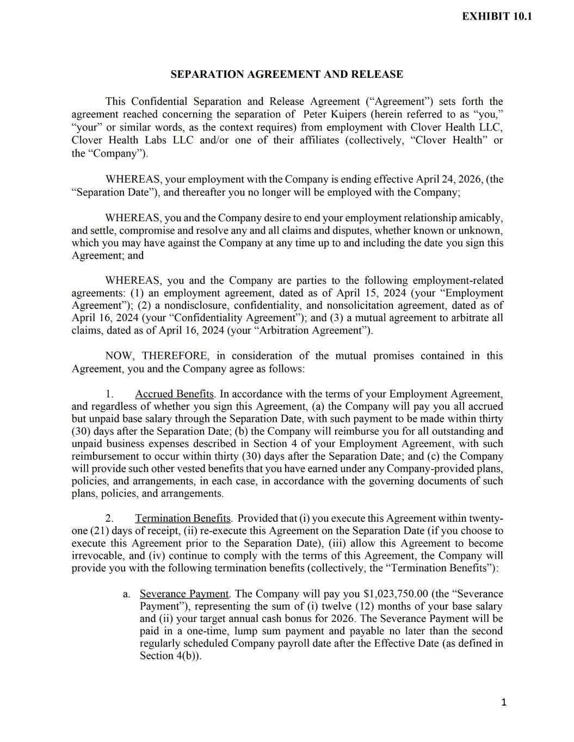
41

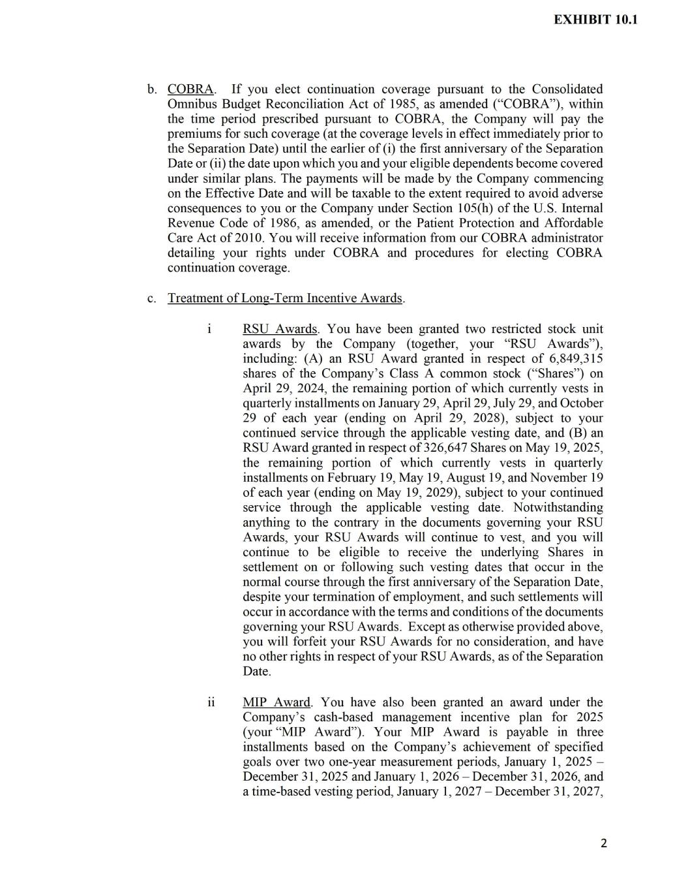

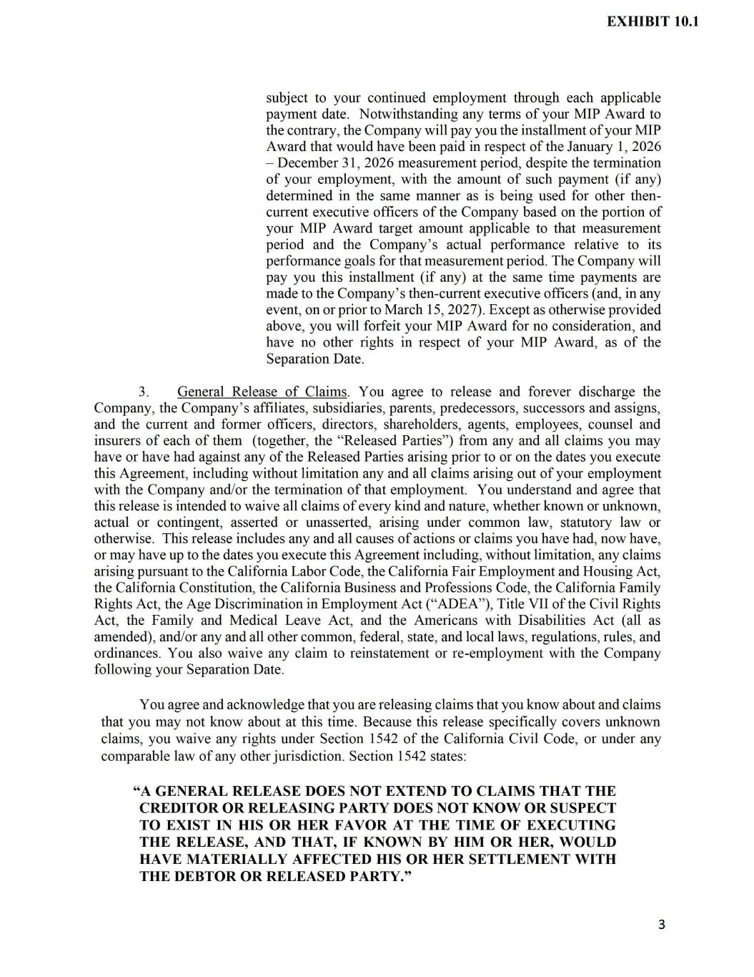

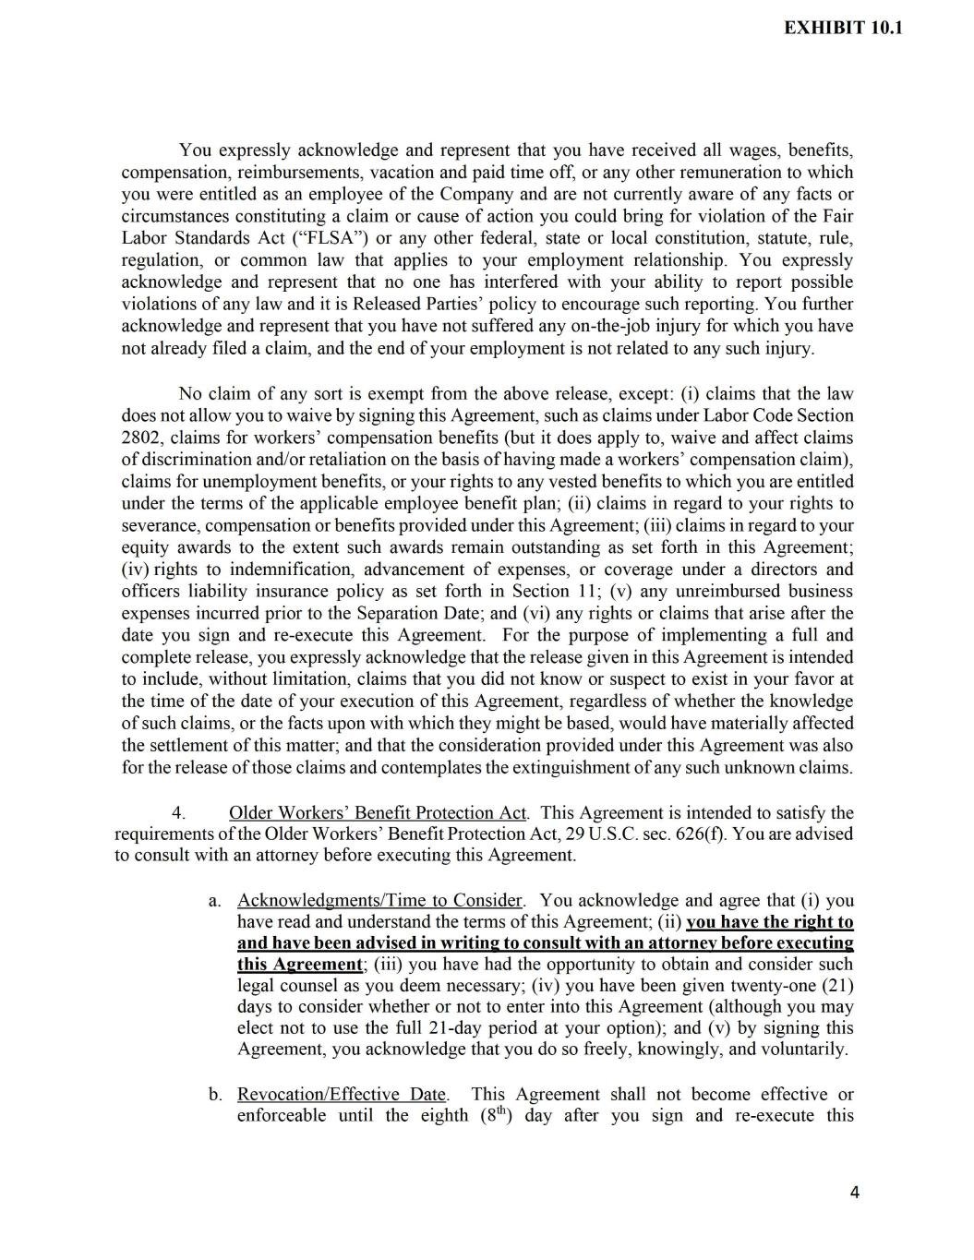

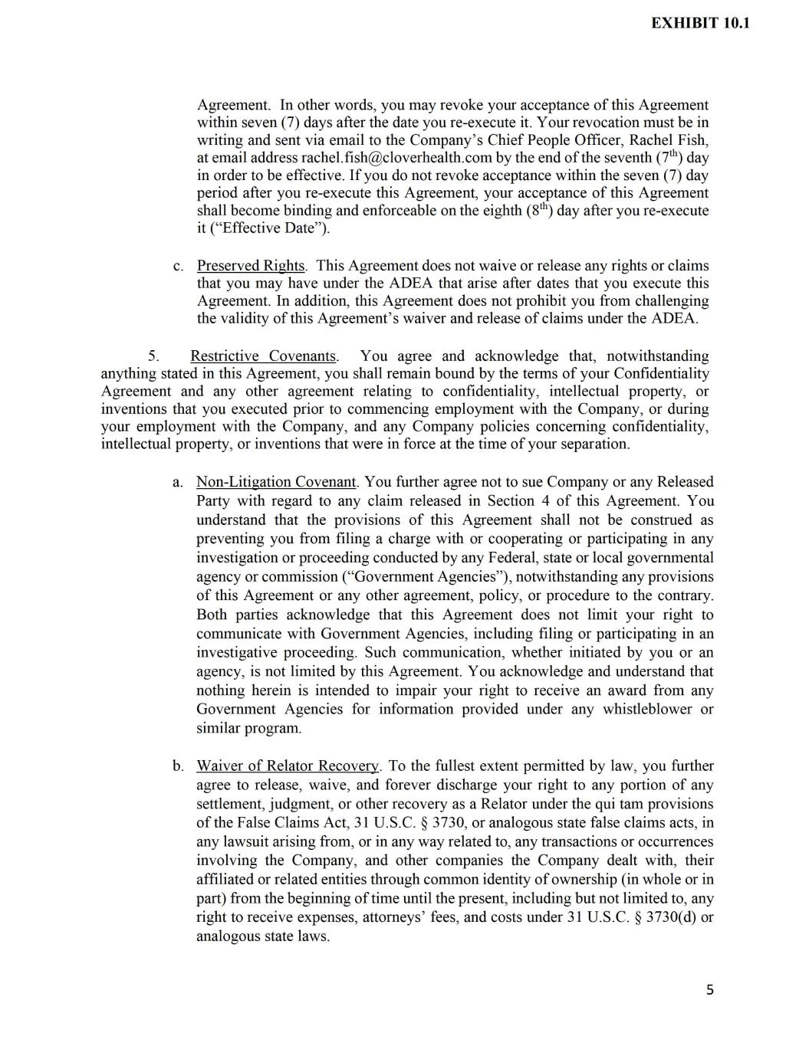

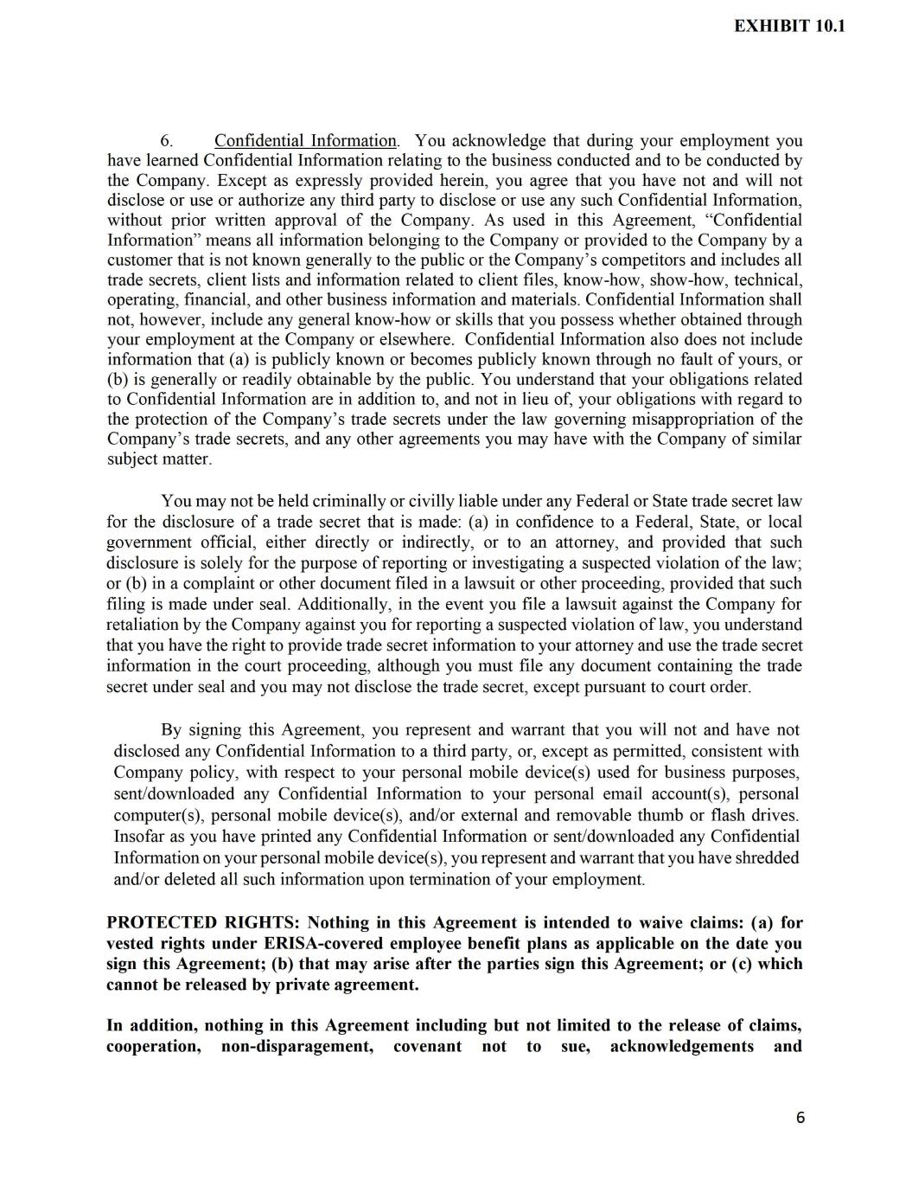

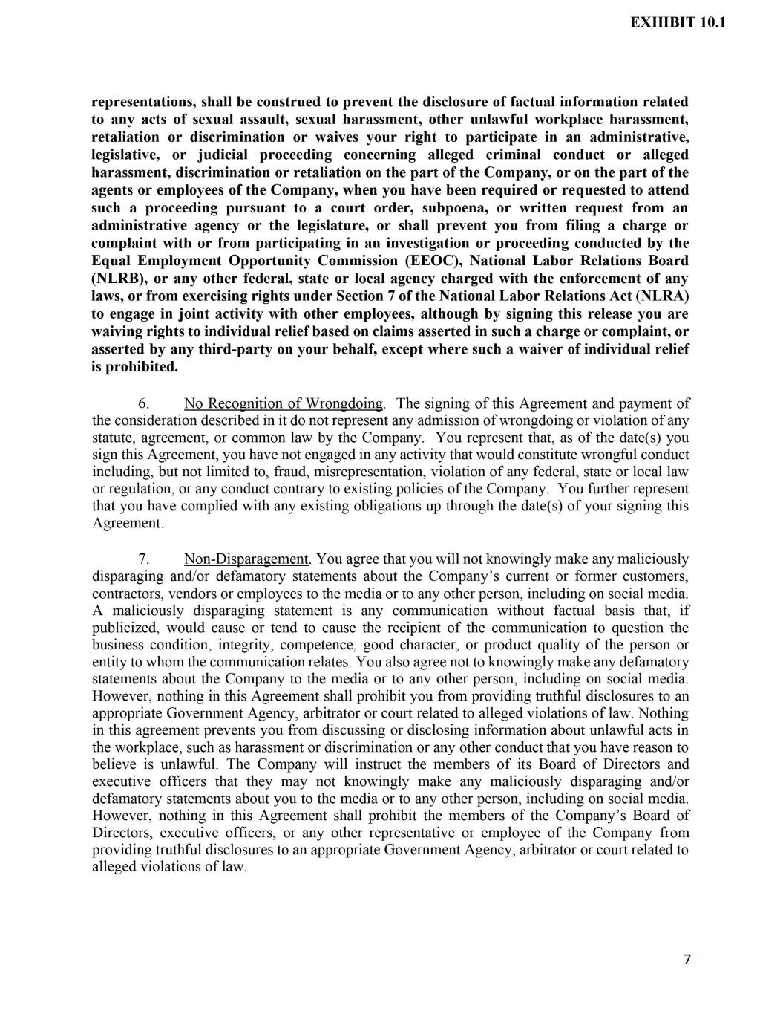

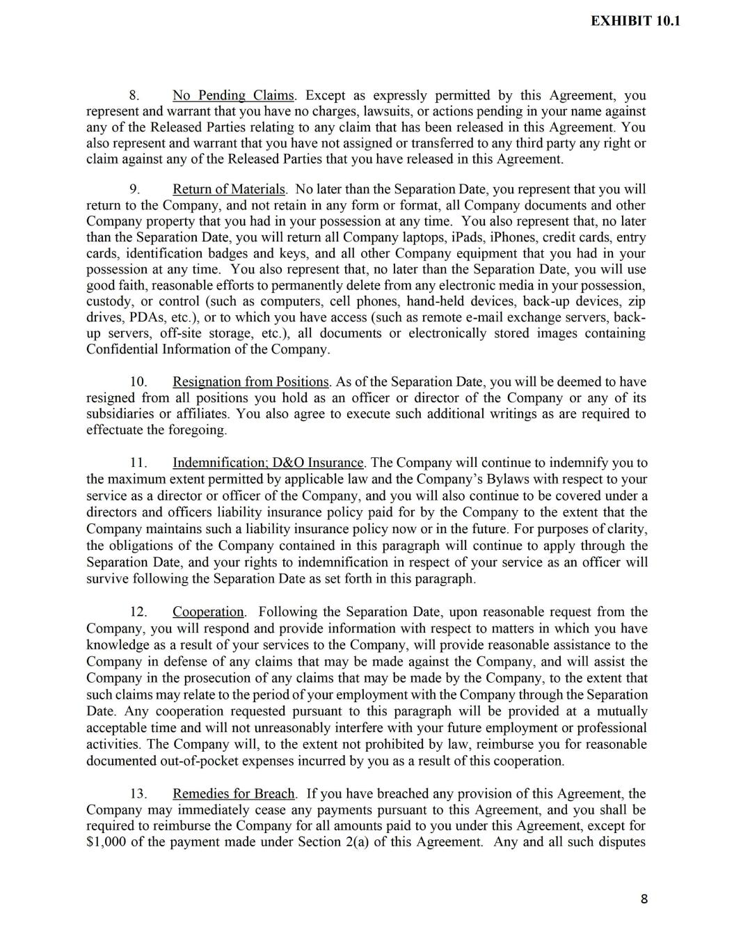

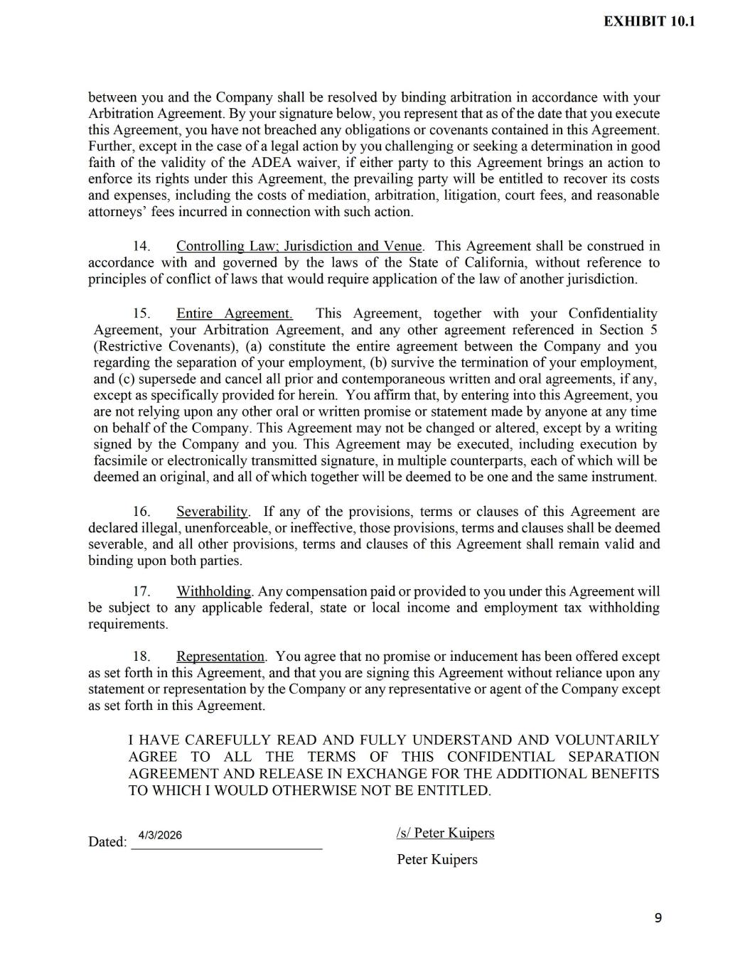



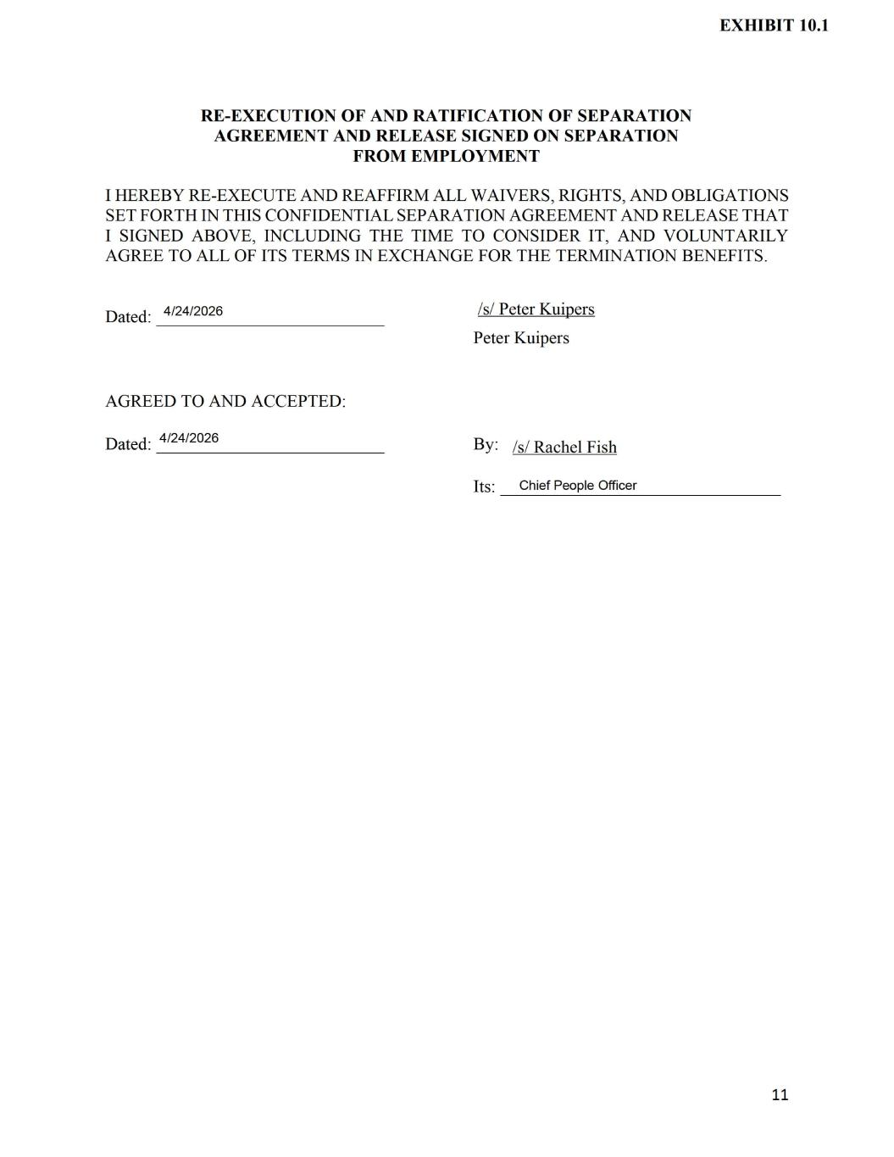

Exhibit 31.1
CERTIFICATION PURSUANT TO
RULES 13a-14(a) AND 15d-14(a) UNDER THE SECURITIES EXCHANGE ACT OF 1934,
AS ADOPTED PURSUANT TO SECTION 302 OF THE SARBANES-OXLEY ACT OF 2002
I, Andrew Toy, certify that:
1.I have reviewed this Quarterly Report on Form 10-Q for the six months ended June 30, 2026, of Clover Health Investments, Corp.;
2.Based on my knowledge, this report does not contain any untrue statement of a material fact or omit to state a material fact necessary to make the statements made, in light of the circumstances under which such statements were made, not misleading with respect to the periods covered by this report;
3.Based on my knowledge, the financial statements, and other financial information included in this report, fairly present in all material respects the financial condition, results of operations and cash flows of the registrant as of, and for, the periods presented in this report;
4.The registrant's other certifying officer(s) and I are responsible for establishing and maintaining disclosure controls and procedures (as defined in Exchange Act Rules 13a-15(e) and 15d-15(e)) and internal control over financial reporting (as defined in Exchange Act Rules 13a-15(f) and 15d-15(f)) for the registrant and have:
(a)Designed such disclosure controls and procedures, or caused such disclosure controls and procedures to be designed under our supervision, to ensure that material information relating to the registrant, including its consolidated subsidiaries, is made known to us by others within those entities, particularly during the period in which this report is being prepared;
(b)Designed such internal control over financial reporting, or caused such internal control over financial reporting to be designed under our supervision, to provide reasonable assurance regarding the reliability of financial reporting and the preparation of financial statements for external purposes in accordance with generally accepted accounting principles;
(c)Evaluated the effectiveness of the registrant's disclosure controls and procedures and presented in this report our conclusions about the effectiveness of the disclosure controls and procedures, as of the end of the period covered by this report based on such evaluation; and
(d)Disclosed in this report any change in the registrant's internal control over financial reporting that occurred during the registrant's most recent fiscal quarter (the registrant's fourth fiscal quarter in the case of an annual report) that has materially affected, or is reasonably likely to materially affect, the registrant's internal control over financial reporting; and
5.The registrant's other certifying officer(s) and I have disclosed, based on our most recent evaluation of internal control over financial reporting, to the registrant's auditors and the audit committee of the registrant's board of directors (or persons performing the equivalent functions):
(a)All significant deficiencies and material weaknesses in the design or operation of internal control over financial reporting which are reasonably likely to adversely affect the registrant's ability to record, process, summarize and report financial information; and
(b)Any fraud, whether or not material, that involves management or other employees who have a significant role in the registrant's internal control over financial reporting.
Date: August 7, 2026 |  |  | By: |  |  | /s/ Andrew Toy
 |  |  |  |  |  | Andrew Toy
 |  |  |  |  |  | Chief Executive Officer

Exhibit 31.2
CERTIFICATION PURSUANT TO
RULES 13a-14(a) AND 15d-14(a) UNDER THE SECURITIES EXCHANGE ACT OF 1934,
AS ADOPTED PURSUANT TO SECTION 302 OF THE SARBANES-OXLEY ACT OF 2002
I, Clay Thornton, certify that:
1.I have reviewed this Quarterly Report on Form 10-Q for the six months ended June 30, 2026, of Clover Health Investments, Corp.;
2.Based on my knowledge, this report does not contain any untrue statement of a material fact or omit to state a material fact necessary to make the statements made, in light of the circumstances under which such statements were made, not misleading with respect to the periods covered by this report;
3.Based on my knowledge, the financial statements, and other financial information included in this report, fairly present in all material respects the financial condition, results of operations and cash flows of the registrant as of, and for, the periods presented in this report;
4.The registrant's other certifying officer(s) and I are responsible for establishing and maintaining disclosure controls and procedures (as defined in Exchange Act Rules 13a-15(e) and 15d-15(e)) and internal control over financial reporting (as defined in Exchange Act Rules 13a-15(f) and 15d-15(f)) for the registrant and have:
(a)Designed such disclosure controls and procedures, or caused such disclosure controls and procedures to be designed under our supervision, to ensure that material information relating to the registrant, including its consolidated subsidiaries, is made known to us by others within those entities, particularly during the period in which this report is being prepared;
(b)Designed such internal control over financial reporting, or caused such internal control over financial reporting to be designed under our supervision, to provide reasonable assurance regarding the reliability of financial reporting and the preparation of financial statements for external purposes in accordance with generally accepted accounting principles;
(c)Evaluated the effectiveness of the registrant's disclosure controls and procedures and presented in this report our conclusions about the effectiveness of the disclosure controls and procedures, as of the end of the period covered by this report based on such evaluation; and
(d)Disclosed in this report any change in the registrant's internal control over financial reporting that occurred during the registrant's most recent fiscal quarter (the registrant's fourth fiscal quarter in the case of an annual report) that has materially affected, or is reasonably likely to materially affect, the registrant's internal control over financial reporting; and
5.The registrant's other certifying officer(s) and I have disclosed, based on our most recent evaluation of internal control over financial reporting, to the registrant's auditors and the audit committee of the registrant's board of directors (or persons performing the equivalent functions):
(a)All significant deficiencies and material weaknesses in the design or operation of internal control over financial reporting which are reasonably likely to adversely affect the registrant's ability to record, process, summarize and report financial information; and
(b)Any fraud, whether or not material, that involves management or other employees who have a significant role in the registrant's internal control over financial reporting.
Date: August 7, 2026 |  |  | By: |  |  | /s/ Clay Thornton
 |  |  |  |  |  | Clay Thornton
 |  |  |  |  |  | Interim Chief Financial Officer

Exhibit 32.1
CERTIFICATION PURSUANT TO
18 U.S.C. SECTION 1350, AS ADOPTED PURSUANT TO
SECTION 906 OF THE SARBANES-OXLEY ACT OF 2002
In connection with the Quarterly Report on Form 10-Q of Clover Health Investments, Corp. (the “Company”) for the six months ended June 30, 2026, as filed with the Securities and Exchange Commission on the date hereof (the “Report”), I certify, pursuant to 18 U.S.C. § 1350, as adopted pursuant to § 906 of the Sarbanes-Oxley Act of 2002, that:
(1)The Report fully complies with the requirements of Section 13(a) or 15(d) of the Securities Exchange Act of 1934; and
(2)The information contained in the Report fairly presents, in all material respects, the financial condition and results of operations of the Company.
Dated: August 7, 2026 |  |  | By: |  |  | /s/ Andrew Toy
 |  |  |  |  |  | Andrew Toy
 |  |  |  |  |  | Chief Executive Officer

Exhibit 32.2
CERTIFICATION PURSUANT TO
18 U.S.C. SECTION 1350, AS ADOPTED PURSUANT TO
SECTION 906 OF THE SARBANES-OXLEY ACT OF 2002
In connection with the Quarterly Report on Form 10-Q of Clover Health Investments, Corp. (the “Company”) for the six months ended June 30, 2026, as filed with the Securities and Exchange Commission on the date hereof (the “Report”), I certify, pursuant to 18 U.S.C. § 1350, as adopted pursuant to § 906 of the Sarbanes-Oxley Act of 2002, that:
(1)The Report fully complies with the requirements of Section 13(a) or 15(d) of the Securities Exchange Act of 1934; and
(2)The information contained in the Report fairly presents, in all material respects, the financial condition and results of operations of the Company.
Dated: August 7, 2026 |  |  | By: |  |  | /s/ Clay Thornton
 |  |  |  |  |  | Clay Thornton
 |  |  |  |  |  | Interim Chief Financial Officer

