UNITED STATES

SECURITIES AND EXCHANGE COMMISSION

WASHINGTON, DC 20549

________________________________________

FORM 10-Q

________________________________________

(Mark One)

- QUARTERLY REPORT PURSUANT TO SECTION 13 OR 15(d) OF THE SECURITIES EXCHANGE ACT OF 1934

For the quarterly period ended September 30, 2024

OR

o TRANSITION REPORT PURSUANT TO SECTION 13 OR 15(d) OF THE SECURITIES EXCHANGE ACT OF 1934

For the transition period from ________ to ________

Commission File Number: 001-39252

________________________________________

Clover Health Investments, Corp.

(Exact Name of Registrant as Specified in its Charter)

________________________________________

Delaware | 98-1515192
(State or other jurisdiction of | (I.R.S. Employer
incorporation or organization) | Identification No.)
3401 Mallory Lane, Suite 210 | 37067
Franklin, Tennessee | 37067
(Address of principal executive offices) | (Zip Code)
Registrant's telephone number, including area code: (201) 432-2133
________________________________________

Securities registered pursuant to Section 12(b) of the Act:

 |  | Trading
Title of each class |  | Symbol(s) |  | Name of each exchange on which registered
Class A Common Stock, par value $0.0001 per share |  | CLOV |  | The NASDAQ Stock Market LLC

Indicate by check mark whether the registrant (1) has filed all reports required to be filed by Section 13 or 15(d) of the Securities Exchange Act of 1934 during the preceding 12 months (or for such shorter period that the registrant was required to file such reports), and (2) has been subject to such filing requirements for the past 90 days. Yes x No o

Indicate by check mark whether the registrant has submitted electronically every Interactive Data File required to be submitted pursuant to Rule 405 of Regulation S-T (§232.405 of this chapter) during the preceding 12 months (or for such shorter period that the registrant was required to submit such files). Yes x No o

Indicate by check mark whether the registrant is a large accelerated filer, an accelerated filer, a non-accelerated filer, a smaller reporting company, or an emerging growth company. See the definitions of "large accelerated filer," "accelerated filer," "smaller reporting company," and "emerging growth company" in Rule 12b-2 of the Exchange Act.

Large accelerated filer | o | Accelerated filer | x
Non-accelerated filer | o | Smaller reporting company | o
Emerging growth company | o

If an emerging growth company, indicate by check mark if the registrant has elected not to use the extended transition period for complying with any new or revised financial accounting standards provided pursuant to Section 13(a) of the Exchange Act. ☐

Indicate by check mark whether the registrant is a shell company (as defined in Rule 12b-2 of the Exchange Act). Yes o No x

At October 31, 2024, the registrant had 412,076,431 shares of Class A Common Stock, $0.0001 par value per share, and 89,032,605 shares of Class B Common Stock, $0.0001 par value per share, issued and outstanding.

1

 |  |  |  |  |  |  |  |  |  |  |  |  |  |  |  |  |  |  |  |  |  |  | Page
 | PART I. |  |  |  |  | FINANCIAL INFORMATION |  |  |  |  |  |  |  |  |  |  |  |  |  |  |  |  |  | 5
 | Item 1. |  |  |  |  | Financial Statements (Unaudited) |  |  |  |  |  |  |  |  |  |  |  |  |  |  |  |  | 5
 |  |  |  |  |  | Condensed Consolidated Balance Sheets at September 30, 2024 and December 31, 2023 |  |  |  |  |  |  |  |  |  |  |  |  |  |  |  |  | 5
 |  |  |  |  |  | Condensed Consolidated Statements of Operations and Comprehensive Loss for the three and nine months ended September 30, 2024 and 2023 |  |  |  |  |  |  |  |  |  |  |  |  |  |  |  |  | 7
 |  |  |  |  |  | Condensed Consolidated Statements of Changes in Convertible Preferred Stock and Stockholders' Equity for the three and nine months ended September 30, |  |  |  |  |  |  |  |  |  |  |  |  |  |  |  |  | 8
 |  |  |  |  |  | 2024 and 2023
 |  |  |  |  |  | Condensed Consolidated Statements of Cash Flows for the nine months ended September 30, 2024 and 2023 |  |  |  |  |  |  |  |  |  |  |  |  |  |  |  |  | 10
 |  |  |  |  |  | Notes to Condensed Consolidated Financial Statements |  |  |  |  |  |  |  |  |  |  |  |  |  |  |  |  | 11
 | Item 2. |  |  |  |  | Management's Discussion and Analysis of Financial Condition and Results of Operations |  |  |  |  |  |  |  |  |  |  |  |  |  |  |  |  | 34
 | Item 3. |  |  |  |  | Quantitative and Qualitative Disclosures About Market Risk |  |  |  |  |  |  |  |  |  |  |  |  |  |  |  |  | 44
 | Item 4. |  |  |  |  | Controls and Procedures |  |  |  |  |  |  |  |  |  |  |  |  |  |  |  |  | 44
 | PART II. |  |  |  |  | OTHER INFORMATION |  |  |  |  |  |  |  |  |  |  |  |  |  |  |  |  | 45
 | Item 1. |  |  |  |  | Legal Proceedings |  |  |  |  |  |  |  |  |  |  |  |  |  |  |  |  | 45
 | Item 1A. |  |  |  |  | Risk Factors |  |  |  |  |  |  |  |  |  |  |  |  |  |  |  |  | 45
 | Item 2. |  |  |  |  | Unregistered Sales of Equity Securities and Use of Proceeds |  |  |  |  |  |  |  |  |  |  |  |  |  |  |  |  | 45
 | Item 3. |  |  |  |  | Defaults Upon Senior Securities |  |  |  |  |  |  |  |  |  |  |  |  |  |  |  |  | 45
 | Item 4. |  |  |  |  | Mine Safety Disclosures |  |  |  |  |  |  |  |  |  |  |  |  |  |  |  |  | 45
 | Item 5. |  |  |  |  | Other Information |  |  |  |  |  |  |  |  |  |  |  |  |  |  |  |  | 45
 | Item 6. |  |  |  |  | Exhibits |  |  |  |  |  |  |  |  |  |  |  |  |  |  |  |  | 46
 | Signatures |  |  |  |  |  |  |  |  |  |  |  |  |  |  |  |  |  |  |  |  |  | 47
 |  |  |  |  |  | 2

As used in this report, "Company," "Clover," "Clover Health," "we," "us," "our," "our company," and similar terms refer to Clover Health Investments, Corp. and its consolidated subsidiaries, unless otherwise noted or the context otherwise requires.

CAUTIONARY NOTE REGARDING FORWARD-LOOKING STATEMENTS

This document contains forward-looking statements within the meaning of Section 27A of the Securities Act of 1933, as amended (the "Securities Act"), and Section 21E of the Securities Exchange Act of 1934, as amended (the "Exchange Act"). All statements contained in this document other than statements of historical fact, including statements regarding our future results of operations, financial position, market size and opportunity, our business strategy and plans, the factors affecting our performance and our objectives for future operations, are forward-looking statements. The words "believe," "may," "will," "estimate," "continue," "anticipate," "intend," "could," "should," "would," "can," "expect," "project," "outlook," "forecast," "objective," "plan," "potential," "seek," "grow," "target," "if," and the negative or plural of these words and similar expressions are intended to identify forward-looking statements. We have based these forward-looking statements largely on our current expectations and projections about future events and trends that we believe may affect our financial condition, results of operations, business strategy, short-term and long-term business operations and objectives and financial needs. These forward-looking statements are subject to a number of risks, uncertainties and assumptions, including the risk factors described in our filings with the Securities and Exchange Commission (the "SEC"). Moreover, we operate in a very competitive and rapidly changing environment. New risks emerge from time to time. It is not possible for our management to predict all risks, nor can we assess the impact of all factors on our business or the extent to which any factor, or combination of factors, may cause actual results to differ materially from those contained in any forward-looking statements we may make. In light of these risks, uncertainties and assumptions, the future events and trends discussed in this document may not occur, and actual results could differ materially and adversely from those anticipated or implied in the forward-looking statements. Forward-looking statements contained in this document involve a number of judgments, risks and uncertainties, including, without limitation, risks related to:

- our expectations regarding results of operations, financial condition, and cash flows;

- our expectations regarding the development and management of our Insurance business;
- our ability to successfully enter new service markets and manage our operations;
- anticipated trends and challenges in our business and in the markets in which we operate;
- our ability to effectively manage our beneficiary base and provider network;
- our ability to maintain and increase adoption and use of Clover Assistant, including the expansion of Clover Assistant for external payors and providers under the brand name Counterpart Assistant;
- the anticipated benefits associated with the use of Clover Assistant, including our ability to utilize the platform to manage our medical care ratios;
- our expectations regarding costs and expenses associated with our exit from the ACO Reach Program;
- our ability to maintain or improve our Medicare Star ratings or otherwise continue to improve the financial performance of our business;
- our ability to develop new features and functionality that meet market needs and achieve market acceptance;
- our ability to retain and hire necessary employees and staff our operations appropriately;
- the timing and amount of certain investments in growth;
- the outcome of any known and unknown litigation and regulatory proceedings;
- any current, pending, or future legislation, regulations or policies that could have a negative effect on our revenue and businesses, including rules, regulations, and policies relating to healthcare and Medicare;
- our ability to maintain, protect, and enhance our intellectual property;
- general economic conditions and uncertainty; and
- persistent high inflation and interest rates.

We caution you that the foregoing list of judgments, risks, and uncertainties that may cause actual results to differ materially from those in the forward-looking statements may not be complete. You should not rely upon forward-looking statements as predictions of future events. The events and circumstances reflected in the forward-looking statements may not be achieved or occur or may be materially different from what we expect. Although we believe that the expectations reflected in the forward-looking statements are reasonable, we cannot guarantee future results, levels of activity, performance, or achievements. Except as required by law, we undertake no obligation to update any of these forward-looking statements after the date of this document or to conform these statements to actual results or revised expectations.

This document contains estimates, projections, and other information concerning our industry, our business, and the markets for our products. We obtained the industry, market, and similar data set forth in this document from our own internal estimates and research and from industry research, publications, surveys, and studies conducted by third parties, including governmental agencies, and such information is inherently subject to uncertainties. Actual events or circumstances may differ materially from events and circumstances that are assumed in this information. You are cautioned not to give undue weight to any such information, projections, or estimates.

3

As a result of a number of known and unknown risks and uncertainties, including without limitation, the important factors described in our reports filed with the SEC, including the discussion under "Risk Factors" in our Annual Report on Form 10-K for the year ended December 31, 2023, as filed with the SEC, and in our subsequent periodic reports, our actual results or performance may be materially different from those expressed or implied by these forward-looking statements.

Additional Information

Our website address is www.cloverhealth.com. Our filings with the SEC are posted on our website and available free of charge as soon as reasonably practicable after they are electronically filed with, or furnished to, the SEC. The content on our website or on any other website referred to in this document is not incorporated by reference in this document. Further, the Company's references to website URLs are intended to be inactive textual references only.

Channels for Disclosure of Information

Investors and others should note that we routinely announce material information to investors and the marketplace using filings with the SEC, press releases, public conference calls, presentations, webcasts, and the investor relations page of our website at investors.cloverhealth.com. We use the investor relations page of our website for purposes of compliance with Regulation FD and as a routine channel for distribution of important information, including news releases, analyst presentations, financial information, and corporate governance practices. We also use certain social media channels as a means of disclosing information about the Company and our products to our customers, investors, and the public, including @CloverHealth and #CloverHealth on X (formerly known as Twitter), and the LinkedIn account of our Chief Executive Officer, Andrew Toy. The information posted on social media channels is not incorporated by reference in this report or in any other report or document we file with the SEC. While not all of the information that we post to the investor relations page of our website or to social media accounts is of a material nature, some information could be deemed to be material. Accordingly, we encourage investors, the media, and others interested in the Company to review the information that we share on our investor relations page of our website at investors.cloverhealth.com and to sign up for and regularly follow our social media accounts. Users may automatically receive email alerts and other information about the Company when enrolling an email address by visiting "Email Alerts" in the "Investor Resources" section of our website at investors.cloverhealth.com.

4

Part I

Item 1. Financial Statements and Supplementary Data

CLOVER HEALTH INVESTMENTS, CORP.

CONDENSED CONSOLIDATED BALANCE SHEETS

(Dollars in thousands, except share amounts)

 |  | September 30, 2024 |  |  | December 31, 2023
 |  | (Unaudited) |  |  | December 31, 2023
Assets
Current assets
Cash and cash equivalents | $ | 287,956 |  | $ | 116,407
Short-term investments |  | 1,779 |  |  | 12,218
Investment securities, available-for-sale (Amortized cost: 2024: $43,695; 2023: $101,412) |  | 43,302 |  |  | 100,702
Investment securities, held-to-maturity (Fair value: 2024: $15; 2023: $6,778) |  | 15 |  |  | 6,902
Accrued retrospective premiums |  | 20,963 |  |  | 22,076
Other receivables |  | 14,962 |  |  | 16,666
Healthcare receivables |  | 37,314 |  |  | 64,164
Surety bonds and deposits |  | 596 |  |  | 542
Prepaid expenses |  | 12,949 |  |  | 14,418
Other assets, current |  | 2,804 |  |  | 1,404
Assets related to discontinued operations (Note 17) |  | 10,087 |  |  | 72,471
Total current assets |  | 432,727 |  |  | 427,970
Investment securities, available-for-sale (Amortized cost: 2024: $182,840; 2023: $121,868) |  | 184,085 |  |  | 120,208
Investment securities, held-to-maturity (Fair value: 2024: $14,178; 2023: $692) |  | 14,294 |  |  | 793
Property and equipment, net |  | 5,336 |  |  | 5,082
Operating lease right-of-use assets |  | 2,585 |  |  | 3,382
Other intangible assets |  | 2,990 |  |  | 2,990
Other assets, non-current |  | 10,996 |  |  | 10,246
Total assets | $ | 653,013 |  | $ | 570,671

The accompanying notes are an integral part of these condensed consolidated financial statements.

5

CLOVER HEALTH INVESTMENTS, CORP.

CONDENSED CONSOLIDATED BALANCE SHEETS

(Dollars in thousands, except share amounts)

 |  | September 30, 2024 |  |  | December 31, 2023
 |  | (Unaudited) |  |  | December 31, 2023
Liabilities and Stockholders' Equity
Current liabilities
Unpaid claims | $ | 166,070 |  | $ | 135,737
Due to related parties, net |  | 1,340 |  |  | 1,363
Accounts payable and accrued expenses |  | 25,746 |  |  | 37,184
Accrued salaries and benefits |  | 35,340 |  |  | 20,951
Deferred revenue |  | 17 |  |  | 3,099
Operating lease liabilities |  | 1,345 |  |  | 1,665
Other liabilities, current |  | 836 |  |  | 1,017
Liabilities related to discontinued operations (Note 17) |  | 48,941 |  |  | 60,099
Total current liabilities |  | 279,635 |  |  | 261,115
Long-term operating lease liabilities |  | 2,321 |  |  | 2,998
Other liabilities, non-current |  | 28,891 |  |  | 20,164
Total liabilities |  | 310,847 |  |  | 284,277
Commitments and contingencies (Note 13)
Stockholders' equity
Class A Common Stock, $0.0001 par value; 2,500,000,000 shares authorized at September 30, 2024 and December 31, 2023; 411,256,965 and
401,183,882 issued and outstanding at September 30, 2024 and December 31, 2023, respectively |  | 41 |  |  | 40
Class B Common Stock, $0.0001 par value; 500,000,000 shares authorized at September 30, 2024 and December 31, 2023; 89,032,305 and
87,867,732 issued and outstanding at September 30, 2024 and December 31, 2023, respectively |  | 9 |  |  | 9
Additional paid-in capital |  | 2,546,167 |  |  | 2,461,238
Accumulated other comprehensive income (loss) |  | 852 |  |  | (2,370)
Accumulated deficit |  | (2,180,711) |  |  | (2,159,794)
Less: Treasury stock, at cost; 16,817,010 and 7,912,750 shares held at September 30, 2024 and December 31, 2023, respectively |  | (24,192) |  |  | (12,729)
Total stockholders' equity |  | 342,166 |  |  | 286,394
Total liabilities and stockholders' equity | $ | 653,013 |  | $ | 570,671

The accompanying notes are an integral part of these condensed consolidated financial statements.

6

CLOVER HEALTH INVESTMENTS, CORP.

CONDENSED CONSOLIDATED STATEMENTS OF OPERATIONS AND COMPREHENSIVE LOSS

(Unaudited)

(Dollars in thousands, except per share and share amounts)

 |  | Three Months Ended |  |  |  |  |  | Nine Months Ended
 |  | September 30, |  |  |  |  |  | September 30,
 |  | 2024 |  |  | 2023 |  |  | 2024 |  |  | 2023
Revenues:
Premiums earned, net (Net of ceded premiums of $97 and $106 for the three months ended
September 30, 2024 and 2023, respectively; net of ceded premiums of $301 and $341 for the nine
months ended September 30, 2024 and 2023, respectively) | $ | 322,579 |  | $ | 301,230 |  | $ | 1,014,201 |  | $ | 932,699
Other income |  | 8,407 |  |  | 4,798 |  |  | 19,967 |  |  | 15,459
Total revenues |  | 330,986 |  |  | 306,028 |  |  | 1,034,168 |  |  | 948,158
Operating expenses:
Net medical claims incurred |  | 249,774 |  |  | 235,785 |  |  | 763,283 |  |  | 754,836
Salaries and benefits |  | 54,995 |  |  | 60,567 |  |  | 169,717 |  |  | 191,985
General and administrative expenses |  | 35,201 |  |  | 41,030 |  |  | 124,194 |  |  | 140,384
Premium deficiency reserve expense (benefit) |  | — |  |  | 392 |  |  | — |  |  | (6,556)
Depreciation and amortization |  | 339 |  |  | 557 |  |  | 987 |  |  | 1,835
Restructuring (recoveries) costs |  | (538) |  |  | 1,313 |  |  | 288 |  |  | 7,870
Total operating expenses |  | 339,771 |  |  | 339,644 |  |  | 1,058,469 |  |  | 1,090,354
Loss from continuing operations |  | (8,785) |  |  | (33,616) |  |  | (24,301) |  |  | (142,196)
Change in fair value of warrants |  | — |  |  | — |  |  | 17 |  |  | —
Interest expense |  | — |  |  | — |  |  | — |  |  | 7
Loss on investment |  | — |  |  | — |  |  | 467 |  |  | —
Net loss from continuing operations |  | (8,785) |  |  | (33,616) |  |  | (24,785) |  |  | (142,203)
Net (loss) income from discontinued operations (Note 17) |  | (370) |  |  | (7,853) |  |  | 3,868 |  |  | (686)
Net loss | $ | (9,155) |  | $ | (41,469) |  | $ | (20,917) |  | $ | (142,889)
Per share data:
Basic weighted average number of Class A and Class B common shares and common share
equivalents outstanding |  | 490,180,103 |  |  | 480,770,283 |  |  | 488,501,812 |  |  | 480,921,520
Diluted weighted average number of Class A and Class B common shares and common share
equivalents outstanding |  | 490,180,103 |  |  | 480,770,283 |  |  | 488,501,812 |  |  | 480,921,520
Continuing operations:
Basic loss per share | $ | (0.02) |  | $ | (0.07) |  | $ | (0.05) |  | $ | (0.30)
Diluted loss per share |  | (0.02) |  |  | (0.07) |  |  | (0.05) |  |  | (0.30)
Discontinued operations:
Basic earnings (loss) per share |  | 0.00 |  |  | (0.02) |  |  | 0.01 |  |  | 0.00
Diluted earnings (loss) per share |  | 0.00 |  |  | (0.02) |  |  | 0.01 |  |  | 0.00
Net unrealized gain on available-for-sale investments |  | 3,111 |  |  | 1,643 |  |  | 3,222 |  |  | 4,302
Comprehensive loss | $ | (6,044) |  | $ | (39,826) |  | $ | (17,695) |  | $ | (138,587)

The accompanying notes are an integral part of these condensed consolidated financial statements.

7

CLOVER HEALTH INVESTMENTS, CORP.

CONDENSED CONSOLIDATED STATEMENTS OF CHANGES IN CONVERTIBLE PREFERRED STOCK AND STOCKHOLDERS' EQUITY

(Unaudited)

(Dollars in thousands, except share amounts)

 |  |  |  |  |  |  |  |  |  |  |  |  |  |  |  |  |  |  |  |  |  |  | Accumulated
 |  |  |  |  |  |  |  |  |  |  |  |  |  |  |  | Additional |  |  |  |  |  |  | other |  |  | Total
 |  |  |  |  |  |  |  |  |  |  |  |  |  |  |  |  |  |  | Accumulated |  |  | comprehensive |  |  |  | Total
 | Class A Common Stock |  |  |  |  | Class B Common Stock |  |  |  |  | Treasury Stock |  |  |  |  |  | paid-in |  |  |  |  |  | income |  | stockholders'
 |  |  |  |  |  |  |  |  |  |  |  |  |  |  |  |  | capital |  |  | deficit |  |  | (loss) |  |  | equity
 | Shares |  | Amount |  |  | Shares |  | Amount |  |  | Shares |  |  | Amount
Balance, December 31, 2023 | 401,183,882 |  | $ | 40 |  | 87,867,732 |  | $ | 9 |  | 7,912,750 |  | $ | (12,729) |  | $ | 2,461,238 |  | $ | (2,159,794) |  | $ | (2,370) |  | $ | 286,394
Stock issuance for exercise of stock options,
Stock issuance for exercise of stock options, | 83 |  |  | — |  | — |  |  | — |  | — |  |  | — |  |  | — |  |  | — |  |  | — |  |  | —
net of early exercise liability | 83 |  |  |  |  |  |  |  |  |  |  |  |  |  |  |  |  |  |  |  |  |  |  |  |  | —
Stock-based compensation | — |  |  | — |  | — |  |  | — |  | — |  |  | — |  |  | 28,798 |  |  | — |  |  | — |  |  | 28,798
Vested restricted stock units | 8,672,362 |  |  | 1 |  | 1,781,633 |  |  | — |  | — |  |  | — |  |  | — |  |  | — |  |  | — |  |  | 1
Unrealized holdings gain on investment | — |  |  | — |  | — |  |  | — |  | — |  |  | — |  |  | — |  |  | — |  |  | (190) |  |  | (190)
securities, available for sale |  |  |  |  |  |  |  |  |  |  |  |  |  |  |  |  |  |  |  |  |  |  | (190) |  |  | (190)
Treasury stock acquired | (3,700,995) |  |  | — |  | — |  |  | — |  | 3,700,995 |  |  | (3,359) |  |  | — |  |  | — |  |  | — |  |  | (3,359)
Net loss | — |  |  | — |  | — |  |  | — |  | — |  |  | — |  |  | — |  |  | (19,170) |  |  | — |  |  | (19,170)
Balance, March 31, 2024 | 406,155,332 |  | $ | 41 |  | 89,649,365 |  | $ | 9 |  | 11,613,745 |  | $ | (16,088) |  | $ | 2,490,036 |  | $ | (2,178,964) |  | $ | (2,560) |  | $ | 292,474
Stock issuance for exercise of stock options, net | 61,212 |  |  | — |  | — |  |  | — |  | — |  |  | — |  |  | 23 |  |  | — |  |  | — |  |  | 23
of early exercise liability | 61,212 |  |  |  |  |  |  |  |  |  |  |  |  |  |  |  | 23 |  |  |  |  |  |  |  |  | 23
Stock-based compensation | — |  |  | — |  | — |  |  | — |  | — |  |  | — |  |  | 27,900 |  |  | — |  |  | — |  |  | 27,900
Vested restricted stock units | 3,003,054 |  |  | — |  | — |  |  | — |  | — |  |  | — |  |  | — |  |  | — |  |  | — |  |  | —
Unrealized holdings gain on investment | — |  |  | — |  | — |  |  | — |  | — |  |  | — |  |  | — |  |  | — |  |  | 301 |  |  | 301
securities, available for sale |  |  |  |  |  |  |  |  |  |  |  |  |  |  |  |  |  |  |  |  |  |  | 301 |  |  | 301
Treasury stock acquired | (1,122,347) |  |  | — |  | — |  |  | — |  | 1,122,347 |  |  | (1,446) |  |  | — |  |  | — |  |  | — |  |  | (1,446)
Issuance of Common Stock under Employee | 227,502 |  |  | — |  | — |  |  | — |  | — |  |  | — |  |  | — |  |  | — |  |  | — |  |  | —
Stock Purchase Plan | 227,502 |  |  |  |  |  |  |  |  |  |  |  |  |  |  |  |  |  |  |  |  |  |  |  |  | —
Repurchases of Common Stock | (1,838,309) |  |  | — |  | — |  |  | — |  | 1,838,309 |  |  | (1,772) |  |  | — |  |  | — |  |  | — |  |  | (1,772)
Net loss | — |  |  | — |  | — |  |  | — |  | — |  |  | — |  |  | — |  |  | 7,408 |  |  | — |  |  | 7,408
Balance, June 30, 2024 | 406,486,444 |  | $ | 41 |  | 89,649,365 |  | $ | 9 |  | 14,574,401 |  | $ | (19,306) |  | $ | 2,517,959 |  | $ | (2,171,556) |  | $ | (2,259) |  | $ | 324,888
Stock issuance for exercise of stock options, net
Stock issuance for exercise of stock options, net | 122,662 |  |  | — |  | — |  |  | — |  | — |  |  | — |  |  | 220 |  |  | — |  |  | — |  |  | 220
of early exercise liability | 122,662 |  |  |  |  |  |  |  |  |  |  |  |  |  |  |  | 220 |  |  |  |  |  |  |  |  | 220
Stock-based compensation | — |  |  | — |  | — |  |  | — |  | — |  |  | — |  |  | 27,988 |  |  | — |  |  | — |  |  | 27,988
Vested restricted stock units | 6,273,408 |  |  | — |  | — |  |  | — |  | — |  |  | — |  |  | — |  |  | — |  |  | — |  |  | —
Unrealized holdings gain on investment | — |  |  | — |  | — |  |  | — |  | — |  |  | — |  |  | — |  |  | — |  |  | 3,111 |  |  | 3,111
securities, available for sale |  |  |  |  |  |  |  |  |  |  |  |  |  |  |  |  |  |  |  |  |  |  | 3,111 |  |  | 3,111
Conversion from Class B Common Stock to | 617,060 |  |  | — |  | (617,060) |  |  | — |  | — |  |  | — |  |  | — |  |  | — |  |  | — |  |  | —
Class A Common Stock | 617,060 |  |  |  |  | (617,060) |  |  |  |  |  |  |  |  |  |  |  |  |  |  |  |  |  |  |  | —
Treasury stock acquired | (2,242,609) |  |  | — |  | — |  |  | — |  | 2,242,609 |  |  | (4,886) |  |  | — |  |  | — |  |  | — |  |  | (4,886)
Issuance of Common Stock under Employee | — |  |  | — |  | — |  |  | — |  | — |  |  | — |  |  | — |  |  | — |  |  | — |  |  | —
Stock Purchase Plan |  |  |  |  |  |  |  |  |  |  |  |  |  |  |  |  |  |  |  |  |  |  |  |  |  | —
Repurchases of Common Stock | — |  |  | — |  | — |  |  | — |  | — |  |  | — |  |  | — |  |  | — |  |  | — |  |  | —
Net loss | — |  |  | — |  | — |  |  | — |  | — |  |  | — |  |  | — |  |  | (9,155) |  |  | — |  |  | (9,155)
Balance, September 30, 2024 | 411,256,965 |  | $ | 41 |  | 89,032,305 |  | $ | 9 |  | 16,817,010 |  | $ | (24,192) |  | $ | 2,546,167 |  | $ | (2,180,711) |  | $ | 852 |  | $ | 342,166

8

 |  |  |  |  |  |  |  |  |  |  |  |  |  |  |  | Additional |  |  |  |  |  |  | Accumulated |  |  | Total
 |  |  |  |  |  |  |  |  |  |  |  |  |  |  |  |  |  |  | Accumulated |  |  |  | other |  |  | Total
 | Class A Common Stock |  |  |  |  | Class B Common Stock |  |  |  |  | Treasury Stock |  |  |  |  |  | paid-in |  |  |  |  | comprehensive |  |  | stockholders'
 |  |  |  |  |  |  |  |  |  |  |  |  |  |  |  |  | capital |  |  | deficit |  |  | loss |  |  | equity
 | Shares |  | Amount |  |  | Shares |  | Amount |  |  | Shares |  |  | Amount
Balance, December 31, 2022 | 383,998,718 |  | $ | 37 |  | 94,394,852 |  | $ | 9 |  | 2,072,752 |  | $ | (6,509) |  | $ | 2,319,157 |  | $ | (1,955,582) |  | $ | (9,374) |  | $ | 347,738
Change in accounting policy | — |  |  | — |  | — |  |  | — |  | — |  |  | — |  |  | — |  |  | 9,149 |  |  | — |  |  | 9,149
Stock issuance for exercise of stock options, | 1,240 |  |  | — |  | — |  |  | — |  | — |  |  | — |  |  | 848 |  |  | — |  |  | — |  |  | 848
net of early exercise liability | 1,240 |  |  |  |  |  |  |  |  |  |  |  |  |  |  |  | 848 |  |  |  |  |  |  |  |  | 848
Stock-based compensation | — |  |  | — |  | — |  |  | — |  | — |  |  | — |  |  | 38,617 |  |  | — |  |  | — |  |  | 38,617
Vested restricted stock units | 5,390,973 |  |  | — |  | 1,773,104 |  |  | — |  | — |  |  | — |  |  | — |  |  | — |  |  | — |  |  | —
Unrealized holdings gain on investment | — |  |  | — |  | — |  |  | — |  | — |  |  | — |  |  | — |  |  | — |  |  | 2,343 |  |  | 2,343
securities, available for sale |  |  |  |  |  |  |  |  |  |  |  |  |  |  |  |  |  |  |  |  |  |  | 2,343 |  |  | 2,343
Conversion from Class B Common Stock to | 7,672,463 |  |  | — |  | (7,672,463) |  |  | — |  | — |  |  | — |  |  | — |  |  | — |  |  | — |  |  | —
Class A Common Stock | 7,672,463 |  |  |  |  | (7,672,463) |  |  |  |  |  |  |  |  |  |  |  |  |  |  |  |  |  |  |  | —
Treasury stock acquired | (2,933,721) |  |  | — |  | — |  |  | — |  | 2,933,721 |  |  | (2,982) |  |  | — |  |  | — |  |  | — |  |  | (2,982)
Net loss | — |  |  | — |  | — |  |  | — |  | — |  |  | — |  |  | — |  |  | (72,606) |  |  | — |  |  | (72,606)
Balance, March 31, 2023 | 394,129,673 |  | $ | 37 |  | 88,495,493 |  | $ | 9 |  | 5,006,473 |  | $ | (9,491) |  | $ | 2,358,622 |  | $ | (2,019,039) |  | $ | (7,031) |  | $ | 323,107
Stock issuance for exercise of stock options, | 1,241 |  |  | — |  | — |  |  | — |  | — |  |  | — |  |  | 270 |  |  | — |  |  | — |  |  | 270
net of early exercise liability | 1,241 |  |  |  |  |  |  |  |  |  |  |  |  |  |  |  | 270 |  |  |  |  |  |  |  |  | 270
Stock-based compensation | — |  |  | — |  | — |  |  | — |  | — |  |  | — |  |  | 36,108 |  |  | — |  |  | — |  |  | 36,108
Vested restricted stock units | 1,180,084 |  |  | — |  | — |  |  | — |  | — |  |  | — |  |  | — |  |  | — |  |  | — |  |  | —
Unrealized holdings gain on investment | — |  |  | — |  | — |  |  | — |  | — |  |  | — |  |  | — |  |  | — |  |  | 316 |  |  | 316
securities, available for sale |  |  |  |  |  |  |  |  |  |  |  |  |  |  |  |  |  |  |  |  |  |  | 316 |  |  | 316
Conversion from Class B Common Stock to | 627,761 |  |  | — |  | (627,761) |  |  | — |  | — |  |  | — |  |  | — |  |  | — |  |  | — |  |  | —
Class A Common Stock | 627,761 |  |  |  |  | (627,761) |  |  |  |  |  |  |  |  |  |  |  |  |  |  |  |  |  |  |  | —
Treasury Stock | (439,241) |  |  | — |  | — |  |  | — |  | 439,241 |  |  | (417) |  |  | — |  |  | — |  |  | — |  |  | (417)
Issuance of Common Stock under Employee | 271,152 |  |  | — |  | — |  |  | — |  | — |  |  | — |  |  | — |  |  | — |  |  | — |  |  | —
Stock Purchase Plan | 271,152 |  |  |  |  |  |  |  |  |  |  |  |  |  |  |  |  |  |  |  |  |  |  |  |  | —
Net loss | — |  |  | — |  | — |  |  | — |  | — |  |  | — |  |  | — |  |  | (28,814) |  |  | — |  |  | (28,814)
Balance, June 30, 2023 | 395,770,670 |  | $ | 37 |  | 87,867,732 |  | $ | 9 |  | 5,445,714 |  | $ | (9,908) |  | $ | 2,395,000 |  | $ | (2,047,853) |  | $ | (6,715) |  | $ | 330,570
Stock issuance for exercise of stock options,
Stock issuance for exercise of stock options, | 76,156 |  |  | — |  | — |  |  | — |  | — |  |  | — |  |  | 31 |  |  | — |  |  | — |  |  | 31
net of early exercise liability | 76,156 |  |  |  |  |  |  |  |  |  |  |  |  |  |  |  | 31 |  |  |  |  |  |  |  |  | 31
Stock-based compensation | — |  |  | — |  | — |  |  | — |  | — |  |  | — |  |  | 33,070 |  |  | — |  |  | — |  |  | 33,070
Vested restricted stock units | 5,178,305 |  |  | 1 |  | — |  |  | — |  | — |  |  | — |  |  | — |  |  | — |  |  | — |  |  | 1
Unrealized holdings gain on investment | — |  |  | — |  | — |  |  | — |  | — |  |  | — |  |  | — |  |  | — |  |  | 1,643 |  |  | 1,643
securities, available for sale |  |  |  |  |  |  |  |  |  |  |  |  |  |  |  |  |  |  |  |  |  |  | 1,643 |  |  | 1,643
Treasury Stock | (1,650,446) |  |  | — |  | — |  |  | — |  | 1,650,446 |  |  | (1,994) |  |  | — |  |  | — |  |  | — |  |  | (1,994)
Net loss | — |  |  | — |  | — |  |  | — |  | — |  |  | — |  |  | — |  |  | (41,469) |  |  | — |  |  | (41,469)
Balance, September 30, 2023 | 399,374,685 |  | $ | 38 |  | 87,867,732 |  | $ | 9 |  | 7,096,160 |  | $ | (11,902) |  | $ | 2,428,101 |  | $ | (2,089,322) |  | $ | (5,072) |  | $ | 321,852
The accompanying notes are an integral part of these condensed consolidated financial statements.

9

CLOVER HEALTH INVESTMENTS, CORP.

CONDENSED CONSOLIDATED STATEMENTS OF CASH FLOWS

(Unaudited)

(Dollars in thousands)

Nine Months Ended
September 30,

 |  | 2024 |  |  | 2023
Cash flows from operating activities:
Net loss | $ | (20,917) |  | $ | (142,889)
Adjustments to reconcile net loss to net cash used in operating activities:
Depreciation and amortization expense |  | 987 |  |  | 1,835
Stock-based compensation |  | 84,686 |  |  | 107,795
Change in fair value of warrants and amortization of warrants |  | 17 |  |  | —
Accretion, net of amortization |  | (2,140) |  |  | (3,096)
Accrued interest earned |  | (354) |  |  | —
Net realized gains on investment securities |  | (174) |  |  | (20)
Loss on investment |  | 467 |  |  | —
Premium deficiency reserve |  | — |  |  | (6,556)
Changes in operating assets and liabilities:
Accrued retrospective premiums |  | 1,113 |  |  | 4,741
Other receivables |  | 1,704 |  |  | 8,836
Surety bonds and deposits |  | (54) |  |  | (17)
Prepaid expenses |  | 1,469 |  |  | 2,920
Other assets |  | (2,640) |  |  | 5,244
Healthcare receivables |  | 26,850 |  |  | 18,534
Operating lease right-of-use assets |  | 797 |  |  | 405
Unpaid claims |  | 30,310 |  |  | (24,164)
Accounts payable and accrued expenses |  | (11,438) |  |  | 2,851
Accrued salaries and benefits |  | 14,389 |  |  | 371
Deferred revenue |  | (3,082) |  |  | 103,295
Other liabilities |  | 8,546 |  |  | 179
Operating lease liabilities |  | (997) |  |  | (900)
Net cash provided by operating activities from continuing operations |  | 129,539 |  |  | 79,364
Net cash (used in) provided by operating activities from discontinued operations (Note 17) |  | (8,861) |  |  | 34,060
Net cash provided by operating activities |  | 120,678 |  |  | 113,424
Cash flows from investing activities:
Purchases of short-term investments, available-for-sale, and held-to-maturity securities |  | (153,347) |  |  | (142,359)
Proceeds from sales of short-term investments and available-for-sale securities |  | 47,804 |  |  | 60,436
Proceeds from maturities of short-term investments, available-for-sale, and held-to-maturity securities |  | 108,788 |  |  | 139,122
Purchases of property and equipment |  | (1,241) |  |  | (848)
Net cash provided by investing activities |  | 2,004 |  |  | 56,351
Cash flows from financing activities:
Issuance of common stock, net of early exercise liability |  | 243 |  |  | 1,149
Repurchases of common stock |  | (1,772) |  |  | —
Treasury stock acquired |  | (9,691) |  |  | (5,393)
Net cash used in financing activities |  | (11,220) |  |  | (4,244)
Net increase in cash, cash equivalents, and restricted cash for discontinued and continuing operations |  | 111,462 |  |  | 165,531
Cash, cash equivalents, and restricted cash, beginning of period for discontinued and continuing operations |  | 176,494 |  |  | 186,213
Cash, cash equivalents, and restricted cash, end of period for discontinued and continuing operations | $ | 287,956 |  | $ | 351,744
Reconciliation of cash and cash equivalents and restricted cash for discontinued and continuing operations
Cash and cash equivalents | $ | 287,956 |  | $ | 299,014
Restricted cash |  | — |  |  | 52,730
Total cash, cash equivalents, and restricted cash for discontinued and continuing operations | $ | 287,956 |  | $ | 351,744
Supplemental disclosure of non-cash activities
Performance year receivable | $ | — |  | $ | (185,404)
Performance year obligation |  | — |  |  | 185,404

The accompanying notes are an integral part of these condensed consolidated financial statements.

10

CLOVER HEALTH INVESTMENTS, CORP.

Notes to Condensed Consolidated Financial Statements

(Unaudited)

1. Organization and Operations

Clover Health Investments, Corp. (collectively with its affiliates and subsidiaries, "Clover" or the "Company") is focused on empowering physicians to identify and manage chronic diseases early.

Clover has centered its strategy on building and deploying technology through its flagship software platform, Clover Assistant, to help America's seniors receive better care at lower costs.

Clover aims to provide affordable, high-quality Medicare Advantage plans, including Preferred Provider Organization ("PPO") and Health Maintenance Organization ("HMO") plans, through its regulated insurance subsidiaries. The Company's regulated insurance subsidiaries consist of Clover Insurance Company and Clover HMO of New Jersey Inc., which operate the Company's PPO and HMO health plans, respectively. On April 1, 2021, the Company's subsidiary, Clover Health Partners, LLC ("Health Partners"), began participating as a Direct Contracting Entity ("DCE") in the Global and Professional Direct Contracting Model ("DC Model") of the Centers for Medicare and Medicaid Services ("CMS"), an agency of the United States Department of Health and Human Services, through which the Company had previously provided care to aligned Medicare fee-for-service ("FFS") beneficiaries (the "Non-Insurance Beneficiaries") through our prior participation in ACO REACH Program, as defined herein. CMS redesigned the DC Model and renamed it the Accountable Care Organization ("ACO") Realizing Equity, Access, and Community Health ("REACH") ("ACO REACH") Model effective January 1, 2023. On December 1, 2023, the Company notified CMS that it will no longer participate as a REACH ACO in the CMS ACO Reach Program, effective as of the end of the 2023 performance year. The Company’s exit from the ACO REACH Program follows its November 2022 announcement of a strategic reduction in the number of ACO REACH participating physicians in 2023, and was made after the Company determined that it is in the Company's best interest to fully exit the ACO REACH Program starting with the 2024 performance year. The activity recognized during 2024 relates to prior performance years with CMS and are presented in discontinued operations for all periods presented in the condensed consolidated financial statements. See Note 17 for further discussion of discontinued operations. Medical Service Professionals of NJ, LLC, houses Clover's employed physicians and the related support staff for Clover's in-home care program. Clover's administrative functions and insurance operations are primarily operated by its Clover Health, LLC and Clover Health Labs, LLC subsidiaries.

For any information following the aforementioned paragraph, the Company will refer to its participation in ACO REACH Model or the Company's participation in the predecessor DC Model as ACO REACH Model henceforth.

Clover's approach is to combine technology, data analytics, and preventive care to lower costs and increase the quality of health and life of Medicare beneficiaries. Clover's technology platform is designed to use machine learning-powered systems to deliver data and insights to physicians in order to improve outcomes for beneficiaries through the early identification and management of chronic disease and drive down costs. Clover's MA plans generally provide access to a wide network of primary care providers, specialists, and hospitals, enabling its members to see any doctor participating in Medicare willing to accept them. Clover focuses on minimizing members' out-of-pocket costs and offers many plans that allow members to pay the same co-pays for primary care provider visits regardless of whether their physician is in- or out-of-network.

During the second quarter of 2024, the Company launched Counterpart Health, Inc., a new Software-as-a-Service (“SaaS”) and Tech Enabled Services Solution to bring the power of CA Technology to Medicare Advantage payors and providers. This external offering aims to equip clinician users with the Company's already built, clinician-centric, and AI-powered care management platform. Strategically, Counterpart Health, Inc., a subsidiary of Clover Health, aims to extend the benefits of data-driven proven technology and personalized care to a wider audience, enabling enhanced patient outcomes and reduced healthcare costs across the nation. Counterpart Health is complementary to Clover Health, and enables the Company to deploy and expand the reach of its existing technology asset for new potential growth and high margin business opportunities, with low startup costs.

For additional information, see Note 1 included in the Company's Annual Report on Form 10-K for the year ended December 31, 2023 (the "2023 Form 10-K").

11

2. Summary of Significant Accounting Policies

Basis of presentation

The Company's condensed consolidated financial statements have been prepared in conformity with the generally accepted accounting principles in the United States ("GAAP") as well as in accordance with the rules and regulations of the U.S. Securities and Exchange Commission (the “SEC”) and include the accounts of the Company and its wholly-owned subsidiaries. In the opinion of management, the Company has made all necessary adjustments, which include normal recurring adjustments, necessary for a fair presentation of its financial condition and its results of operations for the periods presented. All material intercompany balances and transactions have been eliminated in consolidating these financial statements. Investments over which we exercise significant influence, but do not control, are accounted for using the applicable accounting treatment based on the nature of the investment. These condensed consolidated financial statements should be read in conjunction with the audited consolidated financial statements and related notes to the financial statements included in the 2023 Form 10-K.

Use of estimates

The preparation of the condensed consolidated financial statements in conformity with GAAP requires management to make estimates and assumptions that impact the amounts reported in the condensed consolidated financial statements and the accompanying notes.

The areas involving the most significant use of estimates are the amounts of incurred but not reported claims. Many factors can cause actual outcomes to deviate from these assumptions and estimates, such as changes in economic conditions, changes in government healthcare policy, advances in medical technology, changes in treatment patterns, and changes in average lifespan. Accordingly, the Company cannot determine with precision the ultimate amounts that it will pay for, or the timing of payment of actual claims, or whether the assets supporting the liabilities will grow to the level the Company assumes prior to payment of claims. If the Company's actual experience is different from its assumptions or estimates, the Company's reserves may prove inadequate. As a result, the Company would incur a charge to operations in the period in which it determines such a shortfall exists, which could have a material adverse effect on the Company's business, results of operations, and financial condition. Other areas involving significant estimates include risk adjustment provisions related to Medicare contracts and the valuation of the Company's investment securities, reinsurance, premium deficiency reserve, stock-based compensation, recoveries from third parties for coordination of benefits, and final determination of medical cost adjustment pools.

Reclassifications

Certain amounts in the prior year's Condensed Consolidated Statements of Cash Flows have been reclassified to conform to the current year's presentation, primarily related to Surety bonds and deposits and Change in restricted cash related to surety bonds, deposits, and escrow accounts.

Discontinued Operations

The results of operations for the Company's former Non-Insurance segment have been reclassified as discontinued operations for all periods presented in the Condensed Consolidated Statements of Operations and Comprehensive Loss. Assets and liabilities related to the Company's former Non-Insurance segment have been reclassified as discontinued operations for all periods presented in the Condensed Consolidated Balance Sheets. Refer to Note 17 (Discontinued Operations) for additional information.

Equity method of accounting and variable interest entities

Investments in entities in which the Company does not have control but its ownership falls between 20.0% and 50.0%, or it has the ability to exercise significant influence over operating and financial policies, are accounted for under the equity method of accounting.

The Company continuously assesses its partially-owned entities to determine if these entities are variable interest entities ("VIEs") and, if so, whether the Company is the primary beneficiary and, therefore, required to consolidate the VIE. To make this determination, the Company applies a qualitative approach to determine whether the Company has both the power to direct the activities of the VIE that most significantly impact the VIE's economic performance and the obligation to absorb losses of, or the rights to receive benefits from, the VIE that could potentially be significant to that VIE. If the Company has an interest in a VIE but is determined to not be the primary beneficiary, the Company accounts for the interest under the equity method of accounting.

When the Company's carrying value in an equity method investee company is reduced to zero, no further losses are recorded in the Company's condensed consolidated financial statements unless the Company guaranteed obligations of the investee company or has committed additional funding. When the investee company subsequently reports income, the Company will not record its share of such income until it equals the amount of its share of losses not previously recognized.

12

Segment information

Operating segments are defined as components of an enterprise for which separate financial information is available that is evaluated on a regular basis by the chief operating decision maker ("CODM") in deciding how to allocate resources to an individual segment and in assessing performance. The Company's CODM is its Chief Executive Officer. At September 30, 2024, the Company has one reportable segment, Insurance. Beginning in 2024, the Company exited the ACO REACH Model and as a direct result, the reportable operating segment formerly known as Non-Insurance no longer meets the criteria of a required reportable operating segment.

Capitalized software development costs - cloud computing arrangements

The Company's cloud computing arrangements are mostly comprised of hosting arrangements that are mostly service contracts, whereby the Company gains remote access to use enterprise software hosted by the vendor or another third party on an as-needed basis for a period of time in exchange for a subscription fee. Implementation costs for cloud computing arrangements are capitalized if certain criteria are met and consist of internal and external costs directly attributable to developing and configuring cloud computing software for its intended use. These capitalized implementation costs are presented in the Condensed Consolidated Balance Sheets within Prepaid expenses and are generally amortized over the fixed, non-cancelable term of the associated hosting arrangement on a straight-line basis.

Deferred acquisition costs

Acquisition costs directly related to the successful acquisition of new business, which are primarily made up of commissions costs, are deferred and subsequently amortized. Deferred acquisition costs are recorded within Other assets, current in the Condensed Consolidated Balance Sheets and are amortized over the estimated life of the related contracts. The amortization of deferred acquisition costs is recorded within General and administrative expenses in the Condensed Consolidated Statements of Operations and Comprehensive Loss. For the three months ended September

30, 2024 and 2023, charges related to deferred acquisition costs of $2.7 million and $0.6 million, respectively. For the nine months ended September 30, 2024 and 2023, charges related to deferred acquisition costs of $5.5 million and $5.8 million, respectively, were recognized in General and administrative expenses.

Restructuring Activities

Restructuring related expenses, which are recorded within Restructuring costs in the Condensed Consolidated Statements of Operations and Comprehensive Loss, include employee termination benefits, vendor costs associated with restructuring activities, and other costs associated with the business transformation initiatives. Restructuring costs are determined based on estimates, which are prepared at the time the restructuring actions are approved by management and are periodically reviewed and updated for changes in estimates. The Company applies the provisions of ASC 420, Exit or Disposal Cost Obligations ("ASC 420") as these costs meet the criteria of a one-time benefit. Under ASC 420-10, the Company establishes a liability for a cost associated with an exit or disposal activity, including employee termination benefits and other restructuring related costs, when the liability is incurred, rather than at the date that the Company commits to an exit plan. At each reporting date, there is an evaluation of the liability to ensure the amount is still appropriate. See Note 16 (Restructuring costs) for further discussion.

Recent accounting pronouncements

Recently adopted accounting pronouncements

There have been no new accounting pronouncements adopted during the nine months ended September 30, 2024 that had a material impact on the Company's condensed consolidated financial statements.

Accounting pronouncements effective in future periods

In July 2023, the FASB issued ASU 2023-03, Presentation of Financial Statements (Topic 205), Income Statement—Reporting Comprehensive Income (Topic 220), Distinguishing Liabilities from Equity (Topic 480), Equity (Topic 505), and Compensation—Stock Compensation (Topic 718); Amendments to SEC Paragraphs Pursuant to SEC Staff Accounting Bulletin No. 120, SEC Staff Announcement at the March 24, 2022 EITF Meeting, and Staff Accounting Bulletin Topic 6.B, Accounting Series Release 280—General Revision of Regulation S-X: Income or Loss Applicable to Common Stock (“ASU 2023-03”). This ASU amends or supersedes various SEC paragraphs within the applicable codification to conform to past SEC staff announcements. This ASU does not provide any new guidance. Accordingly, the Company adopted ASU 2023-03 immediately upon its issuance. The adoption of ASU 2023-03 did not have any impact on its condensed consolidated financial statements and related disclosures.

13

In November 2023, the FASB issued ASU 2023-07, Segment Reporting (Topic 280): Improvements to Reportable Segment Disclosures. The amendments in this update aim to improve reportable segment disclosures by requiring enhanced disclosures around significant segment expenses that are regularly provided to the chief operating decision maker. Additionally, ASU 2023-07 requires that all existing annual disclosures about segment profit or loss must be provided on an interim basis and clarifies that single reportable segment entities are subject to the disclosure requirement under Topic 280 in its entirety. ASU 2023-07 is effective for fiscal years beginning after December 15, 2023 and interim periods within those fiscal years beginning after December 15, 2024. A public entity should apply ASU 2023-07 retrospectively to all prior periods presented in the financial statements. Early adoption is permitted. The Company is currently evaluating the impact of ASU 2023-07 on its condensed consolidated financial statements and related disclosures.

In December 2023, the FASB issued ASU 2023-09, Income Taxes (Topic 740): Improvements to Income Tax Disclosures. The amendments in this update aim to provide more transparency regarding tax disclosures mainly related to the rate reconciliation and income taxes paid information. ASU 2023-09 is effective for fiscal years beginning after December 15, 2024. The Company is currently evaluating the impact of ASU 2023-09 on its condensed consolidated financial statements and related disclosures.

3. Investment Securities

The following tables present amortized cost and fair values of investments at September 30, 2024 and December 31, 2023, respectively:

 |  |  |  |  |  |  | Accumulated |  |  | Accumulated
September 30, 2024 |  |  |  | Amortized cost |  |  | unrealized gains |  |  | unrealized losses |  |  | Fair value
 |  |  |  |  |  |  | (in thousands)
Investment securities, held-to-maturity
U.S. government and government agencies and authorities | $ |  |  | 14,309 |  | $ | 7 |  | $ | (123) |  | $ | 14,193
Investment securities, available-for-sale
U.S. government and government agencies and authorities |  |  |  | 141,551 |  |  | 1,396 |  |  | (1,258) |  |  | 141,689
Corporate debt securities |  |  |  | 83,321 |  |  | 714 |  |  | (32) |  |  | 84,003
Other |  |  |  | 1,663 |  |  | 32 |  |  | — |  |  | 1,695
Total held-to-maturity and available-for-sale investment securities |  |  | $ | 240,844 |  | $ | 2,149 |  | $ | (1,413) |  | $ | 241,580
 |  |  |  |  |  |  | Accumulated |  |  | Accumulated
December 31, 2023 |  |  |  | Amortized cost |  |  | unrealized gains |  |  | unrealized losses |  |  | Fair value
 |  |  |  |  |  |  | (in thousands)
Investment securities, held-to-maturity
U.S. government and government agencies and authorities | $ |  |  | 7,695 |  | $ | — |  | $ | (225) |  | $ | 7,470
Investment securities, available-for-sale
U.S. government and government agencies and authorities |  |  |  | 126,071 |  |  | 713 |  |  | (3,070) |  |  | 123,714
Corporate debt securities |  |  |  | 95,354 |  |  | 165 |  |  | (176) |  |  | 95,343
Other |  |  |  | 1,855 |  |  | — |  |  | (2) |  |  | 1,853
Total held-to-maturity and available-for-sale investment securities |  |  | $ | 230,975 |  | $ | 878 |  | $ | (3,473) |  | $ | 228,380
 | 14

The following table presents the amortized cost and fair value of debt securities at September 30, 2024, by contractual maturity:

September 30, 2024 |  |  | Held-to-maturity |  |  |  |  |  | Available-for-sale
 |  |  | Amortized cost |  |  | Fair value |  |  | Amortized cost |  |  | Fair value
 |  |  |  |  |  | (in thousands)
Due within one year |  | $ | 15 |  | $ | 15 |  | $ | 43,695 |  | $ | 43,302
Due after one year through five years |  |  | 14,183 |  |  | 14,083 |  |  | 182,840 |  |  | 184,085
Due after five years through ten years |  |  | — |  |  | — |  |  | — |  |  | —
Due after ten years |  |  | 111 |  |  | 95 |  |  | — |  |  | —
Total |  | $ | 14,309 |  | $ | 14,193 |  | $ | 226,535 |  | $ | 227,387

For the three and nine months ended September 30, 2024 and 2023, respectively, net investment income, which is included in Other income in the Condensed Consolidated Statements of Operations and Comprehensive Loss, was derived from the following sources:

 | Three Months Ended |  |  |  |  |  |  | Nine Months Ended
 |  | September 30, |  |  |  |  |  | September 30,
 | 2024 |  |  | 2023 |  |  |  | 2024 |  |  | 2023
 |  |  |  |  | (in thousands)
Cash and cash equivalents | $ | 4,488 |  | $ | 1,944 |  | $ | 10,120 |  | $ | 5,978
Short-term investments |  | 232 |  |  | 605 |  |  | 548 |  |  | 1,920
Investment securities |  | 2,099 |  |  | 1,840 |  |  | 6,351 |  |  | 5,322
Investment income, net | $ | 6,819 |  | $ | 4,389 |  | $ | 17,019 |  | $ | 13,220

Gross unrealized losses and fair values aggregated by investment category and length of time that individual securities have been in a continuous unrealized loss position were as follows at

September 30, 2024, and December 31, 2023, respectively:

September 30, 2024 |  |  | Less than 12 months |  |  |  |  |  | Greater than 12 months |  |  |  |  |  | Total
 |  |  | Fair value |  |  | Unrealized loss |  |  | Fair value |  |  | Unrealized loss |  |  | Fair value |  |  | Unrealized loss
 |  |  |  |  |  |  |  |  | (in thousands, except number of positions)
U.S. government and government agencies and
authorities |  | $ | 10,269 |  | $ | (40) |  | $ | 39,379 |  | $ | (1,341) |  | $ | 49,648 |  | $ | (1,381)
Corporate debt securities |  |  | 19,118 |  |  | (30) |  |  | 4,290 |  |  | (2) |  |  | 23,408 |  |  | (32)
Total |  | $ | 29,387 |  | $ | (70) |  | $ | 43,669 |  | $ | (1,343) |  | $ | 73,056 |  | $ | (1,413)
Number of positions
 |  |  |  |  |  | 21 |  |  |  |  |  | 19 |  |  |  |  |  | 40
December 31, 2023 |  |  | Less than 12 months |  |  |  |  |  | Greater than 12 months |  |  |  |  |  | Total
 |  |  | Fair value |  |  | Unrealized loss |  |  | Fair value |  |  | Unrealized loss |  |  | Fair value |  |  | Unrealized loss
 |  |  |  |  |  |  |  |  | (in thousands, except number of positions)
U.S. government and government agencies and
authorities |  | $ | 12,584 |  | $ | (32) |  | $ | 61,628 |  | $ | (3,259) |  | $ | 74,212 |  | $ | (3,291)
Corporate debt securities |  |  | 61,007 |  |  | (175) |  |  | 5,017 |  |  | (7) |  |  | 66,024 |  |  | (182)
Total |  | $ | 73,591 |  | $ | (207) |  | $ | 66,645 |  | $ | (3,266) |  | $ | 140,236 |  | $ | (3,473)
Number of positions
 |  |  |  |  |  | 69 |  |  |  |  |  | 27 |  |  |  |  |  | 96
 |  |  |  |  |  | 15

The Company did not record any credit allowances for debt securities that were in an unrealized loss position at September 30, 2024 and December 31, 2023.

At September 30, 2024, all securities were investment grade, with credit ratings of BBB+ or higher by S&P Global or as determined by other credit rating agencies within the Company's investment policy. Unrealized losses on investment grade securities are principally related to changes in interest rates or changes in issuer or sector related credit spreads since the securities were acquired. The gross unrealized investment losses at September 30, 2024, were assessed, based on, among other things:

- The relative magnitude to which fair values of these securities have been below their amortized cost was not indicative of an impairment loss;

- The absence of compelling evidence that would cause the Company to call into question the financial condition or near-term prospects of the issuer of the applicable security; and

- The Company's ability and intent to hold the applicable security for a period of time sufficient to allow for any anticipated recovery.

Proceeds from sales and maturities of investment securities, inclusive of short-term investments, and related gross realized gains (losses) which are included in Other income in the Condensed Consolidated Statements of Operations and Comprehensive Loss, were as follows for the three and nine months ended September 30, 2024 and 2023, respectively:

 | Three Months Ended |  |  |  |  |  |  | Nine Months Ended
 |  | September 30, |  |  |  |  |  | September 30,
 | 2024 |  |  | 2023 |  |  |  | 2024 |  |  | 2023
 |  |  |  |  | (in thousands)
Proceeds from sales of investment securities | $ | 47,804 |  | $ | — |  | $ | 47,804 |  | $ | 60,436
Proceeds from maturities of investment securities |  | 42,137 |  |  | 32,240 |  |  | 108,788 |  |  | 139,122
Gross realized gains |  | 170 |  |  | — |  |  | 174 |  |  | 39
Gross realized losses |  | — |  |  | — |  |  | — |  |  | (19)
Net realized gains | $ | 170 |  | $ | — |  | $ | 174 |  | $ | 20

At September 30, 2024 and December 31, 2023, the Company had $14.9 million and $14.7 million, respectively, in deposits with various states and regulatory bodies that are included as part of the Company's investment balances.

16

4. Fair Value Measurements
The following tables present a summary of fair value measurements for financial instruments at September 30, 2024 and December 31, 2023, respectively:
 |  |  |  |  |  |  |  |  |  |  |  | Total fair
September 30, 2024 |  |  | Level 1 |  |  | Level 2 |  | Level 3 |  |  |  | value
 |  |  |  |  |  | (in thousands)
U.S. government and government agencies |  | $ | — |  | $ | 141,689 |  | $ | — |  | $ | 141,689
Corporate debt securities |  |  | — |  |  | 84,003 |  |  | — |  |  | 84,003
Other |  |  | — |  |  | 1,695 |  |  | — |  |  | 1,695
Warrants receivable |  |  | — |  |  | — |  |  | 797 |  |  | 797
Total assets at fair value |  | $ | — |  | $ | 227,387 |  | $ | 797 |  | $ | 228,184
 |  |  |  |  |  |  |  |  |  |  |  | Total fair
December 31, 2023 |  |  | Level 1 |  |  | Level 2 |  | Level 3 |  |  |  | value
 |  |  |  |  |  | (in thousands)
U.S. government and government agencies |  | $ | — |  | $ | 123,714 |  | $ | — |  | $ | 123,714
Corporate debt securities |  |  | — |  |  | 95,343 |  |  | — |  |  | 95,343
Other |  |  | 1,853 |  |  | — |  |  | — |  |  | 1,853
Warrants receivable |  |  | — |  |  | — |  |  | 814 |  |  | 814
Total assets at fair value |  | $ | 1,853 |  | $ | 219,057 |  | $ | 814 |  | $ | 221,724
The changes in balances of Clover's Level 3 financial assets and liabilities during the nine months ended September 30, 2024 were as follows:
 |  |  |  |  |  |  |  | Warrants
 |  |  |  |  |  |  |  | receivable |  |  |  | Total
 |  |  |  |  |  |  |  |  | (in thousands)
Balance, December 31, 2023 |  |  |  |  |  |  |  | $ | 814 |  | $ | 814
Total unrealized losses
 |  |  |  |  |  |  |  |  | 17 |  |  | 17
Balance, September 30, 2024 |  |  |  |  |  |  |  | $ | 797 |  | $ | 797

There were no transfers in or out of Level 3 financial assets or liabilities for the nine months ended September 30, 2024 or September 30, 2023.

Private Warrants

At September 30, 2024, the Company had exercisable private warrants which were embedded in several agreements as derivatives. These private warrants were accounted for as assets in accordance with ASC 815-40 and are presented in Other assets, non-current in the Condensed Consolidated Balance Sheets. The warrant assets are measured at fair value at inception and on a recurring basis until redeemed, with changes in fair value presented in Change in fair value of warrants in the Condensed Consolidated Statements of Operations and Comprehensive Loss. These private warrants were classified within Level 3 due to the subjectivity and use of estimates in the calculation of their fair value. These warrants at measurement date, December 31, 2023, were assessed to have a fair value of $0.8 million, with no other activity for the three months ended September 30, 2024. The Company reassesses the fair values of the warrants based on updated estimates and for the nine months ended September 30, 2024, there was less than $0.1 million unrealized losses recognized.

5. Healthcare Receivables

Healthcare receivables include pharmaceutical rebates that are accrued as they are earned and estimated based on contracted rebate rates, eligible amounts submitted to the manufacturers by the Company's pharmacy manager, pharmacy utilization volume, and historical collection patterns. Also included in Healthcare receivables are Medicare Part D settlement receivables, member premium receivables, and other CMS receivables. The Company reported $37.3 million and $64.2 million within Healthcare receivables at September 30, 2024, and December 31, 2023, respectively.

17

6. Related Party Transactions

Related party agreements

The Company has various contracts with IJKG Opco LLC (d/b/a CarePoint Health - Bayonne Medical Center), Hudson Hospital Opco, LLC (d/b/a CarePoint Health - Christ Hospital) and Hoboken University Medical Center Opco LLC (d/b/a CarePoint Health - Hoboken University Medical Center), which collectively do business as the CarePoint Health System ("CarePoint Health"), for the provision of inpatient and hospital-based outpatient services. CarePoint Health was ultimately held and controlled by Vivek Garipalli, the Company's Executive Chairman and a significant stockholder of the Company. In May 2022, Mr. Garipalli and his family completed a donation of their interest in CarePoint Health to a non-profit organization called CarePoint Health Systems, Inc ("the CarePoint Nonprofit"). In September 2024, Sequoia Healthcare Services, LLC, an entity that Mr. Garipalli has an indirect interest in, transferred certain subsidiaries that provided services to CarePoint Health to the CarePoint Nonprofit. Following such transfer, neither Mr. Garipalli nor any entity he has an interest in currently provide any management services to CarePoint Health. However, Mr. Garipalli and certain affiliates of Mr. Garipalli are owed certain money from CarePoint Health for prior obligations. Expenses and fees incurred related to Clover's contracts with

CarePoint Health, recorded in Net medical claims incurred, in the Condensed Consolidated Statements of Operations and Comprehensive Loss, were $2.5 million and $3.2 million for the three months ended September 30, 2024 and 2023, respectively, and $5.3 million and $9.7 million for the nine months ended September 30, 2024 and 2023, respectively. Additionally, $1.3 million and $1.4 million were payable to CarePoint Health at September 30, 2024, and December 31, 2023, respectively.

The Company has a contract with Medical Records Exchange, LLC (formerly known as "ChartFast," now d/b/a Credo) pursuant to which the Company receives administrative services related to

medical records retrieval via Credo's electronic applications and web portal platform. Expenses and fees incurred related to this agreement were $0.1 million and $0.3 million for the three months ended September 30, 2024 and 2023, respectively, and $0.5 million and $0.6 million for the nine months ended September 30, 2024 and 2023, respectively. Vivek Garipalli, the Company's Executive Chairman and significant stockholder of the Company, is an indirect owner of Medical Records Exchange, LLC.

Since July 2, 2021, the Company has contracted with Thyme Care, Inc. ("Thyme Care"), an oncology care management company, through which Thyme Care was engaged to provide cancer care management services to the Company's Insurance members and develop a provider network to help ensure member access to high-value oncology care. The Company and Thyme Care have amended the terms of the engagement, effective April 1, 2023, to include additional clinical services available to Clover members as well as the value based payment terms. The Company entered into an agreement with Thyme Care effective September 23, 2020 where the Company purchased 1,773,049 shares (less than five percent (5%) of its class A common stock). The fair value of these shares is $1.8 million at September 30, 2024, and is recognized in Other assets, non-current, in the Condensed Consolidated Balance Sheets. In accordance with ASC 321, any changes in fair value associated with these shares are recognized in the Condensed Consolidated Statements of Operations and Comprehensive Loss. Mr. Garipalli is a member of the board of directors of Thyme Care and holds an

equity interest of less than five percent (5%) of that entity. Expenses and fees incurred related to this agreement were $0.9 million and $0.9 million for the three months ended September 30, 2024 and 2023, respectively, and $3.2 million and $1.7 million for the nine months ended September 30, 2024 and 2023, respectively. Additionally, $3.0 million and $0.2 million were payable to Thyme Care at September 30, 2024, and December 31, 2023, respectively.

18

7. Unpaid Claims

Activity within the liability for Unpaid claims, including claims adjustment expenses, for the nine months ended September 30, 2024 and 2023, respectively, is summarized as follows:

Nine Months Ended September 30, |  |  | 2024 |  |  | 2023
 |  |  | (in thousands)
Gross and net balance, beginning of period ⁽¹⁾ |  | $ | 137,100 |  | $ | 137,395
Incurred related to:
Current year |  |  | 780,461 |  |  | 750,705
Prior years |  |  | (31,523) |  |  | (7,689)
Total incurred |  |  | 748,938 |  |  | 743,016
Paid related to:
Current year |  |  | 622,126 |  |  | 646,322
Prior years |  |  | 96,502 |  |  | 120,859
Total paid |  |  | 718,628 |  |  | 767,181
Gross and net balance, end of period ⁽¹⁾ |  | $ | 167,410 |  | $ | 113,230

- Includes amounts due to related parties.

The Company uses a variety of standard actuarial techniques to establish unpaid claims reserves. Management estimates are supported by the Company's actuarial analysis. The Company utilizes an internal actuarial team to review the adequacy of unpaid claim and unpaid claim adjustment expense. The estimation of claim costs is inherently difficult and requires significant judgment. The estimation has considerable inherent variability and can fluctuate significantly depending upon several factors, including medical cost trends and claim payment patterns, general economic conditions, and regulatory changes. The time value of money is not taken into account for the purposes of calculating the liability for unpaid claims. Management believes that the current reserves are adequate based on currently available information.

Unpaid Claims for Insurance Operations

Unpaid claims for Insurance operations were $167.4 million at September 30, 2024. During the nine months ended September 30, 2024, $96.5 million was paid for incurred claims attributable to insured events of prior years. A favorable development of $31.5 million was recognized during the nine months ended September 30, 2024, resulting from the Company's actual experience with claims developing differently as compared to the Company's estimates at December 31, 2023. A favorable development of $7.7 million was recognized during the nine months ended September 30, 2023, resulting from the Company's actual experience with claims developing differently as compared to the Company's estimates at December 31, 2022. Original estimates are increased or decreased, as additional information becomes known regarding individual claims. The ratio of current year medical claims paid as a percentage of current year Net medical claims incurred was 79.7% for the nine months ended September 30, 2024, and 86.1% for the nine months ended September 30, 2023. This ratio serves as an indicator of claims processing speed, indicating that claims were processed at a slower rate during the nine months ended September 30, 2024, than during the nine months ended September 30, 2023. As a result of slower claims processing, unpaid claims liability increased which was primarily due to claim submission and payment process disruptions related to a third-party cyber incident.

19

8. Stockholders' Equity and Convertible Preferred Stock

Stockholders' Equity

The Company was authorized to issue up to 2,500,000,000 shares of Class A common stock at September 30, 2024 and December 31, 2023, respectively, and up to 500,000,000 shares of Class B common stock at September 30, 2024 and December 31, 2023. At September 30, 2024 and December 31, 2023, there were 411,256,965 and 401,183,882 shares of Class A common stock issued and outstanding, respectively. There were 89,032,305 and 87,867,732 shares of Class B common stock issued and outstanding at September 30, 2024 and December 31, 2023, respectively. Class B common stock has 10 votes per share, and Class A common stock has one vote per share. The Company had 16,817,010 and 7,912,750 shares held in treasury at September 30, 2024 and December 31, 2023, respectively. These amounts represent shares withheld to cover taxes upon vesting of employee stock-based awards.

On May 6, 2024, the Board of Directors of the Company authorized the repurchase of up to $20,000,000 in shares of the Company’s outstanding Class A Common Stock over a two year period. The timing, manner, price and amount of any repurchases are determined by the discretion of management, depending on market conditions and other factors. Repurchases may be made through open market purchases, including through Rule 10b5-1 trading plans, block trades or privately negotiated purchases or otherwise. The exact number of shares to be repurchased by the Company, if any, is not guaranteed, and there is no minimum number of shares that the Company is required to purchase. Depending on market conditions and other factors, these repurchases may be commenced, suspended or discontinued at any time or periodically without prior notice.

Shares repurchased by the Company are accounted for on the settlement date. Upon settlement, repurchased shares are held as treasury shares and are no longer considered outstanding. The total cost to repurchase shares includes any direct costs incurred, including broker commissions and excise taxes, and is recorded as a reduction to additional paid in capital in the Condensed Consolidated Balance Sheets. During the nine months ended September 30, 2024, the Company repurchased 1,838,309 shares for an aggregate total of $1.8 million.

At September 30, 2024, the Company was authorized to issue 25,000,000 shares of preferred stock having a par value of $0.0001 per share, and the Company's Board has the authority to determine the rights, preferences, privileges, and restrictions, including voting rights, of those shares. At September 30, 2024, there were no shares of preferred stock issued and outstanding.

9. Variable Interest Entity and Equity Method of Accounting

On February 4, 2022, Character Biosciences, Inc. (f/k/a Clover Therapeutics Company) ("Character Biosciences"), an affiliate of the Company, completed a private capital transaction in which it raised $17.9 million from the issuance of 16,210,602 shares of its preferred stock. Upon completion of the transaction, the Company owned approximately 25.46% of Character Biosciences. As a result, the Company reassessed its interest in Character Biosciences and determined that while Character Biosciences is a VIE, the Company is not considered the primary beneficiary of the VIE because it does not have the power, through voting or similar rights and the license agreements, to direct the activities of Character Biosciences that most significantly impact Character Biosciences' economic performance. On January 23, 2023, Character Biosciences, completed a second private capital transaction in which it raised additional capital from the issuance of additional shares of its preferred stock. Upon completion of this transaction, the Company's ownership percentage in Character Biosciences decreased to 23.92%.

The Company determined that it does have a significant influence over Character Biosciences and, therefore, it began accounting for its common stock investment in Character Biosciences using the equity method on February 4, 2022. As the Company applies the equity method to account for its common stock interest in Character Biosciences, the initial value of the investment is adjusted periodically to recognize (i) the proportionate share of the investee's net income or losses after the date of investment, (ii) additional contributions made and dividends or distributions received, and
- impairment losses resulting from adjustments to net realizable value. The Company eliminates all intercompany transactions in accounting for equity method investments and records the proportionate share of the investee's net income or loss in equity in loss on investment in the Consolidated Statements of Operations and Comprehensive Loss.

In accordance with ASC 323, Investments - Equity Method and Joint Ventures (“ASC 323”), the Company recognized the proportionate share of Character Bioscience's net loss up to the investment carrying amount. As a result, the Company did not recognize any shared gain or loss for the three months ended September 30, 2024 and 2023, respectively, and recognized a loss of $0.5 million and none for the nine months ended September 30, 2024 and 2023, respectively. The equity method investment in Character Biosciences was reduced to zero during the three months ended March 31, 2024 and no further losses can recorded in the Company's condensed consolidated financial statements as the Company did not guarantee obligations of the investee company nor has not committed additional funding. The Company will begin recognizing its share of net income only when it is greater than the cumulative net losses not recognized during the period the equity method was suspended.

20

10. Employee Benefit Plans

Employee Savings Plan

The Company has a defined contribution retirement savings plan (the "401(k) Plan") covering eligible employees, which includes safe harbor matching contributions based on the amount of employees' contributions to the 401(k) Plan. The Company contributes to the 401(k) Plan annually 100.0% of the first 4.0% compensation that is contributed by the employee up to 4.0% of eligible annual compensation after one year of service. The Company's service contributions to the 401(k) Plan amounted to approximately $0.5 million and $0.5 million for the three months ended September 30, 2024 and 2023, respectively, and $1.6 million and $1.4 million for the nine months ended September 30, 2024 and 2023, respectively, and are included in Salaries and benefits in the Condensed Consolidated Statements of Operations and Comprehensive Loss. The Company's cash match is invested pursuant to the participant's contribution direction. Employer contributions are immediately 100.0% vested.

Stock-based Compensation

The Company's 2020 Equity Incentive Plan (the "2020 Plan") provides for grants of restricted stocks units ("RSUs"), performance-based restricted stock units ("PRSUs") and stock options to acquire shares of the Company's common stock, to employees, directors, officers, and non-employee consultants of the Company and its affiliates, and the Company's 2020 Management Incentive Plan (the "2020 MIP") provides for grants of RSUs and PRSUs to the Company's Executive Chair and CEO. During the year ended December 31, 2021, the Company approved the 2020 Plan and the 2020 MIP, and the Company's 2014 Equity Incentive Plan (the "2014 Plan") was terminated. When the 2014 Plan was terminated, the outstanding awards previously granted thereunder were assumed by the Company, and no new awards are available for grant under the 2014 Plan. Shares that are expired, terminated, surrendered, or canceled under the 2014 Plan without having been fully exercised are available for awards under the 2020 Plan. On March 9, 2022, the Board adopted the Company's 2022 Inducement Award Plan (the "Inducement Plan" and, collectively with the 2020 Plan, the 2020 MIP, and the 2014 Plan, the "Plans") without stockholder approval in accordance with Nasdaq Listing Rules. Under the Inducement Plan, the Company may grant non-qualified stock options, RSUs, stock appreciation rights, and other stock or cash-based awards to an employee in connection with his or her commencement of employment, or following a bona fide period of non-employment, with the Company or an affiliate.

The 2020 Plan has an evergreen provision that requires the number of shares available for issuance under the plan to be increased on the first day of each fiscal year beginning with the 2022 fiscal year and ending on (and including) the last day of the 2024 fiscal year, in each case, in an amount equal to the lesser of (i) seven percent (7%) of the outstanding shares of Class A common Stock on the last day of the immediately preceding fiscal year and (ii) such number of shares of Class A common Stock determined by the Board; provided that for each fiscal year beginning with the 2025 fiscal year through the fiscal year that includes the expiration date of the plan, each such increase shall be reduced to the lesser of five percent (5%) of the outstanding shares of Class A common Stock on the last day of the immediately preceding fiscal year or such number of shares as determined by the Board.

The maximum number of shares of the Company's common stock reserved for issuance over the term of the Plans, shares outstanding under the Plans, and shares remaining under the Plans at

September 30, 2024 were as follows:

September 30, 2024 |  | Shares Authorized |  | Shares Outstanding |  | Shares Remaining
 |  | Under Plans |  | Under Plans |  | Under Plans
2014 Plan |  | 54,402,264 |  | 34,457,710 |  | N/A
2020 Plan |  | 86,604,581 |  | 39,844,072 |  | 19,817,658
2020 MIP |  | 33,426,983 |  | 23,398,889 |  | —
Inducement Plan |  | 11,000,000 |  | 6,293,605 |  | —

The Plans are administered by the Talent and Compensation Committee of the Board (the "Compensation Committee"). Stock options granted under the Plans are subject to the terms and conditions described in the applicable Plan and the applicable stock option grant agreement. The exercise prices, vesting, and other restrictions applicable to the stock options are determined at the discretion of the Compensation Committee, except that the exercise price per share of incentive stock options may not be less than 100.0% of the fair market value of a share of common stock on the date of grant. Stock options awarded under the Plans expire 10 years after the grant date and generally vest over four or five years. The number of stock options granted is determined by dividing the approved grant date dollar value of an option by the Black Scholes option pricing value per share (as further discussed below). RSU awards are subject to the terms and conditions set forth in the Plans and the applicable RSU grant agreement. Vesting and other restrictions applicable to RSU awards are determined at the discretion of the Compensation Committee, but generally vest over one to four years from the date of the grant. The number of RSUs granted is determined by dividing the cash value of an RSU award by the average closing price of a share of the Company's Class A common stock over a specified period through the date of grant. The total estimated grant date fair value is amortized over the requisite service period.

21

The Company recorded Stock-based compensation for stock options, RSUs, and PRSUs granted under the Plans, and discounts offered in connection with the Company's 2020 Employee Stock Purchase Plan ("ESPP") of $28.0 million and $33.1 million during the three months ended September 30, 2024 and 2023, respectively, and $84.7 million and $107.8 million during the nine months ended September 30, 2024 and 2023, respectively, and such expenses are presented in Salaries and benefits in the Condensed Consolidated Statements of Operations and Comprehensive Loss.

Compensation cost presented in Salaries and benefits in the Condensed Consolidated Statements of Operations and Comprehensive Loss were as follows:

Three Months Ended September 30, |  |  | 2024 |  |  | 2023
 |  |  | (in thousands)
Stock options |  | $ | 384 |  | $ | 559
RSUs |  |  | 21,074 |  |  | 20,603
PRSUs |  |  | 6,170 |  |  | 11,851
ESPP |  |  | 360 |  |  | 57
Total compensation cost recognized for stock-based compensation plans |  | $ | 27,988 |  | $ | 33,070

Nine Months Ended September 30, |  |  | 2024 |  |  | 2023
 |  |  | (in thousands)
Stock options |  | $ | 1,532 |  | $ | 2,648
RSUs |  |  | 62,391 |  |  | 62,539
PRSUs |  |  | 20,327 |  |  | 42,444
ESPP |  |  | 436 |  |  | 164
Total compensation cost recognized for stock-based compensation plans |  | $ | 84,686 |  | $ | 107,795

At September 30, 2024, there was approximately $383.4 million of unrecognized stock-based compensation expense related to unvested stock options, unvested RSUs and unvested PRSUs, estimated to be recognized over a period of four years.

Stock Options
The Company did not grant stock options during the nine months ended September 30, 2024 and 2023, respectively.
A summary of option activity under the 2020 Plan during the nine months ended September 30, 2024, was as follows:
 | Number of stock |  | Weighted-average
 | options |  |  | exercise price
Outstanding, January 1, 2024 | 952,900 |  | $ | 8.88
Granted | — |  |  | —
Exercised | — |  |  | —
Forfeited | (131,212) |  |  | 8.88
Outstanding, September 30, 2024 | 821,688 |  | $ | 8.88

A summary of stock option activity under the 2014 Plan during the nine months ended September 30, 2024, was as follows:

 |  | Number of stock |  | Weighted-average
 |  | options |  |  | exercise price
Outstanding, January 1, 2024 |  | 24,041,753 |  | $ | 1.45
Granted |  | — |  |  | —
Exercised | (210,555) |  |  |  | 1.16
Forfeited | (120,650) |  |  |  | 3.44
Outstanding, September 30, 2024 |  | 23,710,548 |  | $ | 2.73
 | 22

At September 30, 2024, outstanding stock options, substantially all of which are expected to vest, had an aggregate intrinsic value of $16.2 million, and a weighted-average remaining contractual term of four years. At September 30, 2024, there were 24,160,751 options exercisable under the Plan, with an aggregate intrinsic value of less than $16.2 million, a weighted-average exercise price of $2.88 per share, and a weighted-average remaining contractual term of 4.68 years. The total value of stock options exercised during the nine months ended September 30, 2024 and 2023 was $0.3 million. Cash received from stock option exercises during the nine months ended September 30, 2024 and 2023 totaled $0.2 million and none, respectively.

Restricted Stock Units
A summary of total RSU activity is presented below:
 |  |  | Weighted-average
 | Number of RSUs |  |  | grant date fair
 |  |  |  | value per share
Outstanding, January 1, 2024 | 56,928,405 |  | $ | 4.28
Granted | 17,639,741 |  |  | 0.97
Released | (17,249,172) |  |  | 4.56
Forfeited | (7,625,408) |  |  | 1.93
Outstanding, September 30, 2024 | 49,693,566 |  | $ | 3.37

Performance Restricted Stock Units

The Company has granted PRSUs to certain executives and key employees, which become eligible to vest based on achievement of certain Company or individual performance milestones (“Non-Market PRSUs”) and certain Company stock price targets (“Market PRSUs”), each as determined by the Compensation Committee. Market PRSUs will vest if prior to the vesting date the average closing price of one share of the Company's common stock for 90 consecutive days equals or exceeds a specified price. The expense referenced above is mainly attributable to Market PRSUs that vest based on pre-established milestones that primarily consist of the volume-weighted average stock closing price ranging from $20 to $30 for 90 consecutive days. The grant date fair value of the Non-Market PRSUs was based on the closing price of the Company’s Class A common stock and recognized as expense over the requisite performance period under the accelerated attribution method and is adjusted in future periods for the success or failure to achieve the specified performance condition. The grant date fair value of the Market PRSUs was determined using a Monte Carlo simulation model that incorporated multiple valuation assumptions, including the probability of achieving the specified market condition. Expense for Market PRSUs is recognized over the derived service period under the accelerated attribution method and is not adjusted in future periods for the success or failure to achieve the specified market condition.

The assumptions that the Company used in the Monte Carlo model to determine the grant date fair value of Market PRSUs granted for the year ended December 31, 2021, were as follows:

Year ended December 31, 2021

Expected volatility ⁽¹⁾ | 40.7 %
Risk-free interest rate ⁽²⁾ | 0.5
Dividend yield ⁽³⁾ | —

- Expected volatility is based on a blend of peer group company historical data adjusted for the Company's leverage.
- Risk-free interest rate based on U.S. Treasury yields with a term equal to the remaining Performance Period as of the grant date.

- Dividend yield was assumed to be zero as the Company does not anticipate paying dividends.

At September 30, 2024, the market condition component of these PRSUs has not been met, so the awards have not been earned. This expense represents most of the PRSU expense recognized for the three and nine months ended September 30, 2024 related to stock-based compensation plans which is presented in Salaries and benefits in the Condensed Consolidated Statements of Operations and Comprehensive Loss. The Company has also determined the requisite service period for the PRSUs with multiple performance conditions to be the longest of the explicit, implicit, or derived service period for each tranche.

23

A summary of PRSU activity is presented below:
 |  |  |  | Weighted-average
 |  | Number of PRSUs |  |  | grant date fair
 |  |  |  |  | value per share
Non-vested, January 1, 2024 |  | 32,131,532 |  | $ | 8.36
Granted during 2024 |  | — |  |  | —
Adjustment for performance condition achieved⁽¹⁾ |  | 341,459 |  |  | 0.95
Vested |  | (2,389,515) |  |  | 1.14
Forfeited |  | (315,292) |  |  | 1.56
Non-vested at September 30, 2024 |  | 29,768,184 |  | $ | 8.93

- Represents an increase in the number of original CLOV performance share units awarded based on final achievement at the end of the performance period of such awards.

At September 30, 2024, there was $18.2 million of unrecognized share-based compensation expense related to PRSUs, which is expected to be recognized over a period of four years.

2020 Employee Stock Purchase Plan

On January 6, 2021, the Board adopted and the Company's stockholders approved the ESPP, which permits eligible employees and service providers of either the Company or designated related companies and affiliates to contribute up to 15% of their eligible compensation during defined offering periods to purchase shares of the Company’s Class A common stock at a 15% discount from the fair market value of the common stock as determined on specific dates at specific intervals. Subject to adjustments provided in the ESPP that are discussed below, the maximum number of shares of common stock that may be purchased under the ESPP is 14,163,863 shares, and the maximum number of shares that may be purchased on any single purchase date by any one participant is 5,000 shares. At September 30, 2024, 12,851,030 shares of Class A common stock were available for issuance under the ESPP.

The ESPP includes an evergreen provision that limits the maximum number of shares of Class A common stock that may be issued under the plan, to 2,785,582 shares, plus the number of shares of Class A common stock that are automatically added on the first day of each fiscal year beginning with the 2022 fiscal year and ending on (and including) the first day of the 2030 fiscal year, in an amount equal to the lesser of (i) one percent (1%) of the total number of shares of Class A common stock outstanding on the last day of the calendar month prior to the date of such automatic increase, and (ii) such number of shares of Class A common stock as determined by the Board; provided that the maximum number of shares of Class A common stock reserved under the ESPP shall not exceed 10.0% of the total outstanding capital stock of the Company (inclusive of the shares reserved under the ESPP) as of January 7, 2021, on an as-converted basis.

The assumptions that the Company used in the Black-Scholes option-pricing model to determine the fair value of the purchase rights under the ESPP for the most recent offering period, is as follows:

Offering period from May 22, 2024 to November 21, 2024

Weighted-average risk-free interest rate | 5.4 %
Expected term (in years) | 0.50
Expected volatility | 64.0 %

11. Income Taxes

The consolidated effective tax rate of the Company for the three and nine months ended September 30, 2024 and 2023, was 0.0%, and 0.0% respectively. The Company continues to be in a net operating loss for the nine months ended September 30, 2024 and net deferred tax asset position. As a result, and in accordance with accounting standards, the Company recorded a valuation allowance to reduce the value of the net deferred tax assets to zero. The Company believes that at September 30, 2024, it had no material uncertain tax positions. Interest and penalties related to unrecognized tax expense (benefits) are recognized in income tax expense, when applicable.

There were no material liabilities for interest and penalties accrued at September 30, 2024 and December 31, 2023.

24

12. Net Income (Loss) per Share

Basic and diluted net loss per share from continuing operations attributable to Class A common stockholders and Class B common stockholders (collectively, "Common Stockholders") for the years indicated were calculated as follows:

 |  | Three Months Ended September 30, |  |  |  |  |  | Nine Months Ended September 30,
 |  | 2024 |  |  | 2023 |  |  | 2024 |  |  | 2023
 |  |  | (in thousands, except for per share and share amounts)
Numerator:
Net loss from continuing operations attributable to Common Stockholders | $ | (8,785) | $ |  | (33,616) |  | $ | (24,785) |  | $ | (142,203)
Net (loss) income from discontinued operations attributable to Common Stockholders |  | (370) |  |  | (7,853) |  |  | 3,868 |  |  | (686)
Denominator:
Basic weighted average number of common shares and common share equivalents outstanding |  | 490,180,103 |  |  | 480,770,283 |  |  | 488,501,812 |  |  | 480,921,520
Dilutive shares:
RSU |  | N/A |  |  | N/A |  |  | N/A |  |  | N/A
PRSU |  | N/A |  |  | N/A |  |  | N/A |  |  | N/A
Stock Options |  | N/A |  |  | N/A |  |  | N/A |  |  | N/A
Weighted average shares used in computing net income per share of common stock, diluted |  | 490,180,103 |  |  | 480,770,283 |  |  | 488,501,812 |  |  | 480,921,520
Basic loss per share from continuing operations | $ | (0.02) | $ |  | (0.07) |  | $ | (0.05) |  | $ | (0.30)
Basic earnings (loss) per share from discontinued operations |  | 0.00 |  |  | (0.02) |  |  | 0.01 |  |  | 0.00
Diluted loss per share from continuing operations |  | (0.02) |  |  | (0.07) |  |  | (0.05) |  |  | (0.30)
Diluted earnings (loss) per share from discontinued operations |  | 0.00 |  |  | (0.02) |  |  | 0.01 |  |  | 0.00

For all periods presented, the Company had net loss from continuing operations attributable to Common Stockholders. As a result, the Company's potentially dilutive securities, which include Options, RSUs, and PRSUs, have been excluded from the computation of diluted net loss per share from continuing operations, as the effect would be anti-dilutive. Therefore, during these periods, the diluted common shares outstanding equals the average common shares outstanding.

The following table presents the potentially dilutive shares that were excluded from the computation of diluted net income (loss) per share of common stock:

 | Three Months Ended |  |  |  |  | Nine Months Ended
 | September 30, |  |  |  |  | September 30,
 | 2024 |  |  | 2023 |  | 2024 |  |  | 2023
Options to purchase common stock | 24,532,236 |  |  | 25,138,347 |  | 24,532,236 |  |  | 25,138,347
RSUs | 49,693,566 |  |  | 55,544,997 |  | 49,693,566 |  |  | 55,544,997
PRSUs | 29,768,184 |  |  | 30,224,866 |  | 29,768,184 |  |  | 30,224,866
Total potentially dilutive shares excluded from computation of net income (loss) per share | 103,993,986 |  |  | 110,908,210 |  | 103,993,986 |  |  | 110,908,210

13. Commitments and Contingencies

Legal Actions

Various lawsuits against the Company may arise in the ordinary course of the Company's business. Contingent liabilities arising from ordinary course litigation, income taxes and other matters are not expected to be material in relation to the financial position of the Company. At September 30, 2024, and December 31, 2023, respectively, there were no material known contingent liabilities arising outside the normal course of business other than as set forth below. In accordance with ASC No. 450-20, Loss Contingencies, we will record accruals for loss contingencies when it is probable that a liability has been incurred and the amount of loss can be reasonably estimated.

25

Securities Class Actions, Derivative Litigation and Investigations

Since February 2021, the Company has received subpoenas from the SEC related to certain disclosures and aspects of our business as well as certain matters described in an article issued on February 4, 2021, by Hindenburg Research LLC (the "Hindenburg Article"). The Company is cooperating with the SEC's investigation (the "Investigation"). The Hindenburg Article, which discussed, among other things, an inquiry by the U.S. Attorney's Office for the Eastern District of Pennsylvania relating to, among other things, certain of the Company’s arrangements with providers participating in its network and programs, and Clover Assistant, was the subject of the Company’s Current Report on Form 8-K dated February 5, 2021. As previously disclosed on the Company's Current Report on Form 8-K filed on September 30, 2024, by letter dated September 26, 2024 (the “Notice”), the Staff of the SEC Division of Enforcement notified the Company that the SEC had concluded the Investigation, and based on the information that the SEC had as of the date of the Notice, the Staff did not intend to recommend an enforcement action by the SEC against the Company relating to the Investigation.

In February 2021, the Company and certain of its directors and officers were named as defendants in putative class actions filed in the United States District Court for the Middle District of Tennessee: Bond v. Clover Health Investments, Corp. et al., Case No. 3:21-cv-00096 (M.D. Tenn.); Kaul v. Clover Health Investments, Corp. et al., Case No. 3:21-cv-00101 (M.D. Tenn.); Yaniv v. Clover Health Investments, Corp. et al., Case No. 3:21-cv-00109 (M.D. Tenn.); and Tremblay v. Clover Health Investments, Corp. et al., Case No. 3:21-cv-00138 (M.D. Tenn.). The complaints assert violations of sections 10(b) and 20(a) of the Exchange Act and Rule 10b-5 promulgated under the Exchange Act. The Kaul action asserts additional claims under sections 11 and 15 of the Securities Act. The complaints generally relate to allegations published in the Hindenburg Article. The complaints seek unspecified damages on behalf of all persons and entities who purchased or acquired Clover securities during the class period (which begins on October 6, 2020, and, depending on the complaint, ends on February 3, 2021, or February 4, 2021), as well as certain other costs. In April 2021, the Middle District of Tennessee class actions were consolidated under Bond v. Clover Health Investments, Corp. et al., Case No. 3:21-cv-00096 (M.D. Tenn.) as the lead case. On June 28, 2021, the plaintiffs filed an amended complaint, which also generally relates to allegations published in the Hindenburg Article, but adds, among other things, allegations from confidential witnesses who purport to be former employees of the Company. The Company moved to dismiss the amended complaint on August 28, 2021; that motion was denied on February 28, 2022. On February 14, 2023, the court granted the plaintiffs' motion for class certification.

On April 21, 2023, the parties to the securities class action entered into a memorandum of understanding providing for the settlement of the action. The Court approved the settlement and dismissed the action with prejudice on October 3, 2023. Under the settlement, the class will receive $22 million dollars (less an award of fees and expenses to the plaintiffs’ counsel), and the defendants (including the Company) received customary releases. The Company used $19.5 million in insurance proceeds to fund the settlement. The Company previously filed a lawsuit in Delaware state court against certain of its insurers for full payment of its liabilities related to this securities litigation. The Company intends to oppose any efforts by the carrier defendants to recoup insurance proceeds that they have advanced to date.

Shareholder derivative actions parallel to the securities class action have also been filed, naming Clover as a nominal defendant. The first action was filed in the United States District Court for the District of Delaware and is captioned Furman v. Garipalli, et al., Case No. 1:21-cv-00191 (D. Del.). The complaint asserts violations of sections 10(b) and 21D of the Exchange Act, breach of fiduciary duty, and waste of corporate assets against certain of the Company's directors. It seeks unspecified damages and an order requiring Clover to take certain actions to enhance Clover's corporate governance policies, and procedures. The second and third actions were filed in the United States District Court for the Middle District of Tennessee and are captioned Sun v. Garipalli, et al., Case No. 3:21-cv-00311 (M.D. Tenn.), and Luthra v. Garipalli, et al., Case No. 3:21-cv-00320 (M.D. Tenn.). The complaints assert violations of section 14(a) of the Exchange Act, breach of fiduciary duty, and aiding and abetting a breach of fiduciary duty. The Sun action also asserts unjust enrichment, abuse of control, gross mismanagement, waste of corporate assets, and contribution under section 11(f) of the Securities Act, and sections 10(b) and 21D of the Exchange Act. The complaints name certain current and former officers and directors as defendants. They seek unspecified damages and an order requiring Clover to take certain actions to enhance Clover's corporate governance policies and procedures.

The fourth action was filed in the United States District of Delaware and is captioned Wiegand v. Garipalli, et al., Case No. 1:21-cv-01053 (D. Del.). The initial complaint asserted violations of sections 14(a) and 20(a) of the Exchange Act, breach of fiduciary duty, unjust enrichment, and waste of corporate assets. The complaint names certain current and former officers and directors as defendants. It seeks, among other things, unspecified damages and an order requiring Clover to take certain actions to improve Clover's corporate governance and internal procedures. The fifth action was filed in the Supreme Court of the State of New York and is captioned Sankaranarayanan v. Palihapitiya, et al., Index No. 655420/2021 (N.Y. Sup. Ct., N.Y. Cnty.). The complaint asserts breach of fiduciary duty and unjust enrichment. The complaint names certain former officers and directors as defendants. It seeks, among other things, unspecified damages and an order directing Clover to take certain actions to reform and improve its corporate governance and internal procedures.

26

The sixth action was filed in the Delaware Court of Chancery and is captioned Davies v. Garipalli, et al., No. 2021-1016-SG (Del. Ch.). The complaint asserts breach of fiduciary duty. The complaint names certain current and former officers and directors as defendants. It seeks, among other things, unspecified damages and an order directing Clover to take certain actions to reform and improve its corporate governance and internal procedures. The seventh action was filed in the Supreme Court of the State of New York and is captioned Uvaydov v. Palihapitiya, et al., Index No. 656978/2021 (N.Y Sup. Ct., N.Y. Cnty.). The complaint asserts breach of fiduciary duty, unjust enrichment, and aiding and abetting a breach of fiduciary duty. The complaint names certain current and former officers and directors as defendants. It seeks, among other things, unspecified damages, restitution, and disgorgement of profits obtained by defendants.

On May 10, 2021, the Middle District of Tennessee shareholder derivative actions described above were consolidated under Sun v. Garipalli, et al., Case No. 3:21-cv-00311 (M.D. Tenn.) as lead case. On November 30, 2021, the Sun and Luthra plaintiffs filed an amended complaint, asserting violations of section 14(a) of the Exchange Act, breach of fiduciary duty, aiding and abetting a breach of fiduciary duty, unjust enrichment, abuse of control, gross mismanagement, waste of corporate assets, and contribution under sections 10(b) and 21D of the Exchange Act. The amended complaint generally relates to the allegations published in the Hindenburg Article, and names certain current and former officers and directors as defendants. It seeks, among other things, unspecified damages and an order requiring Clover to take certain actions to enhance Clover's corporate governance policies and procedures.

On September 16, 2021, the two District of Delaware derivative actions were consolidated under In re Clover Health Investments, Corp. Derivative Litigation, Case No. 1:21-cv-00191-LPS (Consolidated). The Furman complaint was deemed the operative complaint. On April 19, 2022, the plaintiff in the Wiegand action filed an amended complaint, asserting violations of Sections 10(b), 20(a), and 21D of the Exchange Act, breach of fiduciary duty, waste of corporate assets, and unjust enrichment against certain current and former officers and directors. The amended complaint seeks, among other things, unspecified damages and an order requiring Clover to take certain actions to improve Clover's corporate governance and internal procedures.

On August 19, 2022, the two derivative actions filed in New York state court were consolidated under In re Clover Health Investments, Corp. Stockholder Derivative Litig., Index No. 655420/2021. On November 3, 2022, the plaintiffs in this action filed a consolidated complaint, asserting breach of fiduciary duty, and unjust enrichment, and naming certain former officers and directors as defendants. The complaint seeks, among other things, unspecified damages, restitution, the disgorgement of profits obtained by defendants, and an order directing Clover to take certain actions to reform and improve its corporate governance and internal procedures.

On June 21, 2023, the plaintiffs in the derivative lawsuits, on the one hand, and the Company, on the other hand, entered into a binding memorandum of understanding providing for the settlement of the derivative actions. On February 5, 2024, the parties executed a stipulation of settlement which, subject to final court approval, will provide the defendants in the derivative lawsuits with customary releases and will require the Company to implement a suite of corporate governance enhancements. On July 11, 2024, the United States District Court for the Middle District of Tennessee entered a final judgment approving the settlement. The settlement does not involve any monetary payment, other than payment of an award of fees and expenses to plaintiffs’ counsel in the amount of $2,500,000.

Bylaw Litigation

On March 26, 2024, a putative shareholder filed a class action suit against the Company and its directors and officers in Delaware Chancery Court challenging a Company bylaw governing the process for nominating a candidate to the board of directors as preclusive and coercive. The case is captioned Taylor v. Clinton, et al., Case No. 2024-0305 (Del. Ch.). In June 2024, the Company adopted an amendment to its bylaws mooting the litigation, and the plaintiffs voluntarily dismissed the suit, with the court retaining jurisdiction solely for the purpose of determining plaintiffs’ counsel’s application for attorneys’ fees and reimbursement (the “Fee Application”). On October 23, 2024, solely to avoid the time and expense of continued litigation, the Company and the plaintiffs agreed to resolve the Fee Application in exchange for a payment by the Company of $250,000 to Plaintiff’s counsel. The case is now closed.

27

14. Operating Segments

Starting in 2024, the Company manages its operations based on one reportable operating segment: Insurance. Through the Insurance segment, the Company provides PPO and HMO plans to Medicare Advantage members in several states. These segment groupings are consistent with information used by the CODM, to assess performance and allocate resources.

The operations of the Company are organized into the following segment:

- Insurance Segment includes operations related to the Company's MA plans, which generally provide access to a wide network of primary care providers, specialists, and hospitals.

Corporate/Other includes other clinical services not included in Medicare Advantage, Counterpart Health, and all other corporate overhead. Clinical services is comprised of Clover Care Services and other clinical services that are offered to eligible beneficiaries.

The table below summarizes the Company's results by operating segment:
Three months ended September 30, 2024 |  | Insurance |  |  | Corporate/Other |  |  | Eliminations |  | Consolidated Total
Three months ended September 30, 2024 |  |  |  |  | (in thousands)
Premiums earned, net (net of ceded premiums of $97) | $ | 322,579 |  | $ | — |  | $ | — |  | $ | 322,579
Other income |  | 4,314 |  |  | 32,422 |  |  | (28,329) |  |  | 8,407
Intersegment revenues |  | — |  |  | 46,944 |  |  | (46,944) |  |  | —
Net medical claims incurred |  | 251,643 |  |  | 4,442 |  |  | (6,311) |  |  | 249,774
Gross profit | $ | 75,250 |  | $ | 74,924 |  | $ | (68,962) |  | $ | 81,212
Total assets | $ | 408,381 |  | $ | 918,407 |  | $ | (673,775) |  | $ | 653,013

Nine months ended September 30, 2024 |  |  | Insurance |  |  | Corporate/Other |  |  | Eliminations |  | Consolidated Total
Nine months ended September 30, 2024 |  |  |  |  |  | (in thousands)
Premiums earned, net (net of ceded premiums of $301) |  | $ | 1,014,201 |  | $ | — |  | $ | — |  | $ | 1,014,201
Other income |  |  | 12,085 |  |  | 90,371 |  |  | (82,489) |  |  | 19,967
Intersegment revenues |  |  | — |  |  | 146,608 |  |  | (146,608) |  |  | —
Net medical claims incurred |  |  | 767,125 |  |  | 14,345 |  |  | (18,187) |  |  | 763,283
Gross profit |  | $ | 259,161 |  | $ | 222,634 |  | $ | (210,910) |  | $ | 270,885
Total assets | $ |  | 408,381 |  | $ | 918,407 |  | $ | (673,775) |  | $ | 653,013
 | 28

Three months ended September 30, 2023 |  | Insurance |  |  | Corporate/Other |  |  | Eliminations |  | Consolidated Total
Three months ended September 30, 2023 |  |  |  |  | (in thousands)
Premiums earned, net (net of ceded premiums of $106) | $ | 301,230 |  | $ | — |  | $ | — |  | $ | 301,230
Other income |  | 3,338 |  |  | 14,218 |  |  | (12,758) |  |  | 4,798
Intersegment revenues |  | — |  |  | 43,335 |  |  | (43,335) |  |  | —
Net medical claims incurred |  | 236,533 |  |  | 4,690 |  |  | (5,438) |  |  | 235,785
Gross profit | $ | 68,035 |  | $ | 52,863 |  | $ | (50,655) |  | $ | 70,243
Total assets | $ | 464,942 |  | $ | 905,477 |  | $ | (685,439) |  | $ | 684,980

Nine months ended September 30, 2023 |  | Insurance |  |  | Corporate/Other |  |  | Eliminations |  | Consolidated Total
Nine months ended September 30, 2023 |  |  |  |  | (in thousands)
Premiums earned, net (net of ceded premiums of $341) | $ | 932,699 |  | $ | — |  | $ | — |  | $ | 932,699
Other income |  | 7,192 |  |  | 45,732 |  |  | (37,465) |  |  | 15,459
Intersegment revenues |  | — |  |  | 112,220 |  |  | (112,220) |  |  | —
Net medical claims incurred |  | 753,877 |  |  | 11,820 |  |  | (10,861) |  |  | 754,836
Gross profit | $ | 186,014 |  | $ | 146,132 |  | $ | (138,824) |  | $ | 193,322
Total assets | $ | 464,942 |  | $ | 905,477 |  | $ | (685,439) |  | $ | 684,980

A reconciliation of the reportable segments' gross profit to the Net loss from continuing operations included in the Condensed Consolidated Statements of Operations and Comprehensive Loss is as follows:

 | Three Months Ended |  |  |  |  |  |  | Nine Months Ended
 |  | September 30, |  |  |  |  |  | September 30,
 | 2024 |  |  |  | 2023 |  |  | 2024 |  |  | 2023
 |  |  |  |  | (in thousands)
Gross profit | $ | 81,212 |  | $ | 70,243 |  | $ | 270,885 |  | $ | 193,322
Salaries and benefits |  | 54,995 |  |  | 60,567 |  |  | 169,717 |  |  | 191,985
General and administrative expenses |  | 35,201 |  |  | 41,030 |  |  | 124,194 |  |  | 140,384
Premium deficiency reserve expense (benefit) |  | — |  |  | 392 |  |  | — |  |  | (6,556)
Depreciation and amortization |  | 339 |  |  | 557 |  |  | 987 |  |  | 1,835
Restructuring (recoveries) costs |  | (538) |  |  | 1,313 |  |  | 288 |  |  | 7,870
Change in fair value of warrants |  | — |  |  | — |  |  | 17 |  |  | —
Interest expense |  | — |  |  | — |  |  | — |  |  | 7
Loss on investment |  | — |  |  | — |  |  | 467 |  |  | —
Net loss from continuing operations | $ | (8,785) |  | $ | (33,616) |  | $ | (24,785) |  | $ | (142,203)

15. Dividend Restrictions

The Company's regulated insurance subsidiaries are subject to regulations and standards in their respective jurisdictions. These standards, among other things, require these subsidiaries to maintain specified levels of statutory capital and limit the timing and amount of dividends and other distributions that may be paid to their parent companies. Therefore, the Company's regulated insurance subsidiaries' ability to declare and pay dividends is limited by state regulations including obtaining prior approval by the New Jersey Department of Banking and Insurance. At September 30, 2024 and December 31, 2023, neither of the regulated insurance subsidiaries had been authorized nor paid any dividends.

29

16. Restructuring costs

On April 17, 2023, the Company announced it would implement certain business transformation initiatives, including an agreement to move its core MA operational platform to UST HealthProof’s (“UST HealthProof”) and additional corporate restructuring actions. The agreement with UST HealthProof includes the transition of certain of the Company’s plan operation functions in support of its Medicare Advantage members pursuant to a master services agreement. In addition to the arrangement with UST HealthProof, in April 2023 the Company conducted a reduction in force to better align its Selling, General, and Administrative cost structure with its revenue base. This restructuring resulted in the elimination of approximately 10% of the Company's workforce. The Company incurred costs related to these business transformation initiatives, which consisted of employee termination benefits, vendor related costs, and other costs, which are accounted for as exit and disposal costs and recorded pursuant to ASC 420, Exit or Disposal Cost Obligations. For those costs determined to be one-time termination benefits the Company established a liability for the restructuring related expenses when the plan was established, the remaining costs will be expensed as incurred.

The Restructuring costs are presented in the Company's Condensed Consolidated Statements of Operations and Comprehensive Loss, which were as follows:

 | Three Months Ended |  |  |  |  |  |  | Nine Months Ended
 |  | September 30, |  |  |  |  |  | September 30,
 | 2024 |  |  | 2023 |  |  |  | 2024 |  |  | 2023
 |  |  |  |  | (in thousands)
Employee termination (recoveries) benefits | $ | (547) |  | $ | 58 |  | $ | (547) |  | $ | 4,620
Vendor related costs |  | — |  |  | 1,245 |  |  | 822 |  |  | 3,166
Other |  | 9 |  |  | 10 |  |  | 13 |  |  | 84
Total restructuring (recoveries) costs | $ | (538) |  | $ | 1,313 |  | $ | 288 |  | $ | 7,870

UST HealthProof Transition

As of September 30, 2024, the liability for employee termination benefits was recorded in Accrued salaries and benefits and the liability for vendor related costs and other expenses were recorded in Accounts payable and accrued expenses in the Condensed Consolidated Balance Sheets. The liability recorded reflects the Company's best estimate, which may be revised in subsequent periods as the restructuring progresses. The restructuring costs are recorded within the Corporate/Other operating segment. In addition, the Company incurred costs related to software impairment. These costs are recognized in Depreciation and amortization in the Condensed Consolidated Statements of Operations and Comprehensive Loss, and totaled less than $0.1 million for the three months and nine months ended September 30, 2024. For the three and nine months ended September 30, 2023, software impairment costs totaled $0.1 million.

 |  |  | Employee |  |  | Vendor related
 |  |  | Termination |  |  |  |  | Other |  |  |  | Total
 |  |  | Benefits |  |  | costs |  | Other |  |  |  | Total
 |  |  |  |  |  | (in thousands)
Liability as of December 31, 2023 |  | $ | 1,781 |  | $ | 3,390 |  | $ | — |  | $ | 5,171
(Recoveries) charges |  |  | (547) |  |  | 822 |  |  | 13 |  |  | 288
Cash payments |  |  | (1,234) |  |  | (1,307) |  |  | (13) |  |  | (2,554)
Liability as of September 30, 2024 |  | $ | — |  | $ | 2,905 |  | $ | — |  | $ | 2,905
Total cumulative costs incurred as of September 30, 2024 |  | $ | 4,248 |  | $ | 5,761 |  | $ | 100 |  | $ | 10,109
 | 30

17. Discontinued Operations

On December 1, 2023, the Company notified CMS that it would no longer participate as a REACH ACO in connection with the 2024 performance year. The Company’s exit from the ACO REACH Program was made after the Company determined that it is in its best interest to fully exit the ACO REACH Program starting with the 2024 performance year, and follows the Company's November 2022 announcement of a strategic reduction in the number of ACO REACH participating physicians in 2023. The nature of the remaining activities relate to the settlement with CMS related to prior performance years which is expected to be completed by the end of 2024.

A summary of the carrying amounts of major assets and liabilities, which were classified as held for settlement in the Condensed Consolidated Balance Sheets, follows:

 |  | September 30, 2024 |  |  | December 31, 2023
 |  |  | (in thousands)
 | Assets⁽¹⁾
Cash and cash equivalents | $ |  | — |  | $ | 6,456
Surety bond and deposits |  |  | — |  |  | 55,089
Non-Insurance receivable |  |  | 10,087 |  |  | 10,926
Total assets |  | $ | 10,087 |  | $ | 72,471
 | Liabilities⁽¹⁾
Unpaid claims | $ |  | 1,080 |  | $ | 2,856
Accrued salaries and benefits |  |  | — |  |  | 110
Non-Insurance performance year obligation, current |  |  | 4,740 |  |  | 15,568
Non-Insurance payable |  |  | 43,121 |  |  | 41,565
Total liabilities |  | $ | 48,941 |  | $ | 60,099

- The assets and liabilities of the disposal group are classified as current in the Condensed Consolidated Balance Sheet at September 30, 2024 as the settlement with CMS is expected to occur within one year.

A summary of the results from discontinued operations included in the Condensed Consolidated Statements of Operations and Comprehensive Loss follows:

 |  | Three Months Ended |  |  |  |  |  |  | Nine Months Ended
 |  |  | September 30, |  |  |  |  |  | September 30,
 |  | 2024 |  |  |  | 2023 |  |  | 2024 |  |  | 2023
 |  |  |  |  |  | (in thousands)
Revenues:
Non-Insurance revenue | $ |  | (6,149) |  | $ | 176,038 |  | $ | (370) |  | $ | 575,311
Total revenues |  |  | (6,149) |  |  | 176,038 |  |  | (370) |  |  | 575,311
Operating Expenses:
Net medical claims incurred |  |  | (6,009) |  |  | 183,174 |  |  | (5,276) |  |  | 573,567
General and administrative expenses |  |  | 230 |  |  | 717 |  |  | 741 |  |  | 2,430
Restructuring costs |  |  | — |  |  | — |  |  | 297 |  |  | —
Total operating expenses |  |  | (5,779) |  |  | 183,891 |  |  | (4,238) |  |  | 575,997
(Loss) gain from operations |  |  | (370) |  |  | (7,853) |  |  | 3,868 |  |  | (686)
Net (loss) income |  | $ | (370) |  | $ | (7,853) |  | $ | 3,868 |  | $ | (686)
 | 31

A summary of cash flows from discontinued operations included in the Condensed Consolidated Statements of Cash Flows follows:

Nine Months Ended
September 30,

2024 2023

(in thousands)

Net cash (used in) provided by operating activities $ (8,861) $ 34,060

Performance guarantees

Certain of the Company's arrangements with third-party providers require it to guarantee the performance of its care network to CMS. As a result of the Company's participation in the ACO REACH Model, the Company determined that it was making a performance guarantee with respect to providers under the Non-Insurance arrangement that should be recognized in the financial statements. The performance guarantee identified relates to the Company guaranteeing the performance of the third-party medical providers. Thus, the contract with CMS is accounted for as a performance guarantee under ASC 460, Guarantees. At the inception of the performance year, the Company measures and recognizes the performance guarantee receivable and obligation, issued in this standalone arm's length transaction, using the practical expedient to fair value as set forth in ASC 460-10-30-2(a). The Company estimates the annualized benchmark, which is the amount recognized in both the Non-Insurance performance year receivable and the Non-Insurance performance year obligation, current. This is consistent with ASC 460-10-25-4, which provides that a guarantor shall recognize in its statement of financial position a liability for that guarantee. In addition, when the guarantee is issued in a standalone transaction for a premium, the offsetting entry should be considered received (such as cash or a receivable) according to ASC 460-10-25-4. Thus the Company recognizes the Non-Insurance performance year receivable on its balance sheets.

To subsequently measure and recognize the performance guarantee, the Company follows ASC 460-10-35-2(b) and applies a systematic and rational approach to reflect its release from risk. Under this approach, the Company amortizes on a straight-line basis over the performance year, the obligation. The Company has determined this systematic and rational method is appropriate, as it matches the period in which the guarantee is fulfilled. In addition, ASC 460-10-35-2 provides further guidance on the subsequent measurement related to the Company's performance guarantee. Per ASC 460-10-35-2, depending on the nature of the guarantee, the guarantor's release from risk typically can be recognized over the term of the guarantee using one of three methods: (1) upon expiration or settlement, (2) by systematic or rational amortization, or (3) as the fair value of the guarantee changes. The Company has determined that method (2) is the appropriate method of recognition as discussed above.

With respect to each performance year in which the ACO is a participant, the final consideration due to the ACO from CMS ("shared savings") or the consideration due to CMS from the ACO ("shared loss") is reconciled in the subsequent years following the performance year. The shared savings or loss is measured periodically and will be applied to the Non-Insurance performance obligation, current or Non-Insurance performance receivable if the Company is in a probable loss position or probable savings position, respectively. The ACO has entered into an agreement with CMS and a third-party to cover the financial threshold determined by CMS.

In April 2021, the Company began participating in the Global and Professional Direct Contracting of the Centers for Medicare & Medicaid Services ("CMS"), which utilizes a structured model intended to reduce expenditures and preserve or enhance quality of care for people with Medicare fee-for-service ("FFS"). CMS rebranded the DC Model and renamed the model the ACO Realizing Equity, Access, and Community Health (REACH) Model ("ACO REACH Model") effective January 1, 2023. As a participating entity in the DC Model, referred to as the ACO REACH Model at January 1, 2023, with a global risk arrangement, the Company assumed the responsibility of guaranteeing the performance of its care network. The ACO REACH Model is intended to reduce administrative burden and support a focus on complex, chronically ill patients. On December 1, 2023, the Company notified CMS that it will no longer participate as a REACH ACO in connection with the 2024 performance year. The Company’s exit from the ACO REACH Program was made after the Company determined that it is in the Company's best interest to fully exit the ACO REACH Program, and follows its November 2022 announcement of a strategic reduction in the number of ACO REACH participating physicians in 2023.

Certain of the Company's arrangements with third-party providers require it to guarantee the performance of its care network to CMS, which, if not obtained, could potentially result in payment to CMS. The Non-Insurance performance year obligation and receivable are amortized on a straight-line basis for the amount that represents the completed performance. The Company is unable to estimate the maximum potential amount of future payments under the guarantee. This is attributable to the stop-loss arrangement and the corridors (tiered levels) in the arrangement. A certain percentage of these arrangements will still be the responsibility of the Company, in addition to a number of variables that are not reasonable for the Company to estimate, such as, but not limited to, risk ratings and benchmark trends that have an inestimable impact on the estimate of future payments.

For additional information, see Note 2 (Summary of Significant Accounting Policies) and Note 20 (Non-Insurance) in the 2023 Form 10-K.

32

The tables below include the financial statement impacts of the performance guarantee:
 | September 30, 2024 |  | December 31, 2023
 |  | (in thousands)
Non-Insurance performance year obligation ⁽¹⁾ | $ | 4,740 | $ | 15,568
- This obligation represents the consideration due to providers, net of the shared savings or loss for the period and amortization of the liability.

 |  | Three Months Ended September 30, |  |  |  |  | Nine Months Ended
 |  |  |  |  |  |  | September 30,
 |  | 2024 |  | 2023 |  |  | 2024 | 2023
 |  |  |  | (in thousands)
Amortization of the Non-Insurance performance year receivable |  | $ | — $ | (182,753) |  | $ | — $ | (556,211)
Amortization of the Non-Insurance performance year obligation |  |  | — | 182,753 |  |  | — | 556,211
Non-Insurance revenue |  |  | (6,149) | 176,038 |  |  | (370) | 575,311
 | 33

Item 2. Management's Discussion and Analysis of Financial Condition and Results of Operations

The following discussion and analysis provides information that management believes is relevant to an assessment and understanding of our consolidated results of operations and financial condition. The discussion should be read in conjunction with the unaudited condensed consolidated financial statements and notes thereto for the nine months ended September 30, 2024, contained in this Quarterly Report on Form 10-Q (the "Form 10-Q") and the audited consolidated financial statements and notes thereto for the year ended December 31, 2023, contained in the Company's Annual Report on Form 10-K for the year ended December 31, 2023, filed with the Securities and Exchange Commission (the "SEC") on March 14, 2024 (the "2023 Form 10-K"). This discussion contains forward-looking statements and involves numerous risks and uncertainties, including, but not limited to, those described in the "Risk Factors" section of the 2023 Form 10-K. Actual results may differ materially from those contained in any forward-looking statements. See "Cautionary Note Regarding Forward-Looking Statements" for additional information. Unless the context otherwise requires, references in this "Management's Discussion and Analysis of Financial Condition and Results of Operations" to "we," "us," "our," "Clover," "Clover Health," and the "Company" mean the business and operations of Clover Health Investments, Corp. and its consolidated subsidiaries.

Overview

At Clover Health, our vision is to empower Medicare physicians to identify and manage chronic diseases early. Our strategy is to improve the care of people with Medicare, develop wide physician networks, and provide technology to help empower physicians. Our proprietary software platform, Clover Assistant, helps us execute this strategy by enabling physicians to detect, identify, and manage chronic diseases earlier than they otherwise could. This technology is a cloud-based software platform that provides physicians with access to data-driven and personalized insights for the patients they treat.

We operate Preferred Provider Organization ("PPO") and Health Maintenance Organization ("HMO") Medicare Advantage ("MA") plans for Medicare-eligible individuals. We aim to provide high-quality, affordable healthcare for all Medicare beneficiaries. Among plans with similar major characteristics, we offer most members in our MA plans (the "members") among the lowest average out-of-pocket costs for primary care provider and specialist co-pays in their markets. We strongly believe in providing our members provider choice, and we consider our PPO plan to be our flagship insurance product. An important feature of our MA product is wide network access. We believe the use of Clover Assistant and related data insights allows us to improve clinical decision-making through a highly scalable platform. At September 30, 2024, we operated our MA plans in five states and 200 counties, with 81,110 members.

At September 30, 2024, we partnered with providers to care for 81,110 Lives under Clover Management.

Recent Developments

CMS Star Ratings

On June 14, 2024, the Company announced that CMS had recalculated the Company's 2024 Star ratings for its PPO Medicare Advantage plans for the 2025 payment year, and had increased such plans’ rating by 0.5 Star, to a revised rating of 3.5 Stars. Prior to the recalculation, CMS had previously given a rating of 3.0 Stars for the 2025 payment year, which was announced in October 2023. Pursuant to CMS’s Medicare Advantage Star ratings system, CMS annually awards between 1.0 and 5.0 Stars to Medicare Advantage plans based on performance in several categories. In calendar year 2024, the Company will be paid on the basis of 3.5 Stars for the Company's PPO Medicare Advantage plans, which ratings were previously awarded.

On October 10, 2024, the Company announced that CMS has increased the Star rating of its PPO Medicare Advantage plans to 4 Stars for 2025, which will affect payment year 2026. In payment year 2026, the Company expects to experience a general 5% quality bonus increase in benchmark rates as a result of its PPO contract being rated 4.0 Stars, in accordance with CMS regulations. Increased quality bonus payments enable the Company to further reinvest in more competitive benefits, which the Company believes will deliver greater value to its members while fueling continued membership growth. Additionally, CMS increased the rating of Clover’s HMO MA plan to 3.5 Stars. As a reminder, over 95% of our insurance members are members of our PPO Medicare Advantage Plans.

Counterpart Health

During the second quarter of 2024, the Company launched Counterpart Health, Inc. ("Counterpart Health"), a New Software-as-a-Service (“SaaS”) and Tech Enabled Services Solution to bring the power of CA Technology to Medicare Advantage Payors and Providers. This external offering aims to equip clinician users with our already built, clinician-centric, and AI-powered care management platform. Strategically, Counterpart Health, a subsidiary of Clover Health, aims to extend the benefits of data-driven proven technology and personalized care to a wider audience, enabling enhanced patient outcomes and reduced healthcare costs across the nation. Counterpart Health is complimentary to Clover Health, and enables the Company to deploy and expand the reach of its existing technology asset for new potential growth and high margin business opportunities, with low startup costs.

34

ACO REACH

Our subsidiary, Clover Health Partners, LLC ("Health Partners"), participated as a Direct Contracting Entity ("DCE") in the Centers for Medicare and Medicaid Services ("CMS") Accountable Care Organization Realizing Equity, Access, and Community Health Model ("ACO REACH Model" or "ACO REACH"). On December 1, 2023, the Company notified CMS that it will no longer participate as a REACH ACO in connection with the 2024 performance year. The Company’s exit from the ACO REACH Program was made after the Company determined that it is in its best interest to fully exit the ACO REACH Program starting with the 2024 performance year, and follows the Company's November 2022 announcement of a strategic reduction in the number of ACO REACH participating physicians in 2023. The remaining activity recognized during 2024 directly relates to prior performance years with CMS. As of January 1, 2024, this line of business meets the definition of discontinued operations, and prior period amounts have been updated to conform to the current period presentation, refer to Note 17 (Discontinued Operations) in the accompanying notes to condensed consolidated financial statements included in this Form 10-Q for additional information.

Key Performance Measures

Starting in the first quarter of 2024, we manage our operations based on one reportable segment: Insurance. Through our Insurance segment, we provide PPO and HMO plans to Medicare Advantage members in several states. All other clinical services and all corporate overhead not included in the reportable segments are included in Corporate/Other.

The segment grouping is consistent with the information used by our Chief Executive Officer (identified as our chief operating decision maker) to assess performance and allocate the Company's resources.

We review several key performance measures, discussed below, to evaluate our business and results, measure performance, identify trends, formulate plans, and make strategic decisions. We believe that the presentation of such metrics is useful to management and counterparties to model the performance of healthcare companies such as Clover.

Through our Insurance segment, we provide PPO and HMO plans to members in several states. We seek to improve care and lower costs for our Insurance members by empowering providers with data-driven, personalized insights to support treatment of members through our software platform, Clover Assistant.

The following table presents key financial measures for the periods indicated:

 |  |  |  | Three Months Ended September 30, |  |  |  |  |  |  |  |  |  | Nine Months Ended September 30,
 |  | 2024 |  |  |  |  | 2023 |  |  |  |  | 2024 |  |  |  |  | 2023
 |  | Total |  | PMPM ⁽¹⁾ |  |  | Total |  | PMPM ⁽¹⁾ |  |  | Total |  | PMPM ⁽¹⁾ |  |  | Total |  | PMPM ⁽¹⁾
 |  |  |  |  |  |  |  | (amounts in thousands, except PMPM amounts)
Insurance members at period end (#) |  | 81,110 |  | N/A |  |  | 81,275 |  | N/A |  |  | 81,110 |  | N/A |  |  | 81,275 |  | N/A
Premiums earned, gross | $ | 322,676 | $ | 1,333 |  | $ | 301,336 | $ | 1,230 |  | $ | 1,014,502 | $ | 1,409 |  | $ | 933,040 | $ | 1,252
Premiums earned, net | $ | 322,579 | $ | 1,333 |  | $ | 301,230 | $ | 1,230 |  | $ | 1,014,201 | $ | 1,409 |  | $ | 932,699 | $ | 1,251
Insurance medical claim expense incurred, | $ | 251,856 | $ | 1,041 |  | $ | 236,845 | $ | 967 |  | $ | 767,338 | $ | 1,068 |  | $ | 754,422 | $ | 1,012
gross
Insurance net medical claims incurred | $ | 251,643 | $ | 1,040 |  | $ | 236,533 | $ | 966 |  | $ | 767,125 | $ | 1,066 |  | $ | 753,877 | $ | 1,011
Medical care ratio, gross |  | 78.1 % |  | N/A |  |  | 78.6 % |  | N/A |  |  | 75.6 % |  | N/A |  |  | 80.9 % |  | N/A
Medical care ratio, net |  | 78.0 % |  | N/A |  |  | 78.5 % |  | N/A |  |  | 75.6 % |  | N/A |  |  | 80.8 % |  | N/A
Benefits expense ratio, gross |  | 82.8 % |  | N/A |  |  | 83.4 % |  | N/A |  |  | 80.6 % |  | N/A |  |  | 86.2 % |  | N/A
Benefits expense ratio, net |  | 82.8 % |  | N/A |  |  | 83.3 % |  | N/A |  |  | 80.6 % |  | N/A |  |  | 86.2 % |  | N/A
Adjusted EBITDA | $ | 19,263 |  | N/A |  | $ | 2,723 |  | N/A |  | $ | 62,275 |  | N/A |  | $ | (24,879) |  | N/A
Adjusted SG&A | $ | 61,949 |  | N/A |  | $ | 67,520 |  | N/A |  | $ | 208,593 |  | N/A |  | $ | 218,201 |  | N/A

- Calculated per member per month ("PMPM") figures are based on the applicable amount divided by member months in the given period. Member months represents the number of months members are enrolled in a Clover Health plan in the period.

35

Membership and associated premiums earned and medical claim expenses.

We define new and returning members on a calendar year basis. Any member who is active on July 1 of a given year is considered a returning member in the following year. Any member who joins a Clover plan after July 1 in a given year is considered a new member for the entirety of the following calendar year. We view our number of members and associated PMPM premiums earned and medical claim expenses, in the aggregate and on a PMPM basis, as useful metrics to assess our financial performance. Member growth and retention aligns with our mission, drives our Total revenues, expands brand awareness, deepens our market penetration, creates additional opportunities to inform our data-driven insights to improve care and decrease medical claim expenses, and generates additional data to continue to improve the functioning of Clover Assistant. Among other things, the longer a member is enrolled in one of our insurance plans, the more data we collect and synthesize and the more actionable insights we generate. We believe these data-driven insights lead to better care delivery as well as improved identification, documentation and management of members' chronic conditions, helping to lower PMPM medical claim expenses.

Premiums earned, gross.

Premiums earned, gross is the amount received, or to be received, for insurance policies written by us during a specific period of time without reduction for premiums ceded to reinsurance. We believe premiums earned, gross provides useful insight into the gross economic benefit generated by our business operations and allows us to evaluate our underwriting performance without regard to changes in our underlying reinsurance structure. Premiums earned, gross excludes the effects of premiums ceded to reinsurers, and therefore should not be used as a substitute for Premiums earned, net, Total revenues, or any other measure presented in accordance with GAAP in the United States.

Premiums earned, net.

Premiums earned, net represents the earned portion of our premiums earned, gross, less the earned portion that is ceded to third-party reinsurers under our reinsurance agreements. Premiums are earned in the period in which members are entitled to receive services, and are net of estimated uncollectible amounts, retroactive membership adjustments, and any adjustments to recognize rebates under the minimum benefit ratios required under the Patient Protection and Affordable Care Act.

We earn premiums through our plans offered under contracts with CMS. We receive premiums from CMS on a monthly basis based on our actuarial bid and the risk-adjustment model used by CMS. Premiums anticipated to be received within twelve months based on the documented diagnostic criteria of our members are estimated and included in revenues for the period, including the member months for which the payment is designated by CMS.

Premiums ceded is the amount of premiums earned, gross ceded to reinsurers. From time to time, we enter into reinsurance contracts to limit our exposure to potential losses as well as to provide additional capacity for growth. Under these agreements, the "reinsurer," agrees to cover a portion of the claims of another insurer, i.e., us, the "primary insurer," in return for a portion of their premium. Ceded earned premiums are earned over the reinsurance contract period in proportion to the period of risk covered. The volume of our ceded earned premium is impacted by the level of our premiums earned, gross and any decision we make to adjust our reinsurance agreements.

Insurance gross medical claims incurred.

Insurance gross medical claims incurred reflects claims incurred, excluding amounts ceded to reinsurers, and the costs associated with processing those claims. We believe gross medical claims incurred provides useful insight into the gross medical expense incurred by members and allows us to evaluate our underwriting performance without regard to changes in our underlying reinsurance structure.

Insurance gross medical claims incurred excludes the effects of medical claims and associated costs ceded to reinsurers, and therefore should not be used as a substitute for Net claims incurred, Total operating expenses, or any other measure presented in accordance with GAAP.

Insurance net medical claims incurred.

Insurance net medical claims incurred are our medical expenses and consist of the costs of claims, including the costs incurred for claims net of amounts ceded to reinsurers. We enter into reinsurance contracts to limit our exposure to potential catastrophic losses. These expenses generally vary based on the total number of members and their utilization rate of our services.

Medical care ratio, gross and net.

We calculate our medical care ratio ("MCR") by dividing total Insurance medical claim expenses incurred by premiums earned, in each case on a gross or net basis, as the case may be, in a given period. We believe our MCR is an indicator of our gross margin for our Insurance plans and the ability of our Clover Assistant platform to capture and analyze data over time to generate actionable insights for returning members to improve care and reduce medical expenses.

36

Benefits expense ratio, gross and net.

Benefits expense ratio ("Insurance BER") is a non-GAAP financial measure. We calculate our Insurance BER by taking the total of Insurance net medical expenses incurred and quality improvements, and dividing that total by premiums earned on a net basis, in a given period. Quality improvements include expenses associated with activities that improve health outcomes, as defined by the U.S. Department of Health and Human Services ("HHS"), as well as those directly tied to enhancing healthcare quality, such as the Company's spend on health information technology, wellness and prevention programs, initiatives to reduce hospital readmissions, and our clinically focused Member Rewards program. We believe our Insurance BER is useful to management, investors, and others because it offers a clearer and more accurate representation of our investment in healthcare quality and member engagement, and gives a comprehensive view of costs related to maintaining and improving the quality of care of our members, which is crucial for sustaining member satisfaction and adherence to treatment regimens. Refer to the "About Non-GAAP Measures" section below for additional information.

 |  |  | Three Months Ended September 30, |  |  |  |  |  | Nine Months Ended September 30,
 |  |  | 2024 |  |  | 2023 |  |  | 2024 |  |  | 2023
 |  |  |  |  |  | (in thousands)
Net medical claims incurred, gross (GAAP): |  | $ | 251,856 |  | $ | 236,845 |  | $ | 767,338 |  | $ | 754,422
Adjustments
Quality improvements |  |  | 15,445 |  |  | 14,363 |  |  | 50,383 |  |  | 49,882
Benefits expense, gross (non-GAAP) |  | $ | 267,301 |  | $ | 251,208 |  | $ | 817,721 |  | $ | 804,304
Premiums earned, gross (GAAP) | $ |  | 322,676 |  | $ | 301,336 |  | $ | 1,014,502 |  | $ | 933,040
Benefits expense ratio, gross (non-GAAP) |  |  | 82.8 % |  |  | 83.4 % |  |  | 80.6 % |  |  | 86.2 %
 |  |  | Three Months Ended September 30, |  |  |  |  |  | Nine Months Ended September 30,
 |  |  | 2024 |  |  | 2023 |  |  | 2024 |  |  | 2023
 |  |  |  |  |  | (in thousands)
Net medical claims incurred, net (GAAP): |  | $ | 251,643 |  | $ | 236,533 |  |  | 767,125 |  | $ | 753,877
Adjustments
Quality improvements |  |  | 15,445 |  |  | 14,363 |  |  | 50,383 |  |  | 49,883
Benefits expense, net (non-GAAP) |  | $ | 267,088 |  | $ | 250,896 |  | $ | 817,508 |  | $ | 803,760
Premiums earned, net (GAAP) | $ |  | 322,579 |  | $ | 301,230 |  | $ | 1,014,201 |  | $ | 932,699
Benefits expense ratio, net (non-GAAP) |  |  | 82.8 % |  |  | 83.3 % |  |  | 80.6 % |  |  | 86.2 %
 | 37

Adjusted EBITDA

Adjusted EBITDA is a non-GAAP financial measure defined by us as net loss from continuing operations before depreciation and amortization, loss on investment, stock-based compensation, premium deficiency reserve expense (benefit), restructuring (recoveries) costs, and non-recurring legal expenses and settlements. Adjusted EBITDA is a key measure used by our management team and the board of directors to understand and evaluate our operating performance and trends, to prepare and approve our annual budget and to develop short and long-term operating plans. In particular, we believe that the exclusion of the amounts eliminated in calculating Adjusted EBITDA provide useful measures for period-to-period comparisons of our business. Accordingly, we believe that Adjusted EBITDA provides investors and others useful information to understand and evaluate our operating results in the same manner as our management and our board of directors. Refer to the "About Non-GAAP Measures" section below for additional information.

 | Three Months Ended September 30, |  |  |  |  |  |  | Nine Months Ended September 30,
 | 2024 |  |  |  | 2023 |  |  | 2024 |  |  | 2023
 |  |  |  |  | (in thousands)
Net loss from continuing operations (GAAP): | $ | (8,785) |  | $ | (33,616) |  | $ | (24,785) |  | $ | (142,203)
Adjustments
Interest expense |  | — |  |  | — |  |  | — |  |  | 7
Depreciation and amortization |  | 339 |  |  | 557 |  |  | 987 |  |  | 1,835
Loss on investment |  | — |  |  | — |  |  | 467 |  |  | —
Stock-based compensation |  | 27,988 |  |  | 33,070 |  |  | 84,686 |  |  | 107,795
Premium deficiency reserve expense (benefit) |  | — |  |  | 392 |  |  | — |  |  | (6,556)
Restructuring (recoveries) costs |  | (538) |  |  | 1,313 |  |  | 288 |  |  | 7,870
Non-recurring legal expenses and settlements |  | 259 |  |  | 1,007 |  |  | 632 |  |  | 6,373
Adjusted EBITDA (non-GAAP) | $ | 19,263 |  | $ | 2,723 |  | $ | 62,275 |  | $ | (24,879)

Adjusted SG&A

Adjusted Salaries and benefits plus General and administrative expenses ("SG&A") is a non-GAAP financial measure defined by us as total SG&A less stock-based compensation and non-recurring legal expenses and settlements. We believe that Adjusted SG&A provides management, investors, and others a useful view of our operating spend as it excludes non-cash, stock-based compensation and expenses related to investments that management believes do not reflect the Company's core operating expenses. We believe that Adjusted SG&A as a percentage of revenue is useful to management, investors, and others because it allows us to measure our operational leverage as revenue scales. Refer to the "About Non-GAAP Measures" section below for additional information.

 |  | Three Months Ended September 30, |  |  |  |  |  | Nine Months Ended September 30,
 |  | 2024 |  |  | 2023 |  |  | 2024 |  |  | 2023
 |  |  |  |  | (in thousands)
Salaries and benefits | $ | 54,995 |  | $ | 60,567 |  |  | 169,717 |  |  | 191,985
General and administrative expenses |  | 35,201 |  |  | 41,030 |  |  | 124,194 |  |  | 140,384
Total SG&A (GAAP) |  | 90,196 |  |  | 101,597 |  |  | 293,911 |  |  | 332,369
Adjustments
Stock-based compensation |  | (27,988) |  |  | (33,070) |  |  | (84,686) |  |  | (107,795)
Non-recurring legal expenses and settlements |  | (259) |  |  | (1,007) |  |  | (632) |  |  | (6,373)
Adjusted SG&A (non-GAAP) | $ | 61,949 |  | $ | 67,520 |  | $ | 208,593 |  | $ | 218,201
Total revenues (GAAP) |  | 330,986 |  |  | 306,028 |  |  | 1,034,168 |  |  | 948,158
Adjusted SG&A (non-GAAP) as a percentage of revenue |  | 19 % |  |  | 22 % |  |  | 20 % |  |  | 23 %
 | 38

Results of Operations

Comparison of the Three Months Ended September 30, 2024 and 2023

The following table summarizes our condensed consolidated results of operations for the three months ended September 30, 2024 and 2023. The period-to-period comparison of results is not necessarily indicative of results for future periods.

Three Months Ended |  |  |  | Change between
 | September 30, |  |  | 2024 and 2023
2024 | 2023 |  | ($) | (%)
 | (in thousands)

Revenues
Premiums earned, net (Net of ceded premiums of $97 and $106 for the three months ended September
30, 2024 and 2023, respectively) $ Other income

Total revenues

322,579 | $ | 301,230 |  | $ | 21,349 |  | 7.1 %
8,407 |  | 4,798 |  |  | 3,609 |  | 75.2
330,986 |  | 306,028 |  |  | 24,958 |  | 8.2

Operating expenses
Net medical claims incurred |  | 249,774 |  |  | 235,785 |  |  | 13,989 |  | 5.9
Salaries and benefits |  | 54,995 |  |  | 60,567 |  |  | (5,572) |  | (9.2)
General and administrative expenses |  | 35,201 |  |  | 41,030 |  |  | (5,829) |  | (14.2)
Premium deficiency reserve expense |  | — |  |  | 392 |  |  | (392) |  | *
Depreciation and amortization |  | 339 |  |  | 557 |  |  | (218) |  | (39.1)
Restructuring (recoveries) costs |  | (538) |  |  | 1,313 |  |  | (1,851) |  | *
Total operating expenses |  | 339,771 |  |  | 339,644 |  |  | 127 |  | —
Net loss from continuing operations |  | (8,785) |  |  | (33,616) |  |  | 24,831 |  | (73.9)%
Net loss from discontinued operations (Note 17) |  | (370) |  |  | (7,853) |  |  | 7,483 |  | (95.3)%
Net loss | $ | (9,155) |  | $ | (41,469) |  | $ | 32,314 |  | (77.9)%

* Not presented because the current or prior period amount is zero or the amount for the line item changed from a gain to a loss (or vice versa) and thus yields a result that is not meaningful.

Premiums earned, net

Premiums earned, net increased $21.3 million, or 7%, to $322.6 million for the three months ended September 30, 2024, compared to the three months ended September 30, 2023. The increase was primarily due to an increase in our risk adjustment revenue driving favorability as a result of the Company focusing on member retention.

Other income

Other income increased $3.6 million, or 75%, to $8.4 million for the three months ended September 30, 2024, compared to the three months ended September 30, 2023. The increase was primarily attributable to a higher interest rate environment as compared to the prior period.

Net medical claims incurred

Net medical claims incurred increased $14.0 million, or 6%, to $249.8 million for the three months ended September 30, 2024, compared to the three months ended September 30, 2023. The increase was primarily driven by an increase in part D related costs.

Salaries and benefits

Salaries and benefits decreased $5.6 million, or 9%, to $55.0 million for the three months ended September 30, 2024, compared to the three months ended September 30, 2023. This decrease was primarily driven by a decrease in share based compensation-related costs.

General and administrative expenses

General and administrative expenses decreased $5.8 million, or 14%, to $35.2 million for the three months ended September 30, 2024, compared to the three months ended September 30, 2023. The decrease was primarily driven by a decrease in professional fees.

39

Restructuring costs

Restructuring costs decreased by $1.9 million, to $(0.5) million for the three months ended September 30, 2024, compared to the three months ended September 30, 2023. This decrease resulted from the reversal of a portion of the original accrual that was previously recognized, since all the remaining restructuring activities have concluded as of September 30, 2024.

Comparison of the Nine Months Ended September 30, 2024 and 2023

The following table summarizes our condensed consolidated results of operations for the nine months ended September 30, 2024 and 2023. The period-to-period comparison of results is not necessarily indicative of results for future periods.

 |  | Nine Months Ended |  |  |  |  |  | Change between
 |  | September 30, |  |  |  |  |  | 2024 and 2023
 |  | 2024 |  |  | 2023 |  |  | ($) |  |  | (%)
 |  |  |  |  | (in thousands)
Revenues
Premiums earned, net (Net of ceded premiums of $301 and $341 for the nine months ended September
30, 2024 and 2023, respectively) | $ | 1,014,201 |  | $ | 932,699 |  | $ | 81,502 |  |  | 8.7 %
Other income |  | 19,967 |  |  | 15,459 |  |  | 4,508 |  |  | 29.2
Total revenues |  | 1,034,168 |  |  | 948,158 |  |  | 86,010 |  |  | 9.1
Operating expenses
Net medical claims incurred |  | 763,283 |  |  | 754,836 |  |  | 8,447 |  |  | 1.1
Salaries and benefits |  | 169,717 |  |  | 191,985 |  |  | (22,268) |  |  | (11.6)
General and administrative expenses |  | 124,194 |  |  | 140,384 |  |  | (16,190) |  |  | (11.5)
Premium deficiency reserve benefit |  | — |  |  | (6,556) |  |  | 6,556 |  |  | *
Depreciation and amortization |  | 987 |  |  | 1,835 |  |  | (848) |  |  | (46.2)
Restructuring costs |  | 288 |  |  | 7,870 |  |  | (7,582) |  |  | (96.3)
Total operating expenses |  | 1,058,469 |  |  | 1,090,354 |  |  | (31,885) |  |  | (2.9)
Loss from continuing operations |  | (24,301) |  |  | (142,196) |  |  | 117,895 |  |  | (82.9)
Change in fair value of warrants |  | 17 |  |  | — |  |  | 17 |  |  | *
Interest expense |  | — |  |  | 7 |  |  | (7) |  |  | *
Loss on investment |  | 467 |  |  | — |  |  | 467 |  |  | *
Net loss from continuing operations |  | (24,785) |  |  | (142,203) |  |  | 117,418 |  |  | (82.6)%
Net income (loss) from discontinued operations (Note 17) |  | 3,868 |  |  | (686) |  |  | 4,554 |  |  | *
Net loss | $ | (20,917) |  | $ | (142,889) |  | $ | 121,972 |  |  | (85.4)%

* Not presented because the current or prior period amount is zero or the amount for the line item changed from a gain to a loss (or vice versa) and thus yields a result that is not meaningful.

Premiums earned, net

Premiums earned, net increased $81.5 million, or 9%, to $1,014.2 million for the nine months ended September 30, 2024, compared to the nine months ended September 30, 2023. The increase was primarily due to an increase in our risk adjustment revenue driving favorability as a result of the Company focusing on member retention.

Other income

Other income increased $4.5 million, or 29%, to $20.0 million for the nine months ended September 30, 2024, compared to the nine months ended September 30, 2023. The increase was primarily attributable to a higher interest rate environment as compared to the prior period.

Net medical claims incurred

Net medical claims incurred remained materially consistent for the nine months ended September 30, 2024, compared to the nine months ended September 30, 2023.

40

Salaries and benefits

Salaries and benefits decreased $22.3 million, or 12%, to $169.7 million for the nine months ended September 30, 2024, compared to the nine months ended September 30, 2023. This decrease was primarily driven by a decrease in share based compensation-related costs.

General and administrative expenses

General and administrative expenses decreased $16.2 million, or 12%, to $124.2 million for the nine months ended September 30, 2024, compared to the nine months ended September 30, 2023. The decrease was primarily driven by a decrease in legal fees.

Loss on investment

Loss on investment increased $0.5 million, or 100%, as compared to the prior for the nine months ended September 30, 2024, compared to the nine months ended September 30, 2023. The increase is driven by the Company's proportional share of net losses incurred. Refer to Note 9 (Variable Interest Entity and Equity Method of Accounting) in the accompanying notes to condensed consolidated financial statements included in this Form 10-Q.

Restructuring costs

Restructuring costs decreased by $7.6 million, or 96%, to less than $0.1 million for the nine months ended September 30, 2024, compared to the nine months ended September 30, 2023. This decrease was primarily driven by the reversal of the original accrual that was recognized as the remaining restructuring activities have concluded as of September 30, 2024.

Liquidity and Capital Resources

We manage our liquidity and financial position in the context of our overall business strategy. We continually forecast and manage our cash, investments, working capital balances, and capital structure to meet the short-term and long-term obligations of our businesses while seeking to maintain liquidity and financial flexibility.

Historically, we have financed our operations primarily from the proceeds we received through public and private sales of equity securities, funds received in connection with the business combination which occurred early in 2021, issuances of convertible notes, premiums earned under our MA plans, and with our Non-Insurance revenue. We expect that our cash, cash equivalents, restricted cash, short-term investments, and our current projections of cash flows, taken together, will be sufficient to meet our projected operating and regulatory requirements for the next 12 months based on our current plans. Our future capital requirements will depend on many factors, including our needs to support our business growth, to respond to business opportunities, challenges or unforeseen circumstances, or for other reasons. We may be required to seek additional equity or debt financing to provide the capital required to maintain or expand our operations. Any future equity financing may be dilutive to our existing investors, and any future debt financing may include debt service requirements and financial and other restrictive covenants that may constrain our operations and growth strategies. If additional financing is required from outside sources, we may not be able to raise it on terms acceptable to us, or at all. If we are unable to raise additional capital when desired, our business, results of operations, and financial condition would be adversely affected.

Consolidated Entities

Our cash equivalents and investment securities consist primarily of money market funds, U.S. government debt securities, and corporate debt securities. At September 30, 2024 and December 31, 2023, total restricted and unrestricted cash, cash equivalents, and investments for all entities, inclusive of discontinued operations, were $531.4 million and $417.3 million, respectively. These totals consist of $241.7 million and $228.6 million at September 30, 2024 and December 31, 2023, respectively, that specifically relate to available-for-sale and held-to-maturity investment securities.

Unregulated Entities

At September 30, 2024 and December 31, 2023, total restricted and unrestricted cash, cash equivalents, and investments for the parent company, Clover Health Investments, Corp., and unregulated subsidiaries (inclusive of discontinued operations) were $205.5 million and $136.8 million, respectively. We operate as a holding company in a highly regulated industry. As such, we may receive dividends and administrative expense reimbursements from our subsidiaries, two of which are subject to regulatory restrictions. We continue to maintain sufficient levels of aggregate excess statutory capital and surplus in our state-regulated insurance subsidiaries. Our use of operating cash derived from our unregulated subsidiaries is generally not restricted by departments of insurance (or comparable state regulatory agencies). Cash, cash equivalents, and investments at the parent company were $201.3 million and $74.0 million at September 30, 2024 and December 31, 2023, respectively. Our unregulated subsidiaries held $4.2 million and $62.8 million of cash, cash equivalents, restricted cash, and investments at September 30, 2024 and December 31, 2023, respectively.

41

Regulated Entities

At September 30, 2024 and December 31, 2023 total cash, cash equivalents, restricted cash, and investments for our regulated subsidiaries were $325.9 million and $280.5 million, respectively. Additionally, our regulated insurance subsidiaries held $239.3 million and $203.4 million of available-for-sale and held-to-maturity investment securities at September 30, 2024 and December 31, 2023, respectively. Our regulated insurance subsidiaries have not paid dividends to the parent, and applicable insurance laws restrict the ability of our regulated insurance subsidiary to declare and pay dividends to the parent. Insurance regulators have broad powers to prevent reduction of statutory surplus to inadequate levels, and there is no assurance that dividends of the maximum amounts calculated under any applicable formula would be permitted. State insurance regulatory authorities that have jurisdiction over the payment of dividends by our regulated insurance subsidiary may in the future adopt statutory provisions more restrictive than those currently in effect.

For a detailed discussion of our regulatory requirements, including aggregate statutory capital and surplus as well as dividends paid from the subsidiaries to the parent, please refer to Notes 22 (Dividend Restrictions), 24 (Statutory Equity), and 25 (Regulatory Matters) in the 2023 Form 10-K.

Cash Flows
The following table summarizes our condensed consolidated cash flows for the nine months ended September 30, 2024 and 2023.
Nine Months Ended September 30, |  |  | 2024 |  |  | 2023
 |  |  | (in thousands)
Cash Flows Data:
Net cash provided by operating activities from continuing operations |  | $ | 129,539 |  | $ | 79,364
Net cash provided by investing activities |  |  | 2,004 |  |  | 56,351
Net cash used in financing activities |  |  | (11,220) |  |  | (4,244)
Net increase in cash, cash equivalents, and restricted cash from continuing operations |  | $ | 120,323 |  | $ | 131,471

Cash Requirements

Our cash requirements within the next twelve months include medical claims payable, accounts payable and accrued liabilities, current liabilities, purchase commitments, and other obligations. We expect the cash required to meet these obligations to be primarily generated through cash, cash equivalents, restricted cash, short-term investments, and our current projections of cash flows from operations.

Operating Activities from Continuing Operations

Our largest source of operating cash flows is capitated payments from CMS. Our primary uses of cash from operating activities are payments for medical benefits and payments of operating expenses.

For the nine months ended September 30, 2024, Net cash provided by operating activities was $129.5 million, which reflects a Net loss of $20.9 million. Non-cash activities included a $84.7 million charge to Stock-based compensation expense and Unpaid claims increased by $30.3 million.

For the nine months ended September 30, 2023, Net cash provided by operating activities was $79.4 million, which reflects a Net loss of $142.9 million. Non-cash activities included a $107.8 million charge to Stock-based compensation expense.

Investing Activities

Net cash provided by investing activities for the nine months ended September 30, 2024 of $2.0 million was primarily due to $156.6 million provided from the sale and maturity of investment securities. This was offset by $153.3 million used to purchase investments.

Net cash provided by investing activities for the nine months ended September 30, 2023, of $56.4 million was primarily due to $199.6 million provided from the sale and maturity of investment securities. This was offset by $142.4 million used to purchase investments.

For additional information regarding our investing activities, please refer to Note 3 (Investment Securities) in the accompanying notes to condensed consolidated financial statements included in this Form 10-Q.

42

Financing Activities

Net cash used in financing activities for the nine months ended September 30, 2024 of $11.2 million was primarily the result of the acquisition of $9.7 million in Treasury stock and repurchases of $1.8 million of Class A Common stock.

Net cash used in financing activities for the nine months ended September 30, 2023 of $4.2 million was primarily the result of the acquisition of $5.4 million in Treasury stock.

Financing Arrangements

There have been no material changes to our financing arrangements at September 30, 2024, as compared to those disclosed in the 2023 Form 10-K.

Contractual Obligations and Commitments

We believe that funds from projected future operating cash flows, cash, cash equivalents, and investments will be sufficient for future operations and commitments, and for capital acquisitions and other strategic transactions, over at least the next 12 months.

Material cash requirements from known contractual obligations and commitments at September 30, 2024 include: (1) the recognition of a performance guarantee of $4.7 million in connection with the Company's participation in the ACO REACH Model and (2) operating lease obligations of $3.7 million. These commitments are associated with contracts that were enforceable and legally binding at September 30, 2024, and that specified all significant terms, including fixed or minimum serves to be used, fixed, minimum, or variable price provisions, and the approximate timing of the actions under the contracts. There were no other material cash requirements from known contractual obligations and commitments at September 30, 2024. For additional information regarding our remaining estimated contractual obligations and commitments, see Note 13 (Commitments and Contingencies) and Note 17 (Discontinued Operations) in the accompanying notes to condensed consolidated financial statements included in this Form 10-Q.

Indemnification Agreements

In the ordinary course of business, we enter into agreements, with various parties (providers, vendors, consultants, etc.), with varying scope and terms, pursuant to which we may agree to defend, indemnify, and hold harmless the other parties from any claim, demand, loss, lawsuit, settlement, judgment, fine, or other liability, and all related expenses that may accrue therefrom (including reasonable attorneys' fees), arising from or in connection with third party claims, including, but not limited to, negligence, recklessness, willful misconduct, fraud, or otherwise wrongful act or omission with respect to our obligations under the applicable agreements.

Off-balance Sheet Arrangements

We do not have any off-balance sheet arrangements, as defined by applicable regulations of the SEC, that are reasonably likely to have a current or future material effect on our financial condition, results of operations, liquidity, capital expenditures, or capital resources.

Critical Accounting Policies and Estimates

We believe that the accounting policies and estimates involve a significant degree of judgment and complexity. There have been no significant changes in our critical accounting policies and estimates during the three months ended September 30, 2024, as compared to the critical accounting policies and estimates disclosed in the section titled "Management's Discussion and Analysis of Financial Condition and Results of Operations" included in the 2023 Form 10-K.

Recently Issued and Adopted Accounting Pronouncements

See Note 2 (Summary of Significant Accounting Policies) in the accompanying notes to condensed consolidated financial statements included in this Form 10-Q for a discussion of accounting pronouncements recently adopted and recently issued accounting pronouncements not yet adopted and their potential impact our condensed consolidated financial statements.

43

About Non-GAAP Financial Measures

We use non-GAAP measures including Insurance BER, Adjusted EBITDA, Adjusted SG&A, and Adjusted SG&A as a percentage of revenue. These non-GAAP financial measures are provided to enhance the reader's understanding of Clover Health's past financial performance and our prospects for the future. Clover Health's management team uses these non-GAAP financial measures in assessing Clover Health's performance, as well as in planning and forecasting future periods. These non-GAAP financial measures are not computed according to GAAP, and the methods we use to compute them may differ from the methods used by other companies. Non-GAAP financial measures are supplemental to and should not be considered a substitute for financial information presented in accordance with generally accepted accounting principles in the United States (“GAAP”) and should be read only in conjunction with our consolidated financial statements prepared in accordance with GAAP. Readers are encouraged to review the reconciliations of these non-GAAP financial measures to the comparable GAAP measures, which are included above, together with other important financial information, including our other filings with the SEC, on the Investor Relations page of our website at investors.cloverhealth.com.

For a description of these non-GAAP financial measures, including the reasons management uses such measures, please see "Benefits expense ratio, gross and net", "Adjusted EBITDA" and "Adjusted SG&A" above.

Item 3. Quantitative and Qualitative Disclosures About Market Risk

Market risk is the risk of economic losses due to adverse changes in the estimated fair value of a financial instrument as the result of changes in equity prices, interest rates, foreign currency exchange rates and commodity prices. Our Condensed Consolidated Balance Sheets include assets and liabilities with estimated fair values that are subject to market risk. Our primary market risk has been interest rate risk associated with investments in instruments with fixed maturities. We do not have material exposure to commodity risk.

We are also exposed to credit risk on our investment portfolio. We manage the exposure to credit risk in our portfolio by investing in high quality securities and diversifying our holdings.

We monitor our investment portfolio to ensure that credit risk does not exceed prudent levels. Our investment policy is focused on preservation of capital, liquidity and earning a modest yield. Substantially all of our investment portfolio is invested in U.S. Treasury fixed maturity securities. At September 30, 2024, none of our fixed maturity securities portfolio was unrated or rated below investment grade.

Item 4. Controls and Procedures

Evaluation of Disclosure Controls and Procedures

Disclosure controls are procedures that are designed with the objective of ensuring that information required to be disclosed in our reports filed under the Exchange Act, such as this report, is recorded, processed, summarized, and reported within the time period specified in the SEC's rules and forms. Disclosure controls are also designed with the objective of ensuring that such information is accumulated and communicated to our management, including the chief executive officer and chief financial officer, as appropriate to allow timely decisions regarding required disclosure. Our management evaluated, with the participation of our current chief executive officer and chief financial officer (our "Certifying Officers"), the effectiveness of our disclosure controls and procedures at September 30, 2024, pursuant to Rule 13a-15(b) under the Securities Exchange Act of 1934, as amended (the "Exchange Act"). Based upon that evaluation, our Certifying Officers concluded that, at September 30, 2024, our disclosure controls and procedures were effective.

We do not expect that our disclosure controls and procedures will prevent all errors and all instances of fraud. Disclosure controls and procedures, no matter how well conceived and operated, can provide only reasonable, not absolute, assurance that the objectives of the disclosure controls and procedures are met. Further, the design of disclosure controls and procedures must reflect the fact that there are resource constraints, and the benefits must be considered relative to their costs. Because of the inherent limitations in all disclosure controls and procedures, no evaluation of disclosure controls and procedures can provide absolute assurance that we have detected all our control deficiencies and instances of fraud, if any. The design of disclosure controls and procedures also is based partly on certain assumptions about the likelihood of future events, and there can be no assurance that any design will succeed in achieving its stated goals under all potential future conditions.

Changes in Internal Control over Financial Reporting

There were no changes in our internal control over financial reporting (as such term is defined in Rules 13a-15(f) and 15d-15(f) of the Exchange Act) during the most recent fiscal quarter that have materially affected, or are reasonably likely to materially affect, our internal control over financial reporting.

44

PART II

Item 1. Legal Proceedings

From time to time, in the normal course of business, we are subject to various legal proceedings, investigations (both formal and informal), and claims incidental to the conduct of a highly regulated business. Such proceedings can be costly, time consuming, and unpredictable. Therefore, no assurance can be given on the outcome of any proceeding or the potential impact on our financial condition or results of operation.

Information concerning legal proceedings can be found in Note 13 (Commitments and Contingencies) in the accompanying notes to condensed consolidated financial statements included in Part I, Item 1 of this Form 10-Q, which information is incorporated by reference into this item.

Item 1A. Risk Factors

Except as subsequently disclosed in our periodic reports, there have been no material changes in our risk factors from those disclosed in Part I, Item 1A of the 2023 Form 10-K. In the course of conducting our business operations, we are exposed to a variety of recurring and new risks, any of which have affected or could materially adversely affect our business, financial condition, and results of operations. The market price of our Class A common stock could decline, possibly significantly or permanently, if one or more of these risks and uncertainties occurs. Any factor described in this report or in any of our other SEC filings could by itself, or together with other factors, adversely affect our financial results and condition. For a discussion of risk factors that could adversely affect our financial results and condition, and the value of, and return on, an investment in the Company, please see the "Item 1A. Risk Factors" section included in the 2023 Form 10-K, as well as the factors identified under "Cautionary Note Regarding Forward-Looking Statements" at the beginning of Part I, Item 1 of this Form 10-Q and as may be updated in subsequent filings with the SEC.

Item 2. Unregistered Sales of Equity Securities and Use of Proceeds

On May 6, 2024, the Board of Directors of the Company authorized the repurchase of up to $20,000,000 in shares of the Company’s outstanding Class A Common Stock over a two year period. The timing, manner, price and amount of any repurchases are determined by the discretion of management, depending on market conditions and other factors. Repurchases may be made through open market purchases, including through Rule 10b5-1 trading plans, block trades or privately negotiated purchases or otherwise. The exact number of shares to be repurchased by the Company, if any, is not guaranteed, and there is no minimum number of shares that the Company is required to purchase. Depending on market conditions and other factors, these repurchases may be commenced, suspended or discontinued at any time or periodically without prior notice.

No share repurchases occurred during the three months ended September 30, 2024.

Item 3. Defaults Upon Senior Securities

None.

Item 4. Mine Safety Disclosures

Not applicable.

Item 5. Other Information.

During the three months ended September 30, 2024, none of the Company’s directors or officers (as defined in Rule 16a-1(f) of the Exchange Act) adopted or terminated a Rule 10b5-1 trading arrangement or non-Rule 10b5-1 trading arrangement (as such terms are defined in Item 408(a) of Regulation S-K of the Securities Act).

45

Item 6. Exhibits and Financial Statement Schedules

A list of exhibits to this Form 10-Q is set forth below:

Exhibit
No. |  |  |  | Description
10.1* |  |  | Employment Agreement, effective as of April 16, 2024, between the Registrant and Peter Kuipers
31.1* |  |  | Certification of Principal Executive Officer Pursuant to Rules 13a-14(a) and 15d-14(a) under the Securities Exchange Act of 1934, as Adopted Pursuant to Section 302 of the
 |  |  | Sarbanes-Oxley Act of 2002
31.2*
31.2* |  |  | Certification of Principal Financial Officer Pursuant to Rules 13a-14(a) and 15d-14(a) under the Securities Exchange Act of 1934, as Adopted Pursuant to Section 302 of the
 |  |  | Sarbanes-Oxley Act of 2002
32.1†
 |  |  | Certification of Principal Executive Officer Pursuant to 18 U.S.C. Section 1350, as Adopted Pursuant to Section 906 of the Sarbanes-Oxley Act of 2002
32.2† |  |  | Certification of Principal Financial Officer Pursuant to 18 U.S.C. Section 1350, as Adopted Pursuant to Section 906 of the Sarbanes-Oxley Act of 2002
101.INS |  |  | Inline XBRL Instance Document – the instance document does not appear in the Interactive Data File because XBRL tags are embedded within the Inline XBRL document.
101.SCH |  |  | Inline XBRL Taxonomy Extension Schema Document
101.CAL |  |  | Inline XBRL Taxonomy Extension Calculation Linkbase Document
101.DEF |  |  | Inline XBRL Taxonomy Extension Definition Linkbase Document
101.LAB |  |  | Inline XBRL Taxonomy Extension Label Linkbase Document
101.PRE |  |  | Inline XBRL Taxonomy Extension Presentation Linkbase Document
104 |  |  | Cover Page Interactive Data File (embedded within the Inline XBRL document)

_____________

* Filed herewith.

† Furnished herewith.

46

SIGNATURES

Pursuant to the requirements of the Securities Exchange Act of 1934, the registrant has duly caused this report to be signed on its behalf by the undersigned thereunto duly authorized.

CLOVER HEALTH INVESTMENTS, CORP.

Date: November 8, 2024 By: /s/ Andrew Toy

Andrew Toy

Chief Executive Officer (Principal Executive Officer)

Date: November 8, 2024 By: /s/ Peter Kuipers

Peter Kuipers

Chief Financial Officer (Principal Financial Officer and Principal Accounting Officer)

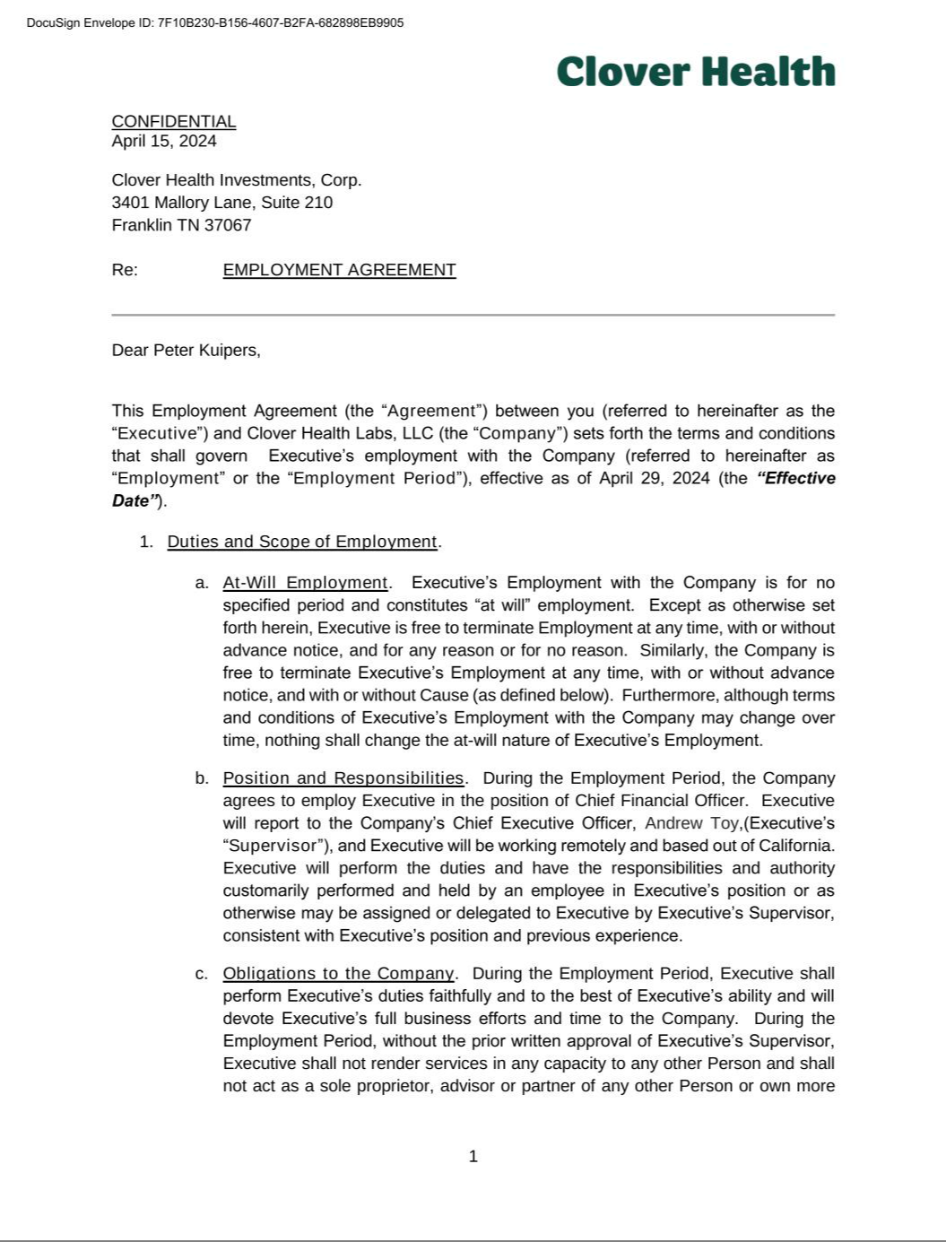

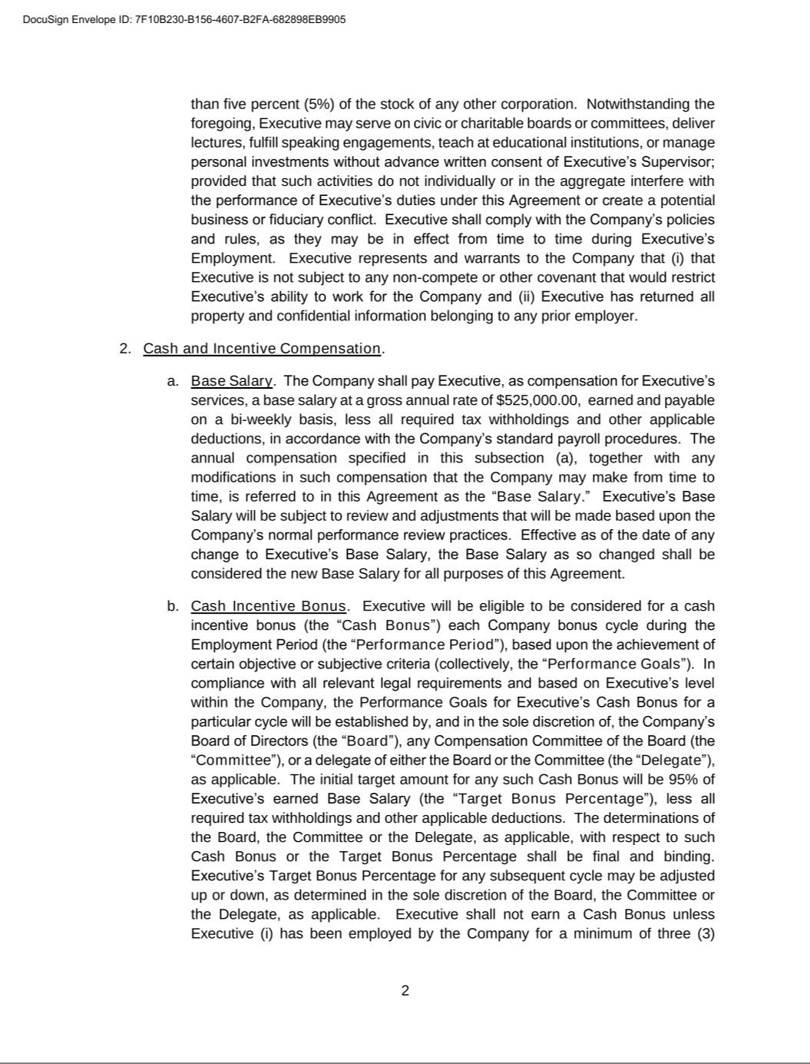

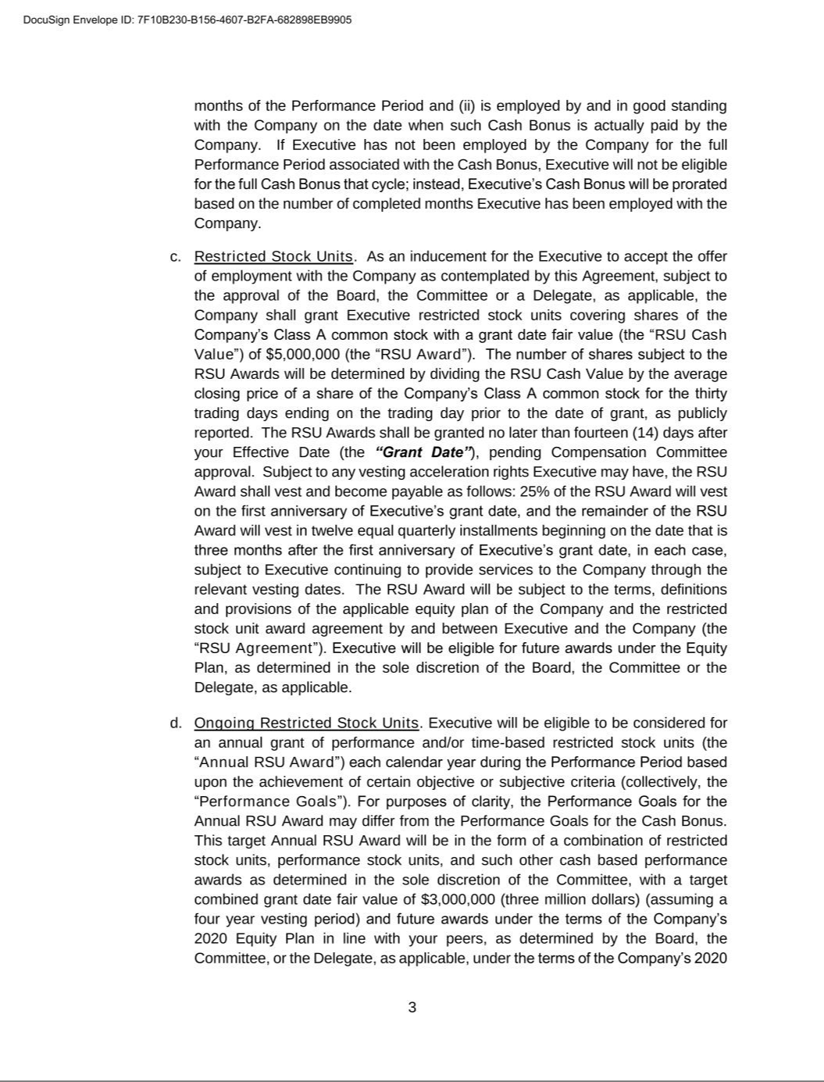

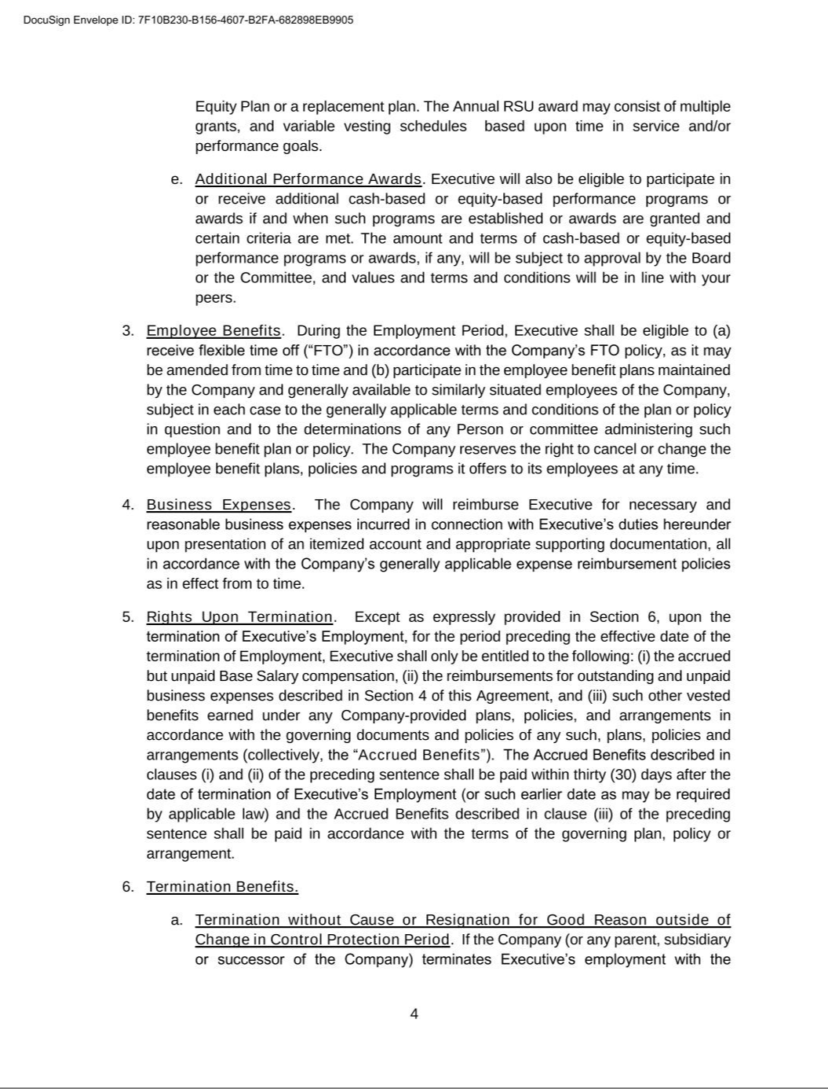

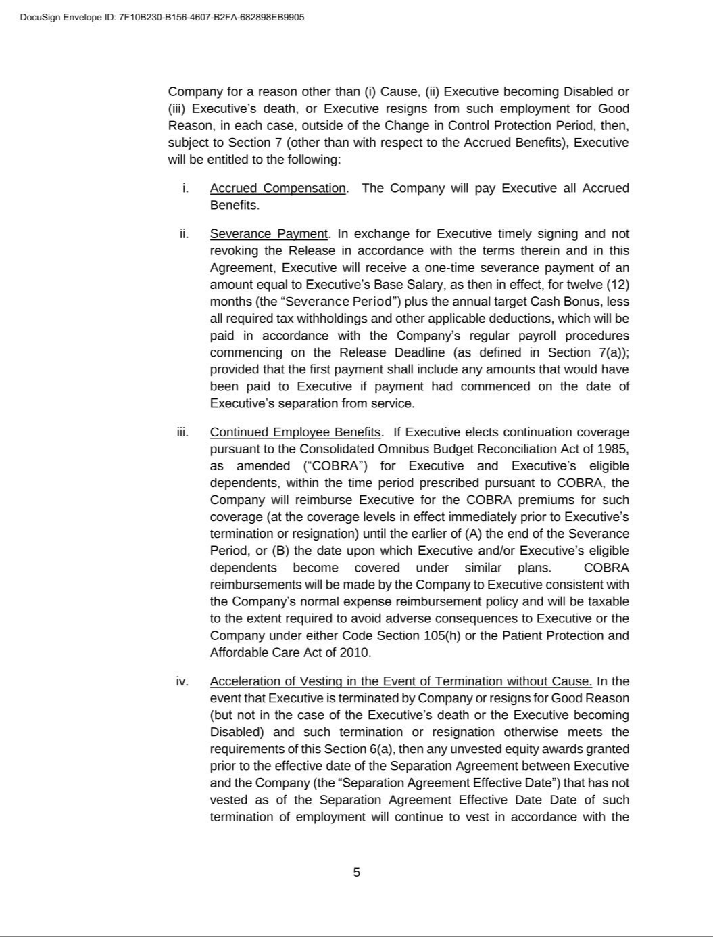

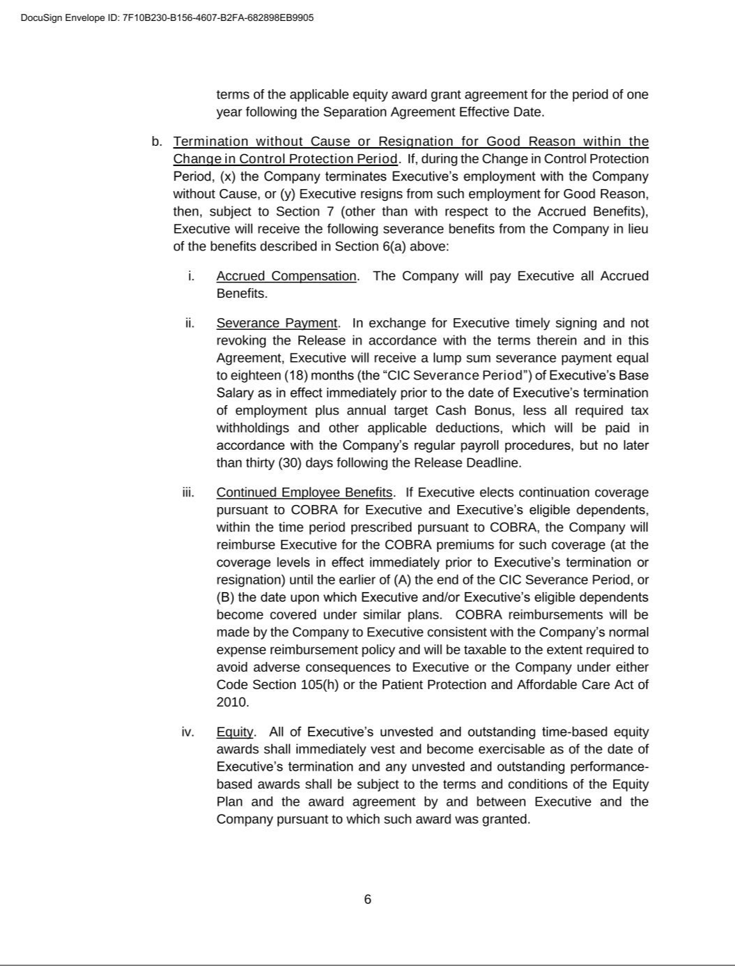

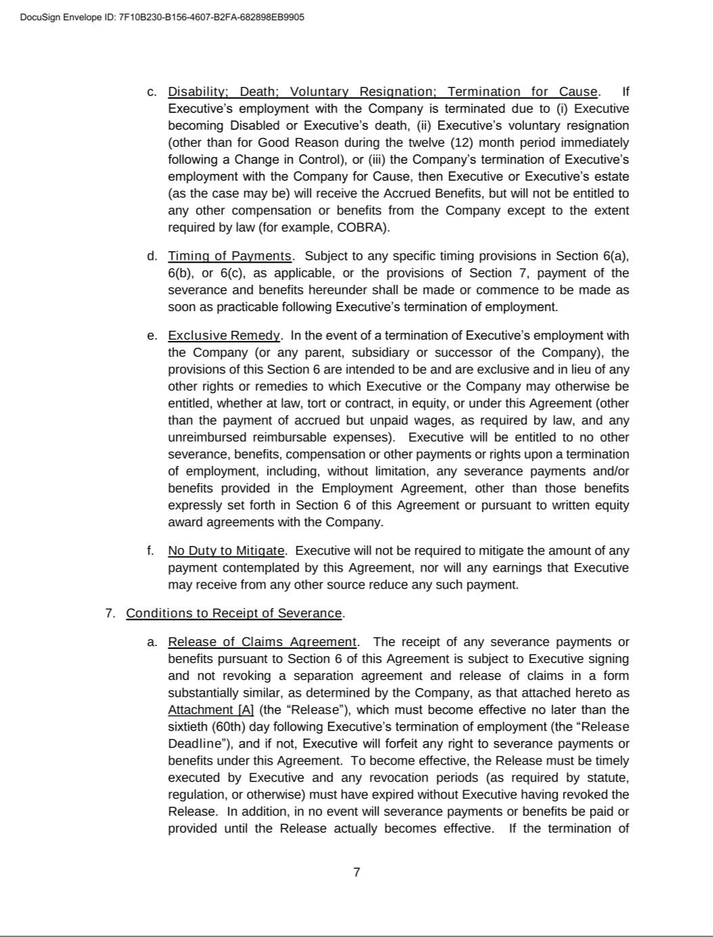

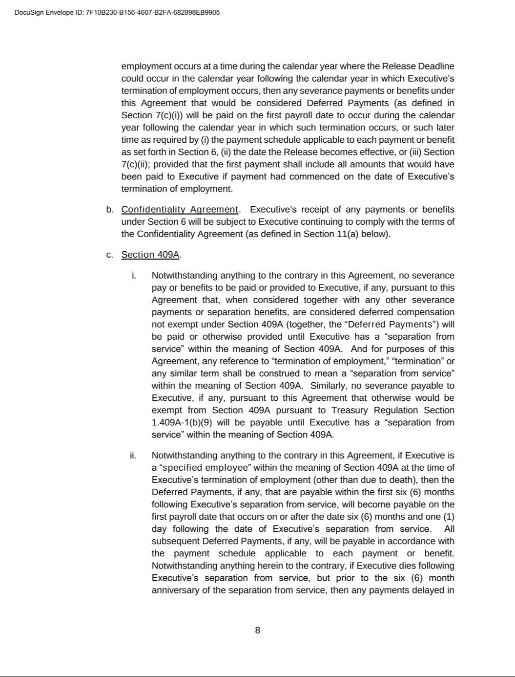

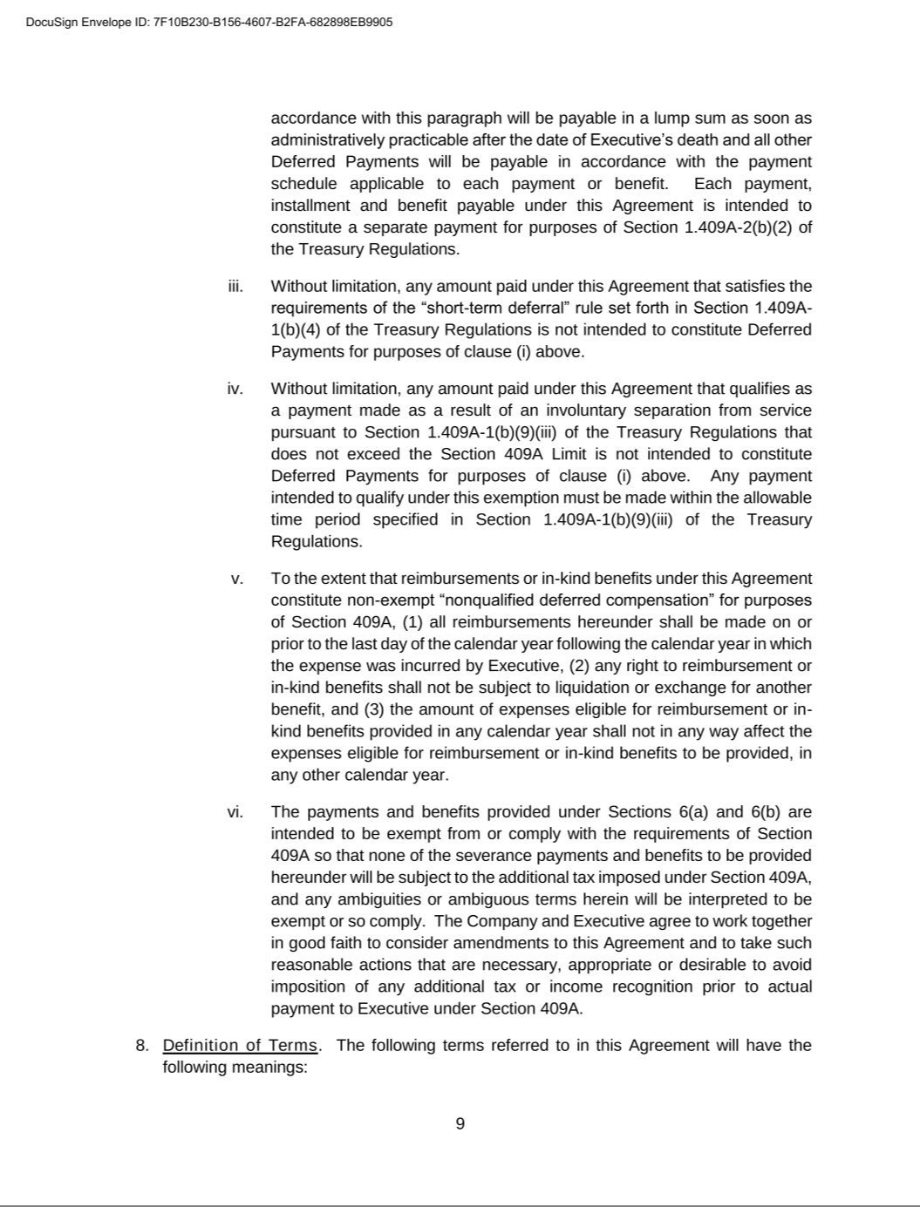

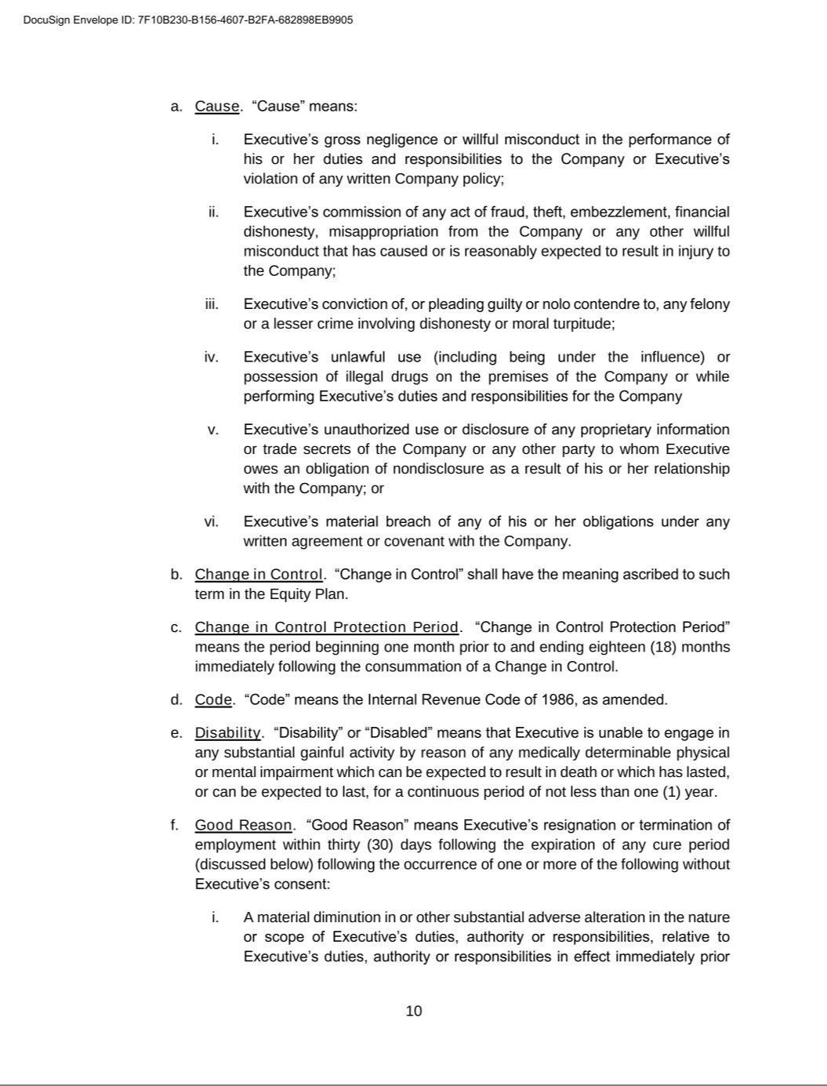

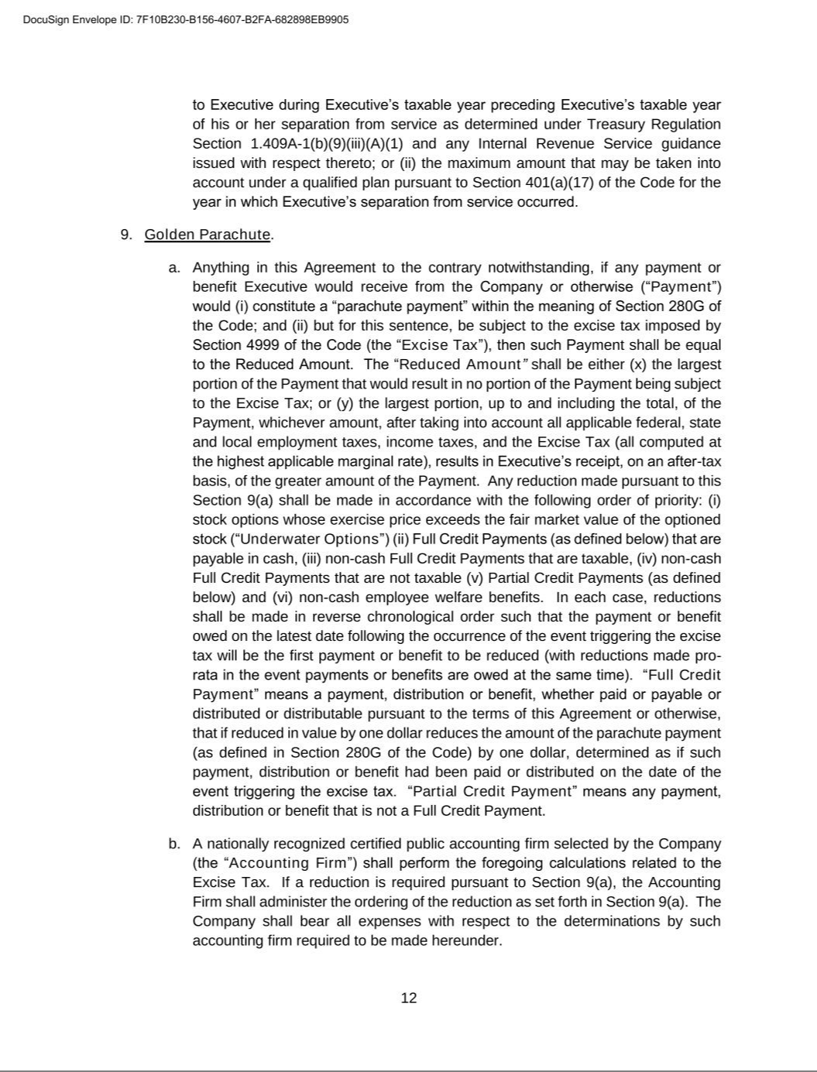

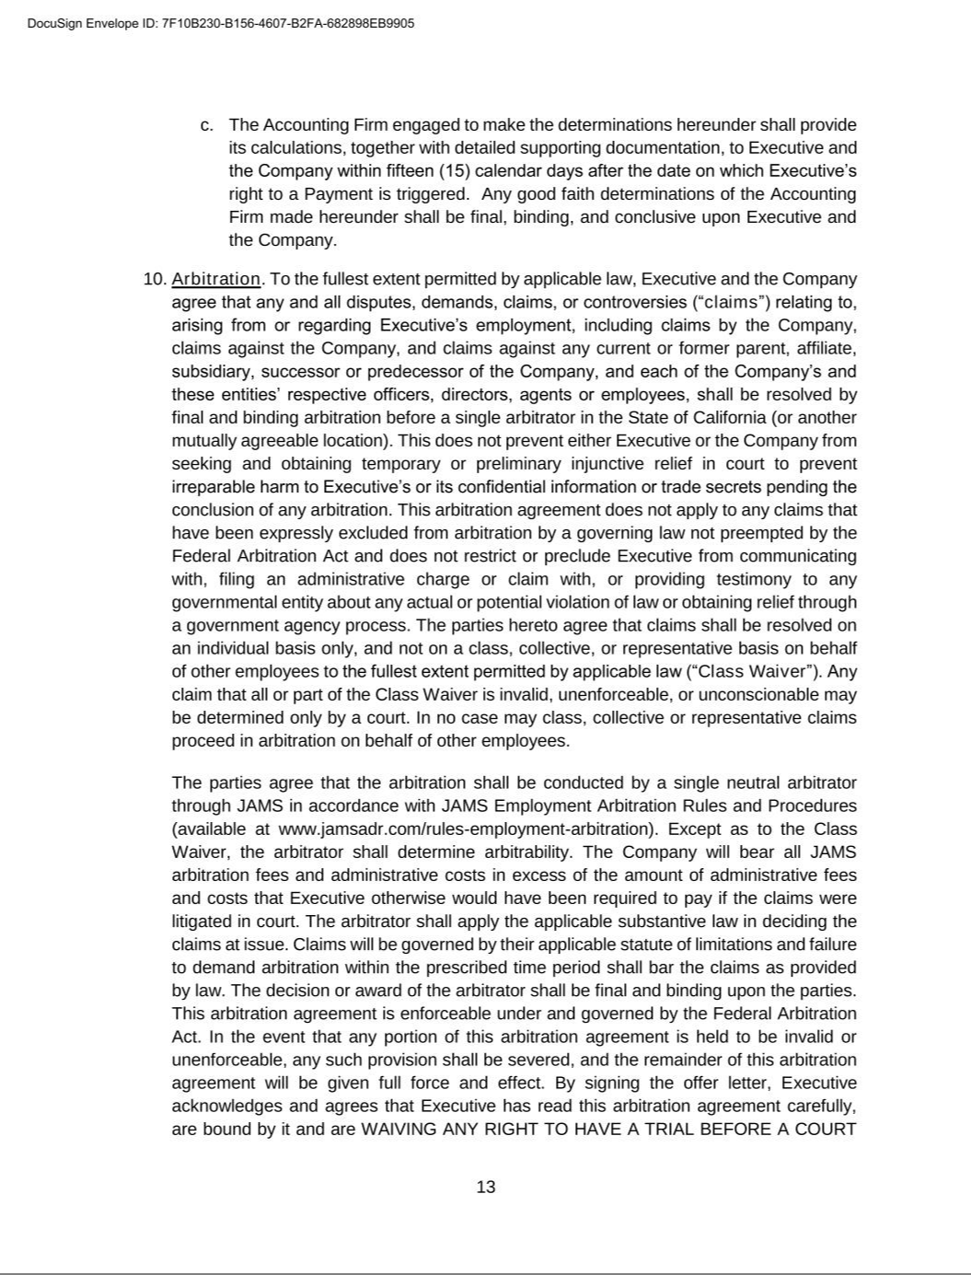

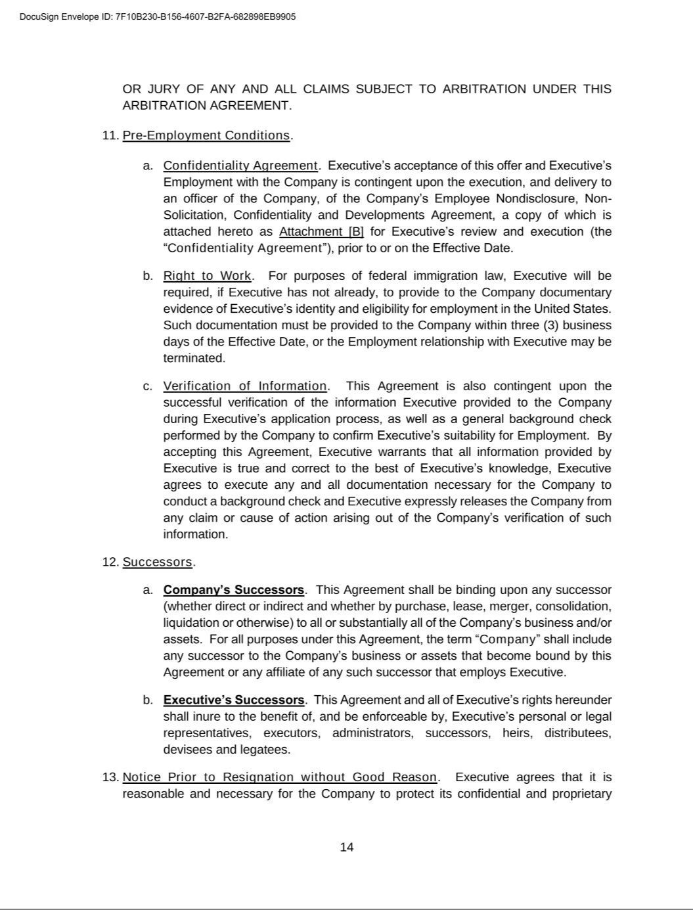

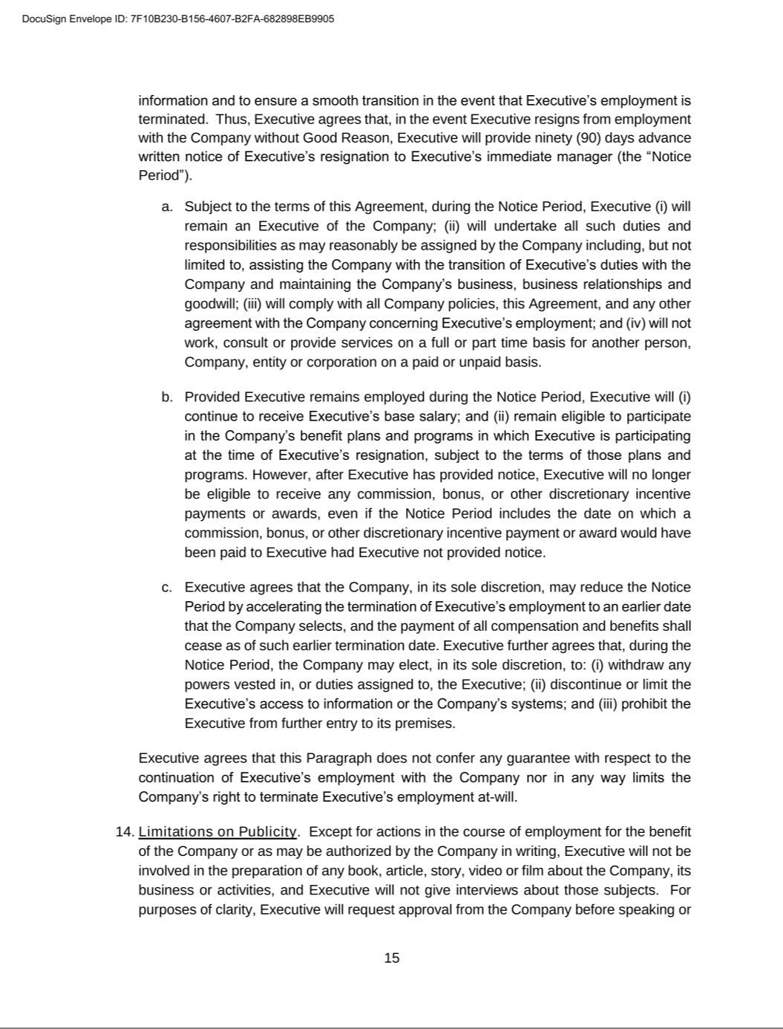

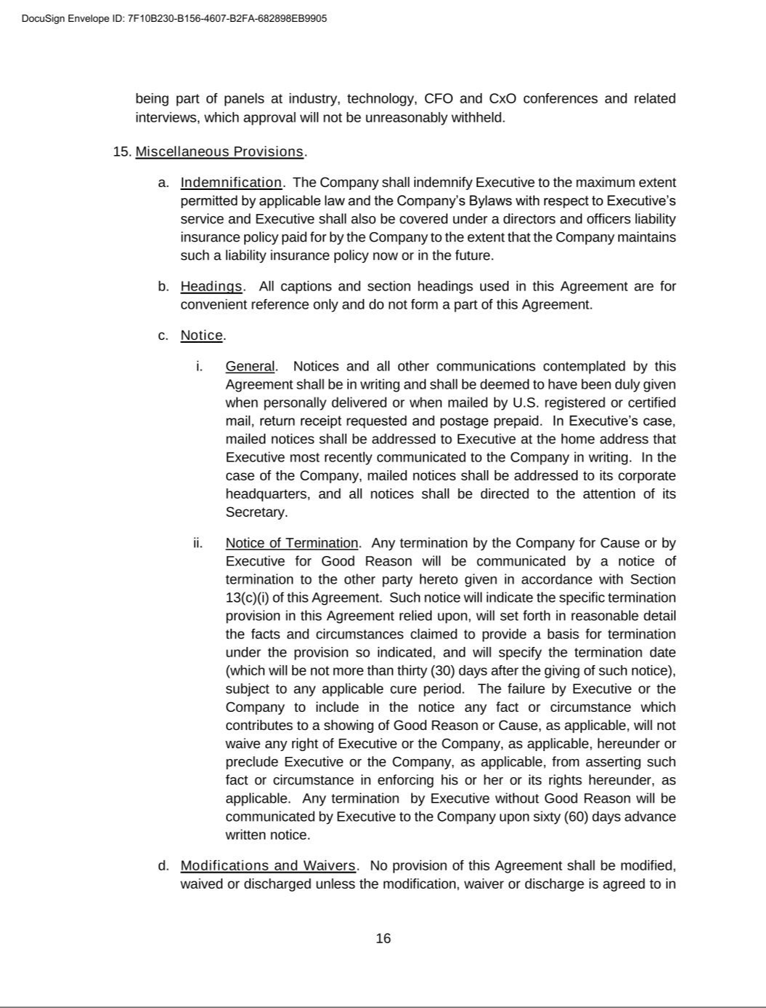

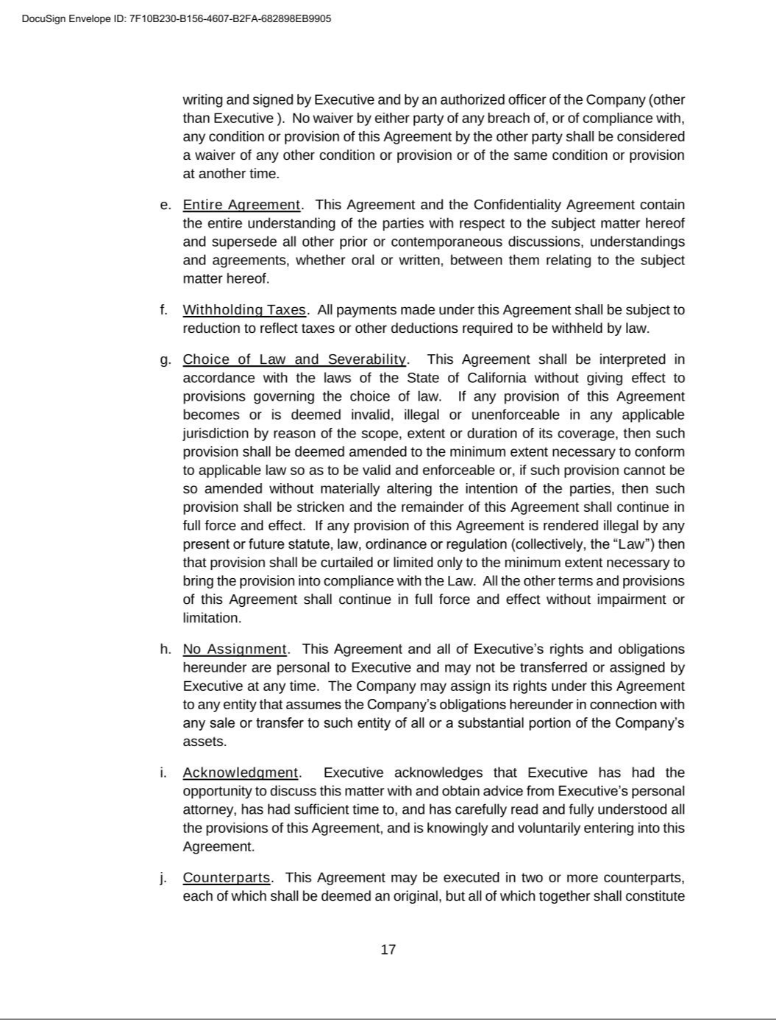

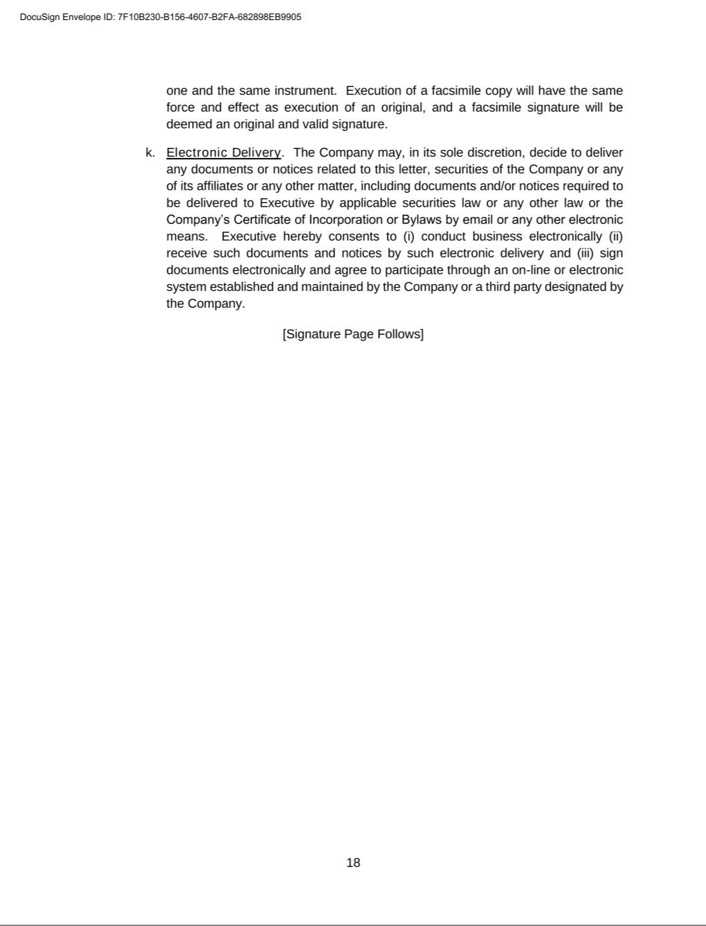

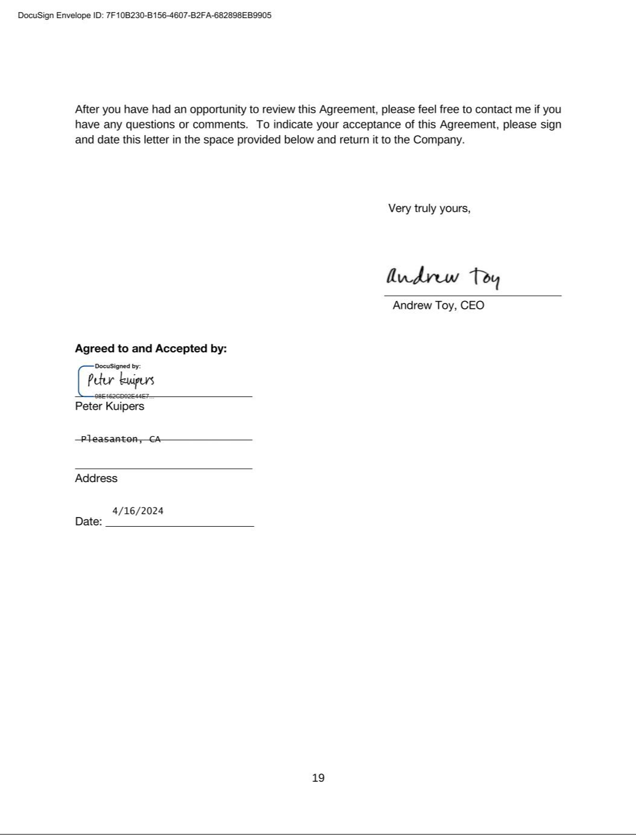

Exhibit 31.1

CERTIFICATION PURSUANT TO

RULES 13a-14(a) AND 15d-14(a) UNDER THE SECURITIES EXCHANGE ACT OF 1934,

AS ADOPTED PURSUANT TO SECTION 302 OF THE SARBANES-OXLEY ACT OF 2002

I, Andrew Toy, certify that:

- I have reviewed this Quarterly Report on Form 10-Q for the three months ended September 30, 2024, of Clover Health Investments, Corp.;

- Based on my knowledge, this report does not contain any untrue statement of a material fact or omit to state a material fact necessary to make the statements made, in light of the circumstances under which such statements were made, not misleading with respect to the periods covered by this report;

- Based on my knowledge, the financial statements, and other financial information included in this report, fairly present in all material respects the financial condition, results of operations and cash flows of the registrant as of, and for, the periods presented in this report;

- The registrant's other certifying officer(s) and I are responsible for establishing and maintaining disclosure controls and procedures (as defined in Exchange Act Rules 13a-15(e) and 15d-15(e)) and internal control over financial reporting (as defined in Exchange Act Rules 13a-15(f) and 15d-15(f)) for the registrant and have:

  - Designed such disclosure controls and procedures, or caused such disclosure controls and procedures to be designed under our supervision, to ensure that material information relating to the registrant, including its consolidated subsidiaries, is made known to us by others within those entities, particularly during the period in which this report is being prepared;

  - Designed such internal control over financial reporting, or caused such internal control over financial reporting to be designed under our supervision, to provide reasonable assurance regarding the reliability of financial reporting and the preparation of financial statements for external purposes in accordance with generally accepted accounting principles;

  - Evaluated the effectiveness of the registrant's disclosure controls and procedures and presented in this report our conclusions about the effectiveness of the disclosure controls and procedures, as of the end of the period covered by this report based on such evaluation; and

  - Disclosed in this report any change in the registrant's internal control over financial reporting that occurred during the registrant's most recent fiscal quarter (the registrant's fourth fiscal quarter in the case of an annual report) that has materially affected, or is reasonably likely to materially affect, the registrant's internal control over financial reporting; and

- The registrant's other certifying officer(s) and I have disclosed, based on our most recent evaluation of internal control over financial reporting, to the registrant's auditors and the audit committee of the registrant's board of directors (or persons performing the equivalent functions):

  - All significant deficiencies and material weaknesses in the design or operation of internal control over financial reporting which are reasonably likely to adversely affect the registrant's ability to record, process, summarize and report financial information; and

  - Any fraud, whether or not material, that involves management or other employees who have a significant role in the registrant's internal control over financial reporting.

Date: November 8, 2024 By: /s/ Andrew Toy

Andrew Toy

Chief Executive Officer

Exhibit 31.2

CERTIFICATION PURSUANT TO

RULES 13a-14(a) AND 15d-14(a) UNDER THE SECURITIES EXCHANGE ACT OF 1934,

AS ADOPTED PURSUANT TO SECTION 302 OF THE SARBANES-OXLEY ACT OF 2002

I, Peter Kuipers, certify that:

- I have reviewed this Quarterly Report on Form 10-Q for the three months ended September 30, 2024, of Clover Health Investments, Corp.;

- Based on my knowledge, this report does not contain any untrue statement of a material fact or omit to state a material fact necessary to make the statements made, in light of the circumstances under which such statements were made, not misleading with respect to the periods covered by this report;

- Based on my knowledge, the financial statements, and other financial information included in this report, fairly present in all material respects the financial condition, results of operations and cash flows of the registrant as of, and for, the periods presented in this report;

- The registrant's other certifying officer(s) and I are responsible for establishing and maintaining disclosure controls and procedures (as defined in Exchange Act Rules 13a-15(e) and 15d-15(e)) and internal control over financial reporting (as defined in Exchange Act Rules 13a-15(f) and 15d-15(f)) for the registrant and have:

  - Designed such disclosure controls and procedures, or caused such disclosure controls and procedures to be designed under our supervision, to ensure that material information relating to the registrant, including its consolidated subsidiaries, is made known to us by others within those entities, particularly during the period in which this report is being prepared;

  - Designed such internal control over financial reporting, or caused such internal control over financial reporting to be designed under our supervision, to provide reasonable assurance regarding the reliability of financial reporting and the preparation of financial statements for external purposes in accordance with generally accepted accounting principles;

  - Evaluated the effectiveness of the registrant's disclosure controls and procedures and presented in this report our conclusions about the effectiveness of the disclosure controls and procedures, as of the end of the period covered by this report based on such evaluation; and

  - Disclosed in this report any change in the registrant's internal control over financial reporting that occurred during the registrant's most recent fiscal quarter (the registrant's fourth fiscal quarter in the case of an annual report) that has materially affected, or is reasonably likely to materially affect, the registrant's internal control over financial reporting; and

- The registrant's other certifying officer(s) and I have disclosed, based on our most recent evaluation of internal control over financial reporting, to the registrant's auditors and the audit committee of the registrant's board of directors (or persons performing the equivalent functions):

  - All significant deficiencies and material weaknesses in the design or operation of internal control over financial reporting which are reasonably likely to adversely affect the registrant's ability to record, process, summarize and report financial information; and

  - Any fraud, whether or not material, that involves management or other employees who have a significant role in the registrant's internal control over financial reporting.

Date: November 8, 2024 By: /s/ Peter Kuipers

Peter Kuipers

Chief Financial Officer (Principal Financial Officer and Principal Accounting
Officer)

Exhibit 32.1

CERTIFICATION PURSUANT TO

18 U.S.C. SECTION 1350, AS ADOPTED PURSUANT TO

SECTION 906 OF THE SARBANES-OXLEY ACT OF 2002

In connection with the Quarterly Report on Form 10-Q of Clover Health Investments, Corp. (the “Company”) for the three months ended September 30, 2024, as filed with the Securities and

Exchange Commission on the date hereof (the “Report”), I certify, pursuant to 18 U.S.C. § 1350, as adopted pursuant to § 906 of the Sarbanes-Oxley Act of 2002, that:

- The Report fully complies with the requirements of Section 13(a) or 15(d) of the Securities Exchange Act of 1934; and

- The information contained in the Report fairly presents, in all material respects, the financial condition and results of operations of the Company.

Dated: November 8, 2024 By: /s/ Andrew Toy

Andrew Toy

Chief Executive Officer

Exhibit 32.2

CERTIFICATION PURSUANT TO

18 U.S.C. SECTION 1350, AS ADOPTED PURSUANT TO

SECTION 906 OF THE SARBANES-OXLEY ACT OF 2002

In connection with the Quarterly Report on Form 10-Q of Clover Health Investments, Corp. (the “Company”) for the three months ended September 30, 2024, as filed with the Securities and

Exchange Commission on the date hereof (the “Report”), I certify, pursuant to 18 U.S.C. § 1350, as adopted pursuant to § 906 of the Sarbanes-Oxley Act of 2002, that:

- The Report fully complies with the requirements of Section 13(a) or 15(d) of the Securities Exchange Act of 1934; and

- The information contained in the Report fairly presents, in all material respects, the financial condition and results of operations of the Company.

Dated: November 8, 2024 By: /s/ Peter Kuipers

Peter Kuipers

Chief Financial Officer (Principal Financial Officer and Principal Accounting
Officer)

