SEC Form 3
FORM 3 | UNITED STATES SECURITIES AND EXCHANGE COMMISSION  Washington, D.C. 20549  INITIAL STATEMENT OF BENEFICIAL OWNERSHIP OF SECURITIES  Filed pursuant to Section 16(a) of the Securities Exchange Act of 1934  or Section 30(h) of the Investment Company Act of 1940
  OMB APPROVAL
  OMB Number: | 3235-0104
  Estimated average burden
  hours per response: | 0.5
1. Name and Address of Reporting Person*  (Street) | 2. Date of Event Requiring Statement (Month/Day/Year)  09/22/2026 | 3. Issuer Name and Ticker or Trading Symbol  CLOVER HEALTH INVESTMENTS, CORP. /DE [ CLOV ]  Foreign Trading Symbol
  Miller Brian James
  (Last) | (First) | (Middle)
  1209 ORANGE STREET
  WILMINGTON | DE | 19801
  (City) | (State) | (Zip)
 |  | 4. Relationship of Reporting Person(s) to Issuer  (Check all applicable) | 5. If Amendment, Date of Original Filed (Month/Day/Year)
   | Director |  | 10% Owner
   | Officer (give title below) |  | Other (specify below)
6. Individual or Joint/Group Filing (Check Applicable Line)
Form filed by One Reporting Person
Form filed by More than One Reporting Person

Table I - Non-Derivative Securities Beneficially Owned
1. Title of Security (Instr. 4) | 2. Amount of Securities Beneficially Owned (Instr. 4) | 3. Ownership Form: Direct (D) or Indirect (I) (Instr. 5) | 4. Nature of Indirect Beneficial Ownership (Instr. 5)
Table II - Derivative Securities Beneficially Owned
(e.g., puts, calls, warrants, options, convertible securities)
1. Title of Derivative Security (Instr. 4) | 2. Date Exercisable and Expiration Date (Month/Day/Year) |  | 3. Title and Amount of Securities Underlying Derivative Security (Instr. 4) |  | 4. Conversion or Exercise Price of Derivative Security | 5. Ownership Form: Direct (D) or Indirect (I) (Instr. 5) | 6. Nature of Indirect Beneficial Ownership (Instr. 5)
1. Title of Derivative Security (Instr. 4) | Date Exercisable | Expiration Date | Title | Amount or Number of Shares | 4. Conversion or Exercise Price of Derivative Security | 5. Ownership Form: Direct (D) or Indirect (I) (Instr. 5) | 6. Nature of Indirect Beneficial Ownership (Instr. 5)
Explanation of Responses:
Remarks:
EX. 24 POWER OF ATTORNEY OF BRIAN J. MILLER
No securities are beneficially owned.
 | /S/PETER J. RIVAS AS ATTORNEY-IN-FACT FOR BRIAN J. MILLER | 10/01/2026
 | ** Signature of Reporting Person | Date
Reminder: Report on a separate line for each class of securities beneficially owned directly or indirectly.
* If the form is filed by more than one reporting person, see Instruction 5 (b)(v).
** Intentional misstatements or omissions of facts constitute Federal Criminal Violations See 18 U.S.C. 1001 and 15 U.S.C. 78ff(a).
Note: File three copies of this Form, one of which must be manually signed. If space is insufficient, see Instruction 6 for procedure.
Persons who respond to the collection of information contained in this form are not required to respond unless the form displays a currently valid OMB Number.
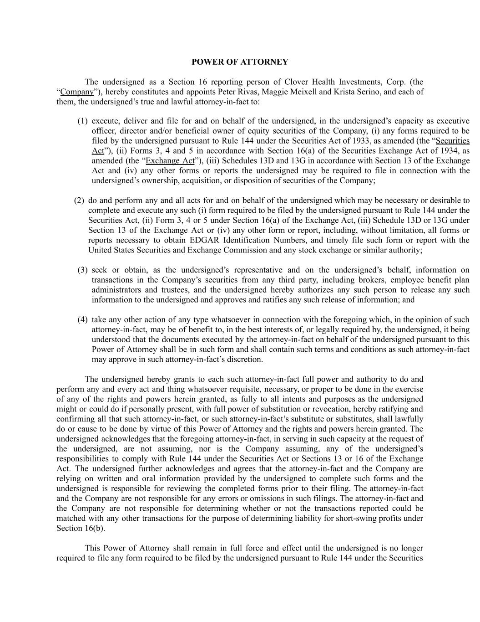
POWER OF ATTORNEY The undersigned as a Section 16 reporting person of Clover Health Investments, Corp. (the “Company”), hereby constitutes and appoints Peter Rivas, Maggie Meixell and Krista Serino, and each of them, the undersigned’s true and lawful attorney-in-fact to: (1) execute, deliver and file for and on behalf of the undersigned, in the undersigned’s capacity as executive officer, director and/or beneficial owner of equity securities of the Company, (i) any forms required to be filed by the undersigned pursuant to Rule 144 under the Securities Act of 1933, as amended (the “Securities Act”), (ii) Forms 3, 4 and 5 in accordance with Section 16(a) of the Securities Exchange Act of 1934, as amended (the “Exchange Act”), (iii) Schedules 13D and 13G in accordance with Section 13 of the Exchange Act and (iv) any other forms or reports the undersigned may be required to file in connection with the undersigned’s ownership, acquisition, or disposition of securities of the Company; (2) do and perform any and all acts for and on behalf of the undersigned which may be necessary or desirable to complete and execute any such (i) form required to be filed by the undersigned pursuant to Rule 144 under the Securities Act, (ii) Form 3, 4 or 5 under Section 16(a) of the Exchange Act, (iii) Schedule 13D or 13G under Section 13 of the Exchange Act or (iv) any other form or report, including, without limitation, all forms or reports necessary to obtain EDGAR Identification Numbers, and timely file such form or report with the United States Securities and Exchange Commission and any stock exchange or similar authority; (3) seek or obtain, as the undersigned’s representative and on the undersigned’s behalf, information on transactions in the Company’s securities from any third party, including brokers, employee benefit plan administrators and trustees, and the undersigned hereby authorizes any such person to release any such information to the undersigned and approves and ratifies any such release of information; and (4) take any other action of any type whatsoever in connection with the foregoing which, in the opinion of such attorney-in-fact, may be of benefit to, in the best interests of, or legally required by, the undersigned, it being understood that the documents executed by the attorney-in-fact on behalf of the undersigned pursuant to this Power of Attorney shall be in such form and shall contain such terms and conditions as such attorney-in-fact may approve in such attorney-in-fact’s discretion. The undersigned hereby grants to each such attorney-in-fact full power and authority to do and perform any and every act and thing whatsoever requisite, necessary, or proper to be done in the exercise of any of the rights and powers herein granted, as fully to all intents and purposes as the undersigned might or could do if personally present, with full power of substitution or revocation, hereby ratifying and confirming all that such attorney-in-fact, or such attorney-in-fact’s substitute or substitutes, shall lawfully do or cause to be done by virtue of this Power of Attorney and the rights and powers herein granted. The undersigned acknowledges that the foregoing attorney-in-fact, in serving in such capacity at the request of the undersigned, are not assuming, nor is the Company assuming, any of the undersigned’s responsibilities to comply with Rule 144 under the Securities Act or Sections 13 or 16 of the Exchange Act. The undersigned further acknowledges and agrees that the attorney-in-fact and the Company are relying on written and oral information provided by the undersigned to complete such forms and the undersigned is responsible for reviewing the completed forms prior to their filing. The attorney-in-fact and the Company are not responsible for any errors or omissions in such filings. The attorney-in-fact and the Company are not responsible for determining whether or not the transactions reported could be matched with any other transactions for the purpose of determining liability for short-swing profits under Section 16(b). This Power of Attorney shall remain in full force and effect until the undersigned is no longer required to file any form required to be filed by the undersigned pursuant to Rule 144 under the Securities

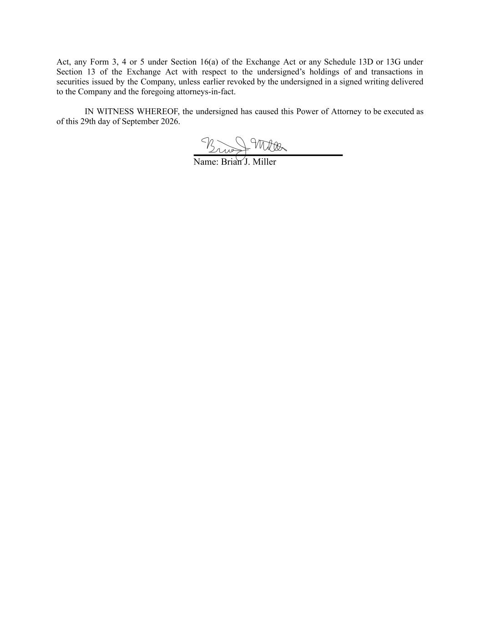
Act, any Form 3, 4 or 5 under Section 16(a) of the Exchange Act or any Schedule 13D or 13G under Section 13 of the Exchange Act with respect to the undersigned’s holdings of and transactions in securities issued by the Company, unless earlier revoked by the undersigned in a signed writing delivered to the Company and the foregoing attorneys-in-fact. IN WITNESS WHEREOF, the undersigned has caused this Power of Attorney to be executed as of this 29th day of September 2026. Name: Brian J. Miller

