UNITED STATES

SECURITIES AND EXCHANGE COMMISSION
Washington, D.C. 20549

FORM 8-K

CURRENT REPORT

PURSUANT TO SECTION 13 OR 15(D)
OF THE SECURITIES EXCHANGE ACT OF 1934

Date of Report (Date of earliest event reported): February 5, 2021

Clover Health Investments, Corp.

(Exact name of registrant as specified in its charter)

Delaware | 001-39252 | 98-1515192
(State or other jurisdiction | (Commission | (I.R.S. Employer
of incorporation) | File Number) | Identification No.)
725 Cool Springs Boulevard, Suite 320,
Franklin, Tennessee |  | 37067
(Address of principal executive offices) |  | (Zip Code)

(201) 432-2133

(Registrant’s telephone number, including area code)

Not Applicable

(Former name or former address, if changed since last report)

Check the appropriate box below if the Form 8-K filing is intended to simultaneously satisfy the filing obligation of the registrant under any of the following provisions:

- Written communications pursuant to Rule 425 under the Securities Act (17 CFR 230.425)

- Soliciting material pursuant to Rule 14a-12 under the Exchange Act (17 CFR 240.14a-12)

- Pre-commencement communications pursuant to Rule 14d-2(b) under the Exchange Act (17 CFR 240.14d-2(b))

- Pre-commencement communications pursuant to Rule 13e-4(c) under the Exchange Act (17 CFR 240.13e-4(c)) Securities registered pursuant to Section 12(b) of the Act:
Title of each class |  | Trading |  | Name of each exchange
 |  | Symbol(s) |  | on which registered
Class A Common Stock, par value $0.0001 per |  | CLOV |  | The Nasdaq Stock Market LLC
share
Redeemable Warrants, each whole warrant |  | CLOVW |  | The Nasdaq Stock Market LLC
exercisable for one Class A Common Stock at an
exercise price of $11.50

Indicate by check mark whether the registrant is an emerging growth company as defined in Rule 405 of the Securities Act of 1933 (§230.405 of this chapter) or Rule 12b-2 of the Securities Exchange Act of 1934 (§240.12b-2 of this chapter).

Emerging growth company ☒

If an emerging growth company, indicate by check mark if the registrant has elected not to use the extended transition period for complying with any new or revised financial accounting standards provided pursuant to Section 13(a) of the Exchange Act. ☐

Item 7.01. Regulation FD Disclosure.

On February 5, 2021, Clover Health Investments, Corp. issued a response to an article by Hindenburg Research dated February 4, 2021. A copy of the response is furnished as an exhibit to this report and is incorporated herein by reference.

The information furnished in this report, including the exhibit hereto, shall not be deemed “filed” for purposes of Section 18 of the Securities Exchange Act of 1934, as amended (the “Exchange Act”), or incorporated by reference in any filing under the Securities Act of 1933, as amended, or the Exchange Act, except as shall be expressly set forth by specific reference in such a filing.

Item 9.01 Financial Statements and Exhibits.

(d) List of Exhibits.

Exhibit No. |  | Exhibit title
99.1 |  | Clover Health response to Hindenburg Research

SIGNATURE

Pursuant to the requirements of the Securities Exchange Act of 1934, the registrant has duly caused this report to be signed on its behalf by the undersigned hereunto duly authorized.

 | Clover Health Investments, Corp.
Date: February 5, 2021 | /s/ Gia Lee
 | Name: | Gia Lee
 | Title: | General Counsel and Secretary

Exhibit 99.1

In Response to Short Seller Firm’s Questions

Andrew Still-Baxter 18 min read

From:

Vivek Garipalli, CEO and Andrew Toy, President of Clover Health

Clover’s mission is to improve every life. We do that by scaling the Clover Assistant platform across physicians to drive a meaningful positive clinical impact towards as wide a percentage of our membership as possible. We align our incentives for the Clover Assistant by embedding our software platform inside of the business of our Medicare Advantage plan. As we improve outcomes, and lower costs, Clover can pass those savings on to consumers, improving the attractiveness of our plans and spurring rapid growth. We ultimately seek to transform healthcare for each and every one of us.

Clover welcomes questions about our business, as it gives us the opportunity to share our vision and to address any skepticism, whether founded or unfounded. As you will see from our detailed,

point-by-point response to the short seller firm’s questions, the alleged “report” is rife with ad-hominem attacks, sweeping inaccuracies and gross mischaracterizations. Importantly, the short seller firm did not contact Clover, and we had no knowledge of the short seller report prior to it being made publicly available. In our view, it belies a desperate attempt for publicity while sacrificing any regard for the truth.

In addition, we would note that the report’s title specifically calls out the involvement of “The King of SPACs,” Chamath Palihapitiya, and accuses him of a dearth of diligence. This, as we will show, is completely untrue, and we suspect this was done in order to sensationalize what is otherwise a rather underwhelming piece of research. Given the market’s latest views on short sellers, we believe that Hindenburg, which takes pains to call out their altruism in saying that they are not short on CLOV stock, is foolheartedly seeking to redeem itself by posturing as a white knight of the financial markets.

We’ve put together this response as rapidly as possible. We hope you will find it extremely informative.

##

1. Did Chamath and/or Clover know about the ongoing DOJ investigation? If so, why was it concealed from investors?

Chamath and Clover were fully aware of the DOJ inquiry.

To be clear, Clover does not believe it is, or has been, in violation of any rules or regulations related to the inquiry.

We went through both an IPO and de-SPAC due diligence process, and this subject received extensive focus and attention. Consistent with the views of Clover’s outside counsel, Social Capital’s outside counsel, and independently retained outside counsel of third parties, including IPO underwriters’ counsel, we concluded that the fact of DOJ’s request for information was not material and was not required to be specifically disclosed in our SEC filings.

How could a DOJ inquiry not be considered material information? As heavily regulated organizations participating in Medicare Advantage, Clover and its peers receive frequent requests for information from regulatory bodies. These are typically confidential. We promptly respond to these requests as and when they come in. As the short selling firm points out, the DOJ also often reaches out to ex-employees, including by civil investigative demands, as part of their information-gathering process.

For absolute clarity:

- Clover Health believes it has made all appropriate disclosures, which were reviewed and vetted by outside counsel to all parties.

- Clover has not received any civil investigative demands or subpoenas from the Department of Justice.

- Clover has received a request for information from the Justice Department, to which, as we do with all requests from regulatory bodies, we responded. This was on a voluntary basis.

- Clover has conducted a detailed review of matters potentially addressed by the DOJ request for information and has concluded that it is in compliance with all laws and regulations material to its business.

- Up until the publishing of the short selling report yesterday morning, Clover was unaware of any other ongoing investigations of the Company, its officers, or any companies with which they are affiliated.

- Following the report yesterday, Clover received notice of an investigation from the SEC. We believe this inquiry is based on the short selling report issued yesterday morning.

2. Is Clover aware of any other regulatory investigations into the company or Vivek Garipalli and his related companies? If so, what are the details?

Clover is unaware of any other ongoing regulatory investigations, except, as noted above, following the short selling firm’s report yesterday morning, Clover received an inquiry from the SEC. We believe this request is based on the short selling report issued yesterday morning.

3. Has Clover received any subpoenas or civil investigative demands from regulators? If so, how many and from which regulators?

No. Clover has not received any civil investigative demands or subpoenas from the Department of Justice. Clover has received a request for information from the Justice Department, to which, as we do with all requests from regulatory bodies, we responded on a voluntary basis.

- Why does Clover’s subsidiary, “Seek Insurance” operate a website called “SeekMedicare.com” claiming to offer “independent” and “unbiased” advice on selecting Medicare plans without disclosing that it is owned by a Medicare plan provider, representing a blatant conflict of interest?

Seek Medicare is a startup that was incubated and set up as a separate company from Clover — it has its own management team, outside investor (a nationally-recognized public company), board and employees. Clover and the outside investor share in governance of Seek at the board level, including decisions such as the nomination of the CEO. Clover has the right to appoint a Board Member (currently Andrew Toy, Clover’s President & CTO), the outside investor has a right to appoint a Board Member (currently an employee of the outside investor), and the third Board Member, the CEO, must be mutually agreed upon. In addition, this investor has a unilateral contractual option to convert its investment into 50% equity ownership of Seek.

It’s not unusual for payors to create or have stakes in FMOs. What makes Seek different is its fundamental belief that Medicare consumers are simply not well-informed and that hurts their ability to get affordable, great healthcare. Seek is purpose-built to deliver against that problem. In order to make sure it could effectively pursue its goals, Seek was set up as a separate company, and it has raised nearly all of its capital from the outside investor.

At Clover, we obviously want everyone to pick a Clover plan, but we want to earn that business by providing great and affordable healthcare coverage.

The most important thing is that Medicare eligibles end up in the right plan for them.

One final note here: Seek is a brand new startup, and its website is still in version 1.0. Please take a look back next week when its planned version 2.0 comes out.

- Clover’s subsidiary, Seek Insurance, claims on its website “We don’t work for insurance companies. We work for you” despite literally being owned by Clover, an insurance company. What is your response?

While Seek is an affiliate, as we said, it operates separately from Clover, with its own financing and its own goals, which are to provide neutral, objective advice to Medicare eligibles and to empower, educate and assist them. Seek offers Clover plans but, more importantly, Seek also offers many more coverage options. In fact, in every market in which Seek operates, Seek endeavors to offer at least 80% of available plans in that market.

Even though Seek began very recently, it was able to stand up its agency in the most recent AEP and also launched a pilot in ~100 retail locations in six states, with a focus on markets in Georgia, New Jersey and Texas.

If you want to see the objectivity of Seek, we think the results of Seek’s initial sales period speak for themselves:

Percent of Seek sales, by insurance plan, in the most recent AEP:

- Cigna: 20%

- Humana: 20%

- CVS/Aetna: 17%

- Clover: 13.5%

- UnitedHealth Group: 11.3%

- WellCare: 8.5%

- Horizon: 5.7%

- Other (unrelated to Clover): 4.0%

In terms of scale, applications from Seek totaled less than 1% of the total applications Clover received in the most recent AEP.

- How much has Clover paid B&H Assurance, the undisclosed outside brokerage firm run by Hiram Bermudez (its Head of Sales) since inception? Clover has paid approximately $160k directly to B&H since 2017.

Hiram has disclosed the following in connection with his B&H relationship:

- He does not receive any compensation, direct or indirect, from B&H Assurance for any work related to Clover.

- He maintains a 50% ownership interest in B&H Assurance, which he has owned since before he joined Clover.

- Hiram’s only work on behalf of B&H Assurance is monitoring compliance and negotiating contracts, from time to time, with parties that do not include Clover.

- He maintains an ownership interest in B&H Assurance so that, in case he separates from Clover, he has the option to go back to the brokerage agency he co-founded and not have to start over.

As a general matter, Clover engages with brokers in each of its markets in order to distribute its plans. This is standard operating procedure in the Medicare Advantage space. Broker payments are statutorily defined by state insurance regulators, broker scripts are actively monitored by both internal compliance and CMS — including via “secret shopper” and other methods — and we take our obligations to CMS, our members and potential members very seriously. We believe our marketing materials and the brokers that represent us accurately reflect and portray our plans to our members and potential members and do so with transparency and integrity.

- What portion of Clover’s business has been referred by B&H Assurance since inception? How many members? Approximately 8,200 of our current members were referred by B&H Assurance to Clover.

While B&H has been a strong producer, we strongly disagree with the statement that B&H alone has “fueled” Clover’s growth. We believe that all Medicare Advantage plans have key producer relationships, and to say those relationships somehow illegitimately fuel growth is a misnomer.

We believe Clover plans are appealing because they are often amongst the lowest cost plans in our established markets, and they offer the same cost-sharing for in-network and out-of-network primary care and specialist visits. As we expand across the country, we intend to establish relationships with additional brokers and key producers.

- Former employees told us that the relationship between Clover and B&H Assurance was transferred into the name of Hiram Bermudez’s wife “for compliance purposes”. NAIC filings confirm it was transferred into his wife’s (maiden) name weeks after the go-public announcement. What is the explanation for this?

The statement underlying this question is false and misleading. The reason that B&H Assurance’s appointment list does not include Clover is that B&H has what is referred to as a “downline” relationship with Ritter Insurance Marketing, which contracts directly with Clover (note that it appears B&H does contract directly with a number of other plans based on the cited NAIC record page). Rather than a nefarious circumstance, this is also a standard construct in the Medicare Advantage world.

Further, the statements interpreting Yesenia Rivera (Bermudez)’s NAIC profile are incorrect in their conclusions: (1) there was no transfer of any relationship between Clover and B&H Assurance from Hiram to his wife; (2) the NAIC filing simply shows that on August 14, 2020, Mrs. Bermudez was directly appointed by Clover Health to be able to sell Clover plans as an agent.

For context, Hiram underwent a major organ transplant surgery at the end of last summer due to chronic kidney disease. He, thankfully, is doing very well healthwise after the surgery. Hiram informed us that he and his wife made a decision for her to go through broker certification so that, if his condition deteriorated further, she would be able to take over his 50% ownership in B&H.

No one should ever feel compelled to share this type of personal and private health information publicly, but we deeply respect Hiram’s desire to disclose this to make clear he had no malicious intent. Hiram is highly mission-oriented and an amazing teammate at Clover, and pathetic attempts to slander him are shameful.

- Will Clover produce the agreement showing the transfer of the relationship into Hiram Bermudez’s wife’s name? Who signed off on the agreement and which senior members of management knew about the deal?

See previous response.

- Is Clover aware that disclosure of significant transactions with key senior employees is something investors like to know about, so they can be made aware of potential material conflicts of interest?

Consistent with applicable laws and regulations, Clover has conflict of interest policies requiring employees to disclose any existing or potential conflicts of interest. Clover follows SEC rules and regulations regarding the public disclosure of these relationships.

- Was Chamath aware that the DOJ was looking into issues of potential upcoding when he mentioned, unprompted, on CNBC “they don’t motivate doctors to upcode or do all kinds of things in order to get paid”?

We agree (as does Chamath) that upcoding is a significant problem in the Medicare Advantage industry, and Chamath was fully aware that we have built the Clover Assistant to address the problems in the approaches used by other insurers.

To be clear, Chamath’s statement that “we do not motivate doctors to upcode or do all kinds of things to get paid” is accurate:

- We pay Clover Assistant Primary Care physicians a fixed, flat payment per office visit.

- Unlike other plans, we never compensate more for agreeing with the Clover Assistant. We never pay less for disagreeing with the Clover Assistant. This payment is fixed and guaranteed, and physicians use their own judgment on what they believe is clinically correct in relation to their direct understanding of the patient.

- Put another way, a clinician could choose to disagree with every suggestion, which means there are no additional diagnoses and no additional risk adjustment codes, and they still get paid the exact same amount as if they did agree. There is NO financial motivation that we provide to physicians to answer in any particular way.

- This is why we specifically do not believe in capitation contracts the same way that others do. These contracts often share risk adjustment back to physicians — i.e., an indirect way to reward them for coding more. Clover does not support those types of strategies.

To be clear, the focus of the Clover Assistant is driving clinical value. Because of its important role in early and improved detection of disease burden, accurate risk adjustment is one of the byproducts of clinical engagement with the Clover Assistant. Notably, however, much of the content in the Clover Assistant has absolutely nothing to do with risk adjustment. More than 50% of the clinical data we capture through Clover Assistant visits has no risk score impact whatsoever.

Here are just a few examples of the Clover Assistant driving clinical value:
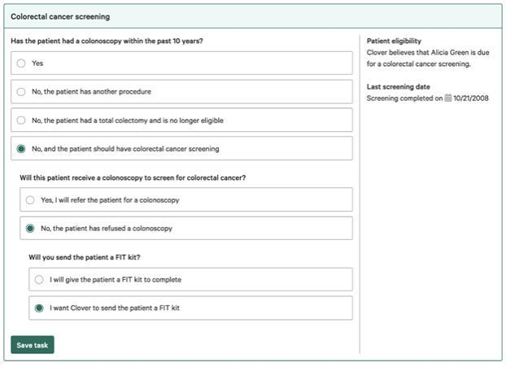

Colorectal Cancer Screening

Medication Therapy Management:

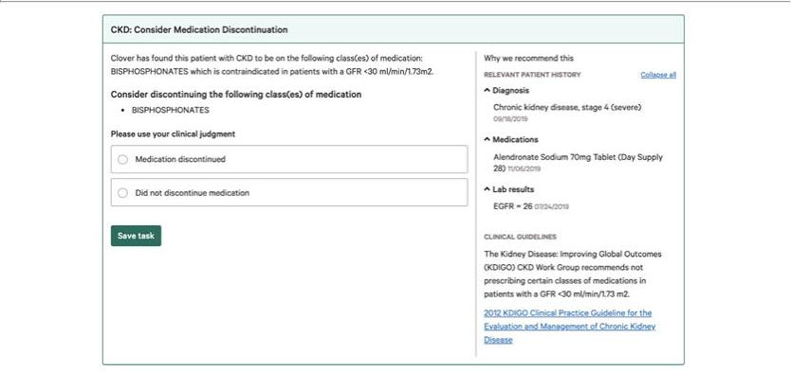

For Chronic Kidney Disease
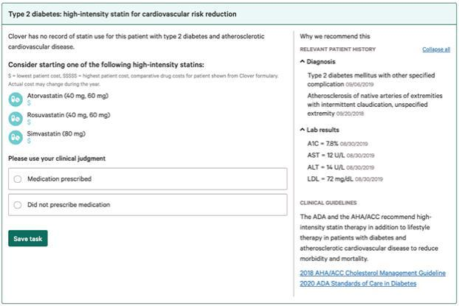

For Statins

Addressing risk:
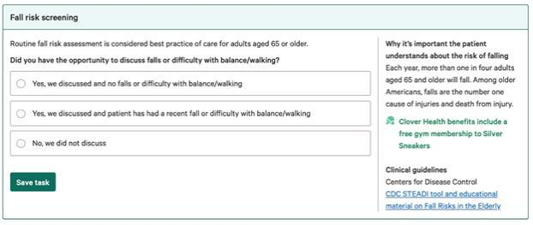

Fall Risk
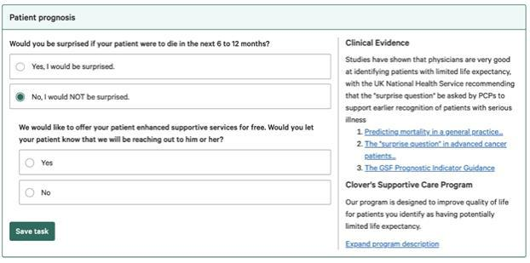

Mortality Risk

Covid — 19 Response

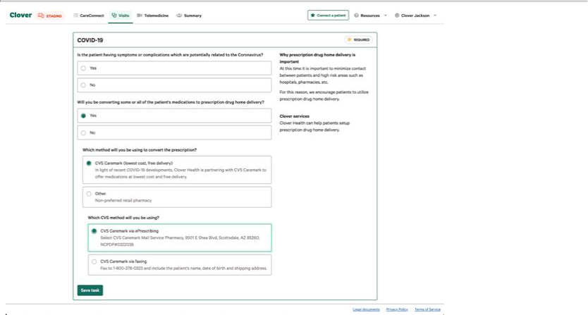

Mail Order and Home Drug Delivery

- Clover reported that “onboarded” physicians used Clover Assistant for 92% of member visits in 2019, but never defined “onboarded”. We found that less than half of Clover’s in-network doctors are considered “Clover Preferred”. What is the definition of an “onboarded” physician? What percentage of Clover’s in-network doctors actually use the Clover Assistant?

This is a good question. Similar to enterprise software, there are two phases of bringing on physicians to Clover Assistant:

Contracting: Where we explain the benefits of Clover Assistant to the physicians and they have agreed to use the software.

Onboarding: Where the physicians have received their initial training and have created their accounts, and we have answered their questions. Basically, they’re ready to use the software. We also refer to the physicians as the “Live” physicians.

We use the Onboarded/Live number (as opposed to Contracted) when discussing engagement because that correlates to the physicians that are trained and ready to use the Clover Assistant. We typically have a pipeline of Contracted physicians waiting to be onboarded at any given time, and our goal is to go from Contracted to Live within 60 days.

Speaking to the second question, currently 22% of all in-network Primary Care Physicians are Live. This correlates to 4% of the total in-network physicians (including PCPs, specialists, etc.), but the Clover Assistant is currently built as a tool for PCPs, so we believe 22% is a more useful number.

That said, we don’t view either of those figures to be particularly relevant to the scalability and impact potential of the Clover Assistant. Instead, we focus on membership coverage. More specifically, as of YE 2020, 56% of our membership were attributed to one of those 22% Live PCPs. An additional 11% are attributed to a PCP who is contracted but in the onboarding pipeline (bringing us to 67% total coverage for Clover Assistant as of YE 2020).

This is because as we bring on physicians, we focus on contracting and onboarding those with more Clover members first, so a disproportionate number of our members are attributed to Clover Assistant-Live PCPs. As we continue to deploy the Clover Assistant, we intend to bring on the remainder of these physicians and we expect to see these numbers converge more. Right now we’re very proud of that 67% coverage number of all Clover members as of year-end 2020.

13. If Clover’s software is so “delightful” to use, why does Clover have to pay doctors extra ($200 per visit) just to use it?

We think this is a big part of the innovation model of Clover and why it’s so important that we build this tool internally as a payor.

The Clover Assistant is a SaaS-type enterprise clinical decision tool, but rather than charge physicians to use it (like regular software startups), we instead reimburse PCPs to encourage them to use it and to recognize the incredibly important role PCPs play in assessing and taking care of our members and controlling costs. PCPs receive less than 5% of total medical expenses in the US, and we believe that to solve the ballooning health care expenses in our country, we need to shift more of our focus, resources, and compensation to primary care doctors.

To be clear, the “extra $200 per visit” is not incremental or “just to use” the Clover Assistant, but represents the overall payment that covers both the PCP office visit and the use of the Clover Assistant. This translates to roughly twice the traditional Medicare fees paid to PCPs for an office visit, more in line with fees paid to specialists.

Most critically, this is a flat fee. We don’t pay them more to agree with us, or less when they disagree. A lot of programs effectively do this, and that creates moral hazards like upcoding or trying to skimp on care. We pay the flat fee because we want to reward PCPs for great data-driven primary care without creating those moral hazards and bad incentives.

Speaking to the delight point — we measure this in an objective, standard way in the form of Net Promoter Score surveys. We run these surveys within Clover Assistant for all Clover Assistant users on a quarterly basis to see how we’re doing in terms of user satisfaction and delight. We’ve traditionally received a score between 55–63 which we think is excellent — particularly for healthcare.

Here’s a screenshot of our NPS survey:

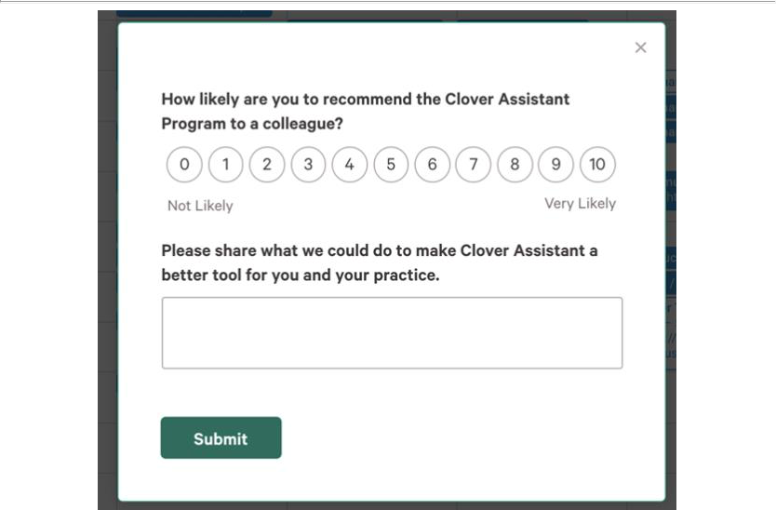

Clover Assistant NPS Survey
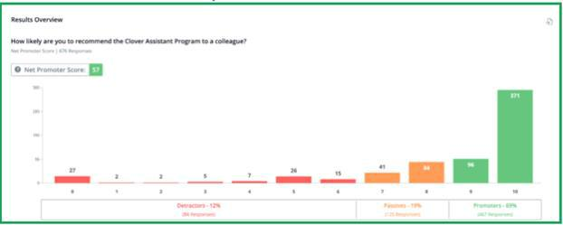

Our most recent NPS results from the end of last year.

As you can see, most of our Clover Assistant survey respondents give us very high ratings. There are a few “middle” scores, and there are, of course, some detractors who give us low scores. When we receive detractor feedback, we strive to send our Product and User Research teams to interview these users to find out how we can do better. We’re not perfect, but our fast iteration rate (releasing a new Clover Assistant version on average every 3–4 weeks) helps us continuously improve our platform.

- Multiple doctors explained that it was difficult to remove prior diagnoses from the Clover Assistant. Is Clover aware of this? And can Clover guarantee that in future versions of the software doctors will be able to remove prior diagnoses, so as to ensure accuracy and cost efficiency?

For clarity, every diagnosis that appears in the Clover Assistant is for physician consideration, and they can choose to tell us they don’t think that diagnosis is currently relevant. Here’s a screenshot of how it’s shown.

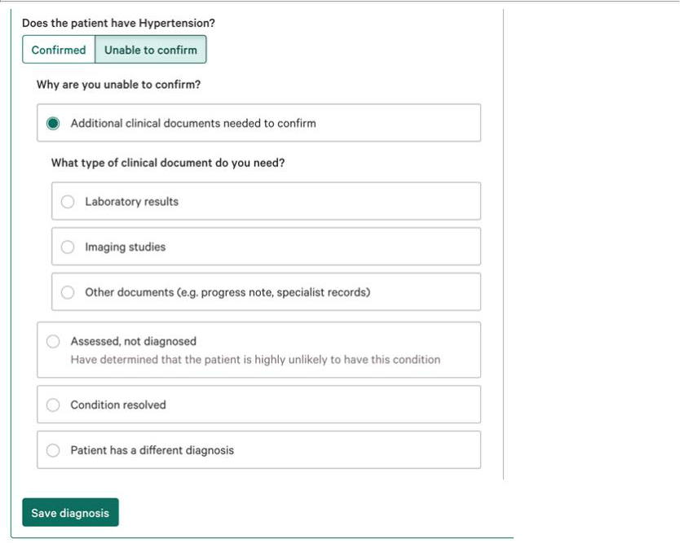

Every suggestion made is based upon clinical data that we have at Clover and personalized for each specific patient. Then the physician can tell us whether they can confirm the diagnosis. If they cannot confirm, they can easily select that option (shown above), and we ask them to share the reason why so we can update our internal data.

Note that when a physician tells us a diagnosis is not currently relevant, we do not show that diagnosis again that calendar year unless there is a new reason to believe that the diagnosis applies (e.g., new clinical data).

We may also resurface a diagnosis the following calendar year for reconfirmation. There’s a reason for this: many chronic diagnoses may come and go in terms of their diagnosis state. For example, diabetes may resolve (removing the diagnosis) if a patient loses weight, but if the patient puts the weight back on, diabetes will come back. Or, active cancer may go into remission, then unfortunately return. As such, it’s clinically appropriate to track these previous diagnoses.

Bonus Question: Is Clover Assistant actually helpful to physicians in providing better care above and beyond their EHR?”

This wasn’t actually in the list of questions addressed to us but was implicit in the short-selling firm’s commentary, so we wanted to hit this on the head, too.

We are incredibly proud of the ways, in only a few short years, we have been able to build the Clover Assistant platform in order to support PCPs in providing better care for our members. The Clover Assistant is not attempting to be an EHR; rather, we are focused on building a product that is supplemental to the EHR and driven by physician feedback.

We’ve supported the rapid transition to remote visits during the outbreak of COVID-19 this past spring, we’ve supported members getting their medications delivered to them when they couldn’t leave their home, and we’ve gotten clinical information otherwise not available to PCPs into the hands of those most equipped to utilize that information.

We also surface evidence-based protocols specific to a member’s disease profile. To be clear, we do this in order to help our members receive the right medications, access the right testing, and achieve better outcomes. By doing so, we pay more money now in order to decrease costs and patient suffering down the line.

If you take a look at our most recent investor presentation, you can easily see a view of that functionality on page 10. On page 19 of the same deck, you can also see a view of the Clover Assistant’s impact outside of accurate diagnosis capture.

We are just starting this journey, and know that, like with any software, there are plenty of opportunities for fine tuning and further improvement. But we are motivated by those challenges and solicit that feedback from the healthcare community and our in-network physicians regularly.

— The Clover Product, Clinical, and Engineering Leads

- A former employee explained that Clover handed out gift cards to doctors and nurses to generate patient leads, a practice prohibited by CMS. These gift cards were justified as being for everything but recruitment, including “morale,” a “thank you,” “motivation,” and “friendship.” How do you respond?

Clover does not provide gift cards to doctors and nurses to generate patient leads.

Clover prides itself on a strong culture of compliance. If we were to discover any violation of CMS regulations or any applicable law or regulation, our compliance department would take decisive and strong corrective action.

16. Does CEO Vivek Garipalli deny that his CarePoint hospitals at one point charged the highest emergency room prices in the entire nation?

It is important to note that CarePoint is a separate and independent business entity, with different management teams, investor structures, and boards of directors. We do not comment on its operations. We also do not respond to ad hominem attacks against our officers.

17. Why did CEO Vivek Garipalli make a secret $1 million donation to the Mayor of Jersey City?

The aforementioned contribution to a PAC has been reported in the media. Like any private citizen, Vivek makes contributions. As our first market, New Jersey is near and dear to us, and Vivek believes the Mayor of Jersey City has done a commendable job of attracting businesses and developing affordable housing policies.

Vivek also donates to other causes in New Jersey and elsewhere — such as a $1MM contribution to the Goodwill Rescue Mission homeless shelter in Newark, NJ.

18. Why has Clover had such extensive executive turnover, with 3 CFOs, 3 COOs, and 2 General Counsels in the last 4 years?

Clover has evolved significantly over the past four years, and we needed different people with different skill sets at each stage of our journey. We are grateful for the contributions of every one of our employees, past and present, and are proud of our current management team. As is evident from our team’s background, they bring extensive experience across their areas of expertise. We believe we should always be looking to bring on more and more talented and mission-oriented individuals as we evolve and grow.

In particular, we are grateful to our co-founder Kris Gale for his work as the original Clover CTO to build the fundamentals of the Clover data platform. When Andrew Toy, our current President and CTO, came on board, one of the first things he did was focus on the creation of a way to turn data into improved care by physicians. The result of that was the Clover Assistant.

